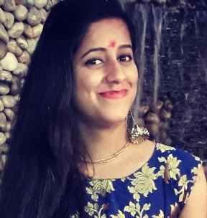

Khushbu Dangwal

Mobile No – (+91)7895580191
E mail – khushdangwal98@gmail.com

- SUMMARY

I want to work with an organization that will provide me an opportunity to exhibit my best ability in order to improve organization and personal development.

- PROFESSIONAL EXPERIENCE:

- Currently working with IBIS, Jaipur – A Unit of Accor Group of Hotels as a Reservation Associate since December 2018. – 140 Keys
- Worked with JSR Continental, Dehradun as a HR Executive (November 2017 to November 2018) – 40 Keys.
- Completed 6 months of Industrial training from IBIS, Jaipur – A Unit of Accor Group of Hotels 2016. – 140 Keys

- JOB PROFILE AS A RESERVATION EXECUTIVE:

- Process all reservation requests, changes and cancellations through Resaweb. Identify guest reservation needs and determine appropriate room type.
- Coordinate with front desk and ensure response to all special guest requests and make all reservations appropriately for all guests.
- Verify availability of room type and rate, explain guarantee, special rate and cancellation policies to Guest. Accommodate and document special requests, answer questions about property services and room accommodations.
- Coordinate with Sales department to maximize revenue by up selling of Rooms.
- Keep track of all offers, confirmations, reminders, deposits, billing and no shows.
- Track all reservations picked up from all On-line channels like hotel website, online travel agent, GDS, other third party.
- Update No-shows and cancellations on all OTA's without fail to avoid and unwanted commissions.
- Process Fastcom (Automatic commission payment system) every week.
- Controlling and updating the hotel pricing points, updating or closing the hotel inventory and applying restrictions on hotel and company level using Data web.
- Prepare pickup report (Room night, ADR, Room revenue) on daily basis.

- SOFTWARE KNOWLEDGE
  - Opera
  - Knowledge of M.S Office ( Word, Excel)

- ACADEMIC CREDENTIALS

Degree | Specialization | University/Board | Division | Year
B.com | Commerce | H.N.B.Garhwal University | IInd | 2018
12 th | Commerce | CBSE | IInd | 2015
10th | Science Group | CBSE | Ist | 2013

PERSONAL DETAILS

Date of Birth 08/08/1998
Address Officer Colony, Dharmapur, Dehradun.
Father’s name Mr. Rajander Dangwal
Nationality Indian

Declaration

I do hereby solemnly affirm and declare that the contents of this resume are true and correct to the best of my knowledge.

Khushbu Dangwal

