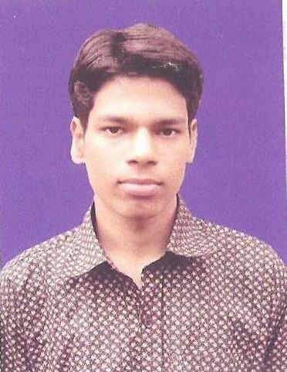
CURRICULUM VITAE
Name : JITENDRA KUMAR BEHERA
Father’s Name : RABINDRA KUMAR BEHERA
Mother’s Name : TILOTTAMA BEHERA
Mob : 8249123400,7008123400
Mail id : zmail.rediff@gmail.com
DOB : 13-12-1992

Objective:
I am looking for a career in an organization that offers a challenging job environment, to broaden horizon and prospect for learning, competition, growth and satisfaction. I assure my fullest support toward the prosperity and well-being of organization.
Personality:
I am result – focused person, who believes in his own strength, skill and roles. I am flexible in my approach hard work and passion to excel in my born traits.
STRENGTH:
Hard working, self- motivation, confident, ambitious and capability to start from the beginning and never accept defeat. I believe in the saying “Great Passion Deft Destiny”
ACADEMIC DETAILS:
Degree/Course | Institution | Year of Passing | Percentage / Grade
M.F.C (Master of finance and | UTKAL UNIVERSITY | 2015 | 62
control) | UTKAL UNIVERSITY | 2015 | 62
B. Com | RAVENSHAW UNIVERSITY | 2013 | 54.85
I. COM | RAVENSHAW JUNIOR COLLEGE | 2010 | 66
H.S.C | URALI HIGH SCHOOL | 2008 | 60

EXPERIENCE:
- Reliance Retail Ltd.:-Since 27th JULY 2017 to Till Date
- Retail Store Associate @Cuttack

- Role and Responsibility:
- Ensure high levels of customer satisfaction through
excellent sales & service.
- Assess customers needs and provide assistance and
information on product features.
- Welcome customers to the store and answer their queries.
- Follow and achieve department’s sales goals on a monthly,
quarterly and yearly basis.
- “Go the extra mile” to drive sales.
- Maintain in-stock and presentable condition assigned area.
- Process POS (point of sale) purchases
- Cross sell products.
- Handle returns of merchandise.
- Working so many things in SAP application.
- Build productive trust relationships with customers.
- Comply with inventory control procedures.
- maintain the EOD Report on Daily Basis.

Permanent Address:-
Name :- Jitendra kumar Behera
C/O-Rabindra kumar Behera
At – Hemanta patana
P.O/Dist – tikiripada/Nayagarh
Pin – 752063
HABIT –
Reading News Paper
Watching T.V
Listening Music
Playing Cricket
Cooking

DECLARATION

I hereby declare that all the above statements given are true to the best of knowledge and belief.

Date : place:

