JYOTIRANJAN BALABANTARAY
Odisha, Kendrapara-754141
Ph: 7077305536
ranjanjyoti386@gmail.com 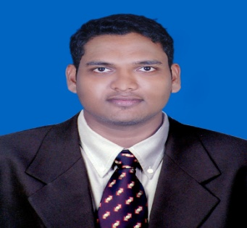

CAREER OBJECTIVE
To enhance my Sales Techniques and experiences in financial sector to become an Asset for the company in every Aspects.
PROFESSIONAL SUMMARY
- An MBA with FINANCE OR MARKETING specialisation .
- Summer training at LINC PEN AND PLASTICS LTD has strengthened and broadened my knowledge in audit report and analysis of Linc pen .
- Good motivetional skills

EDUCATION

MBA (Marketing & finance) from BIITM, Bhubaneswar with 7.48 CGPA mark 2016-2018
BBA from SVM (AUTO) College, Jagathsinghpur with 69% marks 2013 -2016
12th commerce from CHSE board, Marshaghai College, kendrapara 2011-2013
10th BSE, Odisha, Kendrapara 2011

WORK EXPERIENCE
ICICI PRUDENTIAL LIFE INSURANCE LTD. 2nd july 2018 - 16th June 2021
BAJAJ ALLIANZ LIFE INSURANCE 30th Jul 2021 - Present

JOB ROLE – SENIOR KEY RELATIONSHIP MANAGER
- Month and month target achievement
- Development sale strategic
- Cross sale and off sale
- Providing branch customer services
- Direct service providing in customer location
- Processing for payout providing in maturity,surrender and death claim etc
- Customer handling
- Handling 2location Cuttack and bhubaneswar
- Collect information about existing investment product

SUMMERE INTERNSHIP

Title: “PRODUCT KNOWLEDGE ANALYSIS " 01/06/ 17 -11/08/17

Company: LINK PEN AND PLASTICS LTD.
Duration: 60days
DESCRIPTION:
- SIP was based on the interact with the all customer, collect information about the product , providing services
- Development cross sale and off sale to customer

FINDINGS: Need to work on relation building, communication gap analysis.

CERTIFICATIONS

- Blood donate certificate.
- 45 days SIP project work certificate under LINC PEN.

SEMINARS AND WORKSHOPS

- 1 days, clean India seminar at BIITM College, Bhubaneswar. 2016
- 1 days, communication seminar at jaidev bhavan, Bhubaneswar. 2016

KEY SKILLS

- Leadership skills.  - EYE Contact Skills.  - Management skills. | - Team player.  - Decision making ability.
EXTRA CURRICULAR ACTIVITIES

- Participated in SAVE THE TREE campaign.

- Participated in school & college sports activities.

AWARDS & RECOGNITIONS

- Achieve the swimming championship.
- 2nd in running school competition.

Data:
Place: Bhubaneswar (JYOTIRANJAN BALABANTARAY)

