Resume 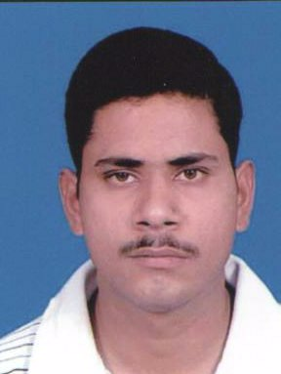
Shardendu Singh
Vill-Deharibhar Post- Bhoopghar Dist- Gorakhpur 273413( Utter Pradesh) Cell No:- 07068909119/09453861415 E-Mail:
singhshardendu5@gmail.com

OBJECTIVE
Highly motivated and result oriented individual with initiative efficiency & a Strong desire to succeed. Work smart to meet organizational goals. Excellent Communication attributes with enthusiasm & interpersonal skill. Looking to contribute as a positive asset to any organization.
EDUCATION

EXAMINATION | INSTITUTE/BOARD | YEAR OF PASSING | MARKS(%)
SSC | U.P. BOARD | 2002 | 53.4%
HSC | U.P.BOARD | 2004 | 60.4%
B.A | D.D.U. Univ. GKP | 2007 | 41%
Tally9 | Uma Ile.Institute | 2009 | 72%

EXPERIENCE

Organization | Designation | Location | Period
BIS. Ind. Ltd. | Admin Officer | Allahabad | Feb-2011 to Aug-2017
OMAX Security Services PVT LTD | Admin & HR | Delhi | Sept-2017 to Nov-2019
Modern Veer Rays Security Force (I) Pvt. Ltd | Admin & HR | Raipur | Dec-2019 To Dec-2021

Job Profile
- Enrollment of new joinee in EPFO & ESIC Portal.
- Complete Access over Challan submission sheet.
- Monthly compliances handling like Audit and legal letter preparation.
- Control Access to company premises & property.
- Monitor & authorize entrance & departure of Employees, Visitors’ and other persons to guard against theft & maintain Security of Company Premises. Dealt with unauthorized access to premises & Property.
- Implement emergency & incident procedure.
- Guiding persons of Rules & Regulation, & apprehend or evict violators from premises.
- Report preparation of daily activities irregularities such as equipments or property damage, theft, presence of unauthorized persons, unusual occurrences. & provide reports to HR Department.
Extra Qualification
Computer Knowledge: - MS Office, Excel, Internet & ERP.
Personal Details.
- Name :- Shardendu Singh
- Age :- 10/07/1988
- Sex :- Male
- Language Known : - English, Hindi,
- Marital Status :- Married
- Area of Interest : - Reading News paper, Listening Music, Driving.
Reference
Will be provided on Request.
Date:-16/12/2021
Place :- Raipur Mr. Shardendu Singh

