CURRICULUM VITAE
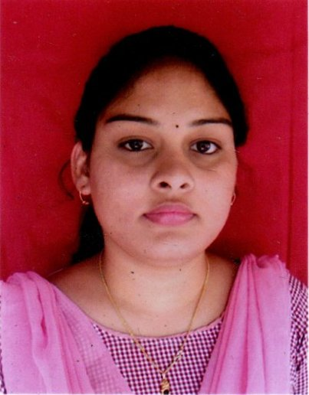

NAME-PARIMITA PURSTY

D/O –GOBARDHAN PURSTY

ADDRESS –AT/PO-RENGALI DAM SITE

PS-RENGALI DAM SITE
DIST-ANGUL–759105
MOBILE NO-7683856712

Email id-paramita1998guduly@gmail.com

CARRIER OBJECTIVE
Want to become a valued member of an organization, which provides an opportunity forlearning and growth and coupled with real time projects. Which will help me enhance myskills’ am looking for an ambience, which is competitive and of responsibilities.

ACADEMIC QUALIFICATION
- Krupajal Business School, Bhubaneswar Post Graduate Diploma in Management, MBA
- Passed Graduation From Mahila Mahavidyalaya, Angul Under RD University In The Year Of 2019 (B.Sc, 3rd Division)
- Passed Intermediate From VSS ISC, Sambalpur Under Council Of Higher Secondary Education In The Year 2015. (+2 Sc., 3rd Division)
- Passed Matriculation From PC High School, Susuba Under Board Of Secondary Education In The Year 2013. (10th 1st Division)

TECHNICAL SKILL
- Advance PGDCA,

HOBBIES
- Gardening
- Listen Music
- Internet buffering

MY STRENGTH
- Confident
- Honesty In Work
- Do not leave my pending work

PERSONAL PROFILE
Father’s Name : Gobardhan Prusty
Mother’s Name : Anjali Prusty
Status : Female / Single
Date of Birth : 5th June 1998
Language Known : Oriya, Hindi& English

DECLARATION

I do hereby declare that all statement made in this application are true, complete to the best of my knowledge and belief.

Place: Signature of the Applicant
Date: (Paramita Prusty)

