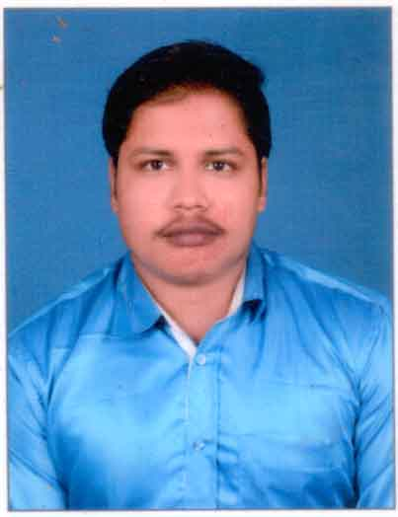
RESUME

PERSONAL DETAILS :MOHAMMED AQUIB
Mail ID :Mohammedaquib14@gmail.com

Residential Address : Near-Odean Talkies , Ar-AradBazar ,
SahadeVkhunta ,Balasore ,756001
Mobile :8917290055
Date of Birth :12/06/1998
Nationality :Indian

CAREER OBJECTIVE

Seeking a responsible position in an organization which would provide a great platform to learn with enhancement of knowledge & professional growth. Keep learning new ways to improve myself each day. Willingness to work in a team oriented environment and accept new challenges.

EDUCATIONAL DETAILS
- Examination | School /College | Board/University | Year of Passing | CGPA/Percentage Secured
B.Tech  (MECHANICAL ENGG.) | Balasore College of Engineering &Technology ,Balasore | BPUT | 2019 | 7.84
12TH SCIENCE | Pradeep College of Science &Technology ,Balasore | CHSE | 2015 | 48.16
10th | Modern Public School ,Balasore | CBSE | 2013 | 7.0

WORK EXPERIANCE

a DYnamic professional with 2 year 7month work EXPERIENCE in areas of Logistics, Transport and Supply Chain Management,technical & retail support

Working as Branch Incharge at Triptivo Logistics and Transportation Pvt. Ltd. (Partner of Elasticrun) Balasore,Odisha from 26th July 2021 to 26th February2022.

- Handle the Branch in well support Operation activity .
- Handle the operation activity Elasticrun at my branch.
- Maintaining all daily SOP parameters at 95%.
- Managing DA's schedules, performance & job assignment
- Job scheduling, assignment & performance monitoring
- Achieving performance metrics through constant monitoring
- Address seller / merchant escalations
- Manage leave calendar & weekly offs & ensure field activities are carried out without any hindrances
- Ensure set practices are implemented & followed to the core
- MIS reports generation & sharing with internal & external stake holders
- Coordinate with Central ops for performance metrics & exceptions if any
- Monitoring the EOD payment follow up from HO & handle delivery day to day activity to maintain 100% delivery arrangement .
- Controlling the inward and outward movement of goods & shipments with control over flow of cash.
- Taken responsibility to have good contact with client to arrange delivery.
- Maintaining the BTS in the Hub
- Having a perfect control over stock in Hub.
- Managing the manpower for smooth operations.
- Handle the with proper schedule time maintain branch record in day to day activity.
- Looking over the sanitation and hygiene.

Past Working as Branch In-charge at TechMahindra(BPS) (Myntra) at Noida,Delhi from 1st April 2021 to 31st June2021:-

- Working for the Retail team.
- The Seller Support Associate demonstrates end to end ownership of every seller interaction coupled with proactive problem solving and provides exceptional support to sellers.
- Demonstrates effective, clear and professional written and oral communication.
- Provides prompt and efficient service to Myntra Sellers and Merchants including the appropriate escalation of Sellers' issues.
- Maintains a positive and professional demeanour always portraying the company in a positive light and effectively managing sensitive issues.
- Demonstrates excellent time-management skills and the ability to work independently while using departmental resources, policies and procedures.
- Contributes to a positive team environment and proactively aids team members with difficult contacts as needed.
- Maintains acceptable performance metrics such as quality, productivity, first contact resolution, and attendance.
- Actively seeks solutions through logical reasoning and data interpretation skills and identifies trends to appropriate channel including improvement suggestions.
- Liaise with other departments such as Customer Service, Merchant Investigations, or Payments teams as required to resolve Seller's issues and questions.

PAST WORKING ORGANISATION
TechMahindra BPS(Amazon):-
- Working for the technical support team.
- The Seller Support Associate demonstrates end to end ownership of every seller interaction coupled with proactive problem solving and provides exceptional support to sellers.
- Demonstrates effective, clear and professional written and oral communication.
- Provides prompt and efficient service to Amazon Sellers and Merchants including the appropriate escalation of Sellers' issues.
- Maintains a positive and professional demeanour always portraying the company in a positive light and effectively managing sensitive issues.
- Demonstrates excellent time-management skills and the ability to work independently while using departmental resources, policies and procedures.
- Contributes to a positive team environment and proactively aids team members with difficult contacts as needed.
- Maintains acceptable performance metrics such as quality, productivity, first contact resolution, and attendance.
- Actively seeks solutions through logical reasoning and data interpretation skills and identifies trends to appropriate channel including improvement suggestions.
- Liaise with other departments such as Customer Service, Merchant Investigations, or Payments teams as required to resolve Seller's issues and questions.

RECOGNISED ACHIVEMENTS

- Served the society as a member and president Rotaract club of Saswata,Balasore

- Did an internship in ITR,DRDO,Balasore on “UNMANNED ARIAL VEHICLE”.

- Did CATIA designing course from CTTC Bhubaneshwar.

- Did CREO designing course from CTTC at BCET Balasore.

MY STRENGTHS
- Hard working
- Sincerity
- Enthusiastic
- Love to work in team
- Working in high pressure conditions

PERSONAL DETAILS

- Father Name : MOHAMMED ZAFAR HODA
- Mother Name : SABANA SULTANA
- Date of Birth : 12th JUNE 1998
- Gender : MALE

PERSONAL DETAILS

ALL THE ABOVE FURNISHED INFORMATION IS TRUE TO THE BEST OF MY KNOWLEDGE AND BELIEF. I ASSURE YOU THAT IF GIVEN A CHANCE, I WILL PROVE TO BE A SYNERGY ADDITION TO THE ORGANIZATION.

PLACE: Balasore
DATE : 03/02/2022 (Mohammed Aquib)

