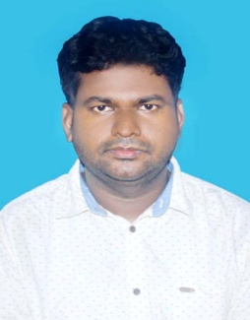
RESUME

Name:-BISWA RANJAN DAS

Mobile:- 9658513813,6370113535

E-mail id:-biswaranjanp45@gmail.com

Career objective
Highly motivated and organized accounting assistrant looking for a fast paced entry level position where I can contribute my experience with financial analysis and developing efficient systems.
Educational Qualification

Examination | School/College | Board/University | Year of passing | CGPA/Percentage Secured
MBA (Marketing & Finance) | Government College (Auto),Angul. | Utkal University | 2017 | 58.59 %
B.Tech (Mech. Engg.) | Gurukula Institute of Technology, Bhubaneswar | BijuPatnaik University of Technology, Odisha | 2014 | 68.20 %
12th | Subas Science College, Bhubaneswar | Council of Higher Secondary Education, Odisha | 2010 | 43.50 %
10th | Gandhiji High School, Jajpur | Board of Secondary Education, Odisha | 2008 | 64.25 %

Skills
- Proficient in MS Office and MS Excel
- Tele sales and Marketing
- Strategic planning & analysis
- Exceptional verbal and written communication
- Business development
- Financial Services
Summer Training
Organization- National Aluminium Company Limited, Angul.
Duration- 1 month
Description-Gained knowledge about financial works of captive power plant(NALCO) undergone Title of the projects- “WORKING CAPITAL MARKET OF NALCO”.
Duration - 3 months
Description – Gained knowledge about works of financial department and I found to know operating captive power plant.
INTERESTED
- Strategic prospecting
- Active listening
- Relationship building
- Effective communication
- Negotiation skills
- Project management
- Time management

LANGUAGES KNOW :-
- Hindi, English.

HOBBIES:-
- Team sports
- Painting & drawing
- Volunteering
- Blogging
Personal Information
- Father’s Name : Bijay Kumar Das
- Mother’s Name : Tanulata Das
- Date of Birth : 13/Sept/1994
- Gender : Male
- Language Know : English, Hindi
- Current Address : MIG-Sector 29, New Raipur C.G
492101
- Permanent Address : At – Kulasahi, Po – Khananagar
Via/Ps – Mangalpur
Dist – Jajpur, Pin – 755011
Declaration:-
I hereby declare that all the above-mentioned information provided by me istrue to the best of my knowledge.
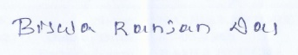
Place : Raipur
Date : 01/05/2022 Biswa Ranjan Das

