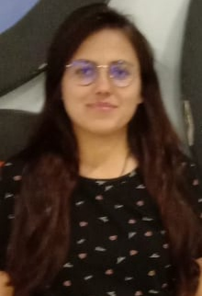
Anju Pandey
Mob:-7008508025
Mail id:- anjupandey625@gmail.com

Career Objective
- Looking forward to join a progressive organization where I can put all the efforts, ability, knowledge, sincerity & experience into work for helping the organization to achieve its growth and prosperity to my full potential.
Work Experience
- Fresher

Educational Qualification
- Completed M.com from SSMV Bhilai, in 2020
- Completed B.com from Govt. College (Autonomous) Angul under Utkal University, Odisha in 2018
- Completed Intermediate from UP board, in 2015
- Completed 10th from UP Board in 2013
Computer Skills
- Basic Knowledge of MS-Word & MS-Excel
- Very well versed with using Internet and new Technologies
Personality Traits
- Efficient Communication skills & Hard working
- Accountable
- Diligent and organized
- Ethical and loyal.
- Willingness to learn new thing
Personal Details
Date of Birth: 05/02/1996
Fathers Name: Mr Umakant Pandey
Mothers Name: Mrs. Geeta Pandey
Marital status: Married
Languages Known: English & Hindi
Address: -Royal A 204
At-Tsbsl colony , Po- mermandli
Dist- Dhenkanal, State- Odisha, Pin- 759121
Declaration
I hereby declare that all the data furnished are true to the best of my knowledge and belief.
Place- Bhubaneswar Anju Pandey

