CURRICULUM VITAE
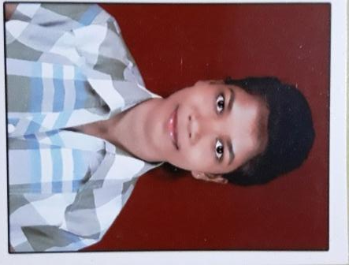

MAMITA PATEL
Mobile no: 9090933587
Email: patelmamita3@gmail.com

OBJECTIVES:-

As per my qualification, I want to be a good team member especially in situations where tough and high stress goals have to be achieved. Have the tenacity to patiently work through an area for achieving results.

ACADEMIC QUALIFICATION:-

Qualification | Board | Percentage/CGPA | Year of Passing
+3(Commerce) | Sambalpur University,Odisha | 40.4 | 2018
+2(Commerce) | Council of Higher Secondary Education,Odisha | 35 | 2015
Matriculation | Board of Secondary  Education,Odisha | 58 | 2013

TECHNICAL SKILLS: -

- OS :Windows XP, 7, 8.10
- Packages : Advance Excel, Word, Power Point
- Web Technologies : HTML
- Programming : C, C++

STRENGTHS:-

- Seeking challenging opportunities that will contribute to the organization and personal growth.
- Having professional attitude with a good collaborative spirit.
- Highly organized and can handle multiple assignments under challenging environment.
- Integrity, sincere & hard working with a positive attitude.
- Better time managing capability, work effectively in a group as well as an individual.

PERMANENT ADDRESS: - PRESENT ADDRESS:-

AT: Qtr No. F-10/7, VSS Colony AT: Qtr No. F-10/7, VSS Colony
PO: HIRAKUD PO/PS: HIRAKUD
PS: HIRAKUD HIRAKUD
SAMBALPUR SAMBALPUR
ODISHA ODISHA
768016 768016

HOBBIES AND INTERESTS:-

- Listening Music
- Playing Badminton
- Travelling with Friends
- Watching Movies

PERSONAL DETAILS:-

- Father’s Name : Gadadhar Patel
- Date of Birth : 06th May 1998
- Gender : Female
- Nationality : Indian
- Marital Status : Single
- Languages Known : English, Hindi and Odia.

DECLARATION:-

I do hereby declare that all the above-mentioned particulars are correct, true and complete to the best of my knowledge and belief.

Date: 29-11-2019
Mamita Patel
Place: Hirakud Signature

