CURRICULUM VITAE
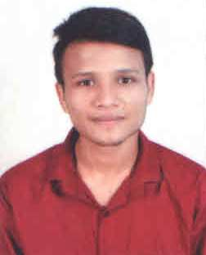

NAME: Suman Kumar Bhanja
EMAIL: sumanbhanja5852@gmail.com

MOBILE: 8917515852

CARRIER OBJECTIVE:
To make a promising career in an organization that gives me scope to update knowledge and skills in accordance with the latest technologies and part of team that dynamically works towards the growth of organization and gain satisfaction thereof.
ACADEMIC PROFILE:
QUALIFICATION | INSTITUTION | UNIVERSITY /BOARD | ACADEMIC YEAR | % / SGPA SECURED
(10th) | PADMAPUR HIGH SCHOOL, PADMAPUR | BSE | 2015 | 44.5%
(+2 ARTS) | SIDDHA BHAIRABI SCIENCE COLLEGE, KONISI | CHSE | 2017 | 39.66%
+3 Honours (Economics) | MODEL DEGREE COLLEGE, BOUDH | SAMBALPUR UNIVERSITY | 2020 | CGPA-5.54
Computer | DIIT ADVANCEMENT OF LEARNING | DIIT EDUCATION GOVT. OF INDIA | 2021 | 71.43%
Work Experience | HDFC BANK SLI DEPARTMENT SALES OFFICER  Date:-25.10.2021/14.08.2022

PERSONNEL PERTICULARS:
Date of Birth : 16/12/1999
Computer knowledge : PG DCA
Hobbies : Photography
Present Address : C/O- Ranjan Kumar Bhanja
At –Babusahi ,Po-Boudh
Dist- Boudh
State-Odisha
Pin- 762014
Language know : English, Hindi, Odia

STRENGTH:
I am a self-motivated, dynamic and hardworking individual with positive and flexible nature. I have good presentation and communication skills and enjoy working in groups. I have great inclination for challenging work.

DECLARATION:
I hereby declare that all the above furnished regarding me is all correct, and true to the best of my knowledge.

Suman Kumar Bhanja
Place: Boudh

