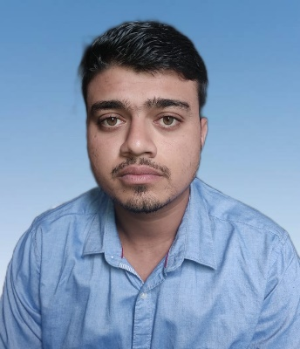
CURRICULUM VITAE
KRUTIBAS TRIPATHY
C/o: SARATA CHANDRA TRIPATHY
At/Po: Jhintisasan
Dist:Khordha, State:Odisha
Pin: 752100 DOB: 14th May 2000
Ph No: (+91) 9692193113
E-Mail: tripathykrutibas2000@gmail.com

CAREER OBJECTIVES:
Willing to work as a key player in challenging and creative environment and to become a successful professional to work in an innovative and competitive world.

Examinations | Institution | Year | Marks (%)
CMA Inter group-I | Institute Of Cost Accountants Of India | Dec 2020 | 292/400 (73.00)

ACADEMIC QUALIFICATIONS:
Course | University/Board | Year | Marks (%)
B.Com (Accounting Honor) | Utkal University, Bhubaneswar | 2020 | 1761/2600 (67.73)
Class-XII (Commerce) | Council of Higher Secondary Education, Odisha | 2017 | 428/600 (71.33)
Class-X | Board of Secondary Education, Odisha | 2015 | 374/600 (62.33)

PROFESSIONAL EXEPERIENCES
- Working at Swosti premium limited Bhubaneswar as auditor from sept 2021to till date and handling verification and reporting of all the bills, issued by hotel.

EXTRACURRICULAR ACTIVITIES

• Takes responsibility singly to cook & serve different type of delicious recipes in family functions, Government programs, social functions etc. for more than 1000 peoples also.

• Distributed masks and aware locals about social distancing during Covid-19 pandemic.

COMPUTER LITERACY:
- Ms Office (Word, Excel & Power Point)
- Tally
- IDS

HOBBIES & AREA OF INTEREST:

• Cook

• Playing Cricket

• Reading Newspaper

DECLARATION:
I do hereby declare that all particulars mentioned above are true, complete and correct to the best of my knowledge.
Date: - 25/06/2022 (KRUTIBAS TRIPATHY
Place: Bhubaneswar

