KUNDAN MOHANTY
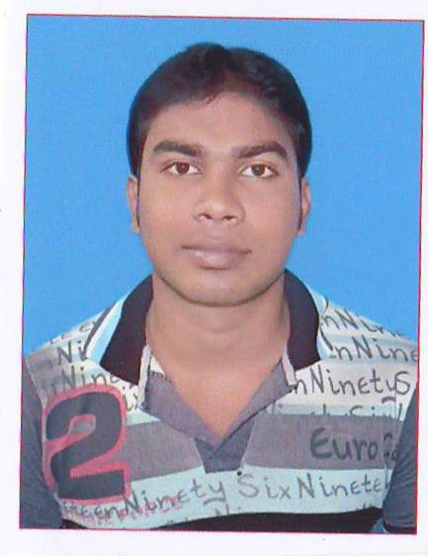

Email:mail4kundan.dipu1994@gmail.com
ContNo.:- 7008085426, 9439297749

PERSONAL DETAILS:-

  - Father’s Name Mr. SURENDRA MOHANTY
  - MOTHER’S NAME Mrs. MINARANI MOHANTY
  - DATE OF birth 10-06-1994
  - Nationality Indian
  - Religion HINDUISM
  - Domicile Odisha .
  - Gender Male
  - Marital Status Single
  - Languages known Oriya, Hindi, English

CAREER OBJECTIVE :-

To utilise my skill and potential to prove myself as a beneficiary element for the organization as professional & take higher corporate responsibilities and also achieve the company goal by giving my best

EDUCATIONAL QUALIFICATION:-

Examinations | Board/University | Division | % of marks | Year of passing
HSC | Board of Secondary Education(BSE), Odisha | Second | 57 | 2009
+2 commerce | Council of Higher Secondary Education(CHSE), Odisha | Third | 46 | 2011
+3  GRADUATION  (commerce) | F.M University ,odisha | Third | 44 | 2014
MBA (marketing&finance) | F.M University,odisha | first | 68 | 2018

Other Training/Certifications:-

- PGDCA:-73.75% (1 YEAR)

WORKING EXPERIENCE :-

- working experience As a executive in Voltech engineering pvt ltd., paradeep FROM 02/12/2019 TO 07/11/2020.

- working experience As a MARKETING executive in Voltech engineering pvt ltd., paradeep FROM 08/11/2020 TO TILL DATE.
STRENGTH:-
- Dedicated to hard work and self-motivated.
- Punctual and Optimistic.
- Quick learn of new software
- Motivation quality.
HOBBIES & INTERESTS:-

- Playing cricket, Badminton
- Surfing Internet.
- Reading Comics & Newspaper
- Playing pc games
- Searching latest software

PERMANENT ADDRESS :- C/o SURENDRA MOHANTY
At- NUAGAON
Po- NUAGAON
Dist-MAYURBHANJ
Pin- 757025, ODISHA, INDIA

PRESENT ADDRESS :- C/o DEBASISH MASANTA
At- GANESWARPUR
Po- JANUGANJ
Dist-BALASORE
Pin-756019, ODISHA, INDIA

Declaration
The information furnished above are true to best of my knowledge.

DATE-
PLACE- balasore SIGNATURE

