RESUME
Name: Sabita Jena
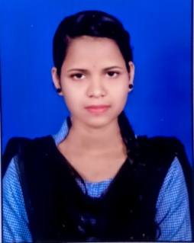
Address: At/Po-Banitia, Dist-Bhadrak, State-Odisha, Pin-756101, PS-Bhadrak(R)
Date of birth: 10/05/1997
Contact No: 8260778909
E-mail: sabitajena1005@gmail.com
Career Objective:
To get elevated in the field assigned, by exploring my skill and working hard as true to my conscience for the upliftment of the Organization as well as my personal growth.
Academic Background:
Board | Institution | Percentage (%) | Year of passing | Subject
10th | B.J. High school , Banitia | 50% | 2013 | All
+2 | Agani Narendra Mahavidyalay ,Antara(Balasore) | 51% | 2015 | PCMB
+3 | Unipower school of IT and MGT ,Bhadrak | 76% | 2022 | BCA

Additional Qualification:
- Pursuing PGDCA
- Microsoft office and internet
- Typing speed of 35-40 words per minute.
Work experience:
- Fresher
Declaration:
I am keen to continue my career and prepared to work hard in order to achieve my organization objective and I hereby declare that the information furnished above is true the best of my knowledge.

Place:

Date: Signature

