CURRICULAM VITAE
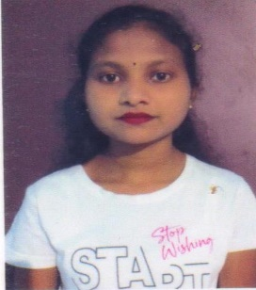
Name- Pinu Patra
E-mail – pinupatraj@gmail.com
Mob - 8658472069

CARRIER OBJECTIVE
Strive for excellence & dedicate my skill for achievement of organizational goals and lead the team. Enhance my managerial skills.

OVERVIEW
An Effective communicate my excellent relationship Building and interpersonal skills ,strong analytical , troubleshotting & organizational abilities possess a fixable and detail oriented attitude.
ACADEMIC QUALIFICATION
NAME OF  DEGREE/EXAM PASSED | YEAR OF PASSING | FULL MARK | SEQUIRED MARK | PERCENTAGE
10th (B.S.E) | 2016 | 600 | 424 | 70.6%
+2 (C.H.S.E) | 2018 | 600 | 289 | 48.1%
+3 (U.U) | 2021 | 2600 | 1707 | 65.65%
PGDCA | 2021 | 1200 | 995 | 82.91%

EXPERIENCE 6 months experience as data entry operator in Mahima furniture ,Angul

PERSONAL BACKGROUND
- Father’s Name : Choura Patra
- Date Of Birth : 25/03/1999
- Nationality : Indian
- Religion : Hindu
- Marital Status : Unmarried
- Language Known : Odia ,English ,Hindi
- Hobbies : Internet Browsing, Story reading
- Strength : Self Confidence , Hardworking ,Sincerity.

PRESENT ADDRESS
AT – Kurumtap
PO – Sanahulla
PS - Thakurgarh
Dist – Angul , Odisha , 759125

DECLARATION
I do hereby declare that , the fact stated above are true ,correct and complete to the best of my knowedge and belief.

Place : Pinu Patra
Date :

