Resume

Your Name
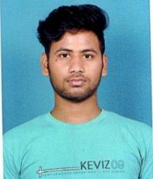

Date of Birth: 20/06/2002

Phone No: 7008571275
Email: rijunaskar4815@gmail.com

Career Objective:

Seeking a career opportunity operations where I will utilize my knowledge and skills which will generate positive growth for your company.

Skills:

- Strong communication skills

- Proficient in Microsoft Office Suite
- Excellent customer service skills
- Ability to work in a fast-paced environment
- Knowledge about financial institutions
- Ability to analyze financial data

Educational Qualifications:

- Bachelor of commerce(Honors) form Sambalpur University

- Intermediate from Counci Of Higher Secondary Education
- High school Board Of Higher Secondary Education

Hobbies:

Reading knowledgeable Books

Jogging
Playing Badminton

References:

Available on request.

Personal Details

Marital Status: Single

Gender: Male

Nationality: Indian

Languages known: Hindi,English,Odia,Bangoli

Permanent Address: Badabazar Saheb Banglow, Khetrajpur -768003

Declaration:

I do hereby declare that the above information is true to the best of my knowledge.

(Signature)
