GYANADEEP DAS
Sunhat,Near Jumma Mosjid lane,Balasore
Odisha,756002
Mobile:8637267565 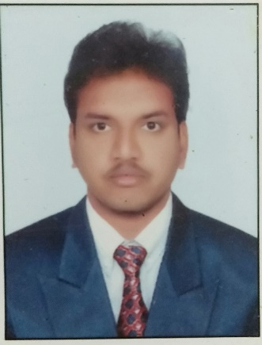
Email:gyanadeepdas98@gmail.com

Objective

I intend to be a part of an organisation where I can constantly learn and develop my technical skills and make best use of it for the growth of the organisation .
I look forward to establishing myself by adapting new technology as well.

Education and Qualifications

- B-Tech (Mechanical Engineering) at Srinix college of Engineering College, Under Biju Pattnaik University Of Technology with CGPA 7.321 in the year 2018 to 2021.
- Completed Diploma from Balasore School of Engineering , Balasore, Under SCTEVT, Odisha Board with 73% in 2014 to 2017.
- Completed Matriculation from Sri Aurobindo centre of integral Education(SACIE), Balasore, Under HSC, Odisha Board with 60% in 2014.

Technical Skills

- Computer Numerical Control(CNC),Ying Lin Machine(YLM),Fanuc Robots Programming and Simulation(Robotics),Large Dia Tube Machining work(LDT),Frame Continuous Coating Machine work(FCC)

Personal Skills

- Good communication & presentation skills.
- Good Time Management skills.
- A good team worker and has the ability to cooperate under extreme circumstances.

- Honest, hardworking & eager to learn.
- Ability to cope with the changing environment.

Area Of Interest,Projects

- Machine Programming work
- Project-Four Stroke and Two stroke Engine(Diploma)
- Automobile Prototyping(B.Tech)

Achievements And Experience

- science exhibition in my School and Gk competition in my diploma carrier.
- I have done 1 year Apprentice Technician training in Faurecia Emissions Control Technologies India Pvt. Lmtd In 2017-2018

Hobbies and Interests

- Love to work in Robotics and leath,grinding machine (job).
- Love to play battle royale game.
- Love to Play Cricket.
- Listening to music occasionally.

Opportunity

If given me an opportunity in your organization I will learn and develop my technical/professional knowledge and generic skills for the betterment of self and the organization by utilizing my academic knowledge and give my cent percent to organization.

Declaration

I hereby declare that the information furnished above is true to the best of my knowledge.

THANKING YOU

(Yours’s Faithfully)

Place: BALASORE, ODISHA (GYANADEEP DAS)

