CURRICULUM VITAE
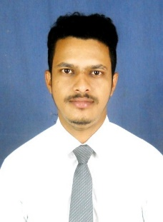

TAPAN KUMAR ACHARYA
+91 7894635872
Email id- tapankumaracharya7894@gmail.com
OBJECTIVE
To work with an organization where can learn new skills and increase my abilities for the organizational goals as well as myself.
EDUCATIONAL QUALIFICATION
- Pursuing MBA from Trident Academy of Creative Technology
- Passed out Bachelor of arts in Psychology honours in 2021
- Passed out 12th from CHSE in 2018
- Passed out 10th from BSE IN 2016
TECHNICAL SKILLS
- PGDCA
STRENGTH & HOBBIES
- Hard & Smart working
- Honest & Punctual
- Good communication skill
- Thinking about new things
- Travel to new place
- Cricket, Reading books
INTERNSHIP
- Bank of Baroda Financial Solutions Limited
Contributions:
- Successfully involved in Market Mapping and Credit Card Sourcing Project.
- Shared innovative ideas with my team members.
Learning Outcomes:
- Developed communication skils & customer convincing ability by field work.
- Gained Practical overview of sales department.

PERSONAL DETAIL

- Father’s Name : Chandrakanta Acharya
- Date of Birth : 04/12/1999
- Marital Status : Single
- Nationality : Indian

DECLARATION
I do here by declare that all above statements furnished are true correct and complete to the basic of my knowledge and belief.
PLACE:
DATE: TAPAN KUMAR ACHARYA

