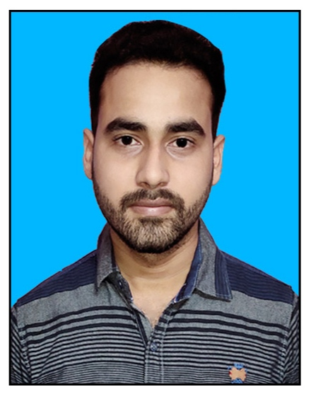
CURRICULUM VITAE
Tapas Ranjan Rath
At  Chatrapur
Dist - Ganjam
Email tapasrath7381@gmail.com
Mobile  7381300982

Objective:
To work in an environment which provides a congenial atmosphere and the scope to expose my potentiality with due challenges; want to grow within a group and want to demonstrate the group culture to help in achieving the organizational goals.

Educational Qualification:
- H.S.C Board Odisha From Saraswati Sishu Bidya Mandir,Chatrapur
Mark Secured- 496/600(82.66%)
- C.H.S.C Board Odisha (Science) From Govt. Junior Science College,Chatrapur
Mark Secured- 334/600(55.66%)
- BSc Hons (Botany) From Khallikote University, Berhampur
Mark Secured- 1407/2600(54.11%)
• Pursuing Post Graduation in Journalism and Mass Communication at Berhampur University, Bhanja Bihar
Professiona Qualification:
. OSCIT Mark Secured- 78%
. PRABESIKA PURNA on Tabla
. Specialized Course Of Vfx and Animation continue
EXTTRA CURRICULAR ACTIVITIES:
- Punctual
- Hard Working
- Determined & Reliable
Hobbies:
- Listen music , Photography and Reading Newspaper
Languages Known:
- Odia,Hindi,Sanskrit & English

Personal Profile
Father’s Name : Late Arun Ku Rath
Date of Birth : 30 September 1999
Nationality : Indian
Religion : Hindu
Gender : Male
Marital Status : Unmarried

Declaration:-
I do hereby declare that the information given above is true, complete and correct to the best of my knowledge and belief and no relevant fact has been concealed and / or misrepresented.
Date :
Place : (Tapas Ranjan Rath)

