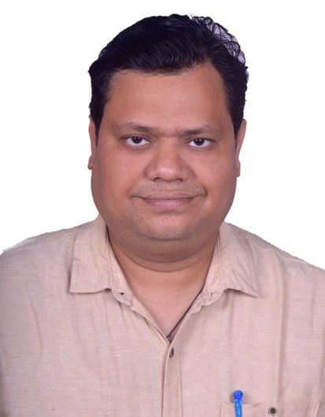
CURRICULUM VITAE
Rasmiranjan Rout House no - 824
GA Colony Bharatpur Bhubaneswar
Khorda 751003

Mobile:+91-9338160413, 7978079609
E-mail:rasmirout1985@gmail.com

PROFESSIONAL OVERVIEW
- 5+ Years of Experience in Marketing and digital marketing field.
- 2+years of Experience in SAP C4C and SAP CRM Field.
- Skills in Project Management, Strategic thinking, data analysis, paid social advertising, Email marketing, content writing, SEO and social media marketing.
- Good business knowledge and Well versed in configuration and Customization in Marketing, Sales and Services in both SAP C4C and SAP CRM modules.
  - Significant experience of developing and working with systems towards optimizing Customer Service Operations and Service deliveries.
  - Experienced in Client Management skills, conducting the Presentations, End-user trainings and achieving the predefined Deadlines also.

PROFESSIONAL EXPERIENCE
- Work with Country Vacation as a Marketing Manager.
- Work with Aakash group as an Area Manager and digital Marketing Manager.
- Work with Integrated Digital Info Services as a Marketing Manager and C4C Functional Consultant.
- Working with Astha School of Management as a Marketing Officer.

ACADEMICS

- Well-versed with SAP C4C and CRM Technology.
- SAP HCM certified from Future Career Solution, Bhubaneswar.
- Post Graduate Diploma in Human Resource Management from Sikkim Manipal University securing 80%.
- Master’s in Business Administration from National Institute of Science and Technology, B.P.U.T, Berhampur, Orissa in 2008 securing 7.25(CGPA).
- Bachelor of Science from Bhadrak Autonomous College, Bhadrak, F.M. University, Orissa in 2005 securing 71%.
- XIIth(CHSE)from Council of Higher Secondary Education, Orissa in 2002 securing 61%.
- Xth(BSEO)from Board of Secondary Education, Orissa in 2000 securing 69%.

PROFESSIONAL EXPERIENCE
Accountabilities:
- Involved in strategic development and implementation of company’s brand products.
- Managing various channels like social media networks, Google ads, website content and E-mail marketing to deliver a persuasive and cohesive marketing message to audience.
- Involved in configuring Marketing concepts like Configuring Marketing attributes & attribute sets, Target Groups, E-mail templates, Approval Process and Campaigns.
- Marketing: - Marketing Planning, Campaign Management, Lead Management, Business Partner segmentation, External List Management.

PERSONALDETAILS:
- Name : Rasmiranjan Rout
- Father’s Name : Haladhar Rout
- Date of Birth : 10-11-1985
- Language Known : Oriya, English & Hindi
- Nationality : Indian
- Religion : Hindu
- Marital status : Married
- Gender : Male

DECLARATION:
I, hereby declare that the information furnished above is true to the best of my knowledge and belief.

Place: Bhubaneswar
Date: Rasmiranjan Rout

