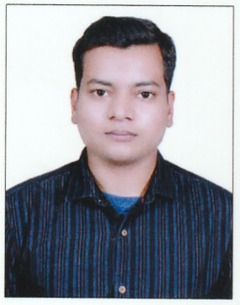  SATRUJIT PANDA  E-Mail:  satrujitpanda.19@gmail.com  Contact Number:  8249252449    Address :  AT : Nuasahi, Choudwar  PO : Kapaleswar  Dist: Cuttack  State : Odisha  Pin: 754071 | Objective  Intend to build a career with leading corporate, which will help me to explore myself fully and realize my potential. Willing to work as a key player in challenging & creative environment.  Academic record  Educational :  - Completed MBA in Finance & Human Resource from Ravenshaw University in 2022.  - Completed B.Com in 2020 from Utkal University  - Completed intermediate in Commerce in 2017 from CHSE.  - Completed Matriculation in 2015 from BSE Odisha.  Technical Career  - Completed A-PGDCA & Tally.  Software Technical Skills –  - MS OFFICE  - Tally ERP 9.0  Professional Competencies –  - Innovative attitude to problem solving  - Aiming at excellence in work through self-motivation  - Professional EXPERIENCE  - Officer In ESAF Small Finance Bank Since September-2022.
Personal Details:  Date of Birth :19th August 2000  Father’s Name : Prakash Kumar Panda  Mother’s Name : Kabita Panda  Sex : Male  Nationality : Indian  Religion : Hinduism  State : Odisha  Blood Group : B -Ve  Category : General  Marital Status : Unmarried  Hobbies:  - Bike Riding  - Playing Cricket  - Listening music  Languages known:  Odia, Hindi, English | Personal Competencies –  - Work effectively with diverse groups of people  - Fast Learner. Adapt well to changes and pressures in the workplace  - Ambitious hardworking and committed to excellence  - Honest, Sincere and a Hard Worker with a high level of integrity  - Adaptive to any kind of Environment  Declaration –  I do hereby declare that all the above statements furnished are true and correct to the best of my knowledge and belief.  Satrujit Panda

