CURRICULUM VITAE

Mobile No.: 8018759738
Email: jyotiira62632@gmail.com

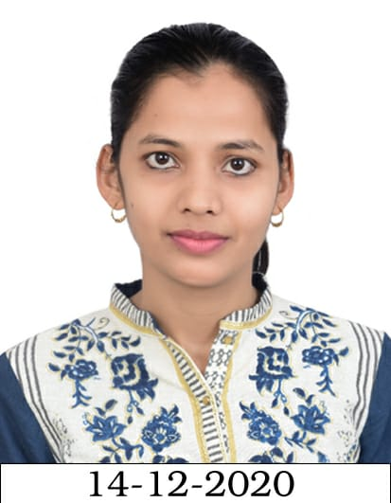 Mobile No.: 8018759738
Jyotismita Mantri Email: jyotiira62632@gmail.com
PROFESSIONAL OBJECTIVE
Seeking excellence in the chosen professional field through self-motivation hard work and augmentation of core skills required to effectively deliver well. Striving to achieve excellence through selective and focused pursuit of the short and long-term goals and trying to create an environment through my chosen organization and work field where knowledge and excellence are given their due.
EDUCATIONAL QUALIFICATIONS
Professional:
- Master in Business Administration from DREAMS (Affiliated by BPUT), in the year 2022

Academic:
- Completed H.S.C from Board of Secondary education, Odisha, in the year 2013.
- Completed Higher Secondary in ARTS (CHSE Board) from Ravenshaw College, Cuttack (Odisha), in the year 2015.
- Completed Bachelor of Arts with English as honors from S.V.M. Autonomous College, Jagatsinghpur (Odisha), in the year 2018

COMPUTER SKILLS
- PGDCA AND TALLY

HOBBIES AND INTEREST
- Reading newspapers and Magazines
- Listening to music.
- Surfing on internet.

Strengths:
- A self starting individual with strong General Knowledge & Analytical skills

PERSONAL PROFILES
Date of Birth : 15th june1997
Father's Name : Dhiren ku. Mantry
Present Address : At Janapal Post Pankapal Via Rahama Dist Jagatsinghpur Odisha Pin 754140
Marital Status : Unmarried
Language Known : English, Hindi & Oriya (MT)
Other Details : To be furnished if necessary

DECLARATIONS
I hereby declare that the statements given above are true to the best of my Knowledge and belief.

Place : Paradeep (Jyotismita Mantri)

