RESUME
NAME | Swagatika Behera | 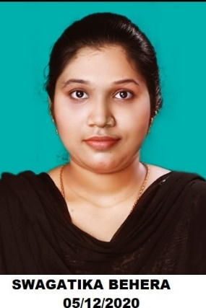
ADDRESS | Park street 1,Chatrapur
Email id | Swagatikabehera31@gmail.com
Mobile no | +91 9348293320
Marital status | Unmarried

Career Objective
Degree/Qualification | Institute | Board/University | Year | OGPA
10th | Atomic energy central school | CBSE | 2015 | 7.6
10+2 | Govt Science College Chatrapur | Orissa Council Of Higher Secondary Education,Odisha | 2017 | 59%
BSC | College Of Basic Science And Humanities | Odisha University Of Agriculture & Technology | pursuing | 7.69
To secure a responsible career opportunity by my skills while making a significant contribution to the success of the respective company.

Operating System: Windows 98 / 2000 /2007
Skils: Communication Skills, Competitive Skills
Hobbies: Reading Books, Cleaning Stuffs, Listening Songs
Subjects Of Interest
Soil Microbiology ,Medical Microbiology , Imnunology

Achievements
Sports
Debate
Personal Details
Date of Birth: 7th January 1999
Gender: Female
Marital Status: Unmarried
Blood Group: B+ve
Languages Known: Odia,Hindi,English

