RESUME

SAI PRASAD ACHARYA 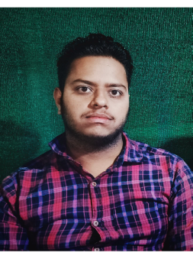
S/O –BIBHUTI BHUSAN ACHARYA
At: -Abidhianandapur
Po: - Kaduapada
Dist.: - Jagatsinghpur
Pin- 754106
Odisha
Mob No:9090333575
Email: saiprasadacharya681@gmail.com
Objective:

To work in an Organization where I shall be able to contribute for the Organization growth and probability with my skill will get an opportunity to gain exposure, which would help me to build a strong career & a good position within the company.
Academic Qualification:

- 10th passed from Narayani Bidyapitha, Chasapada, Jagatsinghpur under BSE Odisha in the year of 2016 with 1st Division (B1 grade).
- +2 Science from Alaka Mahavidyalaya, Jagatsinghpur under CHSE Odisha in the year of 2018 with 3rd Division.
- +3 Bachelor Of Science degree Passed from Govindpur Degree College, Cuttack under Utkal University in the year of 2021 with 7.7 CGPA.
- Master in Business Administration (MBA) degree from Centurion University of Technology and Management, Bhubaneswar in the year of 2023 with 1st division in HR and Marketing.
EXTRA Qualification:

- Having Computer Knowledge PGDCA.
- Having basic Knowledge in Python, AIML.

TEchnical skills:

- Operating System: Windows 7 / 8.1 / 8 / 10 / Windows 11
- Microsoft Tools & Suits: Microsoft office 2007,2010,2013,2016,2019.

Hobbies:

      - Listening Music
      - Reading Books/Stories

Strengths:

- Positive attitude
- Hard Working
- Sincere
- Confident
- Quick Learner
- Ability to Work as Individual as Well as in Group
- Ability to Learn Quickly
- Customer-Oriented
- Problem Solving and Logical Thinking
- Self-Motivated

Personal Details:

Name : SAI PRASAD ACHARYA

Father’s Name : BIBHUTI BHUSAN ACHARYA
Mother’s Name : NALINI PRABHA DASH
Date of Birth : 02/02/2001 Sex : male
Nationality : Indian
Religion : Hinduism
Marital Status : Unmarried
Language Known : Odia, English, Hindi.

Declaration

I do hereby declare that all the details furnished above in my curricular vitae are true to the best of my knowledge and belief.

Date : 30.08.2023
Place : Jagatsinghpur (Sai Prasad Acharya)

Signature

