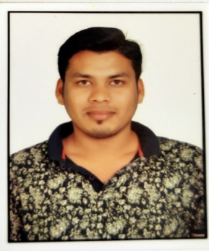
Jayadev behera
Email id: jayamech678@gmail.com
Contact no: 8639862289
Address: laxmipur, Ganjam, Odisha-761010
CAREER OBJECTIVE:
A self-motivated and good team player with a passion to get into IT industry as tester I wish to enhance my technical skill working towards the organization goals

ACADEMIC PROFILE:
no | QUALIFICTION | UNIVERSITY/BOARD | YEAR OF PASSING
1 | B. TECH | Biju pattnaik university of technology, Odisha | 2019
2 | DIPLOMA | State council for technical education and vocation training, Odisha | 2015
3 | CHSE | Chikiti mahavidyala, Odisha | 2012
4 | BSE | Government high school, Odisha | 2010

Technical Skills
MANUAL TESTING:
- Well versed with SDLC, STLC and Defect Life cycle
- Good Knowledge of BLACK BOX TESTING and WHITE BOX TESTING
- Good knowledge in Smoke, Functional, Integration and System testing
- Good knowledge in Compatibility Testing, Regression Testing, Ad-hoc testing, Exploratory Testing
- Extensive Knowledge in writing Test scenarios, Test cases and Test Data
- Good Knowledge on JIRA
SELENIUM TESTING:
- Good in java basic programming
- Knowledge in Finding locators and X-path
- Knowledge in Automation Test Frameworks

WORKING ON PROJECTS
Project Name: primus Bank
Duration : 1 month
Dominie : Banking
Tool Used : Selenium, java, Auto IT, TestNG
Description : This application can offering different type of banking sectors like personal, corporate, international banking. Making several bank transactions and also offering credit cards. Primus bank is UK foremost technology bank and has pioneered internet banking uk
PROFESSIONAL EXPERIENCE
- Trainee Engineer in department of Engineering in DECCAN FINE CHEMICAL PVT LTD (06.11.23 to 01.01.2024)
- junior EXCUTIVE in department of Engineering in VIRCHOW BIOTECH PVT.LTD (16.05.22 to 01.09.23)
Department- maintenance (utility, water system,
- Previous experience- Doing a Company Apprentice Training in BorgWarner Morse System India Pvt. Ltd. (Chennai) 2015-2016
JOB RESPONSEPILITIES
- Operation and maintenance of water system equipment (pretreatment water system, PW)
- Operation and maintenance of chillers and Air compressor
- Maintaining good Documentation for above Equipment’s like Daily log book
- Working knowledge in operation of chiller &cooling towers
- Manpower deployment, Shift Planning and Follow up Material.
- Knowledge in 5s
STRENGTHS
- Good communication and negation skills
- Group work and team building
- Good in time management
HOBBIES

LANGUAGES

- English Listening music
- Hindi Playing cricket

Date: Jayadev Behera

