RESUME
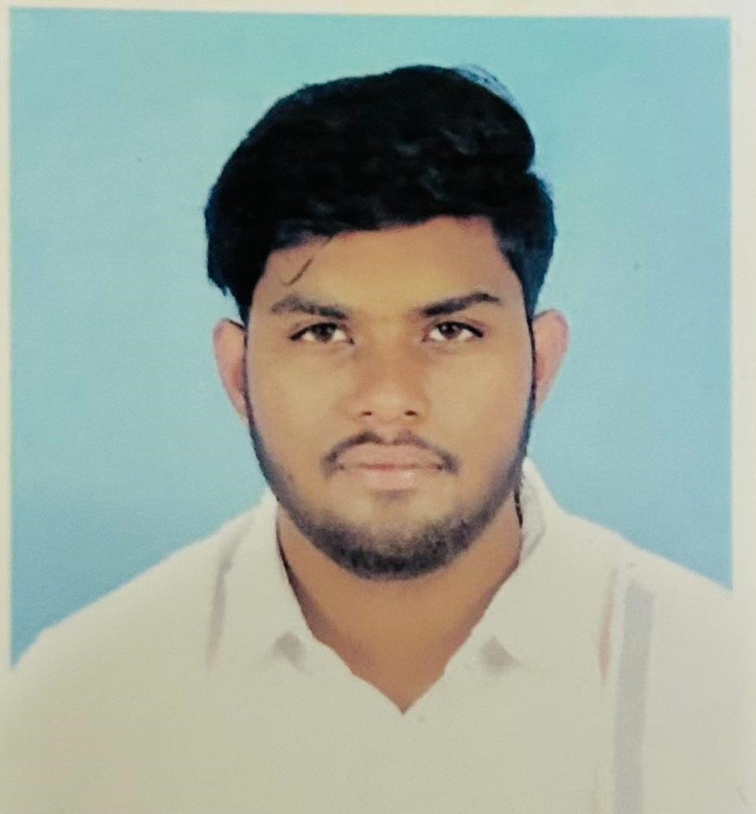
VIBEK KUMAR SAHOO
S/O- Anil Kumar Sahoo
AT- Pradhan Para, Budharaja,
Sambalpur
Pin- 768004
Mobile- 7608923130
E-mail- Kumarvickey241201@gmail.com

CARRIER OBJECTIVE
To secure a challenging position in a reputable organization to expand my learnings, knowledge, and skills. That will help me to grow more in my future carrier.

EDUCATIONAL QUALIFICATION
- Secondary (X) 2018
Roshni Public School
(CBSE BOARD)
Percentage- 49%

- Senior Secondary (XII) 2020
Guru Nanak Public School
(CBSE BOARD)
Percentage- 62%

- Bachelor Of Business Administration (BBA) 2020-2023
Sambalpur University
6.5 SGPA

HOBBY
- TRAVELLING
- PHOTOGRAPHY
- CRICKET
STRENGTH
- HARD WORKING
- POSITIVE ATTITUDE
- MOTIVATED
SKILLS
- COMMUNICATION
- LEADERSHIP
- DECISION MAKING
- SALES AND MARKETING
EXPERIENCES
- FORMER SALES AND MARKETING INTERN AT HDFC SECURITIES LTD.
- CURRENTLY AGENT AT NIVA BUPA HEALTH INSURANCE

PERSONAL PROFILE
NAME- VIBEK KUMAR SAHOO
FATHER’S NAME- ANIL KUMAR SAHOO
DOB- 24/12/2001
SEX- MALE
NATIONALITY- INDIAN
RELIGION- HINDU
CATEGORY- GENERAL
MARITAL STATUS- UNMARRIED
LANGUAGE KNOWN- ENGLISH, HINDI, ODIA

