RESUME

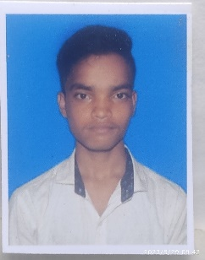
SATYAJIT MAHAPATRA

8260841398


Mohasatya826084@gmail.com
Kuakhia,jajpur,odisha, 755009

Career objective
To have a career in a professional organisation and put all my efforts into the growth of that organisation and
have a great working environment.
Academic Qualification
10th passed from Odisha Board in 2018
12th passed from Odisha board in 2020
Graduate with B.sc from BB AUTONOMOUS COLLEGE,JAJPUR
Personal Details
Father’s Name : Bijay Kumar Mahapatra
Date Of Birth : 15 March 2002
Gender : Male
Nationality : Indian
Marital status : Unmarried
Languages Known : English,Hindi & Odia
Professional Skills
- Basic knowledge Of Computer
- Typing

Work Experience
- Fresher

