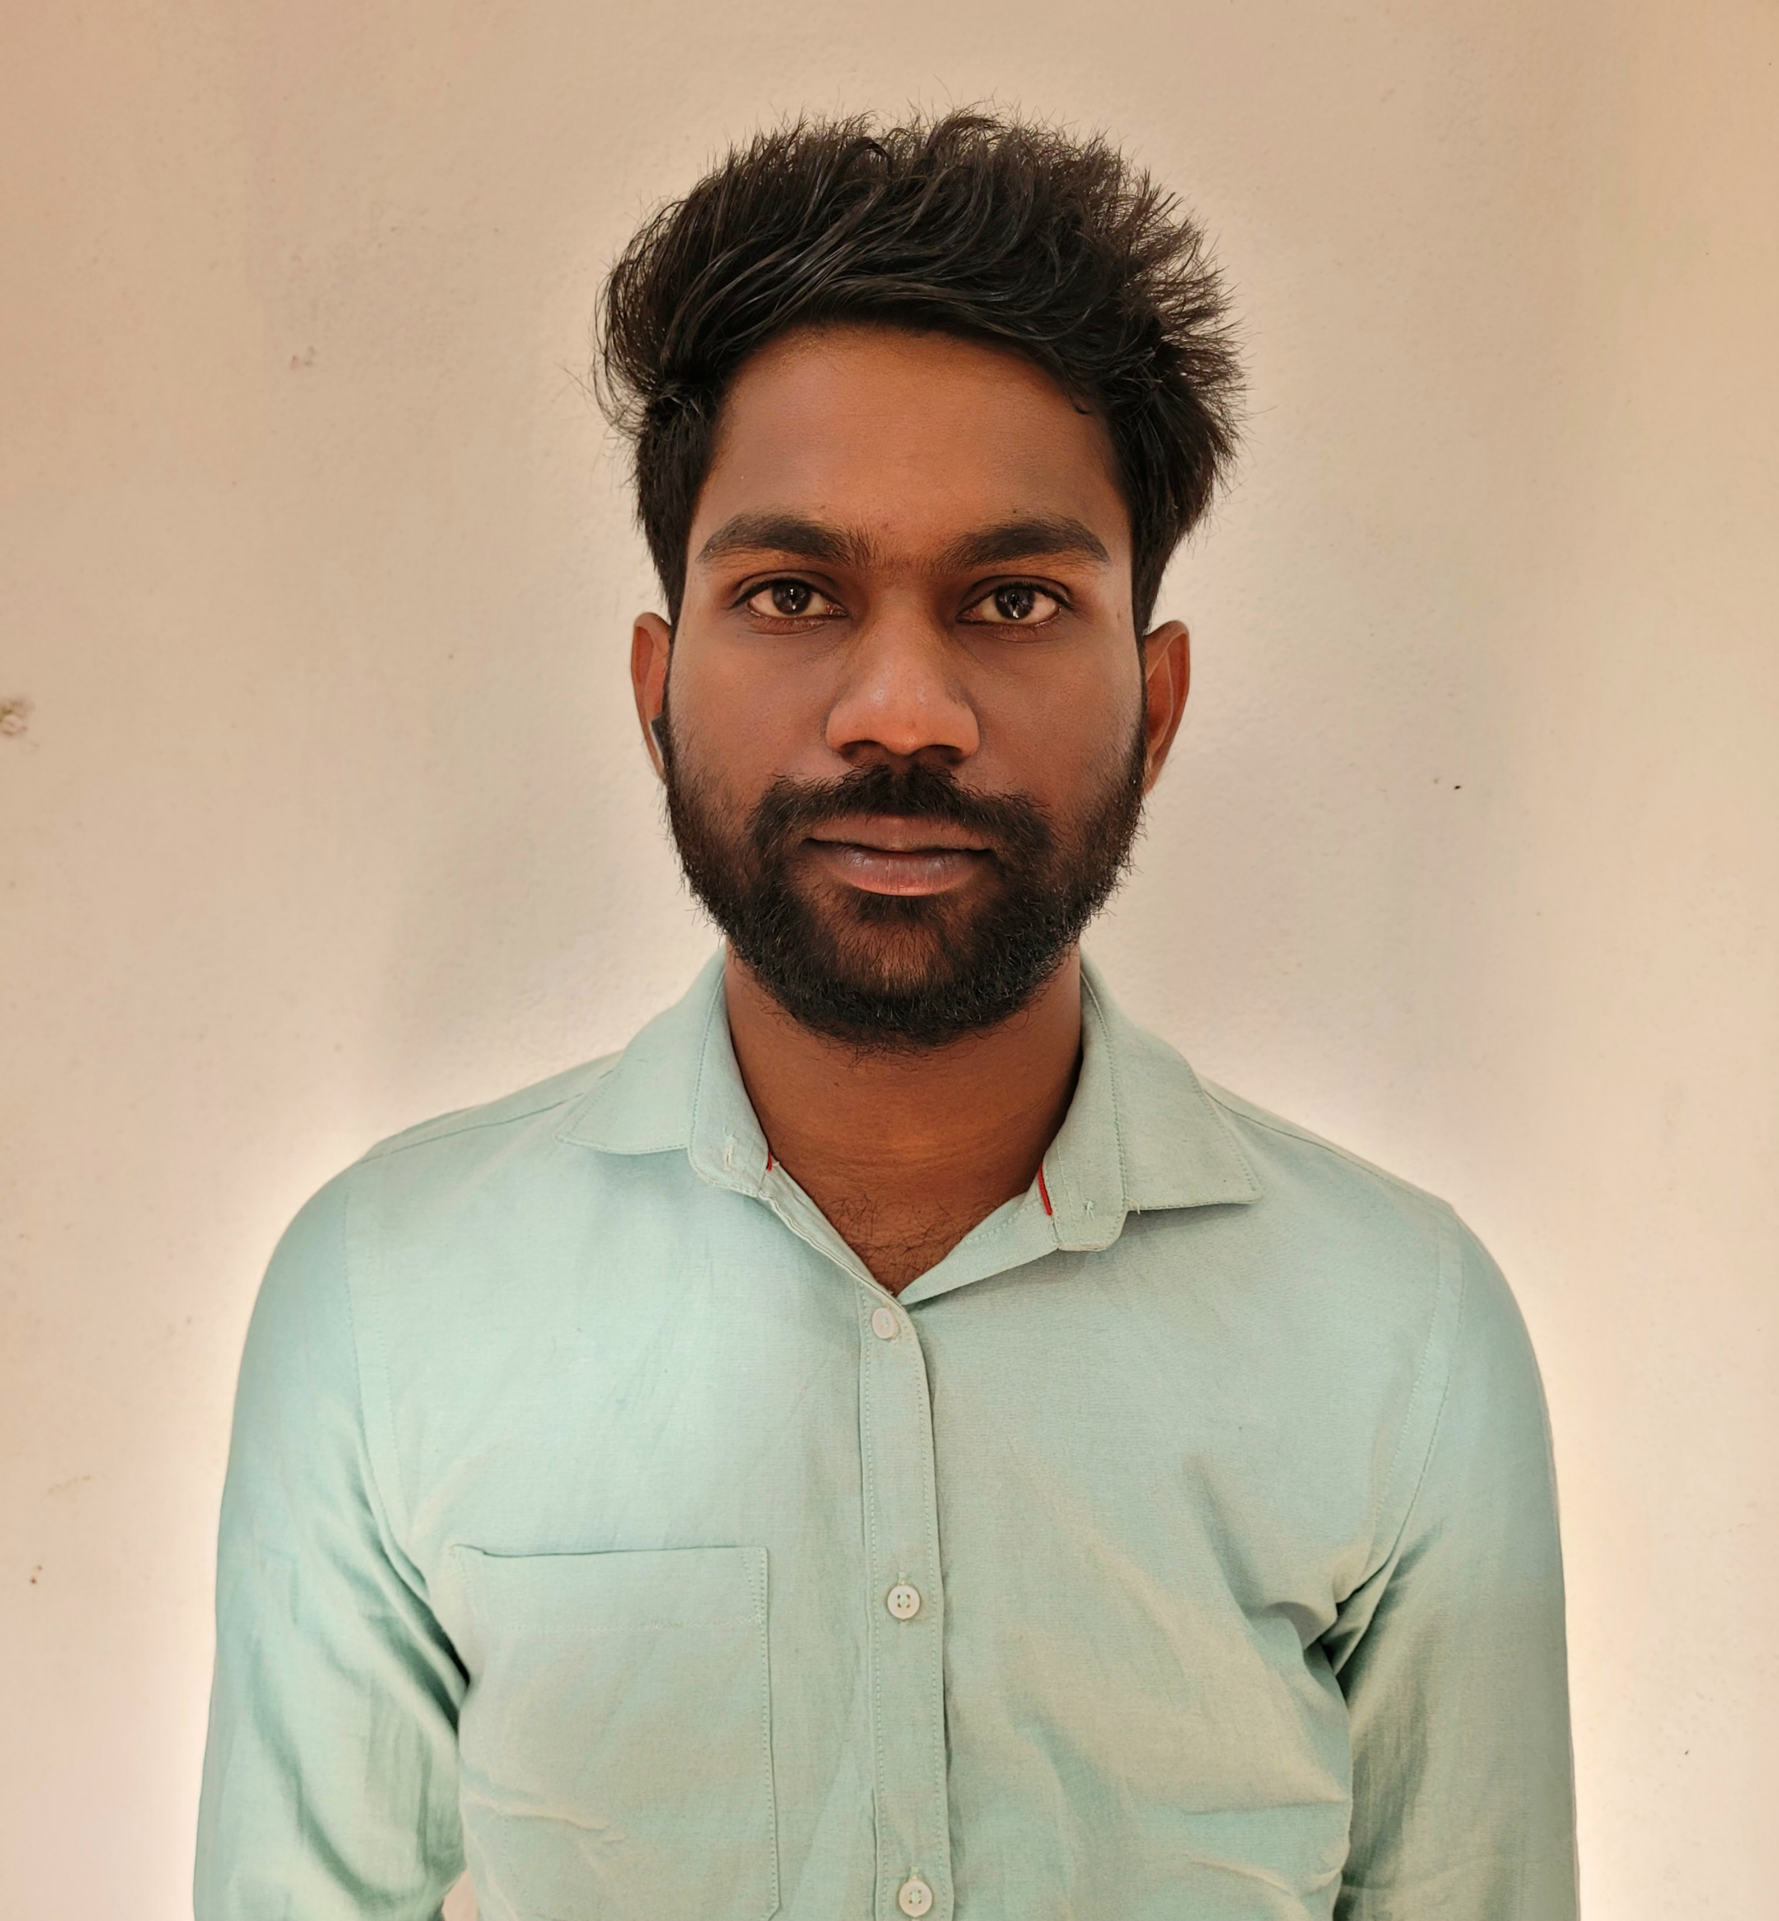 |  | Akash Samal
Profile  To get a position in a financial institution where my skills and knowledge can be improved so that my carrier can be furthered  Contact  PHONE:  7989602113,8220801804  Aadhar:  907002562364  EMAIL:  Akashsamal200106@gmail.com  Adress  Jajpur, Odisha  Pin-755004  Hobbies  Reading books  Reading fictional stories  Watching anime and tv  Reading articles |  | EDUCATION  Sakti Sai Degree College +3 Commerce  Passing year-2022 with Distinction  Mark-74.7%  Kalinga Bharati Residential College 12th Commerce  Passing year-2019  Mark-72.5  Now pursing M.Com (f&c) in Udaynath Autonomous college  1st semester mark-7.38 SGPA  WORK EXPERIENCE  Nuvama Wealth And Investment LTD Internship  From 14/06/2023 To 14/08/2023  SKILLS  Multiple language  Time Management  Multi Tasking

