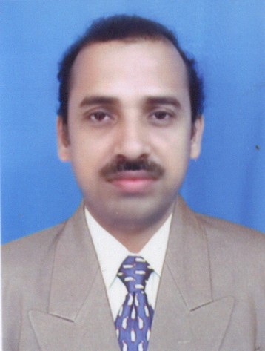
Arobinda Mohanty.
C/O:-Ajay Das Choudhury, Plot No:-1294/p – 16, Behind U.C.O Bank
C.R.P.F. Square Nayapalli – Bhubaneswar, Orissa, 751012, Phone No – 06742563883 (M) 9437292316, E – mail – arobinda.m@rediffmail.com

-------------------------------------------------------------

Aims to pursue challenging assignments in operations management, entailing accounting functions. Recovery receivable management and team management with a reputed organization.

PRECIS
- A result oriented professional with 17 years of working experience in Para – banking division of Sahara India. Presently designated as MARKETING MANAGER.
- Comprehensive experience in managing an array of operation for the branch too ensure smooth execution of operations.
- Significant experience in following up with clients: implementing collection strategies for sticky accounts.
- Proven abilities in cementing healthy relationship with the clients for generating business and leading work force towards accomplishing business and corporate goals.
- An effective communication and team leader with proven team building and management abilities.

CAREER HIGHLIGHTS

FROM 1993 TO 1997 I WAS WORKING AS A SALES MANAGER FOR BAJAJ TEMPO LTD AKRUDI PUNE . FOR INCREASING SALES OF MATADOR ,TEMPO TRAX,AND TEMPO TRAVELLER VEHICLE IN ORISSA
Since 1997 Sahara India
The career path
08.1997, 04. 2006 Junior officer
4.2013 Till date MARKETING MANAGER
Accounting Affairs
- Looking after a gamut of accounting operations fro the branch to ensure seamless operations.
- Handing activities pertaining to payments like maturity, s/ loan, commission, miscellaneous etc.
- Managing receivables inclusive of introduction of new schemes, policies, renewals and other recovery activities.
- Maintaining daily books and conducted checks on bank transaction, payments, receivables and other miscellaneous works.
- Following up with clients: implementing collection strategies for sticky accounts to ensure achievement of pre – set targets.
Team Leadership/ HR functions
- Recruiting, training & monitoring the performance of team members to ensure efficiency in process operations and meeting of individual & group targets.
- Creating and sustaining a dynamic environment to foster development opportunities and motivates high performance amongst team members.
- AND ALSO TAKE SOME SALES IMPROVEMENT WORK OF AVIVA LIFE INSURANCE CORPORATION LTD BHUBANESWAR . PRESENTLY IAM A CLUSTER COUNCIL MEMBER IN AVIVA LIFE INSURANCE CORPORATION LTD WITHIN IN A TWO MONTH

ACADEMIC CREDENTIALS
PGDCA Utkal Services 1992
M.COM.LL.B, Utkal University, Orissa 1992, 1995 50% & 55%
Inter Costing ICWAI Calcutta 1999 & MBA EXECUTIVE FROM MANIPAL UNIVERSITY IN MARKETING IN-2009

COMPUTER PROFICENCY : Ms. – Office, MS – DOS , WINDOWS

PERSONAL DETAILS
Date of Birth: 1st June 1969
Language Proficiency: Oriya, English and Hindi,
Applying for any where in INDIA. AND ABOARD ALSO

