CURRICULCULUM VITAE

NAME : ABINASH KHUNTIA 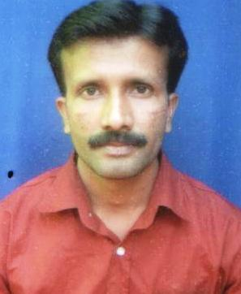

Personal details all about :

Fathers Name : Karunasindhu Khuntia
Date of Birth : 24.01.1975
Sex : Male
Nationality : Indian
Religion : Hindu
Hobbies : Playing cricket & listening Music
Marital Status : Married

PERMANENT ADDRESS : ABINASH KHUNTIA
AT – BARI
PO – BARI KALAMATIA
DIST – JAJPUR
PIN – 755003
ORISSA,INDIA
(M)8908757491,8599011408

PRESENT ADDRESS I Shree Bharat Motors Ltd
Sankarpur
Keonjhar
Dist - Keonjhar
ORISSA,INDIA

E- Mail : khuntia.abinash@rediffmail.com

Educational Qualification :

(1) H.S.E Passed from Board of Secondary Education,Orissa in 1990.
(2) I.Com Passed from Council of Higher Secondary Education ,Orissa in 1992.
(3) B.Com Passed with Accounting Hons. In First Division from Utkal University,Orissa in 1995.
(4) ICWAI Inter stage – 1 in 1997.
(5) LLB From Utkal University in 2001.

Professinal Qualification

Post Graduate Diploma in Computer Application in 2001.

Asset :

Ability to accept challenge and work in adverse situation, Honesty and persistent application of mind in given task

Carrier Objective :

To get an opportunity where I can prove my ability and fulfill the requirements of the organization with Excellency.

Work Experience :

- As Accounts Executive in Baftek Infosys Pvt Ltd, L-1,Kalpana Square, Bhubaneswar from 20.07.2001 to 21.10.2004, Distributor of P.C.S, H.P, Computers & Peripherals & SONY Handy Cam & LCD Projectors.

- As Accountant in BHARAT MOTORS LTD,Barbil,Branch & SHREE BHARAT MOTORS LTD, Keonjhar,Branch, Authorised Dealer of Ashok Leyland Ltd & D.I.C.V (BHARAT BENZ Commercial Vehicles) from 02.02.2007 to till date.

Job Profile :

Handle Cash & Bank Transactions, Posting entries on Tally, Bank Reconciliation, & over all transactions related to Accounts & Looking after the store of spare parts,physical verification(Audit) of spare parts at regular intervals & assists the Branch in charge in day to day transactions of Branch.

Language Known :

Quite Comfortable with Oriya, English & Hindi.

DECLARATION

I herewith declare that all the information’s furnished above are true & complete to the best of my knowledge & belief.

Date : 02.08.2021
Place : Keonjhar Abinash Khuntia

