CURRICULUM VITAE 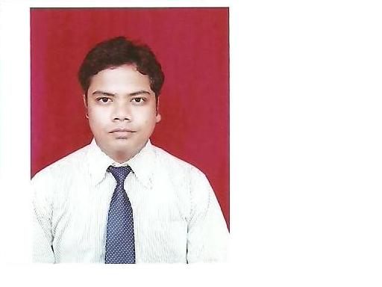
PERMANENT ADDRESS:
Sandeep Kumar Chatter C/o. M/s. Anjali Chatter, Plot
Email id: skumaroct26@gmail.com No.130 (p), Near Sarna Chowk
Mobile no: +91-8280668749 Post- Jhripani, Jagda-765042,ORISSA

Objective:

To build carrier in a growing organization, Where I can get the opportunities to prove my abilities by accepting CHALLEMGES, fulfilling the organizational GOAL and Climb the Career Ladder through continuous learning and commitment.

Educational Qualifications:

Qualification | Institution | University/  Board | Year of Passing | Percentage/  CGPA of marks
Master of Business Administration  (MBA) | Gitam Institute  of Management, GITAM University | GITAM University | 2010 | 6.22
Bachelors of Business  Administration  (BBA) | Ravenshaw  University,  Cuttack, Orissa | Ravenshaw University,  Orissa | 2008 | 59%
12th | Barabati(Art) College  Orissa | CHSE, Orissa | 2005 | 54%
10th | Pragati Vidya  Mandir, Rourkela  Orissa | HSE, Orissa | 1999 | 43%
Diploma in  Computer  Application | Tulibloss Computer Education | TULIBLOSS ACADEMY | 2000 | 81%

Work experience details (Start from present Employer) :

Name of the Employer | Designation | Period of Service |  | Length  of Service  (YY/MM) | Nature of duties performed
Name of the Employer | Designation | From | To | Length  of Service  (YY/MM) | Nature of duties performed
DIBYANSHU ENGG. CORPN.. LTD. Rourkela-14 ORISSA, INDIA  A.I ENTERPRISES  (P) LTD. BANGALORE  DIBYANSHU ENGG. CORPN.. LTD. Rourkela-14 ORISSA, INDIA  KSHAMTA Foundation Pvt. Ltd. | MARKETING  OFFICE ASST.  ASST.  MANAGER  INNOVATIVE RURAL PRODUCTS | 05.04.2010  11.07.2011  02.05.2013  26.10.2017 | 07.07.2011  02.04.2013  10.02.2015  02.11.2018 | 1.3 YEARS  1.8 YEARS  2.7 YEARS  13 MONTH’S | SALES.  EXECUTIVE.  ACCOUNTS ASST.  EXECUTIVE  SR.EXECUTIVE

Specialization:
- 1^{st (}Spec) - Marketing.
- 2nd (Spec)- Finance.

Project:
In recent project with KSHAMTA Foundation. We are dealing with Innovative Rural Products providing Water purifier, Solar Latten, Free Dish TV(Green Way) and also providing Financial Stability to grow and to improve there Life Style, across Chhattisgarh, Odisha and Jharkhand area customers, Providing day-to-day solution in there Door step.
Also dealing with Collection, GST Billing and Accounts settlement.

Achievements:

- Best SALES man award for the month for MARCH 2011 in our Company.
- Participated in Management Excellence Meet 2009 as Finance.
- Participated in Management games conducted by ‘Capsim’ winner 3rd Pries
(All World Bas)
- Participated in volleyball tournament (District Zonal meet).
- Participated and won 3rd prizes in GITAM UNIVERSITY inter collegiate Singing.
- Participated in Andhra University inters collegiate youth fest in Bhimavaram.

Strengths:
- British English Certificate (BEC) Vantage Student.
- Believe in myself
- Speck English, Hindi, Oriya, Bengali and Punjabi
- Great team worker
- Hard working
- Punctual.
Computer Skills:
- Microsoft Office.
- Microsoft Excel.
- Java & Visual Basic.
- Database and Management system.
- GST, CGST & IST BILLING ETC.
Interests:
- Painting
- Cricket
- Dancing
- Cooking
Personal Details:

Date of Birth : 26 OCTOBER 1983
Father Name : Mr. Madan Lal Chatter
Mother Name : Ms. Anjali Chatter

DECLARATION

I hereby declare that the information stated above by me is true, complete to the best of my knowledge and belief. In case, the information stated above by me is found to be false or incorrect, my candidature / appointment may be considered terminated without any notice.

PLACE; ROURKELA
Date;- (Sandeep Kumar Chatter)

