AKASH RANJAN BEHERA
W.N 14, VETERINARY ROAD,
KANTABANJI -767039,
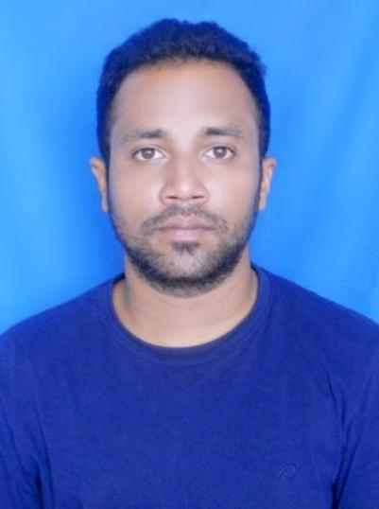
MOB-7008475698
EMAIL: - mankind.rahul@gmail.com,

Passport no – M4129016

OBJECTIVE:
Intend to build a career with leading corporate of hi-tech environment which help me to explore and utilize my technical and managerial skill to the best of my abilities to perform any given task.
PROFESSIONAL QUALIFICATION:
B-Tech in Electrical Engineering from Konark Institute of Science and Technology affiliated from BPUT University, Bhubaneswar having an aggregate of 6.5 CGPA in the academic year 2011-12.
WORK EXPERIENCE:
2.0 years’ of experience as OPERATION & MAINTENANCE ENGINEER in Coal Fired Thermal Power Plant of 4x600 MW, IPP, VEDANTA Site, Jharsuguda, Odisha.
2.1 year’s of experience as FIELD COORDINATOR in women SHG project supported by NABARD in SANJOG, Kantabanji, Balangir.
PRESENT ORGANISATION:
SANJOG:- Working as a Field Coordinator in women SHG group project supported by NABARD in Tureikela block of Balangir district.
Duration: 1st September 2015 to 30th October 2017
Role: - Field Coordinator
Responsibility: -WSHG formation, nurturing, credit linkage, capacity building and business promotion activities.

Abhijeet Engineering works: - Working as Engineer in Department of BOP Operation & Maintenance. Currently involved in operation of common comprehensive pump house,4*600MW IPP VEDANTA site,Jharsuguda.

Duration:January’2013 - January’2015)

Role: - Engineer.

Responsibility:-BOP Operation & electrical maintenance .

ROLES IN OPERATION:
- operating comprehensive pump house as per requirement of all 4*600 MW units.
- Responsible for Monitoring & maintaining all operating parameters such as pressure, temperature and flow within specified control limits to ensure un-interrupted power generation
- Co-ordinate with the maintenance team for emergency, planned and breakdown operations.
- Coordinating with field engineers to operate the equipment carefully and collecting relevant data about each and every rotating machine from time to time and analyse it with the help of past history of trends.
- Proper equipment changeover as per schedule
- Proper Isolation & Issuance of PTW for safe Maintenance Activity through SAP system.

ROLES IN MAINTENANCE:
- Supervising the preventive and corrective maintenance works of LT (up to 415 V, 180 KW) and HT motors (up to 11 KV, 250 KW), dry type transformers (up to 11 KV/415 V, 1250 KVA), air and vacuum circuit breakers (up to 2000 amps), rectifiers (415 V AC/ 70 V DC,110 amps AC/ 1000 amps DC), MCCs and PCCs.
- Executing installation and commissioning of new electrical equipments.
- Modification of existing equipments, panels, wiring circuits and feeders.
- Testing of instruments like CT, PT and relays during shutdown and overhauling.

DOCUMENTS:
- Preparation of maintenance checklist and protocol.
- Preparation of Start-up & Shutdown Checklists along with checklists for Field operation.
- Maintaining log books and records for maintenance activities, materials, tools and equipments both on soft and hard copy and preparing spare lists and modification plans
- Study & Reviewing of Control & protection schemes control/ Logic diagram for various electrical equipment.
- Member of Quality Circle team and actively involved in QC, 5S and EnMS (Energy Management System) implementation initiatives
COMPUTER SKILL:
• C/C++
• MS Office/Outlook
DCA
PERSONAL INFORMATION:
FATHER NAME: - SUBASH BEHERA
MOTHER NAME: - GEETA BEHERA
DATE OF BIRTH: - 29/08/1989
GENDER: - MALE
LANGUAGE: - ENGLISH, HINDI, ODIYA

I hereby declare that the information furnished above is true to the best of my knowledge.

DATE- 01.02.2021 AKASH RANJAN BEHERA
PLACE-BHUBANESWAR

