BIG DATA LAB

Name: SUMAN KR DAS

USN: 1NT19IS164

Date:02.06.2022

1.Problem Statement & Dataset

Create a collection named "Employee" under the "EmployeeDB" database with each document in the format shown below Table

>use EmployeeDBSuman

>db.createCollection(“Employee1nt19is164”)

>show collections

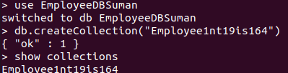

Inserting the values:

>db.Employee1NT19IS147.insertMany([{Firstname:"Suman",Middlename:"Kumar ",Lastname:"Das",Age:22,Salary:40000,Designation:"Employee",Role:"Software developer"},{Firstname:"Tanmay",Middlename:"",Lastname:"Sharan",Age:21,Salary:75000,Designation:"HR",Role:"Manager"},{Firstname:"Sourav",Middlename:"",Lastname:"dey",Age:23,Salary:45000,Designation:"Employee",Role:"Tester"},{Firstname:"Suryansh",Middlename:"",Lastname:"Arya",Age:37,Salary:80000,Designation:"Researcher",Role:"Team Lead"},{Firstname:"Rajesh",Middlename:"Patil",Lastname:"N",Age:36, Salary:50000,Designation:"Scientist",Role:"UI Designer"}])

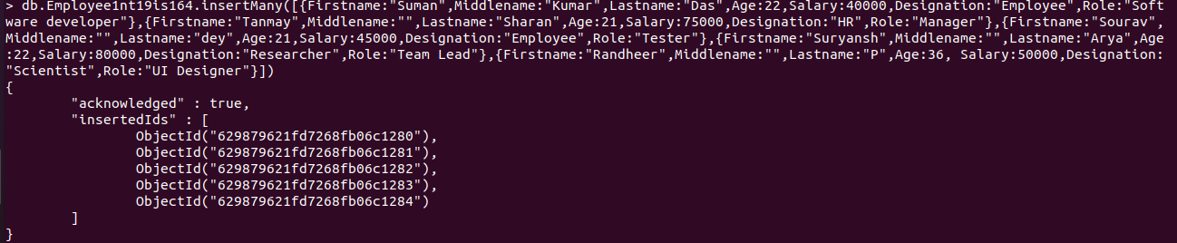

>db.Employee1NT19IS147.insertMany([{Firstname:"Prateek",Middlename:"P",Lastname:"Nayak",Age:30,Salary:45000,Designation:"Employee",Role:"Team Lead"},{Firstname:"T",Middlename:"Madhu",Lastname:"Prakash",Age:30,Salary:40000,Designation:"Employee",Role:"Team Lead"},{Firstname:"T",Middlename:"H",Lastname:"Lakshana",Age:30,Salary:30000,Designation:"Employee",Role:"Software developer"},{Firstname:"Y",Middlename:"Mahitha",Lastname:"Reddy",Age:45,Salary:75000,Designation:"Scientist",Role:"Software developer"},{Firstname:"V",Middlename:"Mohan",Lastname:"Babu",Age:52,Salary:100000,Designation:"President",Role:"Software developer"}])

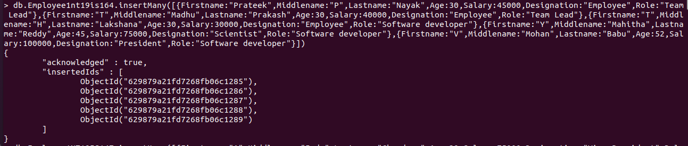

>db.Employee1NT19IS147.insertMany([{Firstname:"A",Middlename:"Indu",Lastname:"Choudary",Age:39,Salary:75000,Designation:"Vice President",Role:"UI Designer"},{Firstname:"P",Middlename:"Snehitha",Lastname:"Choudary",Age:35,Salary:60000,Designation:"Associate",Role:"Tester"},{Firstname:"P",Middlename:"Pradeep",Lastname:"Kumar",Age:30,Salary:75000,Designation:"HR",Role:"Team Lead"},{Firstname:"Harsha",Middlename:"Vardhan",Lastname:"G",Age:31,Salary:40000,Designation:"Employee",Role:"Manager"},{Firstname:"S",Middlename:"Bhavana",Lastname:"Reddy",Age:27,Salary:50000,Designation:"Associate",Role:"UI Designer"}])

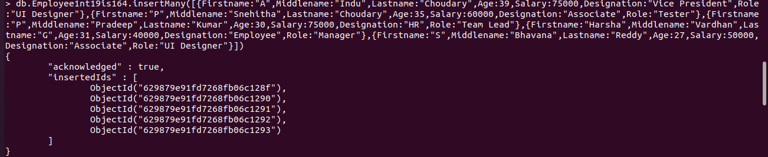

2. Queries

1. Populate the database with atleast 15 documents

>db.Employee1NT19IS147.find()

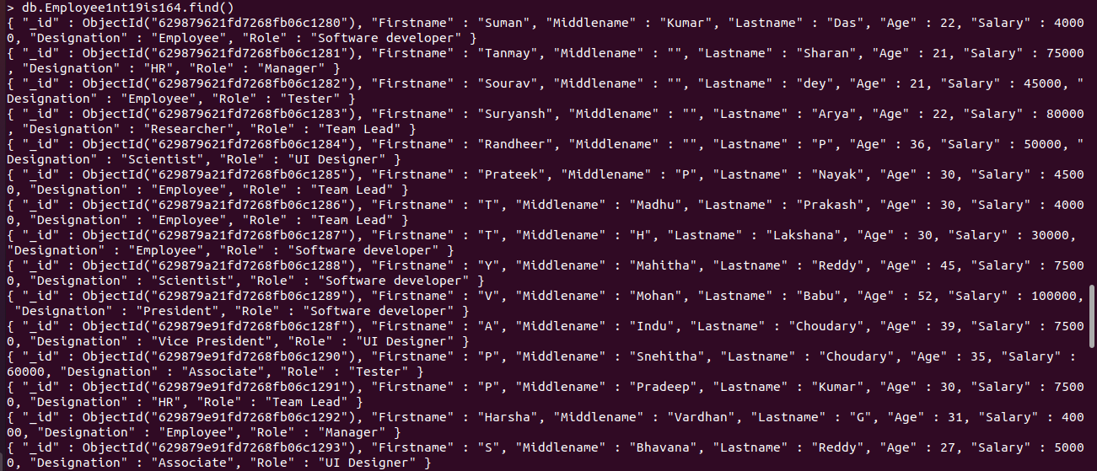

2. List all the records having salary in the range of 20000 - 35000(Exclusive)

>db.Employee1nt19is164.find({$and:[{Salary:{$gt:20000}},{Salary:{$lt:35000}}]})



3. List all the Employee whose Middle name is "Kumar"

> db.Employee1nt19is164.find({Middlename:"Kumar"})



4. Count the number of Employees who has a role "Manager" in the Role field

> db.Employee1nt19is164.count({Role:"Manager"})



5. Find out all the documents who have age < 35 and salary in the range of 30000-50000

>db.Employee1nt19is164.find({$and:[{Salary:{$gt:30000}},{Salary:{$lt:50000}},{Age:{$lt:35}}]})

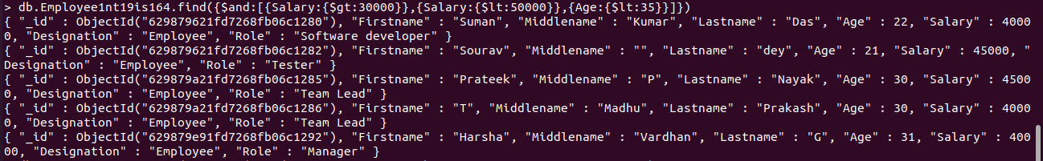

6. Delete an Employee whose "Firstname" is "Rajesh" and having the designation as "Scientist"

>db.Employee1nt19is164.deleteOne({$and:[{Firstname:"Rajesh"},{Designation:"Scientist"}]})



>db.Employee1nt19is164.find()

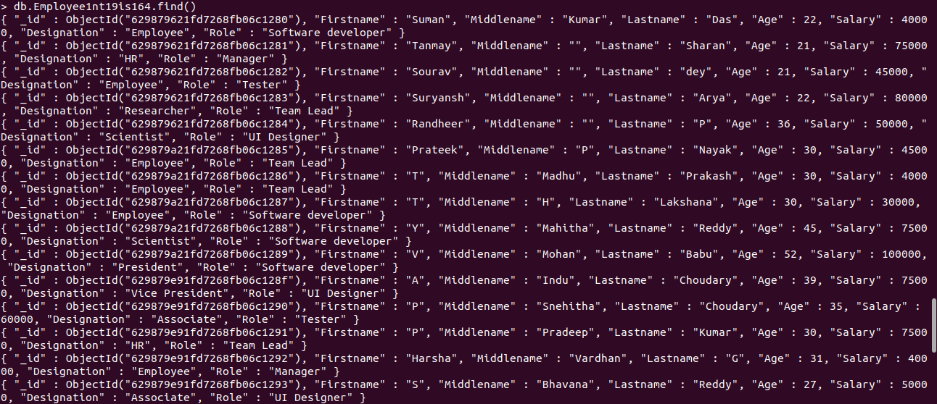

7. Update all the Employees whose role is "Team Lead" with a salary of 55650 INR

> db.Employee1nt19is164.updateMany({Role:"Team Lead"},{$set:{Salary:55650}})



>db.Employee1nt19is164.find()

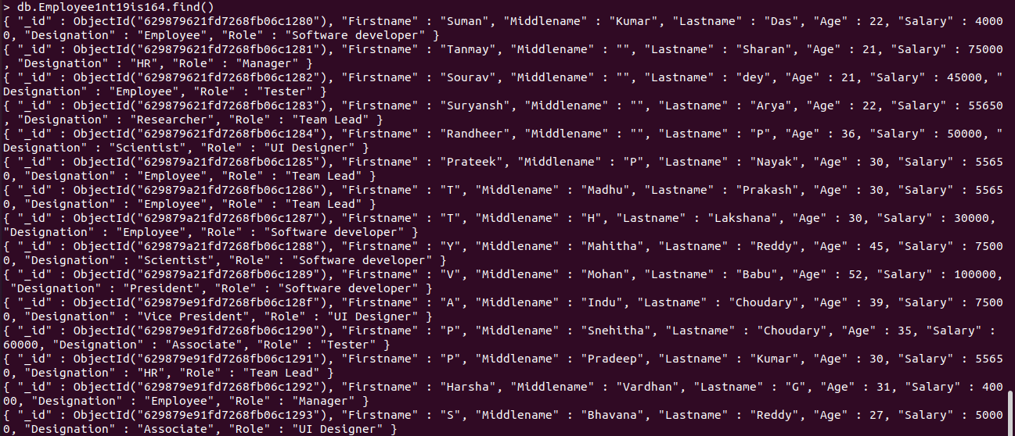

8. Group all the Employees by their age(common age should be there) and calculate the average salary obtained in the each group

>db.Employee1nt19is164.aggregate([{$group:{_id:"$Age",Average:{$avg:"$Salary"}}}])

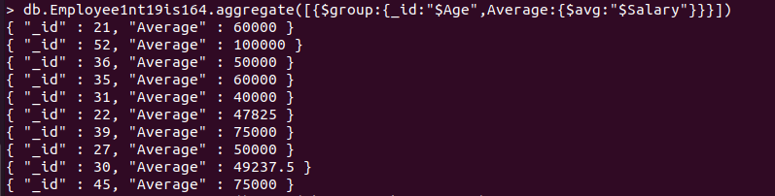

9. Apply the map-reduce to perform the above operation and obtain the results

> var mapfunction=function(){emit(this.Age,this.Salary)}

> var reducefunction=function(key,values){return Array.avg(values)}

>db.Employee1nt19is164.mapReduce(mapfunction,reducefunction,{'out':'result'})

{ "result" : "result", "ok" : 1 }

> db.result.find()

