  Clover Digital Sdn Bhd (Co. Reg. 201501034912)  7A Jalan PP2/1, Taman Putra Prima, 47100 Puchong, Selangor  admin@cloverdigital.com.my www.cloverdigital.com.my |  |  | Engineer’s Service Report  ESR No. 26/011
Customer: TNB Engineering Corporation Sdn Bhd |  | Site Address: IJN Chiller Plant
Contact: |  | Date/Time: 21/8/2026
Reported Fault:
STLP1 & 2 failed to run. Inverter show running but no power output to pump.
Engineer’s Report:
The existing Danfoss VLT 6000 Variable Frequency Drive (VFD) for STLP1 and STLP 2have suffered a critical failure, resulting in zero power output to the connected motor. Given the unit's age (~19 years), operation runtime (~50,000 hours), and obsolete support status, direct replacement with a modern equivalent VFD is strongly recommended over component repair.
At 50,000 operating hours, critical internal hardware—such as DC bus capacitors, power card gate drivers, IGBT modules, and internal cooling fans—has reached end-of-life. Repairing only the output stage circuit will leave other worn components intact, causing high likelihood of secondary failures shortly after startup.
The Danfoss VLT 6000 series is mature legacy hardware. Sourcing refurbished or old-stock replacement circuit boards incurs high costs and extended lead times, without restoring warranty coverage or reliable operation.
Downtime Risk & Operational Efficiency

- Repair: Long lead time to source legacy components with zero guarantee of system reliability post-repair.

- Replacement: Modern drives offer direct mechanical/electrical migration paths, seamless protocol integration, superior energy efficiency, full 12 month warranties, and readily available spare parts.

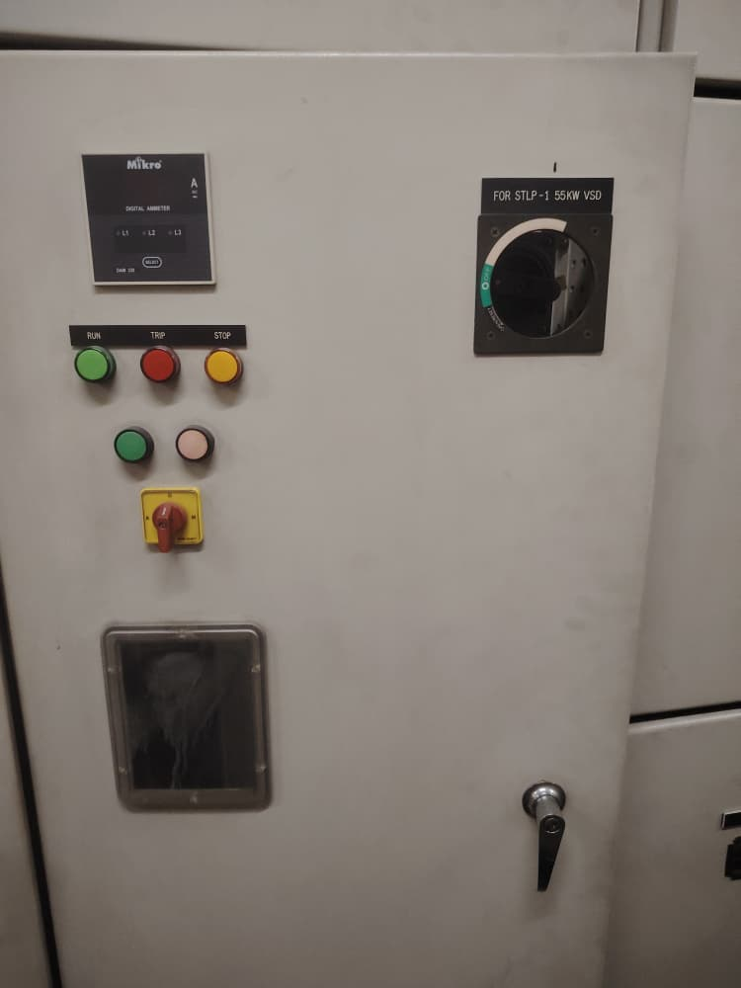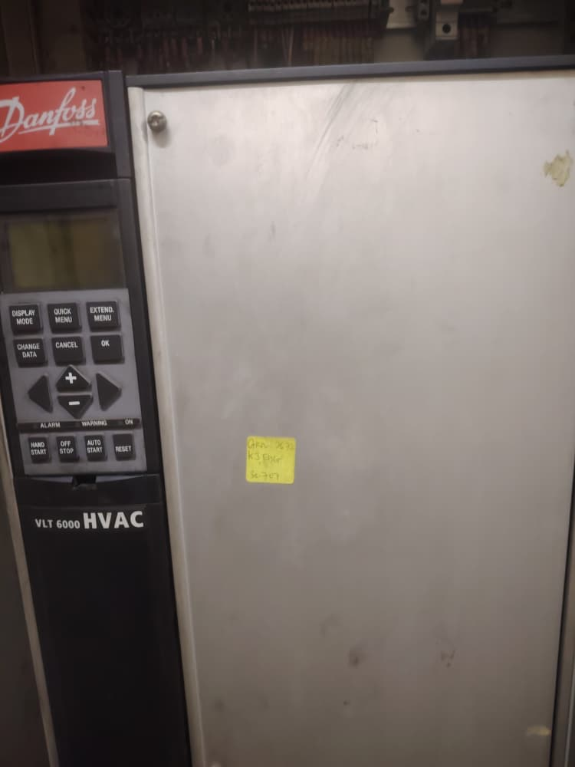
STLP1
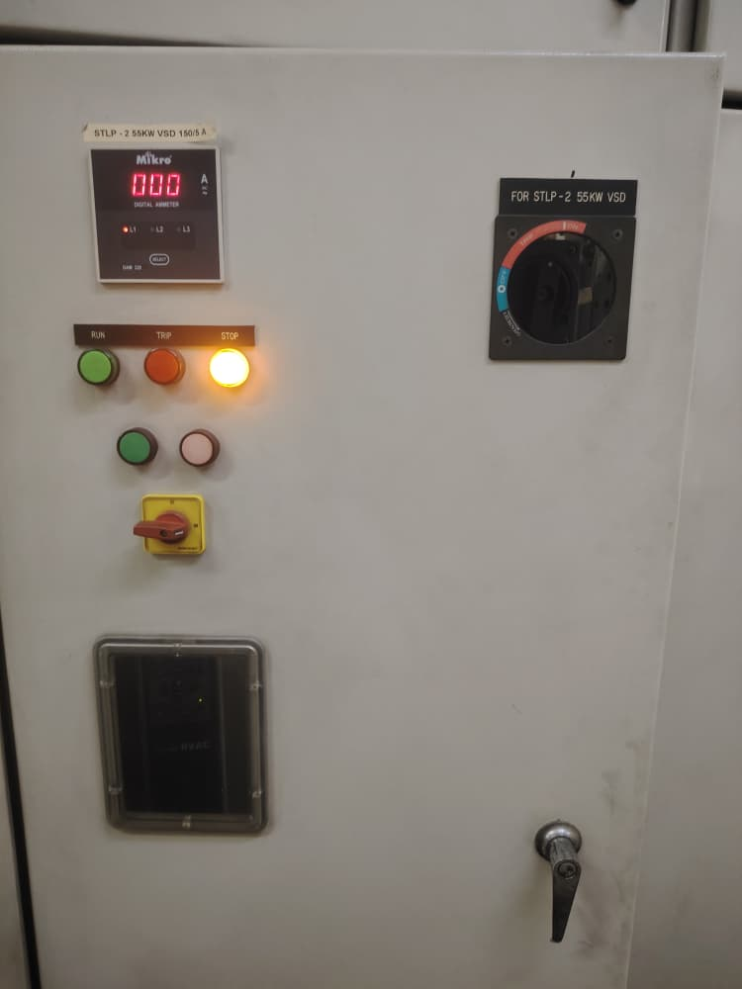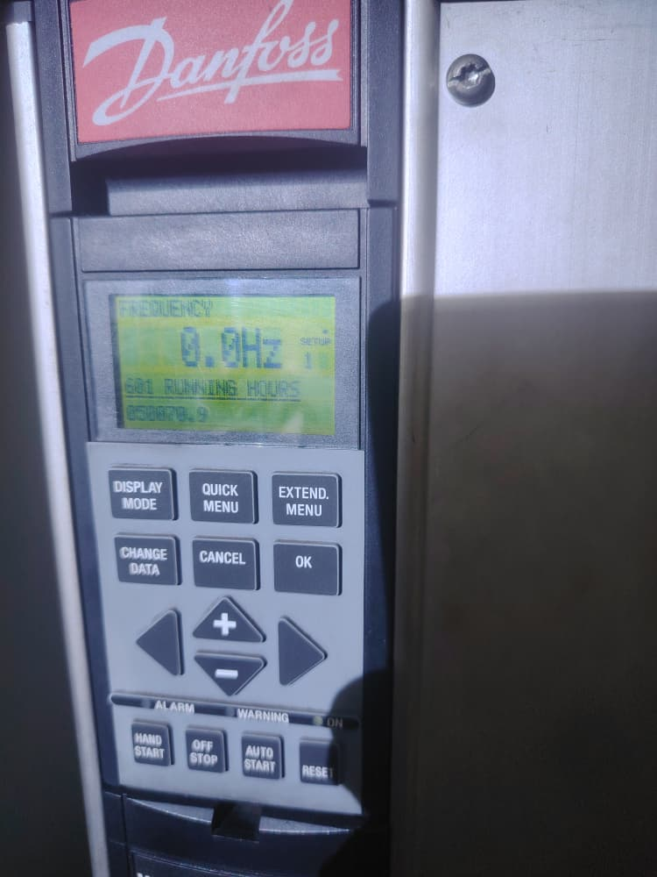
STLP2
Attended By: |  | Verified by:
 |  | Customer’s Signature
Name: SK Ding |  | Name:
Date: 21/8/2026 |  | Date:

