--中间区域
SELECT LIVE_NUMBER AS 常驻人口数,DOMICILE_NUMBER AS 户籍人口数,FLOOR AS 楼栋数,COMMITTEE as 居委数,FAMILY AS 家庭数,SCHOOL as 学校数,RETIREMENT_ORG AS 养老机构 FROM DP_COMMUNITY where ORG_CODE='0000001'
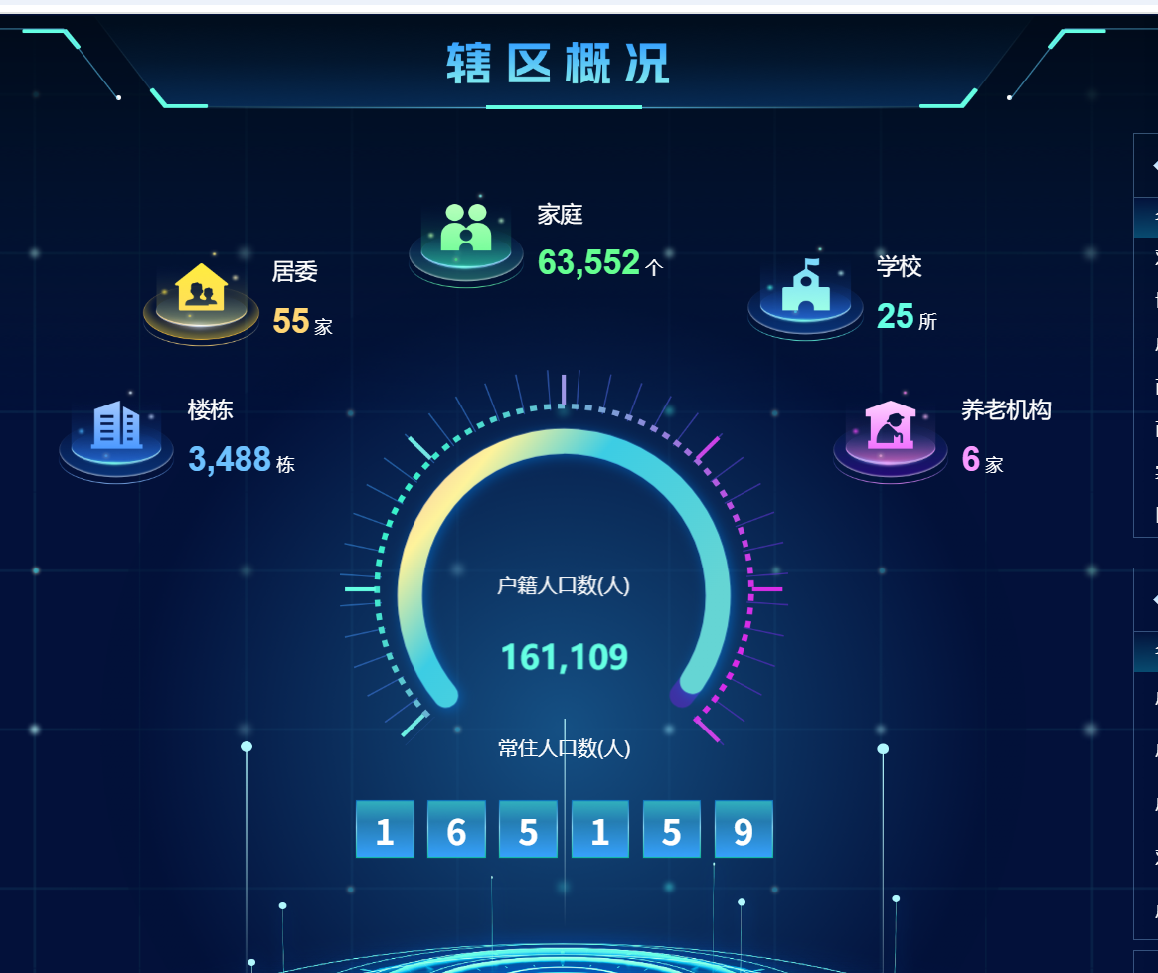

--老年人
SELECT OLD_PEOPLE as 老年人总数,RED as 标红,YELLOW as 标黄,GREEN AS 标绿 FROM DP_COMMUNITY where ORG_CODE='0000001'
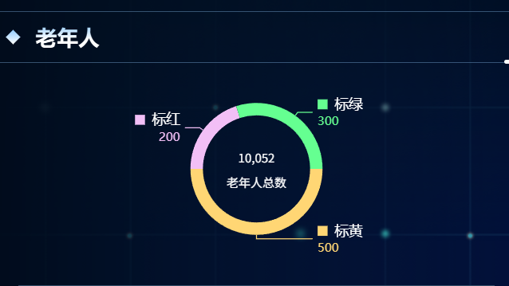

--按年龄段分布老年人
SELECT
-- 年龄段分布
COALESCE(OVER_SIXTY, 0) as '60岁以上',
COALESCE(OVER_SIXTYFIVE, 0) as '65岁以上',
COALESCE(OVER_EIGHTY, 0) as '80岁以上',

-- 老年人总数（用于饼图分母）
COALESCE(OVER_SIXTY, 0) + COALESCE(OVER_SIXTYFIVE, 0) + COALESCE(OVER_EIGHTY, 0) as '总数',

-- 特殊群体
COALESCE(ALONE_OLD_PEOPLE, 0) as 独居老人数,
COALESCE(DISABLED_OLD_PEOPLE, 0) as 失能老人数,

-- 老年人总数（用于百分比计算）
COALESCE(OLD_PEOPLE, 0) as 老年人总数,

-- 百分比计算（保留一位小数，四舍五入）
ROUND(
CASE
WHEN COALESCE(OLD_PEOPLE, 0) = 0 THEN 0
ELSE (COALESCE(ALONE_OLD_PEOPLE, 0) * 100.0 / OLD_PEOPLE)
END, 1
) as 独居老人占比,

ROUND(
CASE
WHEN COALESCE(OLD_PEOPLE, 0) = 0 THEN 0
ELSE (COALESCE(DISABLED_OLD_PEOPLE, 0) * 100.0 / OLD_PEOPLE)
END, 1
) as 失能老人占比

FROM DP_COMMUNITY
WHERE ORG_CODE = '0000001'
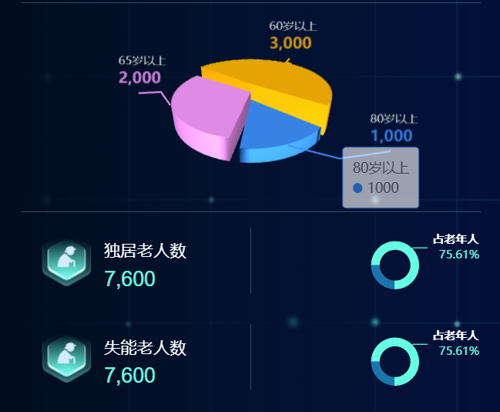

--孕产妇/儿童
SELECT
-- 孕产妇保健人数
COALESCE(MATERNAL, 0) as 孕产妇保健人数,

-- 0-3岁儿童保健人数
COALESCE(SMALL_THREE, 0) as '0-3岁儿童保健人数',

-- 0-6岁儿童保健人数
COALESCE(SMALL_SIX, 0) as '0-6岁儿童保健人数'

FROM DP_COMMUNITY
WHERE ORG_CODE = '0000001'

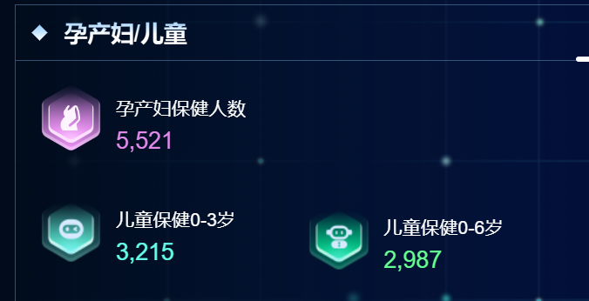

--学校
SELECT
NAME as institution_name,
ADDRESS as institution_address,
COALESCE(TOTAL_NUMBER, 0) as student_count,
COALESCE(NUMBERS, 0) as teacher_count
FROM DP_COMMUNITY_ORG
WHERE ORG_CODE = '0000001' -- 需要替换为实际的机构代码字段名和值
AND TYPE = '1' -- 分类为学校
ORDER BY NAME
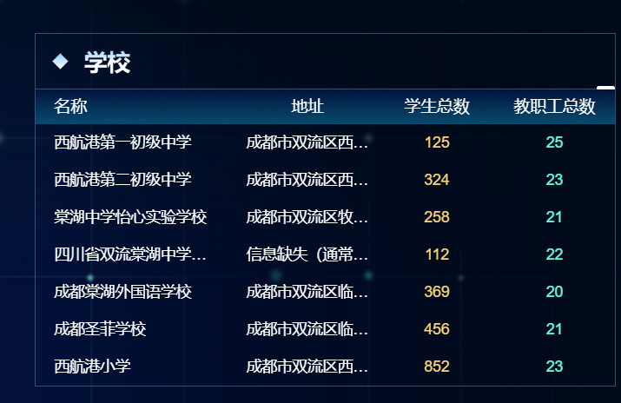

--养老机构
SELECT
SUBSTRING(NAME, 1, 10) AS NAME,
SUBSTRING(ADDRESS, 1, 10) AS ADDRESS,
NUMBERS
FROM DP_COMMUNITY_ORG
WHERE TYPE = '2'
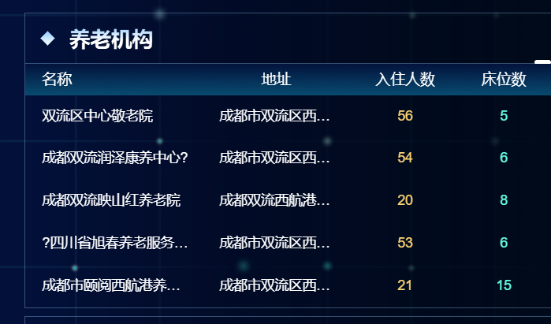

--医疗卫生机构
SELECT
COALESCE(HOSPITAL, 0) AS 综合医院数,
COALESCE(OUTPATIENT_DEPT, 0) AS 社区卫生站数,
COALESCE(HEALTHCARE_STATION, 0) AS 门诊部数,
COALESCE(CLINIC, 0) AS 诊所数,
COALESCE(HOSPITAL, 0) + COALESCE(OUTPATIENT_DEPT, 0) +
COALESCE(HEALTHCARE_STATION, 0) + COALESCE(CLINIC, 0) AS 机构总数,
COALESCE(DOCTOR, 0) AS 执业医师数,
COALESCE(NURSE, 0) AS 注册护士数,
COALESCE(BED, 0) AS 开放床位数
FROM DP_COMMUNITY
WHERE ORG_CODE='0000001'


