Rookery Bay (RKB) NERR Water Quality Metadata
January – December, 2017
Latest Update: May 28, 2021

I. Dataset and Research Descriptors

1) Principal Investigator(s) and Contact Persons
a) Reserve Contacts
Brita Jessen Ph. D., Research Coordinator
Rookery Bay National Estuarine Research Reserve
300 Tower Road
Naples, FL 34113
Tel: (239) 530-5964
Fax: (239) 530-5983
Brita.Jessen@dep.state.fl.us

b) System-Wide Monitoring Technicians
Julie Brader Drevenkar, Water Quality Program Manager
Rookery Bay National Estuarine Research Reserve
300 Tower Road
Naples, FL 34113
Tel: (239) 530-5965
Fax: (239) 530-5983
Julie.Drevenkar@dep.state.fl.us

2) Entry verification
Deployment data are uploaded from the YSI data logger to a Personal Computer (IBM compatible). Files are exported from EcoWatch in a comma-delimited format (.CDF), EcoWatch Lite in a comma separated file (CSV) or KOR Software in an Excel File (.XLS) and uploaded to the CDMO where they undergo automated primary QAQC; automated depth/level corrections for changes in barometric pressure (cDepth or cLevel parameters); and become part of the CDMO’s online provisional database. All pre- and post-deployment data are removed from the file prior to upload. During primary QAQC, data are flagged if they are missing or out of sensor range. The edited file is then returned to the Reserve for secondary QAQC where it is opened in Microsoft Excel and processed using the CDMO’s NERRQAQC Excel macro. The macro inserts station codes, creates metadata worksheets for flagged data and summary statistics, and graphs the data for review. It allows the user to apply QAQC flags and codes to the data, remove any overlapping deployment data, append files, and export the resulting data file for upload to the CDMO. Upload after secondary QAQC results in ingestion into the database as provisional plus data, recalculation of cDepth or cLevel parameters, and finally tertiary QAQC by the CDMO and assimilation into the CDMO’s authoritative online database. Where deployment overlap occurs between files, the data produced by the newly calibrated sonde is generally accepted as being the most accurate. For more information on QAQC flags and codes, see Sections 11 and 12.

Julie Brader Drevenkar, Water Quality Program Manager, performed data management and reporting.

3) Research objectives
Beginning January 1, 2001, two existing water quality stations, Lower Henderson Creek and Middle Blackwater River were designated as the Reserve’s permanent System-Wide Monitoring Program (SWMP) sites for the National Estuarine Research Reserve Program. Except for turbidity, the dataset at these stations are nearly continuous beginning in April of 1996. The dataset from these monitoring stations represents the longest record of continuous water quality measurements of all the Rookery Bay NERR water quality stations. In January 2002 two additional sites, Faka Union Bay and Fakahatchee Bay, were designated as SWMP water quality stations. A fifth site, Pumpkin Bay, was established in November 2003 to augment the SWMP at Rookery Bay National Estuarine Research Reserve as well as biological, fisheries and shark monitoring data. In October of 2016, the Pumpkin Bay site was designated a Secondary SWMP station. All stations currently record temperature, turbidity, salinity, specific conductance, pH, dissolved oxygen, and depth at 15-minute intervals.
The five stations are in estuaries affected by watersheds demonstrating different patterns of land-use. Their placement addresses priority resource management issues that were identified in the Reserve’s management plan. Specifically, the data from these stations provide valuable information concerning the effects of land-use activities on the quantity, quality and timing of freshwater inflow into the Reserve. Each bay studied demonstrates a different pattern of altered freshwater inflow.
The Lower Henderson Creek station receives most of its freshwater from a canal system that drains a watershed area with approximately 50% developed versus natural landscape. Land-use in the developed area is divided equally between residential and agricultural activities. A weir controls most of the freshwater flowing into Henderson Creek. The Reserve obtained grant funding to upgrade the existing weir structure in May 2002 to allow for an automated control of water release. The dataset being obtained from the Lower Henderson Creek station, along with biological monitoring, and hydrologic modeling may be used to develop a water release strategy for Henderson Creek.
One of our primary study foci is to monitor the effects of the Picayune Strand Restoration Project, which is part of the Comprehensive Everglades Restoration Plan (CERP). Due to a failed housing development (Southern Golden Gate Estates) in the 1960’s, 48 miles of canals were constructed to drain an 85-square mile area. Historically, freshwater flowed southwest from this area via sheet flow into several receiving estuaries in the Ten Thousand Islands region. Restoration work is currently underway to restore a near- natural water flow regime to the watershed and the receiving estuaries. By the end of 2015, two of the four canals have been plugged and pump stations at the upper portion of the canals have been completed. In addition, a manatee mitigation area located off Faka Union Canal, near the Port of the Islands community, was completed in early 2016. Four water quality stations, three Primary SWMP stations (Middle Blackwater River, Faka Union Bay, and Fakahatchee Bay) and one Secondary SWMP station (Pumpkin Bay), were chosen to study the effects of this restoration project (before, during, and after).
The Middle Blackwater River station has a watershed that has 75% natural landscape. Agriculture dominates the land-use activities within the developed area of the Blackwater River watershed. The watershed lies to the west of the Picayune Strand (restoration site). Based on modeling of historic flow-way patterns, the watershed draining into Blackwater River has been significantly reduced resulting in higher than historical salinity values.
The Pumpkin Bay watershed lies directly to the southwest of the Picayune Strand (restoration site). Like Blackwater River, the modeling of historic flow-way patterns, show the watershed draining into Pumpkin Bay has been significantly reduced resulting in higher than historical salinity values.
The Faka Union Bay station is located immediately downstream of the failed housing development and current restoration project. Four canals constructed for the original project converge into one canal (Faka Union Canal) which drains into Faka Union Bay. Consequently, this station represents the most extreme state of altered freshwater inflow of the four monitoring sites in the Ten Thousand Islands. Faka Union Bay experiences lower than historical salinity values and extreme fluctuations in salinity during the wet season.
The Fakahatchee Bay station is the least disturbed system relative to the other sites in the Ten Thousand Islands. The Fakahatchee Bay watershed is primarily under Preserve status and has been relatively undisturbed by the hydrologic alteration of the Southern Golden Gate Estates canal system. The water quality data collected from this station serves as a reference for assessing the effectiveness of the Picayune Strand Restoration Project.

4) Research methods
In August 2016, data loggers at the Faka Union Bay and Fakahatchee Bay sites were upgraded from the YSI 6600 Extended Deployment System (EDS) to the YSI EXO2 model. Likewise, in October 2016, the data loggers at the Pumpkin Bay site were upgraded to the YSI EXO2 model. In January 2003, the Henderson Creek and Blackwater River sites were upgraded to the YSI 6600 Extended Deployment System (EDS) model. Prior to deployment, the sondes were calibrated for specific conductivity, pH, turbidity, dissolved oxygen, and depth following the procedures outlined in the YSI Operating and Service Manual. The thermistor accuracy was checked against a NIST calibrated thermometer.
A two-point calibration was used for pH (Biopharm buffer 7, Biopharm buffer 10) and turbidity [0 NTU (in-house deionized water) & 124/126 NTU YSI, Inc.]. A 0.5M KCL solution (Biopharm 50 mS/cm conductivity calibrator) was used to calibrate specific conductivity. Dissolved oxygen (DO) was calibrated in oxygen saturated tap water, using a bucket and an air-stone. ROX optical DO probes were deployed at the Henderson Creek and Blackwater River sites.
All sondes were deployed within 4-inch diameter PVC housing tubes, which were attached to “aid-to-navigation” pilings (Lower Henderson Creek, Middle Blackwater River, and Faka Union Bay), or to 6-inch PVC pipes hydro-jetted into the substrate (Fakahatchee Bay and Pumpkin Bay). The tubes were oriented vertically and were attached tightly with stainless steel hose clamps and large plastic zip ties or stainless-steel brackets bolted to the piling. The bottom portion of the tube was open and sat approximately between 15 and 45 centimeters above the bottom. Probe readings were measured approximately 0.25 to 0.5 meter above the substrate.
Reconditioned PVC housing tubes were deployed at Fakahatchee Bay site on 2/07/2017 and 2/21/2017, Pumpkin Bay site on 2/21/2017, Faka Union Bay site on 6/22/2017, Lower Henderson Creek site on 08/08/2017 and 12/05/2017 and Middle Blackwater River site on 12/20/2017. All the tubes were built using the “EXO Long Term Monitoring Guide, Vertical Tube Deployments" diagram. Thirty-two 1-inch diameter holes were drilled circumferentially around the lower 0.4 m of the tube and fourteen 2.25-inch diameter holes were drilled 180° apart circumferentially around the upper 1 m of the tube to ensure adequate water flow around the probes. The bottom two meters of the PVC housing tube were painted inside and outside with anti-fouling paint. Sondes were hung by plastic coated steel cable inside the tube with the cable bolted to the piling. At the bottom of the tubes, the sondes sat on a ½ inch stainless steel bolt. A cap and lock was used to secure the sonde inside the housing. Currently, all PVC housing tubes have been lowered to approximately 0.25 meter off the bottom to reduce the frequency out of water events that would occur at low tide.
The sondes were further protected from crabs and other live organisms by attempting to restrict the openings on the sonde guard with plastic mesh screening. The plastic mesh (with 1/8 inch diamond-shaped holes) was slid on the outside of the sonde guards’ circumference. The mesh was held together with lightweight fishing line or small zip ties to be able to maintain a cylindrical shape and slide on and off the guard. Electrical tape was used to secure the mesh at the top and bottom of the guard.
Sondes were deployed for 2 to 4 weeks at a time depending on the season. During the heavy fouling season (April through October) the fouling on the probes can become problematic, therefore several antifouling products (copper tape, copper mesh screens on the EDS6600 pH and C-T probes, and copper alloy sonde guards) were used on the probes/sondes. The sampling period was set for 15-minute intervals (readings were made every 15 minutes). The following physical water quality parameters were recorded: temperature (degrees Celsius), specific conductivity (mS/cm), salinity (parts per thousand), dissolved oxygen (mg/L and % saturation), depth (m), pH and turbidity (NTU). To test how well the sondes held calibration, field measurements were performed using a handheld YSI instrument that served as a “spot check” at the time of retrieval. Additionally, a post-deployment calibration check was done after the sonde was taken out of the water and brought back to the lab.
A Sutron Sat-Link2 transmitter was installed at the Lower Henderson Creek station on 12/06/06 and transmits data to the NOAA GOES satellite, NESDIS ID #3B02E17C. (Where 3B02E17C is the GOES ID for that particular station.) The transmissions are scheduled hourly and contain four (4) data sets reflecting fifteen-minute data sampling intervals. Upon receipt by the CDMO, the data undergoes the same automated primary QAQC process detailed in Section 2 above. The “real-time” telemetry data become part of the provisional dataset until undergoing secondary and tertiary QAQC and assimilation in the CDMO’s authoritative online database. Provisional and authoritative data are available at http://cdmo.baruch.sc.edu. NOTE: All data associated with this metadata file are reported in Eastern Standard Time (EST).

5) Site location & character

Lower Henderson Creek (rkblhwq):

Lat/Long (Decimal Degrees): 26.0257 N, 81.7332 W

The “Lower Henderson” site is located at the mouth of Henderson Creek. The Lower Henderson Creek labeling is to clarify the site from other historical water quality stations. The sonde is affixed to a piling (manatee caution sign) located right of center (while facing downstream) of the creek channel, approximately 100 meters from RKB NERR’s boat dock. The monitoring site is approximately 5 km downstream of a four-lane highway (SR 951) that crosses Henderson Creek. The creek is 5.8 km long (mainstream linear dimension), has an average mid-channel depth of approximately 2 meters at MHW, and an average width of 239 meters. At the sampling site, the depth is 2 meters at MHW and the width is 600 meters. Tides at Lower Henderson Creek are mixed and range from 0.23 m to 1.50 m (average 0.84 m). Salinity at this site ranged from 1.9 to 36.6 ppt during the year. Creek bottom habitats are predominantly fine sand and there is no bottom vegetation. The dominant marsh vegetation near the sampling site is red mangrove. The dominant natural vegetation of the watershed is hydric pine and cypress.
Upland land use near the sampling site includes residential areas with septic systems. Watershed activities that potentially impact the site include non-point source pollution from road runoff, drift of mosquito control pesticides, runoff from upstream agricultural areas and leachate from nearby residential septic systems and a weir structure located at SR 41. The amount of water released from this weir can sometimes mask natural tidal salinity patterns. The historic Henderson Creek watershed was approximately 50% under State ownership and much of this protected area had intact cypress sloughs and other wetland vegetation. Canals and water use for agriculture and human consumption have altered the hydroperiod of this watershed. Consequently, the Henderson creek watershed may receive non-point source pollution runoff from a variety of sources.

Middle Blackwater River (rkbmbwq):

Lat/Long (Decimal Degrees): 25.9343 N, 81.5946 W

The “Middle Blackwater River” sonde is located at the mouth of the river. The Middle Blackwater River labeling is to clarify the site from other historical water quality stations. The sonde is affixed to navigational marker #17 within the river channel. The average depth at this marker is approximately 2 meters at MHW. The tidal range for Middle Blackwater River varies between 0.05 and 1.90 meters (average 0.95 m). Salinity at this site ranged from 1.5 to 37.0 ppt during the year. Salinities fluctuate with the tides and watershed rainfall. The substrate within the channel is a mixture of sand and silt with oyster shell with some organic matter mixed in. Mature red mangrove forests dominate the banks of the river.
Upstream influences consist of the Collier-Seminole State Park boat basin and upstream agricultural fields adjacent to Blackwater River’s main feeder canal (SR 41 canal). Nonpoint source pollution from agricultural operations and golf courses may affect this site. In addition, canals and roads built during the 1960’s (Picayune Strand, formerly Southern Golden Gate Estates) may have caused significant disruptions to overland sheet-flow reducing the amounts of freshwater flowing to this estuary. Despite these alterations, the salinity fluctuations of this site suggest that seasonal fluctuations in salinity are more closely correlated to watershed rainfall patterns than salinities of estuaries with water control structures, such as Henderson Creek.

Faka Union Bay (rkbfuwq):

Lat/Long (Decimal Degrees): 25.9005 N, 81.5159 W

The “Faka Union Bay” sonde is located at the mouth of the Faka Union Canal. The sonde is affixed to a manatee speed zone sign next to the main channel. The average depth at this site is approximately 2 meters at MHW. The tidal range for Faka Union Bay varies between 0.06 and 1.68 meters (average 0.79 m). Salinity at this site ranged from 0.3 to 35.3 ppt during the year. Salinities fluctuate daily with tides, seasonal rainfall, and management of upstream water control structures. The substrate within the channel is a mixture of sand and silt with some organic matter. Mature red mangrove forests and spoil islands dominate the banks of the canal.
Upstream influences consist of the Port of the Islands development and marina. The watershed consists of an elaborate canal system (Picayune Strand, formerly Southern Golden Gate Estates) which has altered natural water drainage patterns into Faka Union Bay.

Fakahatchee Bay (rkbfbwq):

Lat/Long (Decimal Degrees): 25.8922 N, 81.4770 W

The Fakahatchee Bay sonde is located at the mouth of two rivers, Fakahatchee River and East River. The sonde is placed in a 4” PVC housing secured to a 6” PVC pipe. The average depth at MHW is approximately 1.5 meters. The tide range for Fakahatchee varies between 0.00 and 1.84 meters (average 0.80 m). Salinity at this site ranged 0.6 to 35.6 ppt during the year. Salinities fluctuate daily with the tides and seasonal rainfall. The substrate within the channel is a mixture of sand, silt and some organic matter. Mature red mangrove forests dominate the banks of the rivers.
Upstream there are minimal influences from the Picayune Strand State Forest with non-point source pollutants possible from the culverts under I-75 and US 41. Fakahatchee Strand State Preserve and Big Cypress National Park manage the headwaters of Fakahatchee Bay. Fakahatchee Bay’s watershed is considered the least altered.

Pumpkin Bay (rkbpbwq):

Lat/Long (Decimal Degrees): 25.9141 N, 81.5404 W

The site is located at the mouth of the Pumpkin River. The tide range for Pumpkin Bay varies between 0.00 and 1.64 meters (average 0.64 m). Salinity at this site ranged from 0.3 to 37.1 ppt during the year. The bottom habitat is predominantly fine sand and there is no bottom vegetation. Mature red mangrove forests dominate the Pumpkin River and the bay. Upland land use is minimal with the main influence US 41 and the Picayune Strand State Forest canal system, which has diverted freshwater. Typically, this site does not receive enough freshwater inflow.

SWMP Station Timeline

Station Code | SWMP Status | Station Name | Location | Active Dates | Reason Decommissioned | Notes
FB | P | Fakahatchee Bay | 25.8922  81.477 | 01/01/2002 00:00 -current | NA | NA
FU | P | Faka Union Bay | 25.9005  81.5159 | 01/01/2002 00:00 –current | NA | NA
LH | P | Lower Henderson Creek | 26.0257  81.7332 | 01/01/2001 00:00 –current | NA | NA
MB | P | Middle Blackwater River | 25.9343  81.5946 | 01/01/2000 00:00 –current | NA | NA
PB | S | Pumpkin Bay | 25.9141  81.5404 | 07/06/2016 00:00 –current | NA | NA
BM | P | Big Marco Pass | 25.979  81.7375 | 01/01/1997 00:00 - 02/01/1998 00:00 | Funded by temporary grant
BR | P | Blackwater River | 25.9678  81.5908 | 02/01/1998 00:00 - 12/01/1999 00: | Location/Funding | This station was moved to a more permanent water quality monitoring station downstream. The downstream location, middle Blackwater River, is RBNERR’s long term biomonitoring program. There is hourly background data dating back to 1996. This site was chosen based on its compatible use with the biomonitoring program and stable funds
UH | P | Upper Henderson Creek | 26.049  81.7012 | 11/01/1996 00:00 - 12/01/2000 00:00 | Funded by temporary grant

6) Data collection period
Water quality data collection at Henderson Creek and Blackwater River began in 1996, while data collection at Faka Union and Fakahatchee began in 2000 and data collection at Pumpkin bay began in November 2003.

Lower Henderson Creek (rkblhwq)
Deployment Start date/time End date/time
120716 12/07/2016 13:30 01/04/2017 12:45
010417 01/04/2017 13:15 02/07/2017 08:15
020717 02/07/2017 08:45 02/21/2017 13:30
022117 02/21/2017 14:00 03/09/2017 08:00
030917 03/09/2017 08:30 03/22/2017 07:15
032217 03/22/2017 07:45 04/05/2017 07:15
040517 04/05/2017 07:45 04/19/2017 07:30
041917 04/19/2017 08:00 05/02/2017 07:15
050217 05/02/2017 07:45 05/16/2017 07:15
051617 05/16/2017 07:45 06/08/2017 10:45
060817 06/08/2017 11:15 06/21/2017 07:00
062117 06/21/2017 07:15 07/05/2017 07:00
070517 07/05/2017 07:45 07/27/2017 10:45
072617 --------------------- ---------------------
080817 08/08/2017 11:30 08/23/2017 06:30
082317 08/23/2017 07:00 09/19/2017 08:15
091917 09/19/2017 08:45 10/04/2017 06:45
100417 10/04/2017 07:30 10/19/2017 07:15
101917 10/19/2017 08:00 11/08/2017 13:00
110817 11/08/2017 13:30 12/05/2017 09:30
120517 12/05/2017 10:30 12/20/2017 11:45
122017 12/20/2017 12:15 01/09/2018 08:00

Middle Blackwater River (rkbmbwq)
Deployment Start date/time End date/time
120716 12/07/2016 09:00 01/04/2017 08:30
010417 01/04/2017 09:30 02/07/2017 12:45
020717 02/07/2017 13:00 03/09/2017 13:15
030917 03/09/2017 13:30 03/22/2017 10:30
032217 03/22/2017 10:45 04/05/2017 08:45
040517 04/05/2017 09:00 04/19/2017 09:00
041917 04/19/2017 09:15 05/02/2017 09:00
050217 05/02/2017 09:15 05/16/2017 08:45
051617 05/16/2017 09:00 06/08/2017 09:15
060817 06/08/2017 09:45 06/21/2017 08:15
062117 06/21/2017 08:30 07/05/2017 09:00
070517 07/05/2017 09:15 07/26/2017 09:00
072617 07/26/2017 09:15 08/08/2017 09:00
080817 08/08/2017 09:15 08/23/2017 09:30
082317 08/23/2017 09:45 09/19/2017 10:30
091917 09/19/2017 10:45 10/04/2017 11:00
100417 10/04/2017 11:15 10/19/2017 10:30
101917 10/19/2017 10:45 11/08/2017 11:15
110817 11/08/2017 11:30 12/06/2017 10:30
120617 12/06/2017 11:00 12/20/2017 09:45
122017 12/20/2017 10:15 01/09/2018 09:45

Faka Union Bay (rkbfuwq)
Deployment Start date/time End date/time
120716 12/07/2016 10:15 01/04/2017 10:15
010417 01/04/2017 10:30 02/07/2017 11:30
020717 02/07/2017 11:45 03/09/2017 12:00
030917 03/09/2017 12:15 03/22/2017 09:45
032217 03/22/2017 10:00 04/05/2017 10:00
040517 04/05/2017 10:15 04/19/2017 10:00
041917 04/19/2017 10:15 05/02/2017 10:00
050217 05/02/2017 10:15 05/16/2017 10:00
051617 05/16/2017 10:15 06/08/2017 08:15
060817 06/08/2017 08:30 06/21/2017 09:00
062117 06/21/2017 09:15 07/05/2017 10:15
070517 07/05/2017 10:30 07/26/2017 08:15
072617 07/26/2017 08:30 08/08/2017 07:45
080817 08/08/2017 08:00 08/23/2017 08:30
082317 08/23/2017 08:45 09/19/2017 11:45
091917 09/19/2017 12:00 10/04/2017 09:00
100417 10/04/2017 09:15 10/19/2017 09:45
101917 10/19/2017 10:00 11/08/2017 10:00
110817 11/08/2017 10:15 12/06/2017 09:15
120617 12/06/2017 09:30 01/09/2018 11:15

Fakahatchee Bay (rkbfbwq)
Deployment Start date/time End date/time
120716 12/07/2016 10:45 01/04/2017 10:45
010417 01/04/2017 11:00 02/07/2017 10:30
020717 02/07/2017 11:30 03/09/2017 11:15
030917 03/09/2017 11:30 03/22/2017 09:30
032217 03/22/2017 09:45 04/05/2017 10:30
040517 04/05/2017 10:45 04/19/2017 10:30
041917 04/19/2017 10:45 05/02/2017 10:30
050217 05/02/2017 10:45 05/16/2017 10:30
051617 05/16/2017 10:45 06/08/2017 07:45
060817 06/08/2017 08:00 06/21/2017 09:15
062117 06/21/2017 09:30 07/05/2017 10:45
070517 07/05/2017 11:00 07/26/2017 07:45
072617 07/26/2017 08:00 08/08/2017 08:15
080817 08/08/2017 08:30 08/23/2017 08:45
082317 08/23/2017 09:00 09/06/2017 08:45
091917 09/19/2017 12:30 10/04/2017 09:30
100417 10/04/2017 09:45 10/19/2017 09:30
101917 10/19/2017 09:45 11/08/2017 09:45
110817 11/08/2017 10:00 12/06/2017 08:45
120617 12/06/2017 09:00 01/09/2018 11:45

Pumpkin Bay (rkbpbwq)
Deployment Start date/time End date/time
120716 12/07/2016 09:45 01/04/2017 09:45
010417 01/04/2017 10:00 02/07/2017 12:00
020717 02/07/2017 12:15 03/09/2017 12:15
030917 03/09/2017 12:45 03/22/2017 10:00
032217* 03/22/2017 10:15 04/05/2017 09:15
040517 04/05/2017 09:30 04/19/2017 09:30
041917 04/19/2017 09:45 05/02/2017 09:30
050217 05/02/2017 09:45 05/16/2017 09:30
051617 05/16/2017 09:45 06/08/2017 08:45
060817 06/08/2017 09:00 06/21/2017 08:45
062117 06/21/2017 09:00 07/05/2017 09:45
070517 07/05/2017 10:00 07/26/2017 08:30
072617 07/26/2017 08:45 08/08/2017 07:15
080817 08/08/2017 07:30 08/23/2017 08:15
082317 08/23/2017 08:30 09/06/2017 08:15
091917 09/19/2017 11:30 10/04/2017 10:15
100417 10/04/2017 10:30 10/19/2017 10:00
101917 10/19/2017 10:15 11/08/2017 08:45
110817 11/08/2017 09:15 12/06/2017 08:15
120617 12/06/2017 08:30 01/09/2018 10:45

*Sonde was deployed but data was not recorded.

7) Distribution
NOAA retains the right to analyze, synthesize and publish summaries of the NERRS System-wide Monitoring Program data. The NERRS retains the right to be fully credited for having collected and process the data. Following academic courtesy standards, the NERR site where the data were collected should be contacted and fully acknowledged in any subsequent publications in which any part of the data are used. The data set enclosed within this package/transmission is only as good as the quality assurance and quality control procedures outlined by the enclosed metadata reporting statement. The user bears all responsibility for its subsequent use/misuse in any further analyses or comparisons. The Federal government does not assume liability to the Recipient or third persons, nor will the Federal government reimburse or indemnify the Recipient for its liability due to any losses resulting in any way from the use of this data.

Requested citation format:
NOAA National Estuarine Research Reserve System (NERRS). System-wide Monitoring Program. Data accessed from the NOAA NERRS Centralized Data Management Office website: http://www.nerrsdata.org/; accessed 12 October 2012.

NERR water quality data and metadata can be obtained from the Research Coordinator at the individual NERR site (please see Principal Investigators and Contact Persons), from the Data Manager at the Centralized Data Management Office (please see personnel directory under the general information link on the CDMO home page) and online at the CDMO home page www.nerrsdata.org. Data are available in comma delimited format.

8) Associated researchers & projects
As part of the SWMP long-term monitoring program, Rookery Bay NERR also monitors 15-minute meteorological along with monthly grab samples and diel sampling for nutrient data which may be correlated with this water quality dataset. These data are available at www.nerrsdata.org. Both water quality and nutrient data generated by Rookery Bay NERR are being used to analyze restoration targets established for the Picayune Strand Restoration Project (PSRP; formerly known as Southern Golden Gate Estates) which is a portion of the Comprehensive Everglades Restoration Plan (CERP). Additional datasets used in this analysis include a long-term fisheries survey (July 1998 to June 2013, October 2015 to the present), a shark demographics survey (May 2000 to the present), and an oyster reef/benthic crab survey (1999 to 2008). The fisheries data are obtained through monthly trawls in the bays corresponding with the SWMP water quality sites to document the population dynamics in a variety of fish species, as well as commercially important invertebrates such as stone crabs, blue crabs and pink shrimp. Shark demographic data are also collected monthly from the reference bays downstream of the Picayune Strand Restoration Project through long-line and gillnet ‘tag, measure and release’ surveys. Benthic crabs were collected from oyster reefs using Hester-Dendy collection substrates at the four SWMP water quality stations. The water quality data is also used by visiting investigators to support their work within the reserve.

II. Physical Structure Descriptors

9) Sensor specifications
RKB NERR deployed two 6600 EDS data sondes and three EXO2 data sondes in 2017. ROX DO sensors were deployed at LH and MB for all of 2017. EXO2 deployments occurred at FU, FB, and PB.

YSI data sondes:
YSI 6600 EDS data sonde: every other deployment at MB starting with 010417 and ending with 120617

YSI 6600 EDS – V2 (2) data sonde: every deployment at LH starting with 120716 and ending with 020717 then every other deployment starting with 020717 and ending with 122017; every other deployment at MB starting with 120716 and ending with 122017

YSI 6600 EDS – V2 (4) data sonde: every other deployment at LH starting with 030917 and ending with 120517

YSI EXO2 data sonde: all deployments at FB, FU and PB.

YSI 6600EDS Sonde:

Parameter: Temperature
Units: Celsius (C)
Sensor Type: Thermistor
Model#: 6560
Range: -5 to 50 C
Accuracy: +/- 0.15 C
Resolution: 0.01 C

Parameter: Conductivity
Units: milli-Siemens per cm (mS/cm)
Sensor Type: 4-electrode cell with auto ranging
Model#: 6560
Range: 0 to 100 mS/cm
Accuracy: +/- 0.5% of reading + 0.001 mS/cm
Resolution: 0.001 mS/cm to 0.1 mS/cm (range dependent)

Parameter: Salinity
Units: parts per thousand (ppt)
Sensor Type: Calculated from conductivity and temperature
Range: 0 to 70 ppt
Accuracy: +/- 1.0% of reading or 0.1 ppt, whichever is greater
Resolution: 0.01 ppt

Sensor Type: Optical probe w/ mechanical cleaning
Model#: 6150 ROX
Range: 0 to 500% air saturation
Accuracy: 0-200% air saturation: +/- 1% of the reading or 1% air saturation, whichever is greater 200-500% air saturation: +/- 15% or reading
Resolution: 0.1% air saturation

Parameter: Dissolved Oxygen mg/L (Calculated from % air saturation, temperature, and salinity)
Units: milligrams/Liter (mg/L)

Units: milligrams/Liter (mg/L)
Sensor Type: Optical probe w/ mechanical cleaning
Model#: 6150 ROX
Range: 0 to 50 mg/L
Accuracy: 0-20 mg/L: +/- 0.1 mg/L or 1% of the reading, whichever is greater
20 to 50 mg/L: +/- 15% of the reading
Resolution: 0.01 mg/L

Parameter: Non-vented Level - Shallow (Depth)
Units: meters (m)
Sensor Type: Stainless steel strain gauge
Range: 0 to 30 ft. (9.1 m)
Accuracy: +/- 0.06 ft. (0.018 m)
Resolution: 0.001 ft. (0.001 m)

Parameter: pH – bulb probe
Units: pH units
Sensor Type: Glass combination electrode
Model#: 6561
Range: 0 to 14 units
Accuracy: +/- 0.2 units
Resolution: 0.01 units

Parameter: Turbidity
Units: nephelometric turbidity units (NTU)
Sensor Type: Optical, 90-degree scatter, with mechanical cleaning
Model#: 6136
Range: 0 to 1000 NTU
Accuracy: +/- 2% of reading or 0.3 NTU (whichever is greater)
Resolution: 0.1 NTU

YSI EXO2 Sonde:

Parameter: Temperature
Units: Celsius (C)
Sensor Type: CT2 Probe, Thermistor
Model#: 599870
Range: -5 to 50 C
Accuracy: -5 to 35 C: +/- 0.01 C, 35 to 50 C: +/- .005 C
Resolution: 0.01 C

Parameter: Temperature
Units: Celsius (C)
Sensor Type: Wiped probe; Thermistor
Model#: 599827
Range: -5 to 50 C
Accuracy: ±0.2 C
Resolution: 0.001 C

Parameter: Conductivity
Units: milli-Siemens per cm (mS/cm)
Sensor Type: Wiped probe; 4-electrode cell with auto ranging
Model#: 599827
Range: 0 to 100 mS/cm
Accuracy: ±1% of the reading or 0.002 mS/cm, whichever is greater
Resolution: 0.0001 to 0.01 mS/cm (range dependent)

Parameter: Salinity
Units: practical salinity units (psu)/parts per thousand (ppt)
Model#: 599827
Sensor Type: Wiped probe; Calculated from conductivity and temperature
Range: 0 to 70 ppt
Accuracy: ±2% of the reading or 0.2 ppt, whichever is greater
Resolution: 0.01 psu

Parameter: Dissolved Oxygen % saturation
Sensor Type: Optical probe w/ mechanical cleaning
Model#: 599100-01
Range: 0 to 500% air saturation
Accuracy: 0-200% air saturation: +/- 1% of the reading or 1% air saturation, whichever is greater 200-500% air saturation: +/- 5% or reading
Resolution: 0.1% air saturation
Parameter: Dissolved Oxygen mg/L (Calculated from % air saturation, temperature, and salinity)
Units: milligrams/Liter (mg/L)
Sensor Type: Optical probe w/ mechanical cleaning
Model#: 599100-01
Range: 0 to 50 mg/L
Accuracy: 0-20 mg/L: +/-0.1 mg/l or 1% of the reading, whichever is greater
20 to 50 mg/L: +/- 5% of the reading
Resolution: 0.01 mg/L

Parameter: Non-vented Level - Shallow (Depth)
Units meters (m)
Sensor Type: Stainless steel strain gauge
Range: 0 to 33 ft. (10 m)
Accuracy: +/- 0.013 ft. (0.004 m)
Resolution: 0.001 ft. (0.001 m)

Parameter: pH
Units: pH units
Sensor Type: Glass combination electrode
Model#: 599701(guarded) or 599702(wiped)
Range: 0 to 14 units
Accuracy: +/- 0.1 units within +/- 10°C of calibration temperature, +/- 0.2 units for entire temperature range
Resolution: 0.01 units

Parameter: Turbidity
Units: formazin nephelometric units (FNU)
Sensor Type: Optical, 90-degree scatter
Model#: 599101-01
Range: 0 to 4000 FNU
Accuracy: 0 to 999 FNU: 0.3 FNU or +/-2% of reading (whichever is greater); 1000 to 4000 FNU +/-5% of reading
Resolution: 0 to 999 FNU: 0.01 FNU, 1000 to 4000 FNU: 0.1 FNU

Depth Qualifier:
The NERR System-Wide Monitoring Program utilizes YSI data sondes that can be equipped with either vented or non-vented depth/level sensors. Readings for both vented and non-vented sensors are automatically compensated for water density change due to variations in temperature and salinity; but for all non-vented depth measurements, changes in atmospheric pressure between calibrations appear as changes in water depth. The error is equal to approximately 1.03 cm for every 1 millibar change in atmospheric pressure, and is eliminated for vented sensors because they are vented to the atmosphere throughout the deployment time interval.

Beginning in 2006, NERR SWMP standard calibration protocol calls for all non-vented depth sensors to read 0 meters at a (local) barometric pressure of 1013.25 mb (760 mm/hg). To achieve this, each site calibrates their depth sensor with a depth offset number, which is calculated using the actual atmospheric pressure at the time of calibration and the equation provided in the SWMP calibration sheet or digital calibration log. This offset procedure standardizes each depth calibration for the entire NERR System. If accurate atmospheric pressure data are available, non-vented sensor depth measurements at any NERR can be corrected.

In 2010, the CDMO began automatically correcting depth/level data for changes in barometric pressure as measured by the Reserve’s associated meteorological station during data ingestion. These corrected depth/level data are reported as cDepth and cLevel, and are assigned QAQC flags and codes based on QAQC protocols. Please see sections 11 and 12 for QAQC flag and code definitions.

NOTE: older depth data cannot be corrected without verifying that the depth offset was in place and whether a vented or non-vented depth sensor was in use. No SWMP data prior to 2006 can be corrected using this method. The following equation is used for corrected depth/level data provided by the CDMO beginning in 2010:
((1013-BP) *0.0102)+Depth/Level = cDepth/cLevel.

Salinity Units Qualifier:
In 2013, EXO sondes were approved for SWMP use and began to be utilized by Reserves. While the 6600 series sondes report salinity in parts per thousand (ppt) units, the EXO sondes report practical salinity units (psu). These units are essentially the same and for SWMP purposes are understood to be equivalent, however psu is considered the more appropriate designation. Moving forward the NERR System will assign psu salinity units for all data regardless of sonde type.

Turbidity Qualifier:
In 2013, EXO sondes were approved for SWMP use and began to be utilized by Reserves. While the 6600 series sondes report turbidity in nephelometric turbidity units (NTU), the EXO sondes use formazin nephelometric units (FNU). These units are essentially the same but indicate a difference in sensor methodology, for SWMP purposes they will be considered equivalent. Moving forward, the NERR System will use FNU/NTU as the designated units for all turbidity data regardless of sonde type. If turbidity units and sensor methodology are of concern, please see the Sensor Specifications portion of the metadata.

10) Coded variable definitions
Sampling Station: Sampling site code: Station code:

Lower Henderson Creek LH rkblhwq
Middle Blackwater River MB rkbmbwq
Faka Union Bay FU rkbfuwq
Fakahatchee Bay FB rkbfbwq
Pumpkin Bay PB rkbpbwq

11) QAQC flag definitions
QAQC flags provide documentation of the data and are applied to individual data points by insertion into the parameter’s associated flag column (header preceded by an F_). During primary automated QAQC (performed by the CDMO), -5, -4, and -2 flags are applied automatically to indicate data that is missing and above or below sensor range. All remaining data are then flagged 0, passing initial QAQC checks. During secondary and tertiary QAQC 1, -3, and 5 flags may be used to note data as suspect, rejected due to QAQC, or corrected.

-5 Outside High Sensor Range
-4 Outside Low Sensor Range
-3 Data Rejected due to QAQC
-2 Missing Data
-1 Optional SWMP Supported Parameter
0 Data Passed Initial QAQC Checks
1 Suspect Data
2 Open - reserved for later flag
3 Calculated data: non-vented depth/level sensor correction for changes in barometric pressure
4 Historical Data: Pre-Auto QAQC
5 Corrected Data

12) QAQC Code definitions
QAQC codes are used in conjunction with QAQC flags to provide further documentation of the data and are also applied by insertion into the associated flag column. There are three (3) different code categories, general, sensor, and comment. General errors document general problems with the deployment or YSI data sonde, sensor errors are sensor specific, and comment codes are used to further document conditions or a problem with the data. Only one general or sensor error and one comment code can be applied to a particular data point, but some comment codes (marked with an * below) can be applied to the entire record in the F_Record column.

General Errors
GIC No instrument deployed due to ice
GIM Instrument malfunction
GIT Instrument recording error; recovered telemetry data
GMC No instrument deployed due to maintenance/calibration
GNF Deployment tube clogged / no flow
GOW Out of water event
GPF Power failure / low battery
GQR Data rejected due to QA/QC checks
GSM See metadata

Corrected Depth/Level Data Codes
GCC Calculated with data that were corrected during QA/QC
GCM Calculated value could not be determined due to missing data
GCR Calculated value could not be determined due to rejected data
GCS Calculated value suspect due to questionable data
GCU Calculated value could not be determined due to unavailable data

Sensor Errors
SBO Blocked optic
SCF Conductivity sensor failure
SCS Chlorophyll spike
SDF Depth port frozen
SDG Suspect due to sensor diagnostics
SDO DO suspect
SDP DO membrane puncture
SIC Incorrect calibration / contaminated standard
SNV Negative value
SOW Sensor out of water
SPC Post calibration out of range
SQR Data rejected due to QAQC checks
SSD Sensor drift
SSM Sensor malfunction
SSR Sensor removed / not deployed
STF Catastrophic temperature sensor failure
STS Turbidity spike
SWM Wiper malfunction / loss

Comments
CAB* Algal bloom
CAF Acceptable calibration/accuracy error of sensor
CAP Depth sensor in water, affected by atmospheric pressure
CBF Biofouling
CCU Cause unknown
CDA* DO hypoxia (<3 mg/L)
CDB* Disturbed bottom
CDF Data appear to fit conditions
CFK* Fish kill
CIP *Surface ice present at sample station
CLT* Low tide
CMC* In field maintenance/cleaning
CMD* Mud in probe guard
CND New deployment begins
CRE* Significant rain event
CSM* See metadata
CTS Turbidity spike
CVT* Possible vandalism/tampering
CWD* Data collected at wrong depth
CWE* Significant weather event

13) Post deployment information:

Lower Henderson Creek (rkblhwq)
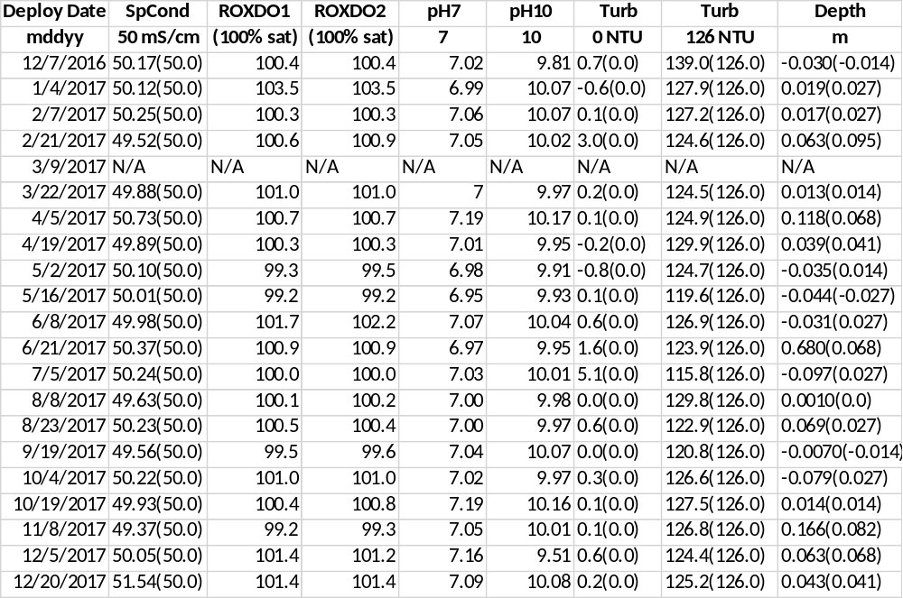

Middle Blackwater River (rkbmbwq)
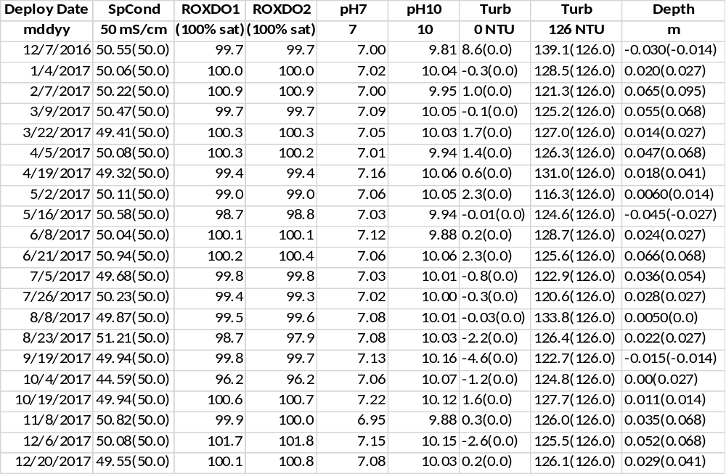

Faka Union Bay (rkbfuwq)
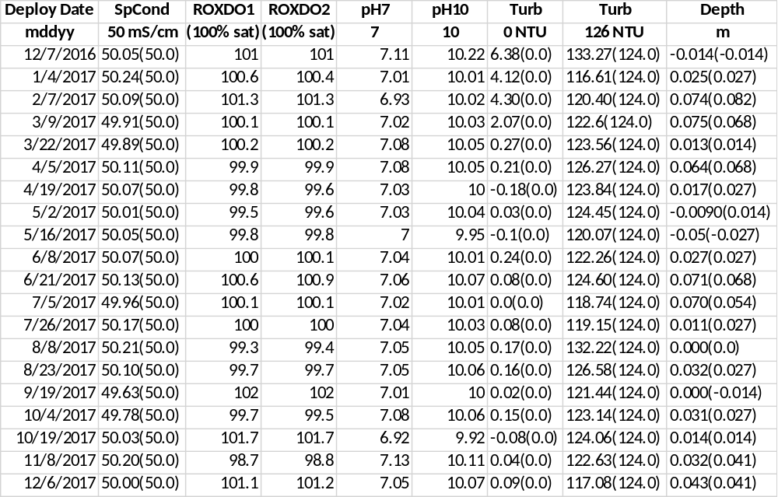
Fakahatchee Bay (rkbfbwq)
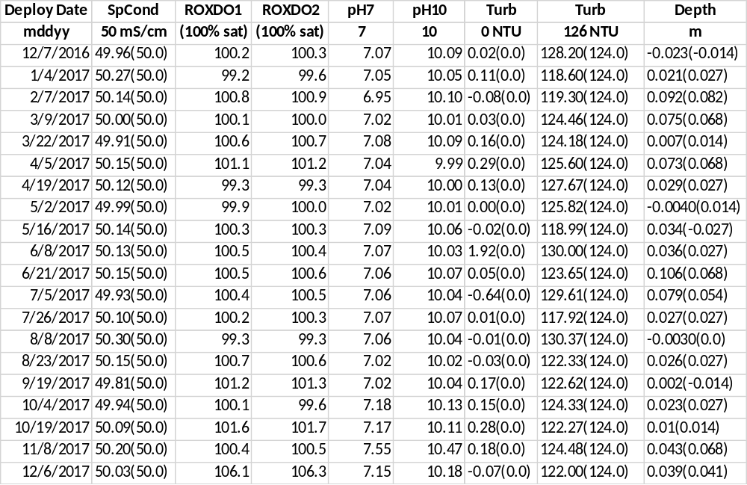

Pumpkin Bay (rkbpbwq)
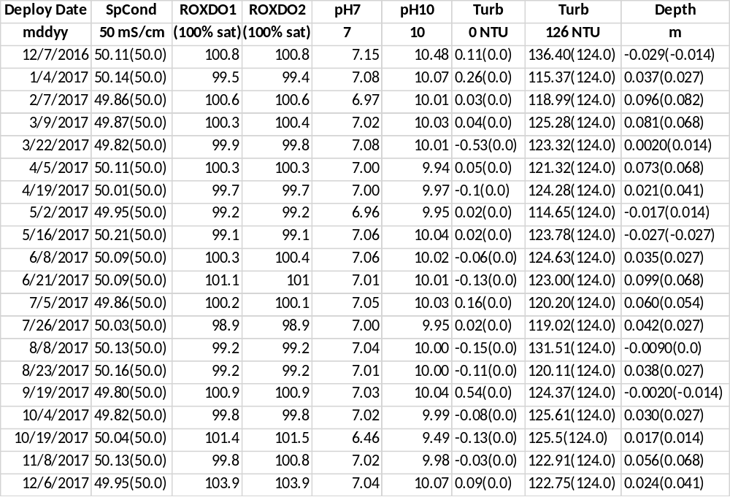

14) Other remarks/notes
Data are missing due to equipment or associated specific probes not being deployed, equipment failure, time of maintenance or calibration of equipment, or repair/replacement of a sampling station platform. Any NANs in the dataset stand for “not a number” and are the result of low power, disconnected wires, or out of range readings. If additional information on missing data is needed, contact the Research Coordinator at the reserve submitting the data.

Lower Henderson Creek (rkblhwq):
From 12/20/2016 19:15 until 01/04/2017 12:45 Turbidity readings were rejected due to drift and a post calibration that was out of range. Biofouling was found on the probe at retrieval. At pre-deployment calibration, the probe calibrated without issue.

For the 010417 deployment, the pH readings were flagged suspect due to a shift in values, low pH slope values and a difference in the field readings. The sonde was replaced for the next deployment and the probe readings and slope adjusted.

From 01/26/2017 13:45 until 02/07/2017 08:15 all Turbidity readings were rejected because of drift caused by algae biofouling on the guard and wiper.

From 03/02/2017 22:45 until 03/09/2017 08:00 all Turbidity readings were rejected because of drift caused by algae biofouling on the guard and wiper.

From 03/09/2017 until 03/22/2017 07:15 SpCond and salinity readings are marked suspect. The precal value for this sonde was 48.72. The sonde deployed during this deployment also had the c/t probe replaced due to a bad port pin.

Turbidity readings from 04/02/2017 04:00 through 05/02/2017 07:15 were rejected due to biofouling, algae growing on probe face and wiper not touching probe face.

From 04/05/2017 07:45 to 04/19/2017 07:30 SpCond and salinity data are marked suspect. The readings here are off compared to the readings surrounding them. The probe used during this deployed was the same probe deployed during the previous deployment. This may have caused the drift or odd readings during this time.

All readings from 04/23/2017 until 05/02/2017 07:15 were flagged suspect from algae growing in the C/T probe and the probe copper guard fell off.

Turbidity readings from 05/10/2017 14:45 through 05/16/2017 07:15 were rejected due to silt on the optics and the wiper not touching all the probe face.

Turbidity readings from 05/16/2017 07:45 through 06/02/2017 15:45 were flagged suspect due to a low 126 FNU post-calibration reading.

Turbidity readings from 06/02/2017 16:00 through 06/08/2017 10:45 were rejected due to biofouling from a guard full of bryozoan and amphipods.

For the 060817 deployment depth was rejected due to blocked depth holes.

On 06/22/2017 from 10:00 through 11:15 the telemetry box brackets were replaced.

From 07/05/2017 07:45 through 07/15/2017 18:45 Turbidity readings were flagged suspect due to a low 126 FNU post-calibration reading.

From 07/15/2017 19:00 through 07/27/2017 10:45 Turbidity readings were rejected due to biofouling from barnacles covering the probe wiper.

On 07/26/2017 the sonde was stuck in the PVC housing and not retrieved.

On 07/27/2017 the sonde PVC housing was removed from the site to retrieve the sonde. Heavy barnacle fouling prevented the sonde from being removed from the housing. A new sonde was deployed on 08/08/2017 11:30.

From 08/15/2017 07:45 through 08/23/2017 06:45 Turbidity readings were rejected due to heavy biofouling of algae on the crab guard mesh.

From 09/09/2017 07:00 until 09/20/2017 10:00 readings were flagged due to hurricane Irma which passed directly over RBNERR on 09/10/2017. The after effects of the hurricane included sewage runoff, increased freshwater runoff and increased detritus matter causing low salinity levels, lower pH, and prolonged low DO.

From 09/11/2017 07:00 through 09/19/2017 08:15 Turbidity readings were flagged for heavy algae covering crab guard mesh.

For the 110817 deployment all pH readings were flagged suspect due to a clear shift in readings at the beginning of the deployment. The post calibration and pre- calibration readings for the next deployment were within acceptance criteria. The cause was unknown.

From 11/15/2017 08:00 until 12/05/2017 09:30 a DO probe malfunction causing 0.0 readings were rejected. All data recorded in-between the malfunction appear to be recorded properly but flagged suspect. The cause was unknown.

For the 120517 deployment the pH readings were flagged suspect due to an out of range post calibration value.

Middle Blackwater River (rkbmbwq):
For all deployments, anomalous Temperature and associated parameter readings that coincide with water depths that occur on or near low tide were flagged -3 GOW CLT.

For all deployments, anomalous SpCond and associated parameter readings that coincide with water depths that occur on or near low tide were flagged -3 SOW CLT.

For all deployments, low SpCond and Salinity readings located directly before or after an out of water event were flagged -3 SOW CSM. These low readings coincide with water depths that occur on or near low tide. The conductivity cells appear to be either completely or partially exposed and not in the water, causing readings that are lower than normally seen.

On 01/04/2017 the PVC tube was replaced between 08:40 and 09:20.

From 04/10/2017 09:15 until 04/13/2017 10:30 the sonde was removed so the piling could be replaced by Collier County. The new piling was at a different depth than the previous piling changing the depth that the sonde sits at this site. From 4/13/2017 10:30 to 12/31/2017 23:45 data is marked 0 GSM CWD. This site is well mixed and data does not appear to have been impacted by this change. After 2017 this is considered the ‘new’ depth for MB.

For the 050217 deployment all Turbidity data were flagged suspect due to a low 126 FNU post-calibration reading.

From 05/15/2017 19:15 until 05/16/2017 08:45 Turbidity readings were rejected due to drift.

For the 051617 deployment the pH readings were flagged suspect due to a post calibration slope of 154.4. The pH probe was replaced for the next deployment.

From 09/09/2017 18:30 until 09/19/2017 08:15 readings were flagged due to hurricane Irma which passed directly over RBNERR on 09/10/2017. The after effects of the hurricane included sewage runoff, increased freshwater runoff and increased organic matter causing low salinity levels, lower pH, and prolonged low DO.

From 09/19/2017 10:45 to 11:30 SpCond and Salinity readings were flagged suspect due to erroneous readings from unknown causes.

From 09/19/2017 08:30 through 10/04/2017 11:00 the after effects of hurricane Irma included sewage runoff, increased freshwater runoff and increased detritus matter causing prolonged low DO readings.

For the 100417 deployment the SpCond and DO readings were flagged suspect due to out of range post calibration values. The pre- calibration readings for the next deployment were within acceptance criteria.

On 12/20/17 from 09:53 - 10:09 the PVC housing was replaced.

Faka Union Bay (rkbfuwq):
On 01/08/2017 08:15 and 08:30 SpCond and Salinity readings were flagged suspect due to heavy rain causing low values.

On 04/13/2017 04:00 the bottom bolt in the sonde housing PVC broke off causing the sonde to fall. The sonde was lifted to the approximate height required until the sonde housing was replaced on 06/22/2017.

During the 060817 deployment the wiper fell off the sonde.

From 06/15/2017 04:30 until 06/21/2017 09:00 Turbidity readings were flagged suspect due to the missing wiper and a buildup of sand and shell in the bottom of the guard.

From 04/13/2017 04:00 through 06/22/2017 13:00 the sonde depth was estimated due to the bottom bolt in the sonde housing tube broke off. The PVC housing was replaced on 06/22/2017 between 13:03 and 13:12.

From 09/09/2017 21:00 until 09/30/2017 23:30 readings were flagged due to hurricane Irma which passed directly over RBNERR on 09/10/2017. The after effects of the hurricane included sewage runoff, increased freshwater runoff and increased detritus matter causing low salinity levels, lower pH, and prolonged low DO.

From 09/11/2017 13:45 through 09/19/2017 11:45 Turbidity readings were flagged suspect due to silt on the probes. The wiper was parked in the housing when the sonde was retrieved.

From 09/29/2017 12:30 through 09/30/2017 01:00 Turbidity readings were flagged suspect due to drift from silt on the probe. The wiper was parked in the housing when the sonde was retrieved.

From 09/30/2017 01:15 through 10/04/2017 09:00 Turbidity readings were rejected due to drift from silt on the probe. The wiper was parked in the housing when the sonde was retrieved.

For the 101917 deployment the pH readings were flagged suspect due to a shift in readings. The cause was unknown.

Fakahatchee Bay (rkbfbwq):
For all deployments, anomalous Temperature and associated parameter readings that coincide with water depths that occur on or near low tide were flagged -3 GOW CLT.

For all deployments, anomalous SpCond and associated parameter readings that coincide with water depths that occur on or near low tide were flagged -3 SOW CLT.

For all deployments, low SpCond and Salinity readings located directly before or after an out of water event were flagged -3 SOW CSM. These low readings coincide with water depths that occur on or near low tide. The conductivity cells appear to be either completely or partially exposed and not in the water, causing readings that are lower than normally seen.

On 01/08/2017 10:00 SpCond and Salinity readings were flagged suspect due to heavy rain causing low values.

The PVC tube was replaced on 02/07/2017 between 10:45 and 11:15.

On 05/03/2017 at 19:53 a funnel cloud was reported. From 05/04/2017 through 05/06/2017 heavy rain with strong SSW winds up to 30 mph occurred.

For the 051617 deployment Turbidity readings were flagged suspect due to low post-calibration 124 FNU reading.

During the 060817 deployment the wiper fell off the sonde.

From 06/18/2017 09:30 until 06/21/2017 09:15 Turbidity readings were flagged suspect due to silt on the probe face.

On 09/06/2017 09:00 the datasonde was removed and not replaced due to approaching hurricane Irma.

From 09/19/2017 12:30 through 10/04/2017 09:00 prolonged low DO readings were due to effects from hurricane Irma.

On 10/04/2017 09:15 – 09:30 the DO readings were rejected due to a clear shift in readings at the end of the deployment.

For the 101917 deployment the DO readings were flagged suspect due to small differences in field readings and surrounding deployment readings. DO Module was replace for the next deployment.

From 11/08/2017 through 11/24/2017 13:45 pH readings were flagged suspect and from 11/24/2017 14:00 until 12/06/2017 08:45 pH readings were rejected due to out of range post calibration value. The pH probe was replaced for the next deployment.

For the 120617 deployment the DO readings were flagged suspect due to out of range post calibration value.

Pumpkin Bay (rkbpbwq):
For all deployments, anomalous Temperature and associated parameter readings that coincide with water depths that occur on or near low tide were flagged -3 GOW CLT.

For all deployments, anomalous SpCond and associated parameter readings that coincide with water depths that occur on or near low tide were flagged -3 SOW CLT.

For all deployments, low SpCond and Salinity readings located directly before or after an out of water event were flagged -3 SOW CSM. These low readings coincide with water depths that occur on or near low tide. The conductivity cells appear to be either completely or partially exposed and not in the water, causing readings that are lower than normally seen.

From 01/04/2017 10:00 through 01/08/2017 03:30 pH readings were flagged suspect due to a shift in values, due to unknow reasons.

From 01/08/2017 03:45 until 10:15 and 01/09/2017 04:30 until 08:45 all data were rejected due to an out of water event from strong northerly winds keeping the low tides out of the bay.

From 02/07/2017 12:15 through 02/17/2017 04:45 readings were not recorded due to an error in programming the deployment start date.

For the 032217 deployment no readings were recorded due to an error in programming the sonde.

During the 040517 deployment the wiper fell off the sonde.

For the 050217 deployment all Turbidity data were flagged suspect due to a low 126 FNU post-calibration reading.

On 09/06/2017 08:30 the datasonde was removed and not replaced due to approaching hurricane Irma.

From 09/19/2017 11:30 through 10/04/2017 10:15 prolonged low DO and low pH readings were due to effects from hurricane Irma.

Weather conditions based on Big Cypress Basin (BCB) Hydrologic Summary and Rainfall Reports:

January: Basin-wide precipitation remained scant last month, although showing much improvement since December. Incoming winter frontal systems generated an average of 1.58 inches across the BCB. However, this total is still below the Basin’s monthly historic weighted average, typically 2.06 inches for January. From a historic perspective, rainfall received last month was also far less than the record 10.6 inches received during this period a year ago.
February: Dry conditions intensified last month, as the impact of the rainfall deficit widened across the Big Cypress Basin [BCB]. Rainfall totals for February remained below par, although an incoming cold front did bring some much needed precipitation towards the end of the month. Rainfall across the BCB was insufficient to top the historic average in February. With one notable exception, arriving around February 23rd, incoming winter frontal systems were generally unproductive in terms of precipitation. The recorded Basin-wide average was 1.25 inches. This tally was 36% below the Basin’s monthly historic weighted average, typically 1.95 inches for February. From a historic perspective, rainfall received last month was also far less than the record 5.14 inches received in 1998.
March: In March, basin-wide precipitation for the month remained sub-par, providing little relief to the dry conditions which have characterized this dry season since last November. For the fifth consecutive month, rainfall across the BCB remained well below the Basin’s historic average. Incoming cold fronts did little to alleviate this deficit which now stands at 2.5 inches for the year. The March recorded Basin-wide average was 0.85 inches. This tally was 61% below the monthly historic weighted average, typically 2.18 inches for the BCB in March. From a historic perspective, rainfall received last month was also far less than the March record 6.10 inches received in 2010.
April: The ongoing dry weather trend across the Big Cypress Basin [BCB] showed some marginal improvement during this past month. Rainfall totals in April saw a modest increase over March, however this uptick was insufficient to alter the Basin-wide dry conditions which have characterized the season thus far. Overall monthly precipitation remained woefully low, helping to spawn numerous wildfires, particularly in the inland areas of Collier County. On a positive note, an incoming frontal system around April 23rd brought some much needed rain, and assisted firefighters in controlling a large forest fire which had developed in southern Golden Gate Estates. For the sixth consecutive month, rainfall across the BCB has been below the Basin’s historic average. Incoming frontal weather systems helped, but did not alleviate this deficit which is now 3.5 inches for 2017. The April recorded Basin-wide average was 1.43 inches, as measured by twenty-two (22) reporting stations (ref. Figures 1, 2, Table 1). This total is still 40% lower than the typical April monthly average, which is 2.38 inches across the BCB. From a historic perspective, rainfall last month was dismally low, in particular when compared to 2010 when a record 5.7 inches fell across the Basin.
May: Dry season weather conditions, having been relentless thus far in 2017, began to abate across the Big Cypress Basin [BCB] in May. Helped by some late-arriving frontal activity, the Basin saw an uptick in rainfall during the second half of the month. In fact, for the first time this year, monthly precipitation was up to par, although these totals remained low in absolute terms, and barely registered in the BCB groundwater levels and canal systems. The unrelenting dry spell over the Lower West coast began to dissipate somewhat in May, which helped boost rainfall totals slightly above the Basin’s historical average. However, the year to date deficit remains considerable, now down 3.3 inches for 2017. The month’s Basin-wide rainfall average was 3.81 inches. This tops the typical May monthly average by 5%, a positive development for the BCB. From a historic perspective, rainfall last month was also within the average, although very modest when compared to 1991 when a record 8.6 inches fell across the Basin
June: Coinciding with the end of May, the dry season conditions across the Big Cypress Basin [BCB] underwent a complete reversal at the beginning of the month. Within the first week of June, some areas of the BCB had received record amounts of rainfall, and by month’s end totals had ramped up dramatically throughout the entire Basin. This abrupt transition into wet season and the associated drenching rainfall can be fairly described as historic, marking this past month as the wettest June over the past twenty-seven (27) years of BCB record-keeping, and the 2nd wettest in the annals of the District, spanning a period of 91 years. The wet conditions in June broke the lengthy dry spell which had gripped the BCB for the previous six months. Basin-wide rainfall average was a record-breaking 21.32 inches for the month. This translates to 132% increase over the typical June monthly average, normally 9.17 inches across the Basin. As previously outlined, this month’s total was the highest ever recorded for the BCB in June, going back to 1990.
July: Following the more dramatic events experienced in June, the weather in July remained generally uneventful, with typical wet season patterns across the Big Cypress Basin [BCB]. However, these conditions did not hold for the entire month, and beginning on the very last day of July, the Lower West Coast became once again the focus of a larger weather system, Tropical Storm EMILY, which dumped over six (6) inches of rain across the BCB, giving a very wet start to the month of August. Boosted by rainfall from the late-arriving Tropical Storm, precipitation was comfortably above par for the month. The basin-wide July average was 11.59 inches, representing a 37% increase over the monthly norm, typically 8.43 inches. Although the Basin experienced exceptionally dry conditions earlier this year, rainfall over the past two months has now been considerable. Cumulative totals for 2017 now tops 41.84 inches, only some 11 inches less than the typical 53 inches expected during an average year. From a historic perspective, the rain totals last month were also significant, although far less than the July 2001 record total of 14.6 inches.
August: The high rainfall events experienced in July continued apace across the Big Cypress Basin [BCB] through the month of August. Basin watersheds still fully staged from Tropical Storm EMILY had little opportunity to recover, as heavy rainfall continued unabated during the following weeks. In the last half of August the BCB began to feel the effects from a low pressure system which had formed off the west coast of Florida. Although it failed to intensify into a named storm, principally due to the influence of Hurricane HARVEY, this weather system (INVEST 92L) dumped significant rainfall over a large swath of central Florida and the Gulf coast. Locally, rainfall across the BCB was heavy, with recorded totals averaging over eight (8) inches by August 28th when the system finally moved north and out of the District. Precipitation was well above the normal average in August. The basin-wide monthly average was 15.21 inches, representing a 64% increase over the 9.27 inches typically collected. Rainfall for the 2017 wet season has thus far been very considerable. The annual cumulative total now tops 56.90 inches, well in excess of the typical 53 inches expected during an average year. From a historic perspective, rainfall this month was similarly record-shattering, surpassing August 1995 which averaged 14.9 inches across the BCB.
September: Events in September were overshadowed by the arrival of Hurricane IRMA. The storm cut a direct path northward through the entire state, traversing from the Keys and exiting through north Florida. Locally, impacts were considerable, with hurricane force winds and significant rainfall across the Lower West Coast and the Big Cypress Basin [BCB]. This event was preceded by an equally wet August, which gave scant opportunity for the BCB watersheds to recover before IRMA made landfall on September 10th. Thus far the 2017 wet season rainfall has been unrelenting, with Basin-wide precipitation totals now well in excess of the typical annual average. As would be expected, canal and groundwater levels experienced significantly high stages during the month, and record amounts of runoff entered the BCB drainage systems from surrounding saturated watersheds. Following a trend uninterrupted since the start of the 2017 wet season, precipitation remained well above the normal average for September. The basin-wide monthly average was 17.49 inches, representing a 106 % increase over the 8.48 inches typically collected. Thus far, the 2017 rainfall total is now 74.1 inches, which also represents a considerable increase (56 %) over the 47.6 inches typically recorded through this period in an average year. Taken from a historical perspective, rainfall this
month was similarly record-shattering and well in excess of 2001, previously the wettest September on record, which had averaged 15.7 inches across the reporting stations of the BCB.
HURRICANE IRMA – SUPPLEMENTAL REPORT:
OVERVIEW:
Hurricane IRMA became the 10th named storm of the 2017 Hurricane Season on August 30th, a status which it maintained through September 12th, two days after making landfall on the lower west coast of Florida. By the first week of September, tropical cyclone activity in the Gulf and Caribbean had shifted into high gear, with three (3) named storms being tracked simultaneously by the NHC, of which two (2) were major (>Cat 3) hurricanes, including IRMA which was directly threatening mainland Florida. The pace of events quickly escalated, and by midweek Thursday, 7th September, after the storm had tracked northwesterly through the Caribbean, the possibility of a south Florida landfall became increasingly obvious - even if certainty over the system’s forecast track remained more elusive. The predicted storm track, initially centered on the east coast, shifted westward, and by Friday 8th had become fully focused on the west coast of Florida. This shift was of great interest to system water managers since it now suggested the possibility of much higher rainfall across the BCB. After first making landfall in the Florida Keys early Sunday, September 10th, IRMA moved northwards finally coming ashore over Collier County on Marco Island at around 3 pm, as a Category 3 Hurricane. Shortly thereafter, the eye of the storm tracked through Naples with maximum sustained winds in excess of 115 mph, and by late evening, had exited northwards into Lee County. Although damages due high winds were considerable, with a maximum gust of 142 mph reported at Naples Airport, the area was spared from a storm surge whose predicted severity (12 ft to 15 ft) would have been devastating to coastal communities. Around Naples, the eventual recorded tidal surge was about 4.25 feet as noted at the Naples Beach Pier, and much less in the interior waterbody of Naples Bay. The tidal fluctuation associated with the passing storm was possibly of greater significance, recording a swing of almost 10 feet on the Gulf-side and 8 feet in the interior, at the US 41 Bridge near Tin City. Rainfall from the event was similarly widespread and significant, followed by equally high runoff which raised canal levels and flooded some portions of the Basin in the storm’s immediate aftermath.
STORM EVENT RAINFALL:
Much of the rain associated with the hurricane occurred as the system moved north across Collier County, such that relatively dry conditions quickly followed within 48 hours of landfall. The RAINDAR rainfall distribution suggests that the heaviest band of precipitation occurred in the inland areas of the County, with more moderate impacts to the coastal zone. Aside from wetter conditions inland, rainfall distribution appears to have been relatively uniform across the localities served by the BCB canal system. To provide further analysis of the rainfall coverage, two BCB stations were selected from the 24-hour and 48-hour dataset which had registered significant rainfall and were deemed representative of the inland and coastal areas of the Basin. These exhibits also confirm that event intensities were highest during the initial phase of the storm and that over 90% of the collected totals occurred within 24 hours of IRMA’s landfall. In the coastal zone, the highest precipitation was recorded at the Collier Government Center Station (COLGOV), and inland at the Immokalee Station (IFAS); the two sites collecting 11.51 inches and 13.60 inches respectively in 24 hours, and 12.39 inches and 14.63 inches within 48 hours. Although maximum recorded intensities were somewhat lower for other BCB sites, the pattern of rainfall intensity was similar, and this may provide suitable guidance from which some useful basin-wide estimates may be drawn. Based on a conservative assessment of this collected data, we can estimate that that most localities within the BCB experienced rainfall intensities in excess of a 25-yr/ 1-day event frequency, and that precipitation frequencies for the 3-day event ranged between a 10-yr and 25-yr return period.
BCB WATERSHED IMPACTS AND RECOVERY:
The intensity and depth of rainfall from IRMA was immediately felt over most areas of Collier County. Water levels in all BCB systems, which had been operationally lowered by a pre-storm draw-down, registered a rapid rise as runoff from the surrounding watersheds quickly filled canals, swales and ditches. By late evening Sunday, and in the early hours of Monday morning, most canals were experiencing historically high stages and soaring discharge rates as this drainage worked its way through all the available conveyances of the system. Control structures which had been kept open throughout the storm were temporarily overwhelmed by high flow volumes, and canals overtopped at many locations throughout the BCB. Even as hurricane force winds began to moderate, left in the wake were downed trees and assorted debris tossed around by the storm, although these impacts turned out to be less consequential to the BCB canal system.
October: Following the dramatic events of September, which included the arrival of Hurricane IRMA, the Big Cypress Basin [BCB] turned relatively quiet in October. Rainfall for the month still bested the average, but weather conditions became noticeably drier as the Basin officially entered Dry Season. Accordingly, the canal operational criteria across the BCB were adjusted to reflect the changed conditions, and all systems were transitioned to optimize water conservation and protect groundwater levels. Signaling the official end of the 2017 Wet Season, precipitation dropped significantly in October. The basin-wide monthly average was 5.30 inches, albeit still more than 50% higher than the 3.40 inches typically collected. Thus far, this year’s accumulated rainfall total is 78.9 inches, a considerable increase (56 %) over the 51 inches normally recorded through this period in an average year. Although respectably above-average, rainfall this month remained far short of the 1995 historic high, when average precipitation recorded was 13.3 inches across the BCB.
November: November was the first full month of dry season, and weather conditions across the Big Cypress Basin [BCB] were the driest of the year. Predictably, water levels in the BCB canals showed a downward trend throughout the month, although most systems continued to track the historical averages. Rainfall across the BCB was well below the norm in November. Basin-wide, the collected average was a dismal 0.31 inches. This represents a significant deficit (83%) from the November historical average, typically 1.78 inches for the month. From a historic perspective, precipitation last month was also far less than the record 7.5 inches received in 1998. However, the accumulated rainfall for 2017 is still at a historic high, 79.9 inches or 51% more than the 52.8 inches typically received through this period in an average year. This is mostly attributable to the wet season rainfall and the impacts from multiple large events earlier in the year.
December: December marked the close of a very active year for the Big Cypress Basin [BCB]. Winter weather patterns held sway and dry conditions persisted throughout the month. Rainfall continued to be slight, generally associated with incoming frontal systems. In a repeat of the previous month, rainfall across the Basin was once again below par in December. The collected average was 1.15 inches, approximately 26% lower than the 1.54 inches typically expected. From a historical perspective, basin-wide precipitation last month was also well below the 5.8 inches received in 1997, a period of record maximum for the Basin. December capped off a record year for rainfall received across the BCB. The final tally from local Basin gage stations topped 81.0 inches, marking 2017 as the wettest year since 1995, the previous record year which barely edged out at 81.4 inches

Acknowledgement: The data included with this document were collected by the staff of the Florida Department of Environmental Protection at the Rookery Bay National Estuarine Research Reserve with funding through NOAA’s Estuarine Research Division. Any products derived from these data should clearly acknowledge this source (please use the attached logos). This recognition is important for ensuring that this long-term monitoring program continues to receive the necessary political and financial support.



