Rookery Bay (RKB) NERR Water Quality Metadata
January – December 2019
Latest Update: March 15, 2021

I. Dataset and Research Descriptors

1) Principal Investigator(s) and Contact Persons
a) Reserve Contacts
Brita Jessen Ph. D., Research Coordinator
Rookery Bay National Estuarine Research Reserve
300 Tower Road
Naples, FL 34113
Tel: (239) 530-5964
Fax: (239) 530-5983
Brita.Jessen@dep.state.fl.us

b) System-Wide Monitoring Technician and Data Management
Julie Brader Drevenkar, Water Quality Program Manager
Rookery Bay National Estuarine Research Reserve
300 Tower Road
Naples, FL 34113
Tel: (239) 530-5965
Fax: (239) 530-5983
Julie.Drevenkar@dep.state.fl.us

2) Entry verification
Deployment data are uploaded from the YSI data logger to a Personal Computer (IBM compatible). Files are exported from EcoWatch in a comma-delimited format (.CDF), EcoWatch Lite in a comma separated file (CSV) or KOR Software in an Excel File (.XLS) and uploaded to the CDMO where they undergo automated primary QAQC; automated depth/level corrections for changes in barometric pressure (cDepth or cLevel parameters); and become part of the CDMO’s online provisional database. All pre- and post-deployment data are removed from the file prior to upload. During primary QAQC, data are flagged if they are missing or out of sensor range. The edited file is then returned to the Reserve for secondary QAQC where it is opened in Microsoft Excel and processed using the CDMO’s NERRQAQC Excel macro. The macro inserts station codes, creates metadata worksheets for flagged data and summary statistics, and graphs the data for review. It allows the user to apply QAQC flags and codes to the data, remove any overlapping deployment data, append files, and export the resulting data file for upload to the CDMO. Upload after secondary QAQC results in ingestion into the database as provisional plus data, recalculation of cDepth or cLevel parameters, and finally tertiary QAQC by the CDMO and assimilation into the CDMO’s authoritative online database. Where deployment overlap occurs between files, the data produced by the newly calibrated sonde is generally accepted as being the most accurate. For more information on QAQC flags and codes, see Sections 11 and 12.
Julie Brader Drevenkar, Water Quality Program Manager, performed data management and reporting.

3) Research objectives
Beginning January 1, 2001, two existing water quality stations, Lower Henderson Creek and Middle Blackwater River were designated as the Reserve’s permanent System-Wide Monitoring Program (SWMP) sites for the National Estuarine Research Reserve Program. Except for turbidity, the dataset at these stations are nearly continuous beginning in April of 1996. The dataset from these monitoring stations represents the longest record of continuous water quality measurements of all the Rookery Bay NERR water quality stations. In January 2002 two additional sites, Faka Union Bay and Fakahatchee Bay, were designated as SWMP water quality stations. A fifth site, Pumpkin Bay, was established in November 2003 to augment the SWMP at Rookery Bay National Estuarine Research Reserve as well as biological, fisheries and shark monitoring data. In October of 2016, the Pumpkin Bay site was designated a Secondary SWMP station. All stations currently record temperature, turbidity, salinity, specific conductance, pH, dissolved oxygen, and depth at 15-minute intervals.
The five stations are in estuaries affected by watersheds demonstrating different patterns of land-use. Their placement addresses priority resource management issues that were identified in the Reserve’s management plan. Specifically, the data from these stations provide valuable information concerning the effects of land-use activities on the quantity, quality and timing of freshwater inflow into the Reserve. Each bay studied demonstrates a different pattern of altered freshwater inflow.
The Lower Henderson Creek station receives most of its freshwater from a canal system that drains a watershed area with approximately 50% developed versus natural landscape. Land-use in the developed area is divided equally between residential and agricultural activities. A weir controls most of the freshwater flowing into Henderson Creek. The Reserve obtained grant funding to upgrade the existing weir structure in May 2002 to allow for an automated control of water release. The dataset being obtained from the Lower Henderson Creek station, along with biological monitoring, and hydrologic modeling may be used to develop a water release strategy for Henderson Creek.
One of our primary study foci is to monitor the effects of the Picayune Strand Restoration Project, which is part of the Comprehensive Everglades Restoration Plan (CERP). Due to a failed housing development (Southern Golden Gate Estates) in the 1960’s, 48 miles of canals were constructed to drain an 85-square mile area. Historically, freshwater flowed southwest from this area via sheet flow into several receiving estuaries in the Ten Thousand Islands region. Restoration work is currently underway to restore a near- natural water flow regime to the watershed and the receiving estuaries. By the end of 2015, two of the four canals have been plugged and pump stations at the upper portion of the canals have been completed. In addition, a manatee mitigation area located off Faka Union Canal, near the Port of the Islands community, was completed in early 2016. In 2019, a majority of the four mile long eastern Stair-Step Canal was being plugged for completion to occur by 2020. Four water quality stations, three Primary SWMP stations (Middle Blackwater River, Faka Union Bay, and Fakahatchee Bay) and one Secondary SWMP station (Pumpkin Bay), were chosen to study the effects of this restoration project (before, during, and after).
The Middle Blackwater River station has a watershed that has 75% natural landscape. Agriculture dominates the land-use activities within the developed area of the Blackwater River watershed. The watershed lies to the west of the Picayune Strand (restoration site). Based on modeling of historic flow-way patterns, the watershed draining into Blackwater River has been significantly reduced resulting in higher than historical salinity values.
The Pumpkin Bay watershed lies directly to the southwest of the Picayune Strand (restoration site). Like Blackwater River, the modeling of historic flow-way patterns, show the watershed draining into Pumpkin Bay has been significantly reduced resulting in higher than historical salinity values.
The Faka Union Bay station is located immediately downstream of the failed housing development and current restoration project. Four canals constructed for the original project converge into one canal (Faka Union Canal) which drains into Faka Union Bay. Consequently, this station represents the most extreme state of altered freshwater inflow of the four monitoring sites in the Ten Thousand Islands. Faka Union Bay experiences lower than historical salinity values and extreme fluctuations in salinity during the wet season.
The Fakahatchee Bay station is the least disturbed system relative to the other sites in the Ten Thousand Islands. The Fakahatchee Bay watershed is primarily under Preserve status and has been relatively undisturbed by the hydrologic alteration of the Southern Golden Gate Estates canal system. The water quality data collected from this station serves as a reference for assessing the effectiveness of the Picayune Strand Restoration Project.

4) Research methods
In August 2016, data loggers at the Faka Union Bay and Fakahatchee Bay sites were upgraded from the YSI 6600 Extended Deployment System (EDS) to the YSI EXO2 model. In October 2016, the data loggers at the Pumpkin Bay site were upgraded and in March of 2018 the Henderson Creek site were also upgraded to the YSI EXO2 model. In January 2003, the Blackwater Creek site was upgraded to the YSI 6600 Extended Deployment System (EDS) model. Prior to deployment, the sondes were calibrated for pH, specific conductivity, turbidity, dissolved oxygen, and depth following the procedures outlined in the YSI Operating and Service Manual. The thermistor accuracy was checked against a NIST calibrated thermometer.
A two-point calibration was used for pH (Biopharm buffer 7, Biopharm buffer 10 starting 7/15/2014) and turbidity [0 NTU (in-house deionized water) & 126 NTU YSI, Inc.]. A 0.5M KCL solution (Biopharm 50 mS/cm conductivity calibrator) was used to calibrate specific conductivity. Dissolved oxygen (DO) was calibrated in oxygen saturated water, using a bucket and an air-stone. ROX optical DO sensors were deployed at all four permanent SWMP sites.
All sondes were deployed within 4-inch diameter PVC tubes, which were attached to “aid-to-navigation” pilings (Lower Henderson Creek, Middle Blackwater River, and Faka Union Bay), or attached to 6 inch PVC pipes hydro-jetted into the substrate (Fakahatchee Bay and Pumpkin Bay). The tubes were oriented vertically and were attached tightly with stainless steel hose clamps and large plastic zip ties. The bottom portion of the tube was open and sat approximately between 15 and 45 centimeters above the bottom. Sensor readings were measured approximately 0.25 to 0.5 meter above the substrate.
Newly restored PVC tubes were deployed at the Faka Union site on 6/13/2018, Pumpkin Bay site on 01/23/2019, Fakahatchee Bay site on 03/06/2019, and the Lower Henderson and Middle Blackwater sites on 10/16/2019. The tubes were built using the “EXO Long Term Monitoring Guide, Vertical Tube Deployments" diagram. Thirty-two 1-inch diameter holes were drilled circumferentially around the lower 0.4 m of the tube and fourteen 2.25-inch diameter holes were drilled 180° apart circumferentially around the upper 1 m of the tube to ensure adequate water flow around the sensors. The bottom two meters of the PVC housing tube were painted inside and outside with anti-fouling paint. Sondes were hung by plastic coated steel cable inside the tubes; the cable was bolted to the piling. At the bottom of the tubes, the sondes sat on a ½” stainless steel eyebolt. A lock was used to secure the sonde inside the housing. By January of 2016, Middle Blackwater (01/07/2016) and Fakahatchee Bay (01/26/2016) PVC tubes were lowered to approximately 0.25 meter off the bottom to reduce the frequency out of water events would occur at low tide.
Previously, PVC tubes with 0.6 m copper end-pieces were deployed on 5/27/2011 at Middle Blackwater River, 6/2/2011 at Lower Henderson Creek, and 6/9/2011 at Faka Union Bay, Fakahatchee Bay, and Pumpkin Bay. The copper end-pieces were added to prevent significant fouling and reduce the need for frequent tube maintenance. The tubes at each station had to be replaced with regular PVC pipes due to the copper end-piece breaking off (brass bolts did not hold up very long). The pipes were replaced on 11/10/2015 at Lower Henderson Creek, 8/18/2016 at Faka Union, 5/17/2012 at Fakahatchee Bay, 5/24/2012 at Middle Blackwater River, and 9/19/2013 at Pumpkin Bay. On 10/16/2012, the Lower Henderson Creek site was revamped with two stainless steel brackets, a PVC pipe with a copper end-piece (attached with bronze bolts), and a locked cap on the top of the pipe. On 12/14/2012 the Faka Union Bay station was revamped with two stainless steel brackets, a PVC pipe with a copper end-piece (attached with bronze bolts), and a locked cap on the top of the pipe.
The sondes were further protected from crabs and other live organisms by attempting to restrict the openings on the sonde guard with plastic mesh screening. The plastic mesh (with 1/8 inch diamond-shaped holes) was slid on the outside of the sonde guards’ circumference. The mesh was held together with lightweight fishing line or small zip ties to be able to maintain a cylindrical shape and slide on and off the guard. Electrical tape was used to secure the mesh at the top and bottom of the guard.
Sondes were deployed for 2 to 4 weeks at a time depending on season. During the heavy fouling season (April through October) the fouling on the sensors can become problematic, therefore several antifouling products (copper tape, copper mesh screens on the pH and C/T sensors, and copper alloy sonde guards) were used on the sensors/sondes. The sampling period was set for 15-minute intervals (readings were made every 15 minutes). The following physical water quality parameters were recorded: temperature (degrees Celsius), specific conductivity (mS/cm), salinity (parts per thousand), dissolved oxygen (mg/l and % saturation), depth (m), pH and turbidity (NTU). To test how well the sondes held calibration, field measurements were performed using a handheld YSI instrument that served as a “spot check” at the time of retrieval. Additionally, a post-deployment calibration was done after the sonde was taken out of the water and brought back to the lab.
A Sutron Sat-Link2 transmitter was installed at the Lower Henderson Creek station on 12/06/06 and transmits data to the NOAA GOES Satellite, NESDIS ID#3B02E17C. (Where 3B02E17C is the GOES ID for that particular station.) The transmissions are scheduled hourly and contained four (4) data sets reflecting fifteen-minute data sampling intervals. Upon receipt by the CDMO, the data undergoes the same automated primary QAQC process detailed in Section 2 above. The “real-time” telemetry data become part of the provisional dataset until undergoing secondary and tertiary QAQC and assimilation in the CDMO’s authoritative online database. Provisional and authoritative data are available at www.nerrsdata.org.
NOTE: All data associated with this metadata file are reported in Eastern Standard Time (EST).

5) Site location & character

Lower Henderson Creek (rkblhwq):

Lat/Long (Decimal Degrees): 26.02749 N, -81.73361 W

The “Lower Henderson” site is located at the mouth of Henderson Creek. The Lower Henderson Creek labeling is to clarify the site from other historical water quality stations. The sonde is affixed to a piling (manatee caution sign) located right of center (while facing downstream) of the creek channel, approximately 100 meters from RKB NERR’s boat dock. The monitoring site is approximately 5 km downstream of a four-lane highway (SR 951) that crosses Henderson Creek. The creek is 5.8 km long (mainstream linear dimension), has an average mid-channel depth of approximately 2 meters at MHW, and an average width of 239 meters. At the sampling site, the depth is 2 meters at MHW and the width is 600 meters. Tides at Lower Henderson Creek are mixed and range from 0.23 m to 1.50 m (average 0.84 m). Salinity at this site ranged from 10.9 to 38.4 ppt during the year. Creek bottom habitats are predominantly fine sand and there is no bottom vegetation. The dominant marsh vegetation near the sampling site is red mangrove. The dominant natural vegetation of the watershed is hydric pine and cypress.
Upland land use near the sampling site includes residential areas with septic systems. Watershed activities that potentially impact the site include non-point source pollution from road runoff, drift of mosquito control pesticides, runoff from upstream agricultural areas and leachate from nearby residential septic systems and a weir structure located at SR 41. The amount of water released from this weir can sometimes mask natural tidal salinity patterns. The historic Henderson Creek watershed was approximately 50% under State ownership and much of this protected area had intact cypress sloughs and other wetland vegetation. Canals and water use for agriculture and human consumption have altered the hydroperiod of this watershed. Consequently, the Henderson creek watershed may receive non-point source pollution runoff from a variety of sources.

Middle Blackwater River (rkbmbwq):

Lat/Long (Decimal Degrees): 25.9343 N, -81.5946 W

The “Middle Blackwater River” sonde is located at the mouth of the river. The Middle Blackwater River labeling is to clarify the site from other historical water quality stations. The sonde is affixed to navigational marker #17 within the river channel. The average depth at this marker is approximately 2 meters at MHW. The tidal range for Middle Blackwater River varies between 0.05 and 1.90 meters (average 0.95 m). Salinity at this site ranged from 5.2 to 39.3 ppt during the year. Salinities fluctuate with the tides and watershed rainfall. The substrate within the channel is a mixture of sand and silt with oyster shell with some organic matter mixed in. Mature red mangrove forests dominate the banks of the river.
Upstream influences consist of the Collier-Seminole State Park boat basin and upstream agricultural fields adjacent to Blackwater River’s main feeder canal (SR 41 canal). Nonpoint source pollution from agricultural operations and golf courses may affect this site. In addition, canals and roads built during the 1960’s (Picayune Strand, formerly Southern Golden Gate Estates) may have caused significant disruptions to overland sheet-flow reducing the amounts of freshwater flowing to this estuary. Despite these alterations, the salinity fluctuations of this site suggest that seasonal fluctuations in salinity are more closely correlated to watershed rainfall patterns than salinities of estuaries with water control structures, such as Henderson Creek.

Faka Union Bay (rkbfuwq):

Lat/Long (Decimal Degrees): 25.9005 N, -81.5159 W

The “Faka Union Bay” sonde is located at the mouth of the Faka Union Canal. The sonde is affixed to a manatee speed zone sign next to the main channel. The average depth at this site is approximately 2 meters at MHW. The tidal range for Faka Union Bay varies between 0.06 and 1.68 meters (average 0.79 m). Salinity at this site ranged from 0.5 to 39.0 ppt during the year. Salinities fluctuate daily with tides, seasonal rainfall, and management of upstream water control structures. The substrate within the channel is a mixture of sand and silt with some organic matter. Mature red mangrove forests and spoil islands dominate the banks of the canal.
Upstream influences consist of the Port of the Islands development and marina. The watershed consists of an elaborate canal system (Picayune Strand, formerly Southern Golden Gate Estates) which has altered natural water drainage patterns into Faka Union Bay.

Fakahatchee Bay (rkbfbwq):

Lat/Long (Decimal Degrees): 25.8922 N, -81.4770 W

The Fakahatchee Bay sonde is located at the mouth of two rivers, Fakahatchee River and East River. The sonde is placed in a 4” PVC housing secured to a 6” PVC pipe. The average depth at MHW is approximately 1.5 meters. The tide range for Fakahatchee varies between 0.00 and 1.84 meters (average 0.80 m). Salinity at this site ranged 8.3 to 40.1 ppt during the year. Salinities fluctuate daily with the tides and seasonal rainfall. The substrate within the channel is a mixture of sand, silt and some organic matter. Mature red mangrove forests dominate the banks of the rivers.
Upstream there are minimal influences from the Picayune Strand State Forest with non-point source pollutants possible from the culverts under I-75 and US 41. Fakahatchee Strand State Preserve and Big Cypress National Park manage the headwaters of Fakahatchee Bay. Fakahatchee Bay’s watershed is considered the least altered.

Pumpkin Bay (rkbpbwq):

Lat/Long (Decimal Degrees): 25.9141 N, -81.5404 W

The site is located at the mouth of the Pumpkin River. The tide range for Pumpkin Bay varies between 0.00 and 1.64 meters (average 0.64 m). Salinity at this site ranged from 12.9 to 39.9 ppt during the year. The bottom habitat is predominantly fine sand and there is no bottom vegetation. Mature red mangrove forests dominate the Pumpkin River and the bay. Upland land use is minimal with the main influence US 41 and the Picayune Strand State Forest canal system, which has diverted freshwater. Typically, this site does not receive enough freshwater inflow.

SWMP Station Timeline
Station Code | SWMP Status | Station Name | Location | Active Dates | Reason Decommissioned | Notes
FB | P | Fakahatchee Bay | 25.8922  -81.477 | 01/01/2002 00:00 -current | NA | NA
FU | P | Faka Union Bay | 25.9005  -81.5159 | 01/01/2002 00:00 –current | NA | NA
LH | P | Lower Henderson Creek | 26.0257  -81.7332 | 01/01/2001 00:00 –current | NA | NA
MB | P | Middle Blackwater River | 25.9343  -81.5946 | 01/01/2000 00:00 –current | NA | NA
PB | S | Pumpkin Bay | 25.9141  -81.5404 | 07/06/2016 00:00 –current | NA | NA
BM | P | Big Marco Pass | 25.979  -81.7375 | 01/01/1997 00:00 - 02/01/1998 00:00 | Funded by temporary grant
BR | P | Blackwater River | 25.9678  -81.5908 | 02/01/1998 00:00 - 12/01/1999 00: | Location/Funding | This station was moved to a more permanent water quality monitoring station downstream. The downstream location, middle Blackwater River, is RBNERR’s long term biomonitoring program. There is hourly background data dating back to 1996. This site was chosen based on its compatible use with the biomonitoring program and stable funds
UH | P | Upper Henderson Creek | 26.049  -81.7012 | 11/01/1996 00:00 - 12/01/2000 00:00 | Funded by temporary grant

6) Data collection period
Water quality data collection at Henderson Creek and Blackwater River began in 1996, while data collection at Faka Union and Fakahatchee began in 2000 and data collection at Pumpkin bay began in November 2003. In 2018, there were 17 deployments at FB, 18 deployments at LH, and 19 deployments at MB, FU, and PB.

Lower Henderson Creek (rkblhwq)
Deployment Start date/time End date/time
120418 12/04/2018 08:30 01/03/2019 08:15
010319 01/03/2019 08:45 02/14/2019 08:15
021419 02/14/2019 08:45 03/06/2019 08:30
030619 03/06/2019 09:00 04/03/2019 06:45
040319 04/03/2019 07:15 04/25/2019 11:15
042519 04/25/2019 11:30 05/08/2019 11:45
050819 05/08/2019 12:15 05/21/2019 11:00
052119 05/21/2019 11:15 06/05/2019 10:45
060519 06/05/2019 11:15 06/20/2019 10:45
062019 06/20/2019 11:15 07/02/2019 06:30
070219 07/02/2019 07:00 07/23/2019 10:45
072319 07/23/2019 11:15 08/06/2019 10:45
080619 08/06/2019 11:15 08/20/2019 10:15
082019 08/20/2019 10:45 09/04/2019 11:15
090419 09/04/2019 11:45 09/19/2019 11:15
091919 09/19/2019 11:45 10/02/2019 11:30
100219 10/02/2019 12:00 10/23/2019 07:15
102319 10/23/2019 08:00 11/06/2019 08:15
110619 11/06/2019 08:30 12/04/2019 08:00
120419 12/04/2019 08:30 12/18/2019 12:00
121819 12/18/2019 12:30 01/08/2020 08:15

Middle Blackwater River (rkbmbwq)
Deployment Start date/time End date/time
120418 12/04/2018 12:15 01/03/2019 12:30
010319 01/03/2019 12:45 01/31/2019 11:45
013119 01/31/2019 12:00 02/14/2019 10:30
021419 02/14/2019 10:45 03/06/2019 14:30
030619 03/06/2019 14:45 04/03/2019 11:00
040319 04/03/2019 11:15 04/25/2019 07:45
042519 04/25/2019 08:00 05/08/2019 07:45
050819 05/08/2019 08:00 05/21/2019 07:30
052119 05/21/2019 07:45 06/05/2019 07:00
060519 06/05/2019 07:45 06/20/2019 07:15
062019 06/20/2019 07:30 07/02/2019 10:30
070219 07/02/2019 11:00 07/23/2019 07:15
072319 07/23/2019 07:30 08/06/2019 09:15
080619 08/06/2019 09:30 08/20/2019 07:15
082019 08/20/2019 07:30 09/04/2019 07:15
090419 09/04/2019 07:45 09/19/2019 09:15
091919 09/19/2019 09:30 10/02/2019 09:30
100219 10/02/2019 10:00 10/23/2019 09:00
102319 10/23/2019 09:30 11/06/2019 10:00
110619 11/06/2019 10:15 12/04/2019 09:45
120419 12/04/2019 10:15 12/18/2019 08:45
121819 12/18/2019 09:00 01/08/2020 13:00

Faka Union Bay (rkbfuwq)
Deployment Start date/time End date/time
120418 12/04/2018 11:00 01/03/2019 11:15
010319 01/03/2019 11:30 02/14/2019 12:00
021419 02/14/2019 12:15 03/06/2019 11:00
030619 03/06/2019 11:15 04/03/2019 09:00
040319 04/03/2019 09:15 04/25/2019 08:45
042519 04/25/2019 09:00 05/08/2019 09:00
050819 05/08/2019 09:15 05/21/2019 08:30
052119 05/21/2019 08:45 06/05/2019 08:15
060519 06/05/2019 08:30 06/20/2019 08:15
062019 06/20/2019 08:30 07/02/2019 09:15
070219 07/02/2019 09:30 07/23/2019 08:15
072319 07/23/2019 08:30 08/06/2019 07:45
080619 08/06/2019 08:00 08/20/2019 08:15
082019 08/20/2019 08:30 09/04/2019 08:30
090419 09/04/2019 08:45 09/19/2019 08:45
091919 09/19/2019 09:00 10/02/2019 08:15
100219 10/02/2019 08:30 10/23/2019 10:00
102319 10/23/2019 10:15 11/06/2019 11:15
110619 11/06/2019 11:30 12/04/2019 11:15
120419 12/04/2019 11:45 01/08/2019 10:30

Fakahatchee Bay (rkbfbwq)
Deployment Start date/time End date/time
120418 12/04/2018 10:30 01/03/2019 10:45
010319 01/03/2019 11:00 02/14/2019 12:30
021419 02/14/2019 12:45 03/06/2019 12:45
030619 03/06/2019 13:30 04/03/2019 09:30
040319 04/03/2019 09:45 04/25/2019 09:00
042519 04/25/2019 09:15 05/08/2019 09:30
050819 05/08/2019 09:45 05/21/2019 08:45
052119 05/21/2019 09:00 06/05/2019 08:45
060519 06/05/2019 09:00 06/20/2019 08:30
062019 06/20/2019 08:45 07/02/2019 08:45
070219 07/02/2019 09:00 07/23/2019 08:45
072319 07/23/2019 09:00 08/06/2019 08:15
080619 08/06/2019 08:30 08/20/2019 08:30
082019 08/20/2019 08:45 09/04/2019 09:00
090419 09/04/2019 09:15 09/19/2019 08:30
091919 09/19/2019 08:45 10/02/2019 07:45
100219 10/02/2019 08:00 10/23/2019 10:30
102319 10/23/2019 10:45 11/06/2019 11:45
110619 11/06/2019 12:00 12/04/2019 11:45
120419 12/04/2019 12:00 01/08/2019 11:15

Pumpkin Bay (rkbpbwq)
Deployment Start date/time End date/time
120418 12/04/2018 11:30 01/03/2019 11:45
010319 01/03/2019 12:00 02/14/2019 03:45
021419 02/14/2019 11:30 03/06/2019 13:45
030619 03/06/2019 14:00 04/03/2019 10:15
040319 04/03/2019 10:30 04/25/2019 08:15
042519 04/25/2019 08:30 05/08/2019 08:30
050819 05/08/2019 08:45 05/21/2019 08:00
052119 05/21/2019 08:15 06/05/2019 07:45
060519 06/05/2019 08:00 06/20/2019 08:00
062019 06/20/2019 08:15 07/02/2019 09:45
070219 07/02/2019 10:00 07/23/2019 08:00
072319 07/23/2019 08:15 08/06/2019 07:15
080619 08/06/2019 07:30 08/20/2019 07:45
082019 08/20/2019 08:00 09/04/2019 08:00
090419 09/04/2019 08:15 09/19/2019 08:00
091919 09/19/2019 08:15 10/02/2019 08:45
100219 10/02/2019 09:00 10/23/2019 09:45
102319 10/23/2019 10:00 11/06/2019 10:45
110619 11/06/2019 11:00 12/04/2019 10:45
120419 12/04/2019 11:00 01/08/2019 12:15

7) Distribution
NOAA retains the right to analyze, synthesize and publish summaries of the NERRS System-wide Monitoring Program data. The NERRS retains the right to be fully credited for having collected and process the data. Following academic courtesy standards, the NERR site where the data were collected should be contacted and fully acknowledged in any subsequent publications in which any part of the data are used. The data set enclosed within this package/transmission is only as good as the quality assurance and quality control procedures outlined by the enclosed metadata reporting statement. The user bears all responsibility for its subsequent use/misuse in any further analyses or comparisons. The Federal government does not assume liability to the Recipient or third persons, nor will the Federal government reimburse or indemnify the Recipient for its liability due to any losses resulting in any way from the use of this data.

Requested citation format:
NOAA National Estuarine Research Reserve System (NERRS). System-wide Monitoring Program. Data accessed from the NOAA NERRS Centralized Data Management Office website: http://www.nerrsdata.org/; accessed 12 October 2020.

NERR water quality data and metadata can be obtained from the Research Coordinator at the individual NERR site (please see Principal Investigators and Contact Persons), from the Data Manager at the Centralized Data Management Office (please see personnel directory under the general information link on the CDMO home page) and online at the CDMO home page www.nerrsdata.org. Data are available in comma delimited format.

8) Associated researchers & projects
As part of the SWMP long-term monitoring program, Rookery Bay NERR also monitors 15-minute meteorological along with monthly grab samples and diel sampling for nutrient data which may be correlated with this water quality dataset. These data are available at www.nerrsdata.org. Both water quality and nutrient data generated by Rookery Bay NERR are being used to analyze restoration targets established for the Picayune Strand Restoration Project (PSRP; formerly known as Southern Golden Gate Estates) which is a portion of the Comprehensive Everglades Restoration Plan (CERP). Additional datasets used in this analysis include a long-term fisheries survey (July 1998 to June 2013, October 2015 to the present), a shark demographics survey (May 2000 to the present), and an oyster reef/benthic crab survey (1999 to 2008). The fisheries data are obtained through monthly trawls in the bays corresponding with the SWMP water quality sites to document the population dynamics in a variety of fish species, as well as commercially important invertebrates such as stone crabs, blue crabs and pink shrimp. Shark demographic data are also collected monthly from the reference bays downstream of the Picayune Strand Restoration Project through long-line and gillnet ‘tag, measure and release’ surveys. Benthic crabs were collected from oyster reefs using Hester-Dendy collection substrates at the four SWMP water quality stations. The water quality data is also used by visiting investigators to support their work within the reserve.

II. Physical Structure Descriptors

9) Sensor specifications
RKB NERR deployed one 6600 EDS data sonde and four EXO2 data sondes in 2019. ROX DO sensors were deployed at MB for all of 2019. EXO2 deployments occurred at LH, FU, FB, and PB.

YSI data sondes in use:
YSI 6600 EDS – V2 (2) data sonde: all deployments at MB starting with 120418 and ending with 072319 and every other deployment at MB starting with 082019 and ending with 120419.

YSI 6600 EDS – V2 (4) data sonde: very other deployment at MB starting with 080619 and ending with 121819.

YSI EXO2 data sonde: all deployments at FB, FU and PB and LH.

YSI 6600EDS Sonde:

Parameter: Temperature
Units: Celsius (C)
Sensor Type: Thermisto
Model#: 6560
Range: -5 to 50 C
Accuracy: +/- 0.15 C
Resolution: 0.01 C

Parameter: Conductivity
Units: milli-Siemens per cm (mS/cm)
Sensor Type: 4-electrode cell with auto ranging
Model#: 6560
Range: 0 to 100 mS/cm
Accuracy: +/- 0.5% of reading + 0.001 mS/cm
Resolution: 0.001 mS/cm to 0.1 mS/cm (range dependent)

Parameter: Salinity
Units: parts per thousand (ppt)
Sensor Type: Calculated from conductivity and temperature
Range: 0 to 70 ppt
Accuracy: +/- 1.0% of reading or 0.1 ppt, whichever is greater
Resolution: 0.01 ppt

Sensor Type: Optical sensor w/ mechanical cleaning
Model#: 6150 ROX
Range: 0 to 500% air saturation
Accuracy: 0-200% air saturation: +/- 1% of the reading or 1% air saturation, whichever is greater 200-500% air saturation: +/- 15% or reading
Resolution: 0.1% air saturation

Parameter: Dissolved Oxygen mg/L (Calculated from % air saturation, temperature, and salinity)
Units: milligrams/Liter (mg/L)

Units: milligrams/Liter (mg/L)
Sensor Type: Optical sensor w/ mechanical cleaning
Model#: 6150 ROX
Range: 0 to 50 mg/L
Accuracy: 0-20 mg/L: +/- 0.1 mg/L or 1% of the reading, whichever is greater
20 to 50 mg/L: +/- 15% of the reading
Resolution: 0.01 mg/L

Parameter: Non-vented Level - Shallow (Depth)
Units: meters (m)
Sensor Type: Stainless steel strain gauge
Range: 0 to 30 ft. (9.1 m)
Accuracy: +/- 0.06 ft. (0.018 m)
Resolution: 0.001 ft. (0.001 m)

Parameter: pH – bulb sensor
Units: pH units
Sensor Type: Glass combination electrode
Model#: 6561
Range: 0 to 14 units
Accuracy: +/- 0.2 units
Resolution: 0.01 units

Parameter: Turbidity
Units: nephelometric turbidity units (NTU)
Sensor Type: Optical, 90-degree scatter, with mechanical cleaning
Model#: 6136
Range: 0 to 1000 NTU
Accuracy: +/- 2% of reading or 0.3 NTU (whichever is greater)
Resolution: 0.1 NTU

YSI EXO2 Sonde:

Parameter: Temperature
Units: Celsius (C)
Sensor Type: CT2 Sensor, Thermistor
Model#: 599870
Range: -5 to 50 C
Accuracy: -5 to 35 C: +/- 0.01 C, 35 to 50 C: +/- .005 C
Resolution: 0.01 C

Parameter: Temperature
Units: Celsius (C)
Sensor Type: Wiped sensor; Thermistor
Model#: 599827
Range: -5 to 50 C
Accuracy: ±0.2 C
Resolution: 0.001 C

Parameter: Conductivity
Units: milli-Siemens per cm (mS/cm)
Sensor Type: Wiped sensor; 4-electrode cell with auto ranging
Model#: 599827
Range: 0 to 100 mS/cm
Accuracy: ±1% of the reading or 0.002 mS/cm, whichever is greater
Resolution: 0.0001 to 0.01 mS/cm (range dependent)

Parameter: Salinity
Units: practical salinity units (psu)/parts per thousand (ppt)
Model#: 599827
Sensor Type: Wiped sensor; Calculated from conductivity and temperature
Range: 0 to 70 ppt
Accuracy: ±2% of the reading or 0.2 ppt, whichever is greater
Resolution: 0.01 psu

Parameter: Dissolved Oxygen % saturation
Sensor Type: Optical sensor w/ mechanical cleaning
Model#: 599100-01
Range: 0 to 500% air saturation
Accuracy: 0-200% air saturation: +/- 1% of the reading or 1% air saturation, whichever is greater 200-500% air saturation: +/- 5% or reading
Resolution: 0.1% air saturation
Parameter: Dissolved Oxygen mg/L (Calculated from % air saturation, temperature, and salinity)
Units: milligrams/Liter (mg/L)
Sensor Type: Optical sensor w/ mechanical cleaning
Model#: 599100-01
Range: 0 to 50 mg/L
Accuracy: 0-20 mg/L: +/-0.1 mg/l or 1% of the reading, whichever is greater
20 to 50 mg/L: +/- 5% of the reading
Resolution: 0.01 mg/L

Parameter: Non-vented Level - Shallow (Depth)
Units meters (m)
Sensor Type: Stainless steel strain gauge
Range: 0 to 33 ft. (10 m)
Accuracy: +/- 0.013 ft. (0.004 m)
Resolution: 0.001 ft. (0.001 m)

Parameter: pH
Units: pH units
Sensor Type: Glass combination electrode
Model#: 599701(guarded) or 599702(wiped)
Range: 0 to 14 units
Accuracy: +/- 0.1 units within +/- 10°C of calibration temperature, +/- 0.2 units for entire temperature range
Resolution: 0.01 units

Parameter: Turbidity
Units: formazin nephelometric units (FNU)
Sensor Type: Optical, 90-degree scatter
Model#: 599101-01
Range: 0 to 4000 FNU
Accuracy: 0 to 999 FNU: 0.3 FNU or +/-2% of reading (whichever is greater); 1000 to 4000 FNU +/-5% of reading
Resolution: 0 to 999 FNU: 0.01 FNU, 1000 to 4000 FNU: 0.1 FNU

Depth Qualifier:
The NERR System-Wide Monitoring Program utilizes YSI data sondes that can be equipped with either vented or non-vented depth/level sensors. Readings for both vented and non-vented sensors are automatically compensated for water density change due to variations in temperature and salinity; but for all non-vented depth measurements, changes in atmospheric pressure between calibrations appear as changes in water depth. The error is equal to approximately 1.02 cm for every 1 millibar change in atmospheric pressure, and is eliminated for vented sensors because they are vented to the atmosphere throughout the deployment time interval.

Beginning in 2006, NERR SWMP standard calibration protocol calls for all non-vented depth sensors to read 0 meters at a (local) barometric pressure of 1013.25 mb (760 mm/hg). To achieve this, each site calibrates their depth sensor with a depth offset number, which is calculated using the actual atmospheric pressure at the time of calibration and the equation provided in the SWMP calibration sheet or digital calibration log. This offset procedure standardizes each depth calibration for the entire NERR System. If accurate atmospheric pressure data are available, non-vented sensor depth measurements at any NERR can be corrected.

In 2010, the CDMO began automatically correcting depth/level data for changes in barometric pressure as measured by the Reserve’s associated meteorological station during data ingestion. These corrected depth/level data are reported as cDepth and cLevel, and are assigned QAQC flags and codes based on QAQC protocols. Please see sections 11 and 12 for QAQC flag and code definitions.

NOTE: older depth data cannot be corrected without verifying that the depth offset was in place and whether a vented or non-vented depth sensor was in use. No SWMP data prior to 2006 can be corrected using this method. The following equation is used for corrected depth/level data provided by the CDMO beginning in 2010:
((1013-BP) *0.0102)+Depth/Level = cDepth/cLevel.

Salinity Units Qualifier:
In 2013, EXO sondes were approved for SWMP use and began to be utilized by Reserves. While the 6600 series sondes report salinity in parts per thousand (ppt) units, the EXO sondes report practical salinity units (psu). These units are essentially the same and for SWMP purposes are understood to be equivalent, however psu is considered the more appropriate designation. Moving forward the NERR System will assign psu salinity units for all data regardless of sonde type.

Turbidity Qualifier:
In 2013, EXO sondes were approved for SWMP use and began to be utilized by Reserves. While the 6600 series sondes report turbidity in nephelometric turbidity units (NTU), the EXO sondes use formazin nephelometric units (FNU). These units are essentially the same but indicate a difference in sensor methodology, for SWMP purposes they will be considered equivalent. Moving forward, the NERR System will use FNU/NTU as the designated units for all turbidity data regardless of sonde type. If turbidity units and sensor methodology are of concern, please see the Sensor Specifications portion of the metadata.

10) Coded variable definitions
Sampling Station: Sampling site code: Station code:

Lower Henderson Creek LH rkblhwq
Middle Blackwater River MB rkbmbwq
Faka Union Bay FU rkbfuwq
Fakahatchee Bay FB rkbfbwq
Pumpkin Bay PB rkbpbwq

11) QAQC flag definitions
QAQC flags provide documentation of the data and are applied to individual data points by insertion into the parameter’s associated flag column (header preceded by an F_). During primary automated QAQC (performed by the CDMO), -5, -4, and -2 flags are applied automatically to indicate data that is missing and above or below sensor range. All remaining data are then flagged 0, passing initial QAQC checks. During secondary and tertiary QAQC 1, -3, and 5 flags may be used to note data as suspect, rejected due to QAQC, or corrected.

-5 Outside High Sensor Range
-4 Outside Low Sensor Range
-3 Data Rejected due to QAQC
-2 Missing Data
-1 Optional SWMP Supported Parameter
0 Data Passed Initial QAQC Checks
1 Suspect Data
2 Open - reserved for later flag
3 Calculated data: non-vented depth/level sensor correction for changes in barometric pressure
4 Historical Data: Pre-Auto QAQC
5 Corrected Data

12) QAQC Code definitions
QAQC codes are used in conjunction with QAQC flags to provide further documentation of the data and are also applied by insertion into the associated flag column. There are three (3) different code categories, general, sensor, and comment. General errors document general problems with the deployment or YSI data sonde, sensor errors are sensor specific, and comment codes are used to further document conditions or a problem with the data. Only one general or sensor error and one comment code can be applied to a particular data point, but some comment codes (marked with an * below) can be applied to the entire record in the F_Record column.

General Errors
GIC No instrument deployed due to ice
GIM Instrument malfunction
GIT Instrument recording error; recovered telemetry data
GMC No instrument deployed due to maintenance/calibration
GNF Deployment tube clogged / no flow
GOW Out of water event
GPF Power failure / low battery
GQR Data rejected due to QA/QC checks
GSM See metadata
Corrected Depth/Level Data Codes
GCC Calculated with data that were corrected during QA/QC
GCM Calculated value could not be determined due to missing data
GCR Calculated value could not be determined due to rejected data
GCS Calculated value suspect due to questionable data
GCU Calculated value could not be determined due to unavailable data

Sensor Errors
SBO Blocked optic
SCF Conductivity sensor failure
SCS Chlorophyll spike
SDF Depth port frozen
SDG Suspect due to sensor diagnostics
SDO DO suspect
SDP DO membrane puncture
SIC Incorrect calibration / contaminated standard
SNV Negative value
SOW Sensor out of water
SPC Post calibration out of range
SQR Data rejected due to QAQC checks
SSD Sensor drift
SSM Sensor malfunction
SSR Sensor removed / not deployed
STF Catastrophic temperature sensor failure
STS Turbidity spike
SWM Wiper malfunction / loss

Comments
CAB* Algal bloom
CAF Acceptable calibration/accuracy error of sensor
CAP Depth sensor in water, affected by atmospheric pressure
CBF Biofouling
CCU Cause unknown
CDA* DO hypoxia (<3 mg/L)
CDB* Disturbed bottom
CDF Data appear to fit conditions
CFK* Fish kill
CIP* Surface ice present at sample station
CLT* Low tide
CMC* In field maintenance/cleaning
CMD* Mud in sensor guard
CND New deployment begins
CRE* Significant rain event
CSM* See metadata
CTS Turbidity spike
CVT* Possible vandalism/tampering
CWD* Data collected at wrong depth
CWE* Significant weather event

13) Post deployment information:

Lower Henderson Creek (rkblhwq):
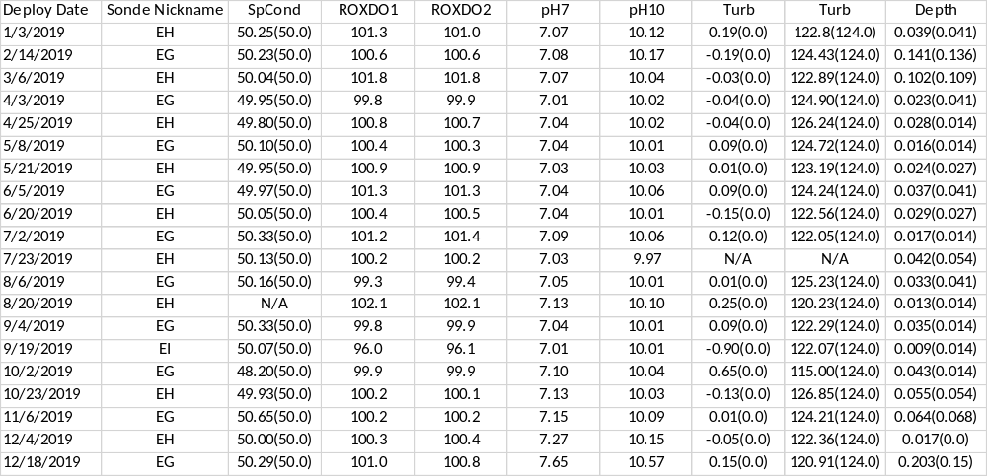

Middle Blackwater River (rkbmbwq):
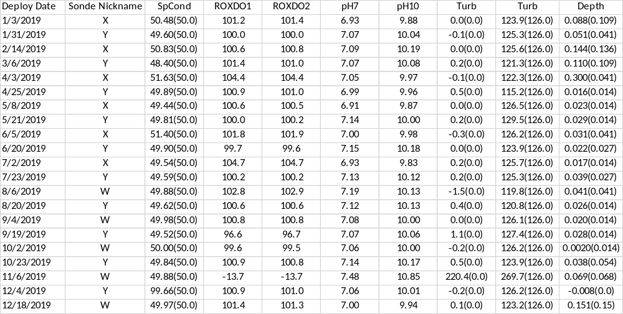

Faka Union Bay (rkbfuwq):
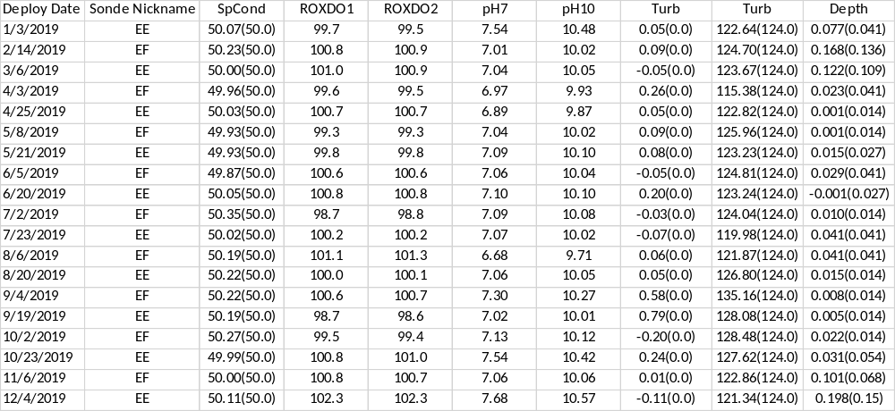

Fakahatchee Bay (rkbfbwq):
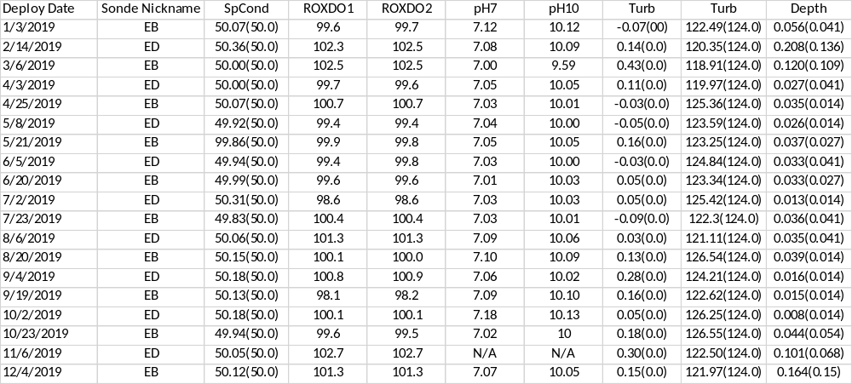

Pumpkin Bay (rkbpbwq):
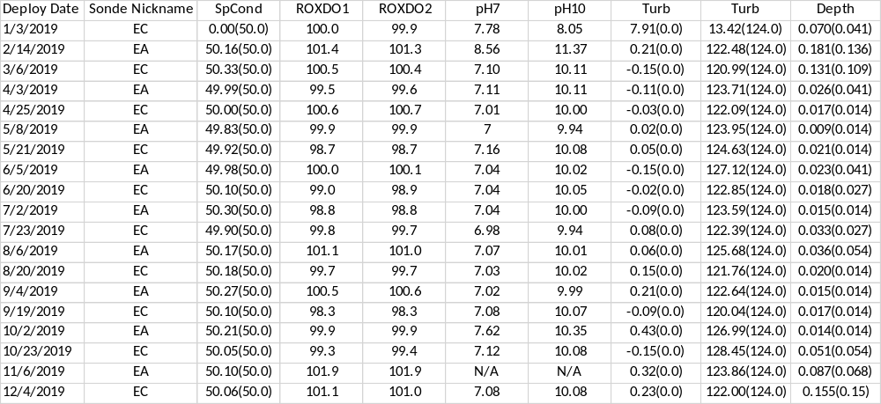

14) Other remarks/notes
Data are missing due to equipment or associated specific sensors not being deployed, equipment failure, time of maintenance or calibration of equipment, or repair/replacement of a sampling station platform. Any NANs in the dataset stand for “not a number” and are the result of low power, disconnected wires, or out of range readings. If additional information on missing data is needed, contact the Research Coordinator at the reserve submitting the data.

For all water quality sites where random Conductivity/ salinity readings dipped throughout the deployment, the readings were flagged along with associated parameters.

Lower Henderson Creek (rkblhwq):
On 03/21/2019 from 09:30 - 09:45 readings were rejected due to replacing the PVC tube. Fouling was also cleaned off the outside of the sonde.

During the 072319 deployment the turbidity sensor stopped working. YSI reviewed the .bin file and found no reason for the malfunction. The probe was replaced for the next deployment.

From 09/01/2019 18:00 until 09/04/2019 11:15 the C/T probe stopped working. The sonde probe port was not recognizing any probe and the probe itself was not working. The sonde and probe were replaced for the next deployment.

On 10/30/2019 09:00 readings were rejected due to replacing the PVC tube.

For the 121819 deployment the pH sensor readings were rejected due to calibration diagnostics were out of acceptance criteria. YSI confirming cause of sensor malfunction possibly from a bad pH module lot.

Middle Blackwater River (rkbmbwq):
For all deployments, anomalous Temperature and associated parameter readings that coincide with water depths that occur on or near low tide were flagged -3 GOW CLT.

For all deployments, anomalous SpCond and associated parameter readings that coincide with water depths that occur on or near low tide were flagged -3 SOW CLT.

For all deployments, low SpCond and Salinity readings located directly before or after an out of water event were flagged -3 SOW CSM. These low readings coincide with water depths that occur on or near low tide. The conductivity cells appear to be either completely or partially exposed and not in the water, causing readings that are lower than normally seen.

For the 120418 deployment DO was flagged suspect due to the wiper fell off during the deployment.

From 02/13/2019 02:30 through 02/14/2019 10:30 the DO readings were flagged suspect due to drift after a rain event in the area.

From 03/02/2019 until 03/06/2019 the DO reading were rejected due to a malfunctioning sensor. The wiper was not parked correctly at post calibration. The ODO sensor was replaced for next deployment.

From 04/03/2019 11:15 until 04/04/2019 13:45 the pH readings were rejected due to significant difference from the field reading.

During the 060319 deployment, the DO and Turbidity readings were rejected due to a malfunctioning Turbidity sensor. The Turbidity sensor was replaced for the next deployment.

On 10/30/2019 from 11:00 – 11:15 readings were rejected due to replacing the PVC tube.

During the 110619 deployment, the DO, SpCond/Salinity, Turbidity and pH readings were rejected due to a malfunctioning ODO sensor. The ODO sensor was replaced for the next deployment.

Faka Union Bay (rkbfuwq):
For all deployments, anomalous Temperature and associated parameter readings that coincide with water depths that occur on or near low tide were flagged -3 GOW CLT.

For all deployments, anomalous SpCond and associated parameter readings that coincide with water depths that occur on or near low tide were flagged -3 SOW CLT.

For all deployments, low SpCond and Salinity readings located directly before or after an out of water event were flagged -3 SOW CSM. These low readings coincide with water depths that occur on or near low tide. The conductivity cells appear to be either completely or partially exposed and not in the water, causing readings that are lower than normally seen.

For the 010319 deployment the pH readings were flagged suspect or rejected due to a post calibration out of range. pH module was replaced for next deployment.

During the 080619 deployment the pH sensor readings were rejected due to a high pre calibration diagnostic reading and an out of range post calibration for the 090419 deployment. The probe was replaced for the 100219 deployment. YSI confirming cause of sensor malfunction possibly from a bad module lot.

During the 090419 deployment the pH sensor readings were rejected due to an out of range post calibration reading. The probe was replaced for the 100219 deployment. YSI confirming cause of sensor malfunction possibly from a bad module lot.

For the 102319 deployment the pH sensor readings were rejected due to calibration diagnostics were out of acceptance criteria. The pH sensor was replaced for the next deployment. YSI confirming cause of sensor malfunction possibly from a bad pH module lot.

For the 120419 deployment the pH sensor readings were rejected due to calibration diagnostics were out of acceptance criteria. YSI confirming cause of sensor malfunction possibly from a bad pH module lot.

Fakahatchee Bay (rkbfbwq):
For all deployments, anomalous Temperature and associated parameter readings that coincide with water depths that occur on or near low tide were flagged -3 GOW CLT.

For all deployments, anomalous SpCond and associated parameter readings that coincide with water depths that occur on or near low tide were flagged -3 SOW CLT.

For all deployments, low SpCond and Salinity readings located directly before or after an out of water event were flagged -3 SOW CSM. These low readings coincide with water depths that occur on or near low tide. The conductivity cells appear to be either completely or partially exposed and not in the water, causing readings that are lower than normally seen.

For the 010319 deployment DO was flagged suspect due to a significant difference from the field readings. Sensor membrane was replaced for next deployment.

On 03/06/2019 from 13:00 – 13:15 readings were missing due to replacing the PVC tube.

On 03/06/2019 at 13:30 Turbidity was rejected due to a high reading most likely from replacing the PVC tube.

During the 030619 deployment the wiper fell off.

For the 030619 deployment Conductivity/ salinity readings were flagged suspect due to random readings that dipped throughout the deployment. The unusual readings were rejected along with associated parameters. The cause is suspected to be due to the missing wiper.

For the 030619 deployment the pH sensor post calibration diagnostics were out of acceptance criteria due to a tunicate growing on the face of the probe. The field data matched up and post calibration after cleaning the probe passed.

For the 100219 deployment the pH sensor post calibration diagnostics were out of acceptance criteria. The field data matched up. YSI confirming cause of sensor malfunction possibly from a bad pH module lot.

For the 110619 deployment the pH sensor readings were rejected due to pre calibration diagnostics were out of acceptance criteria and no replacement probe was available. YSI confirming cause of sensor malfunction possibly from a bad pH module lot.

Pumpkin Bay (rkbpbwq):
For all deployments, anomalous Temperature and associated parameter readings that coincide with water depths that occur on or near low tide were flagged -3 GOW CLT.

For all deployments, anomalous SpCond and associated parameter readings that coincide with water depths that occur on or near low tide were flagged -3 SOW CLT.

For all deployments, low SpCond and Salinity readings located directly before or after an out of water event were flagged -3 SOW CSM. These low readings coincide with water depths that occur on or near low tide. The conductivity cells appear to be either completely or partially exposed and not in the water, causing readings that are lower than normally seen.

On 01/23/2019 from 08:45 – 9:15 readings were rejected due to replacing the PVC tube.

From 02/13/2019 20:45 until 02/14/2019 03:45 all readings were rejected due to a C/T sensor failure. The sensor was replaced for next deployment.

From 02/14/2019 04:00 until 02/14/2019 11:15 missing readings were due to a C/T sensor failure. The sensor was replaced for next deployment.

During the 021419 deployment the pH readings were rejected due to a probe malfunction. The pH tip was replaced for the next deployment.

For the 100219 deployment the pH sensor post calibration diagnostics were out of acceptance criteria. YSI confirming cause of sensor malfunction possibly from a bad pH module lot.

For the 110619 deployment the pH sensor readings were rejected due to calibration diagnostics were out of acceptance criteria and no replacement probe was available. YSI confirming cause of sensor malfunction possibly from a bad pH module lot.

2019 weather conditions based on Big Cypress Basin (BCB) Hydrologic Reports:

January: January rainfall was well above average for the Basin ending the month around 185% of average. The majority of the rainfall occurred during a 3 day rainfall the last weekend of the month. The storm brought beneficial rainfall which increased canal levels across the Basin. January's rainfall was sufficient to bring the Basin out of drought conditions. Meteorologists are anticipating a higher potential for above average rainfall in the 3-month outlook which would be beneficial as the dry season continues. January was an above average dry season month in terms of rainfall and was almost twice the historical average. The basin-wide monthly average was 3.88 inches, which is 185% of the normal 2.10 inches typically collected. Based on collected gage data, rainfall distribution across all BCB localities was very consistent in January.
February: February continued the Basin’s above average rainfall trend for the year. Rainfall was above average for the Basin ending the month around 130%of average. Similarly, to January, the majority of the rainfall occurred during a single rainfall event towards the end of the month. The storm brought more beneficial rainfall which increased canal levels across the Basin. February’s above average rainfall kept the Basin out of drought territory as indicated in the latest Drought Monitor summary. Meteorologists are anticipating equal chances for above and below average for the next 30 days. However, the 3 month forecast continues to show higher than normal chances for above average rainfall for April and May. February was an above average season month in terms of rainfall and was about 30% higher than the historical average. The basin-wide monthly average was 2.42 inches, which is 131% of the normal 1.85 inches typically collected.
March: March was a fairly average month in terms of rainfall for the Basin. March rainfall came in at around 80% of average for the month, however 2019 so far is above average at 133% of normal. The majority of the rain fell in one event near the middle of the month. The rain event did occur although not with as much vigor as predicted. Meteorologists are anticipating above average chances for rainfall for the next 30 days. Also, the 3 month long term forecast continues to show higher than normal chances for above average rainfall for April, May, and June. The basin-wide monthly average was 1.67 inches, which is 80% of the normal 2.06 inches typically collected. Based on collected gage data, rainfall distribution across all BCB localities was mixed in March.
April: April was a calm month in terms of rainfall for the Basin. April rainfall came in around 78% of average for the month, however 2019 so far is slightly above average at 118% of normal. Meteorologists are anticipating above average chances for rainfall for the next 30 days. Also, the 3 month long term forecast no longer shows an above average chance for higher than average rainfall. Most of Florida now has equal chances for above or below average rainfall for June, July, and August. The basin-wide monthly average was 1.80 inches, which is 78% of the normal 2.25 inches typically collected.
May: May was relatively normal for a transition month into wet season. The monthly rainfall was slightly below normal at 88%. May is now the third consecutive month with below average rainfall for the Basin. Even with this trend, the Basin is still running a slight surplus of rainfall for 2019 at 108% of normal. Most water levels continued the downward trend and ended the month below wet season levels but above the 50th percentile, which positions the Basin nicely for the upcoming rain season. Meteorologists are anticipating equal chances for above or below average rainfall for the next 30 days. Also, the 3 month long term forecast continues the equal chances for above or below average rainfall for all of Florida. The basin-wide monthly average was 3.58 inches, which is 88% of the normal 4.06 inches typically collected.
June: Wet season conditions developed across the Big Cypress Basin throughout June as compared to May. A typical summer daily pattern of scattered afternoon and evening thunderstorms accounted for June rainfall. As the month ended, rainfall totals across the Basin were just above the historic average coming in at 10.3 inches. Meteorologists are anticipating equal chances for above or below average rainfall for the next 30 days. Also, the 3 month long term forecast continues the equal chances for above or below average rainfall for all of Florida. June was just above average in terms of rainfall reporting and at about 105% of normal. the basin-wide monthly average was 10.27 inches, which is 105% of the normal 9.73 inches typically collected. Based on collected gauge data, rainfall distribution across all BCB localities showed higher levels of rainfall in the middle region of the basin from the southwest (Marco Island) to north (Bird Rookery). The coastal areas and far eastern areas had smaller totals. The month’s highest total was collected at Rookery Bay (Site R-10), which received 15.64 inches. The lowest rainfall was recorded at two stations Ave Maria (Site R-20) and GG-7 (Site R-22) with 7.24 inches.
July: Wet season conditions persisted across the Big Cypress Basin throughout July. A typical summer daily pattern of scattered afternoon and evening thunderstorms accounted for July rainfall. As the month ended rainfall totals across the Basin were practically the same as June’s rainfall and just above the historic average coming in at 10.3 inches. Looking forward, meteorologists are forecasting a slightly elevated chance for above average rainfall for south Florida for the next 30 days. The 3 month long term forecast shows equal chances for above or below average rainfall for all of Florida. July was a bit above average in terms of rainfall reporting and ended the month at 120% of normal. The basin-wide monthly average was 10.3 inches, which is 120% of the normal 8.6 inches typically collected.
August: Typical wet season conditions persisted across the Big Cypress Basin throughout most of August. A typical summer daily pattern of scattered afternoon and evening thunderstorms accounted for the majority of August rainfall with two notable events. As August started, a tropical wave was approaching South Florida which was forecast to bring significant widespread rainfall (5”-7”) across the Basin. The actual rainfall totals were drastically lower (~2 inches) than forecasted amounts. As the month came to a close, all attention was diverted towards Hurricane Dorian. South Florida was first shown in probable path of Dorian on August 26th at which time it was forecast to be a tropical storm. As the storm matured, it mostly missed Hispaniola and Puerto Rico which allowed it to rapidly intensify into a major hurricane. On August 30th, it was forecast to make landfall somewhere from the Florida Keys to South Carolina as a Category 4 storm. Given the uncertainty of the path, BCB along with all other portions of the District made some pre-storm operations in anticipation of the event. As the storm slowed forward movement, it started turning north and the risk to BCB, but not to other parts of Florida and Bahamas, significantly decreased. As September started, the storm began tracking off the east coast of Florida avoiding widespread impacts to Florida, but left a devasting wake through parts of the Bahamas. Looking forward, meteorologists are forecasting an elevated chance for above average rainfall for south Florida for the next 90 days. August ended the month at 101% of normal. The basin-wide monthly average was 10.03 inches, which is 101% of the normal 9.98 inches typically collected.
September: September started with Hurricane Dorian moving just off-shore the eastern coast of Florida. The District and Basin were largely spared any significant impacts from the storm. A significant dry period followed the passing of Hurricane Dorian and Hurricane Humberto (which moved through mid-month), both of which stayed east of Florida. This dry period brought an abrupt transition from wet season to dry season. The dry period was so prolongated that the month ended as the driest September on record (1990-2019) for the Basin and for the entire District (1932-2019). The BCB system transitioned about one month earlier than normal to dry season settings to conserve water. Looking forward, meteorologists are forecasting an elevated chance for above average rainfall for south Florida for the next 30 days and equal chances for above, below, or average rainfall for following 90 days. September ended the month at 26% of normal. The basin-wide monthly average was 2.39 inches, which is 26% of the normal 9.04 inches typically collected.
October: October was a transition month in terms of weather for the Basin. There were 3 notable wet periods associated with some wet season and dry season style events during October. First, was a stalled front that brought enhanced rainfall in early October. Second was Tropical Storm Nestor which came ashore mid-month in the panhandle. Nestor did bring beneficial rain to the Basin. Lastly, there was a late season tropical wave that enhanced rainfall at the end of the month. The month concluded with just above average rainfall. Looking forward, meteorologists are forecasting an equal chances for above average, average, or below average rainfall for south Florida for the next 30 days and 90 days. October was a fairly average month for rainfall and ended the month at 108% of normal. The basin-wide monthly average was 3.8 inches, which is just above the average 3.5 inches typically collected.
November: November was a typical dry season month with mostly pleasant dry weather patterns. The small amount of rain that did fall was a result of passing cold fronts. Looking further ahead into the dry season, the 30 day outlook is calling for below average rainfall and the 3 month outlook for January, February, and March is indicating equal chances for above, average, or below normal rainfall. November continued the mostly average rainfall pattern and ended the month at 88% of normal. The basin-wide monthly average was 1.4 inches, which is just below the average 1.6 inches typically collected.
December: December’s above average rainfall was very atypical for dry season and was the third wettest December on record for the Basin. The majority of the rain occurred with storm systems on December 12th, 18th, and 22nd. The remainder of the month had sporadic light rain showers. The forecasted rainfall for the December 22nd storm was significant, with 3 inches average and 6 inch local maximum. While the forecasted amount did not occur, the Basin did receive a very beneficial 2 inch average rainfall with that event. It’s worth noting that overnight on December 22nd, portions of the east coast received 9 inches in about four hours. Total 2019 Basin rainfall came in at 56.0 inches or 99% of the Basin’s average 56.6 inches. Even with the extremely average total rainfall, January, September, and December totals are notable compared to typical rainfall. Looking forward, the 30 day outlook and 3 month outlook for February, March, and April are indicating equal chances for above, average, or below normal rainfall. Rainfall in December halted the near average rainfall pattern and ended the month at 264% of normal. The basin wide monthly average was 4.47 inches, which is more than twice the average 1.69 inches typically collected.

Acknowledgement: The data included with this document were collected by the staff of the Florida Department of Environmental Protection at the Rookery Bay National Estuarine Research Reserve with funding through NOAA’s Estuarine Research Division. Any products derived from these data should clearly acknowledge this source (please use the attached logos). This recognition is important for ensuring that this long-term monitoring program continues to receive the necessary political and financial support.



