Working Title: Trends and variability in chlorophyll *a* in a back-barrier lagoonal estuary in the southeastern United States

Shannon D. Kimmel*, Nicole Dix

Guana Tolomato Matanzas National Estuarine Research Reserve, Ponte Vedra Beach, FL 32082

*Corresponding author: [Shannon.Dunnigan@dep.state.fl.us](mailto:Shannon.Dunnigan@dep.state.fl.us)

ORCID:

Keywords: chlorophyll-a, Generalized Additive Model, Time Series, Phytoplankton variability, Estuaries

# Abstract

[providing space here]

# Introduction

Effective management of coastal ecosystems to sustain current status or to mitigate impacts requires information on how these systems have changed over time. This is especially true to differentiate between anthropogenic impacts and natural variability within these systems. Estuaries, the natural buffer zone between rivers and ocean, are often some of the most vulnerable ecosystems as their watersheds are much larger than their area. The problem of nutrient enrichment and pollution in coastal environments is growing worldwide, particularly as populations increase in these watersheds and more of the upland habitats are developed for residential, urban, or industrial complexes (Freeman et al. 2019; Kyzar et al. 2021).

**Nutrient enrichment alters coastal ecosystems often first with increases in algal production and biomass (CITATION?)** and the response of these systems is quite variable over space and time (Cloern and Jassby 2010). Anthropogenic impacts are not the only the primary drivers in these systems as climate also plays a large role in long-term conditions. In the Chesapeake Bay, precipitation and tropical cyclone activity results in variable phytoplankton production coupled with underlying increases in chlorophyll *a* (a common proxy for phytoplankton biomass) due to eutrophication (Harding et al. 2016). In the Indian River Lagoon and St. Lucie estuaries, variability in phytoplankton blooms have been attributed to cyclical patterns (e.g. El Niño/La Niña periods) and tropical cyclone events, typically as these events bring large amounts of precipitation (Phlips et al. 2020; Phlips et al. 2021). There are also systems, like the San Francisco estuary which, though nutrient-enriched, do not experience water quality impacts common to other enriched systems (like frequent phytoplankton blooms or low dissolved oxygen) attributed to a variety of variables such as strong tidal flushing and heavy phytoplankton grazing pressure from bivalves (Jassby 2008; Cloern and Jassby 2010; Cloern 2019). Additionally, the issue of nutrient pollution is not isolated to developed watersheds as even watersheds with low levels of development have been found to exhibit high levels of nutrient and chlorophyll *a* concentrations, such as the tidal creeks in the Ashepoo-Combahee-Edisto Basin in South Carolina (Keppler et al. 2015). Therefore the use of observational information from long-term research and monitoring programs provides the most valuable information for place-based and adaptive strategies in the management of coastal ecosystems.

The System-Wide Monitoring Program (SWMP) of the National Estuarine Research Reserve System (NERRS) is an established long-term monitoring program that has been a cornerstone of the NERRS since its inception in 1995. The SWMP utilizes standardized equipment and protocols to collect high-frequency and continuous water quality and meteorological data in a variety of estuarine environments across the United States and Puerto Rico. Due to the standardization of the program, and its well-developed and documented data management protocols for quality assurance and quality control, it serves as an excellent resource for helping to identify trends, patterns, and scales of variability in phytoplankton dynamics as well as their potential drivers within estuarine environments (System 2022).

One of thirty NERRS nationwide, three of which exist in Florida, the Guana Tolomato Matanzas National Estuarine Research Reserve (GTMNERR) has collected long-term data on water quality and meteorological conditions in the Guana-Tolomato-Matanzas (GTM) estuary since 2002. The GTM is a bar-built estuary with enclosed lagoons “rivers” (the Guana, Tolomato, and Matanzas) that trifurcate at the St. Augustine Inlet (Figure 1). The St. Augustine Inlet is one of two inlets in this system and it is stabilized with a jetty and maintained by the US Army Corps of Engineers to a depth of 5-m and the other, the Matanzas Inlet, is one of Florida’s few remaining unstructured inlets on the Atlantic Coast (Dean and O’Brien 1987). Overall, the GTM estuary is a well-mixed and well-flushed estuary with an absence of a freshwater river and a short residence time of approximately 12.6 days (Phlips et al. 2004; Sheng et al. 2008; Gray et al. 2021). The estuary is within a temperate-subtropical climatic ecotone dominated by salt marsh and mangrove habitats, intertidal oyster reefs, tidal creeks, mud flats, and open water (Williams et al. 2014; Bacopoulos et al. 2019). The GTM estuary hosts exceptionally intact and robust populations of eastern oysters (*Crassostrea virginica*) that filter ~60% of the estuary’s volume within a single residence time (Gray et al. 2021). It is likely these filtration services coupled with the short residence times keep phytoplankton biomass low (Dix et al. 2013; Hart et al. 2015).

Cloern and Jassby (2010) provided a conceptual framework for establishing and comparing variability in chlorophyll *a* by investigating 84 estuarine-coastal sites and established underlying patterns in site-specific relative importance of disturbance, annual climate cycles, and levels of nutrient enrichment. For example, sites with regular seasonal patterns in chlorophyll *a* were found to largely be driven by annual cycles such as bivalve grazing pressure which oscillate over the annual temperature cycle. Sites with large annual variability were commonly attributed to disturbance from natural events (e.g. hurricanes) or human actions (implementation of policies that reduced nutrient input into waterways). This study uses the established long-term monitoring framework of the NERRS SWMP to establish trends, patterns, and scales in variability of chlorophyll *a* for a 20-year time period (2003-2022).

The GTM estuary has previously been described as similar to other temperate estuaries along the southeastern United States in physiochemical variability with factors such as temperature and salinity (Apple et al. 2008). Patterns in community structure and seasonality of ichthyoplankton ingression have also been found to resemble those of temperate, tidally-influenced estuaries such as North-Inlet, South Carolina (Korsman et al. 2017). In Cloern and Jassby (2010), North-Inlet was one of the 84 sites in which strong seasonal patterns were connected with filtration rates of native oyster populations. Dix et al. (2013) previously described bivalve grazing pressure from oysters and high tidal exchange supporting small inter-annual variability in chlorophyll *a* in the GTM estuary. Therefore, coupled with low residence times it is hypothesized that chlorophyll *a* patterns in the GTM estuary over two decades would exhibit low inter- and intra-annual variability. However, as is common around the coastal US, there has been a significant increase in coastal population density pressure in the region (Kyzar et al. 2021). Coupled with the changes in the watershed, increases in chlorophyll *a* concentrations are expected over time.

# Methods

## Study Area

The SWMP of the GTMNERR operates and maintains four water quality stations equipped with YSI EXO2 sondes, deployed within one meter of the bottom, that record environmental parameters (e.g. temperature, salinity) every 15-minutes. It is at these stations in which monthly water samples are collected during an ebb tide for chlorophyll *a* and a suite of other parameters such as nitrogens, phosphorus, bacteria, and total suspended solids.

Established in 2002, the station locations were selected to represent the influence of watersheds with varying degrees of urban development and reflect a diversity of physical processes (e.g., tidal exchange, freshwater input) and climatic conditions (Figure 1). Pine Island (PI) is located off of channel marker 25 in the Tolomato River surrounded by silviculture-dominated uplands in the northern portion of the GTM estuary. The Guana River runs parallel to the Tolomato on the seaward side, with the two lagoons joining 11.3-km north of the St. Augustine Inlet, approximately X-km south of the PI station. The Tolomato River Basin converges with the Matanzas River and Salt Run from the south before flowing into the Atlantic Ocean at the St. Augustine Inlet.

San Sebastian (SS) is located at the confluence of the San Sebastian and Matanzas Rivers. The San Sebastian River drains an urbanized watershed in the western portion of St. Augustine. The Matanzas River estuary is approximately 32 km in length and extends 13 km south of the Matanzas Inlet. The tidal node within the Matanzas is located around the CR-206 bridge with waters flowing northward of the bridge and southward of the bridge at outgoing tides. Fort Matanzas (FM) is located at Channel Marker 75 approximately 4-km north of the Matanzas Inlet.

Pellicer Creek is located in the southern part of the Matanzas River Basin, serves as a border between St. Johns and Flagler counties, and is surrounded by public conservation lands. Pellicer Creek is a tidal creek and is the primary source of natural freshwater drainage into the Matanzas River. SJRWMD collects in the mouth of Pellicer Creek near Marineland, Florida. The Pellicer Creek water quality station (PC) is at the end of a recreational dock in Faver-Dykes State Park located within the Pellicer Creek Aquatic Preserve.

## Field and Laboratory Procedures

All chlorophyll *a* data were “grab” samples except for Pellicer Creek in which some missing data values were filled in with data collected at similar time frames using an automated water sampler. This diel sampling is also performed by the SWMP on the same tidal stage at the Pellicer Creek station. All samples were collected monthly, in duplicate, from as close to sonde depth as possible (no deeper than 3 meters in the deeper sites). Samples were filtered in the field whenever feasible; otherwise, they were placed on ice in the dark and filtered immediately upon returning to the laboratory. All chlorophyll *a* samples were performed using Standard Methods (SM10200H). All duplicate values were averaged into a monthly value at all sites. Temperature (°C) and salinity (practical salinity units, psu) data from each site was averaged to each month. Data was removed that failed to meet quality standards for all parameters. For the SWMP, values below the nominal base minimum detection limit of 0.55 (µg\L) were replaced with this nominal base to standardize across the dataset.

## Climate Data

Continuous meteorological data is also collected by the GTMNERR SWMP at the Pellicer Creek weather station, approximately 4 km southeast of the Pellicer Creek water quality station, at the mouth of Pellicer Creek in Princess Place Preserve in Flagler County. Rainfall (mm) data were totalled for each month and year after removing data that failed to meet quality standards. Information on El Niño/Southern Oscillation (ENSO) was downloaded from the National Oceanic and Atmospheric Administration’s Pacific Coast Laboratory (https://psl.noaa.gov/enso/mei/). The Multivariate ENSO Index (MEI) is based on multiple variables that are used to describe conditions in the tropical Pacific during ENSO events. This index is computed for 12 bimonthly rolling windows per year. This rolling window was summed to the following month (representing preceding and existing conditions) and was used to examine climate patterns during this study period.

## Data analysis

All statistical analyses and data visualizations were carried out using R v4.3.0 (R Core Team 2023). Generalized additive models on log10-transformed chlorophyll *a* data were performed for each station using the wqtrends package with terms *s*(“cont_year”), day of the year converted into a continuous numeric variable to represent annual effect, and the upper limit of the basis complexity (*k*) was set to 11 times the number of years for the input data (11 * 20 = 220) (M. Beck et al. 2022; M. W. Beck et al. 2022). Diagnostic information of the model fit and procedure were checked using the mgcv package (Wood 2011). These models computed a smooth temporal pattern in the raw data with an uncertainty of the smoother. The model results were then used to calculate seasonal metrics, trends, and plot results. Changes in annual chlorophyll *a* were evaluated using a five-year moving window from 2003-2022. The slope is representative for the central year within each block (two years before and after). The predicted values from the model results were also used to fill in data, by creating monthly averages, for missing months at each of the stations (CITE SUPPLEMENTAL MISSING DATA INFORMATION HERE) to complete the time series for decomposition to further investigate patterns and scales of variability using Equation 4 from Cloern and Jassby (2010) (Equation 1).

Equation 1: $c_{ij}=C_{y_{i}}m_{j}ε_{ij}$

This multiplicative seasonal model partitions variability into three components in addition to the long-term mean where $c_{ij}$ is the chlorophyll concentration in year *i* (*i*=1,…,N) and month *j* (*j* = 1,…,12); *C* is the long-term mean of the series; *yi* is the annual effect in the *i*th year; *mj* is the seasonal (monthly) effect in the *j*th month; and $ε_{ij}$ is the residual. As defined by Cloern and Jassby (2010), each of the terms measures (multiplicative) deviation of mean chlorophyll *a* whereby values >1 indicates years (*yi*), months (*mj*), and events ($ε_{ij}$) with above average mean chlorophyll *a*. Each of these components average 1 and are multipliers of *C*, so their magnitudes are independent of overall mean biomass, are comparable across sites (and ecosystems), and their standard deviations are coefficients of variation (Cloern and Jassby 2010).

Seasonality was determined not only through decomposition, but also by measuring changes in phases of annual chlorophyll *a* cycles using wql package (Jassby and Cloern 2022). As an indicator of peak annual biomass, phenoPhase() was used to calculate the fulcrum or “center of gravity” as the date each year in months when the cumulative chlorophyll *a* reached half the total annual cumulative chlorophyll *a* (Greve et al. 2005; Cloern et al. 2023). These fulcrums were then used to determine the time frame of annual peak chlorophyll *a* which was used to further test for trends in seasonal changes over time using meta-analysis with wqtrends.

# Results

## Time series trends

Overall, the GAMs provided a good fit to the chlorophyll *a* data and explained greater than 70% of deviance (range: 71 - 87%) at all sites (Table 1). Chlorophyll *a* ranges were much higher in PC than the other sites. Only significant trends in annual chlorophyll *a* over the entire time period were detected at SS and FM, however a very clear oscillating pattern in average chlorophyll *a* was visible at all sites (Figure PI GAM, SS GAM, FM GAM, PC GAM). All sites showed increasing trends in the first decade of the monitoring and within the last five years. They all also showed significant decreasing trends in either 2011 (PI, FM, and PC) or 2012 (SS).

## Patterns and scales of variation

Low annual and seasonal variability was observed at all stations (Table 2). All scales of variability were larger at PC than the other sites (Table 2). The largest coefficient of variation was observed at PC in the event-scale variability (SDɛ = 0.51) (Table 2). PI and PC show similar patterns to one another as do SS and FM (Figures X-X). Seasonal patterns at PI and PC show higher chlorophyll *a* from April – September (Figures X-X). SS and FM show a protracted seasonal pattern extending from May – November (Figures X-X).

## Seasonality and trends

Average fulcrums at all sites ranged between (6.498-6.9885) indicating peak values in chlorophyll *a* concentration occurring mostly in the middle to late part of June (Figure Fulcrums). Though statistically insignificant, all sites also exhibited a decrease in the annual fulcrum indicating a shift in earlier peak values in the year. The widest range in fulcrums occurred at PC (months 5.01 – 7.91). SS and FM had later fulcrums from months 6.24 to 8.71 (SS) and months 6.16 to 8.51 (FM). PI had an equally narrow range of fulcrums to FM (months 5.4 – 7.78). These fulcrum values mirror the patterns observed in the seasonal-scale variability (Figures X variability) where PI and PC begin earlier in the year and FM and SS extend later in the year. The range of peak biomass of all sites, between May 1 – August 15 (day 121st – 227th), was then tested for trends at each site. This seasonal peak biomass was found to be increasing at FM and SS, but not PC and PI (Figures XXX).

## Correlations with climate variables

Water temperatures ranged from X to X.

# Discussion

The last study to have performed any trend or status of the GTM estuary was performed almost 20 years ago in 2004 using monitoring data collected by the St. Johns River Water Management District (Winkler and Ceric 2004). Their assessment encompassed a suite of water quality indicators which included chlorophyll *a*. At that time, the Northern Coastal Basin, which includes the GTM estuary, was found to have some of the best water quality out of all the basins in the District; however, many of the sites, though deemed of good water quality, provided insufficient data (did not have at least 10 years of data) or had insignificant results for trend tests (Winkler and Ceric 2004).

Given the lack of recent information regarding the status of water quality or nutrients within this system, the access of a robust water quality time series, and the continued increase in coastal population density pressure in the region (Kyzar et al. 2021), this study uses the established long-term continuous monitoring framework of the NERRS SWMP to establish trends, patterns, and scales in variability of chlorophyll *a* for a 20-year time period (2003-2022) while providing some potential drivers of that variation.

# References

Apple, J. K., E. M. Smith, and T. J. Boyd. 2008. Temperature, salinity, nutrients, and the covariation of bacterial production and chlorophyll-a in estuarine ecosystems. *Journal of Coastal Research*: 59–75. <https://doi.org/10.2112/SI55-005.1>.

Bacopoulos, P., A. S. Tritinger, and N. G. Dix. 2019. Sea-Level Rise Impact on Salt Marsh Sustainability and Migration for a Subtropical Estuary: GTMNERR (Guana Tolomato Matanzas National Estuarine Research Reserve). *Environmental Modeling & Assessment* 24: 163–184. <https://doi.org/10.1007/s10666-018-9622-6>.

Beck, M. W., P. De Valpine, R. Murphy, I. Wren, A. Chelsky, M. Foley, and D. B. Senn. 2022. Multi-scale trend analysis of water quality using error propagation of generalized additive models. *Science of The Total Environment* 802: 149927. <https://doi.org/10.1016/j.scitotenv.2021.149927>.

Beck, M., P. de Valpine, R. Murphy, I. Wren, A. Chelsky, M. Foley, and D. Senn. 2022. Wqtrends: Assess water quality trends with generalized additive models.

Cloern, J. E. 2019. Patterns, pace, and processes of water-quality variability in a long-studied estuary. *Limnology and Oceanography* 64. <https://doi.org/10.1002/lno.10958>.

Cloern, J. E., and A. D. Jassby. 2010. Patterns and Scales of Phytoplankton Variability in EstuarineCoastal Ecosystems. *Estuaries and Coasts* 33: 230–241. <https://doi.org/10.1007/s12237-009-9195-3>.

Cloern, J. E., T. S. Schraga, E. Nejad, and T. Eddy. 2023. Phytoplankton as indicators of global warming? *Limnology and Oceanography Letters*: lol2.10354. <https://doi.org/10.1002/lol2.10354>.

Dean, R. G., and M. P. O’Brien. 1987. [*Florida’s east coast inlets: Shoreline effects and recommeded action*](http://hdl.handle.net/1834/18098). University of Florida.

Dix, N., E. Phlips, and P. Suscy. 2013. Factors Controlling Phytoplankton Biomass in a Subtropical Coastal Lagoon: Relative Scales of Influence. *Estuaries and Coasts* 36: 981–996. <https://doi.org/10.1007/s12237-013-9613-4>.

Freeman, L. A., D. R. Corbett, A. M. Fitzgerald, D. A. Lemley, A. Quigg, and C. N. Steppe. 2019. Impacts of Urbanization and Development on Estuarine Ecosystems and Water Quality. *Estuaries and Coasts* 42: 1821–1838. <https://doi.org/10.1007/s12237-019-00597-z>.

Gray, M. W., D. Pinton, A. Canestrelli, N. Dix, P. Marcum, D. Kimbro, and R. Grizzle. 2021. Beyond Residence Time: Quantifying Factors that Drive the Spatially Explicit Filtration Services of an Abundant Native Oyster Population. *Estuaries and Coasts* 45: 1343–1360. <https://doi.org/10.1007/s12237-021-01017-x>.

Greve, W., S. Prinage, H. Zidowitz, J. Nast, and F. Reiners. 2005. [On the phenology of north sea ichthyoplankton](https://doi.org/10.1016/j.icesjms.2005.03.011). *ICES Journal of Marine Science* 62: 1216–1223.

Harding, L. W., C. L. Gallegos, E. S. Perry, W. D. Miller, J. E. Adolf, M. E. Mallonee, and H. W. Paerl. 2016. Long-Term Trends of Nutrients and Phytoplankton in Chesapeake Bay. *Estuaries and Coasts* 39: 664–681. <https://doi.org/10.1007/s12237-015-0023-7>.

Hart, J. A., E. J. Phlips, S. Badylak, N. Dix, K. Petrinec, A. L. Mathews, W. Green, and A. Srifa. 2015. Phytoplankton biomass and composition in a well-flushed, sub-tropical estuary: The contrasting effects of hydrology, nutrient loads and allochthonous influences. *Marine Environmental Research* 112: 9–20. <https://doi.org/10.1016/j.marenvres.2015.08.010>.

Jassby, A. D. 2008. Phytoplankton in the Upper San Francisco Estuary: Recent Biomass Trends, Their Causes, and Their Trophic Significance. *San Francisco Estuary and Watershed Science* 6. <https://doi.org/10.15447/sfews.2008v6iss1art2>.

Jassby, A. D., and J. E. Cloern. 2022. [Wq: Exploring water quality monitoring data](https://CRAN.R-project.org/package=wq).

Keppler, C., D. Bergquist, L. Brock, J. Felber, and D. Greenfield. 2015. A spatial assessment of baseline nutrient and water quality values in the ashepoo–combahee–edisto (ACE) basin, south carolina, USA. *Marine Pollution Bulletin* 99: 332–337. <https://doi.org/10.1016/j.marpolbul.2015.07.035>.

Korsman, B. M., M. E. Kimball, and F. J. Hernandez. 2017. Spatial and temporal variability in ichthyoplankton communities ingressing through two adjacent inlets along the southeastern US Atlantic coast. *Hydrobiologia* 795: 219–237. <https://doi.org/10.1007/s10750-017-3131-5>.

Kyzar, T., I. Safak, J. Cebrian, M. W. Clark, N. Dix, K. Dietz, R. K. Gittman, et al. 2021. Challenges and opportunities for sustaining coastal wetlands and oyster reefs in the southeastern United States. *Journal of Environmental Management* 296: 113178. <https://doi.org/10.1016/j.jenvman.2021.113178>.

Phlips, E. J., S. Badylak, N. G. Nelson, L. M. Hall, C. A. Jacoby, M. A. Lasi, J. C. Lockwood, and J. D. Miller. 2021. [Cyclical patterns and a regime shift in the character of phytoplankton blooms in a restricted sub-tropical lagoon, indian river lagoon, florida, united states](https://www.frontiersin.org/articles/10.3389/fmars.2021.730934). *Frontiers in Marine Science* 8.

Phlips, E. J., S. Badylak, N. G. Nelson, and K. E. Havens. 2020. Hurricanes, El Niño and harmful algal blooms in two sub-tropical Florida estuaries: Direct and indirect impacts. *Scientific Reports* 10: 1910. <https://doi.org/10.1038/s41598-020-58771-4>.

Phlips, E. J., N. Love, S. Badylak, P. Hansen, J. Lockwood, C. V. John, and R. Gleeson. 2004. A Comparison of Water Quality and Hydrodynamic Characteristics of the Guana Tolomato Matanzas National Estuarine Research Reserve and the Indian River Lagoon of Florida**. *Journal of Coastal Research* 10045: 93–109. <https://doi.org/10.2112/SI45-093.1>.

R Core Team. 2023. [*R: A language and environment for statistical computing*](https://www.R-project.org/). Vienna, Austria: R Foundation for Statistical Computing.

Sheng, Y. P., B. Tutak, J. R. Davis, and V. Paramygin. 2008. Circulation and Flushing in the Lagoonal System of the Guana Tolomato Matanzas National Estuarine Research Reserve (GTMNERR), Florida. *Journal of Coastal Research* 10055: 9–25. <https://doi.org/10.2112/SI55-002.1>.

System, N. N. E. R. R. 2022. *System-wide monitoring program data management manual* (version Version 6.7). Centralized Data Management Office.

Williams, A. A., S. F. Eastman, W. E. Eash-Loucks, M. E. Kimball, M. L. Lehmann, and J. D. Parker. 2014. Record Northernmost Endemic Mangroves on the United States Atlantic Coast with a Note on Latitudinal Migration. *Southeastern Naturalist* 13: 56–63. <https://doi.org/10.1656/058.013.0104>.

Winkler, S., and A. Ceric. 2004. *Status and trends in water quality at selected sites in the st. Johns river water management district*. Palatka, Florida.

Wood, S. N. 2011. Fast stable restricted maximum likelihood and marginal likelihood estimation of semiparametric generalized linear models 73: 3–36.

**Table 1**. Generalized additive model output for models fit to chlorophyll *a* timeseries at Pine Island, San Sebastian, Fort Matanzas, and Pellicer Creek with the Guana Tolomato Matanzas National Estuarine Research Reserve. Estimated degrees of freedom (edf) is a measure of wiggliness of the smooth term *s*(“cont_year”), which is the day of the year converted into a continuous numeric variable to represent annual effect. Additional performance statistics are also provided as Akaike Information Criterion (AIC), generalized cross-validation scores (GCV), and adjusted r-squared values.

|  |  |  |  |  |  |  |
| --- | --- | --- | --- | --- | --- | --- |
| Station | edf | *p* | AIC | GCV | Adj. R2 | % deviance explained |
| Pine Island | 83.326 | < 0.001 | -185.29 | 0.031 | 0.631 | 76.2 |
| San Sebastian | 76.291 | < 0.001 | -236.69 | 0.024 | 0.617 | 74.3 |
| Fort Matanzas | 102.870 | < 0.001 | -243.43 | 0.027 | 0.762 | 86.6 |
| Pellicer Creek | 72.590 | < 0.001 | 55.91 | 0.084 | 0.582 | 71.3 |

**Table 2**. Standard deviations of chlorophyll *a* variability extracted from timeseries at Pine Island, San Sebastian, Fort Matanzas, and Pellicer Creek with the Guana Tolomato Matanzas National Estuarine Research Reserve. The mean value of each of these (dimensionless) components is 1, so these standard deviations are equivalent to coefficients of variation.

|  |  |  |  |
| --- | --- | --- | --- |
| Station | Annual (SDy) | Seasonal (SDm) | Residual (SDɛ) |
| Pine Island | 0.23 | 0.34 | 0.35 |
| San Sebastian | 0.23 | 0.22 | 0.34 |
| Fort Matanzas | 0.24 | 0.33 | 0.41 |
| Pellicer Creek | 0.35 | 0.41 | 0.51 |

**Table 3**. Trend summaries for chlorophyll *a* timeseries at Pine Island, San Sebastian, Fort Matanzas, and Pellicer Creek with the Guana Tolomato Matanzas National Estuarine Research Reserve.

Figure Legends

**Figure 1 Map** of Guana Tolomato Matanzas estuary located in northeast Florida, United States around the city of Saint Augustine, Florida with the water body identification layers and the water quality monitoring stations (circles) and location of the weather station (triangle).

**Figure PI GAM and trend.** Chlorophyll *a* at the Pine Island station in the Guana Tolomato Matanzas estuary. (A) time series of monthly average chlorophyll *a* 2003-2022 with generalized additive model predictions (blue line). (B) annual averages (January 1 – December 31; +/- 95% confidence intervals) with trend estimates from meta-analysis. The trend lines (red with 95% CI) estimate the rate of change of chlorophyll *a* per year reported as the log10 slope (+/- 95% CI) in the subtitle: ns: not significant at α = 0.05. (C) estimates of log10 chlorophyll *a* change per year (+/- 95% CI) with trend estimates from a five-year, centered moving window where each point shows a linear trend estimate from two years prior and two years after each year. Estimates prior to 2005 and after 2020 are not available because of an incomplete two-year record for estimating the trend. Significant estimates are shown in red.

**Figure SS GAM and trend.** Chlorophyll *a* at the San Sebastian station in the Guana Tolomato Matanzas estuary. (A) time series of monthly average chlorophyll *a* 2003-2022 with generalized additive model predictions (blue line). (B) annual averages (January 1 – December 31; +/- 95% confidence intervals) with trend estimates from meta-analysis. The trend lines (red with 95% CI) estimate the rate of change of chlorophyll *a* per year reported as the log10 slope (+/- 95% CI) in the subtitle: ns: not significant at α = 0.05. (C) estimates of log10 chlorophyll *a* change per year (+/- 95% CI) with trend estimates from a five-year, centered moving window where each point shows a linear trend estimate from two years prior and two years after each year. Estimates prior to 2005 and after 2020 are not available because of an incomplete two-year record for estimating the trend. Significant estimates are shown in red.

**Figure FM GAM and trend.** Chlorophyll *a* at the Fort Matanzas station in the Guana Tolomato Matanzas estuary. (A) time series of monthly average chlorophyll *a* 2003-2022 with generalized additive model predictions (blue line). (B) annual averages (January 1 – December 31; +/- 95% confidence intervals) with trend estimates from meta-analysis. The trend lines (red with 95% CI) estimate the rate of change of chlorophyll *a* per year reported as the log10 slope (+/- 95% CI) in the subtitle: ns: not significant at α = 0.05. (C) estimates of log10 chlorophyll *a* change per year (+/- 95% CI) with trend estimates from a five-year, centered moving window where each point shows a linear trend estimate from two years prior and two years after each year. Estimates prior to 2005 and after 2020 are not available because of an incomplete two-year record for estimating the trend. Significant estimates are shown in red.

**Figure PC GAM and trend.** Chlorophyll *a* at the Pellicer Creek station in the Guana Tolomato Matanzas estuary. (A) time series of monthly average chlorophyll *a* 2003-2022 with generalized additive model predictions (blue line). (B) annual averages (January 1 – December 31; +/- 95% confidence intervals) with trend estimates from meta-analysis. The trend lines (red with 95% CI) estimate the rate of change of chlorophyll *a* per year reported as the log10 slope (+/- 95% CI) in the subtitle: ns: not significant at α = 0.05. (C) estimates of log10 chlorophyll *a* change per year (+/- 95% CI) with trend estimates from a five-year, centered moving window where each point shows a linear trend estimate from two years prior and two years after each year. Estimates prior to 2005 and after 2020 are not available because of an incomplete two-year record for estimating the trend. Significant estimates are shown in red.

**Figure PI variability**. Phytoplankton patterns of variability at Pine Island in the Guana Tolomato Matanzas estuary. Blue lines are monthly chlorophyll *a* values; red bars are annual components *y*; purple lines are residual components $ε$; and green bars are standard seasonal patterns *m* (Equation 1).

**Figure SS variability**. Phytoplankton patterns of variability at San Sebastian in the Guana Tolomato Matanzas estuary. Blue lines are monthly chlorophyll *a* values; red bars are annual components *y*; purple lines are residual components $ε$; and green bars are standard seasonal patterns *m* (Equation 1).

**Figure FM variability**. Phytoplankton patterns of variability at Fort Matanzas in the Guana Tolomato Matanzas estuary. Blue lines are monthly chlorophyll *a* values; red bars are annual components *y*; purple lines are residual components $ε$; and green bars are standard seasonal patterns *m* (Equation 1).

**Figure PC variability**. Phytoplankton patterns of variability at Pellicer Creek in the Guana Tolomato Matanzas estuary. Blue lines are monthly chlorophyll *a* values; red bars are annual components *y*; purple lines are residual components $ε$; and green bars are standard seasonal patterns *m* (Equation 1).

**Figure Fulcrums**. Annual variability in the season pattern of chlorophyll *a* variability measured as the fulcrum – the date in months when cumulative chlorophyll *a* reached 50% of the total annual cumulative chlorophyll *a* at (A) Pine Island (mean= 6.498), (B) San Sebastian (6.9885), (C) Fort Matanzas (6.8555), and (D) Pellicer Creek (6.6095). Orange horizontal line represents the mean for each station and the black dashed line is a basic linear regression where no sites showed statistical significance (α = 0.05).

**Figure 1 Map**

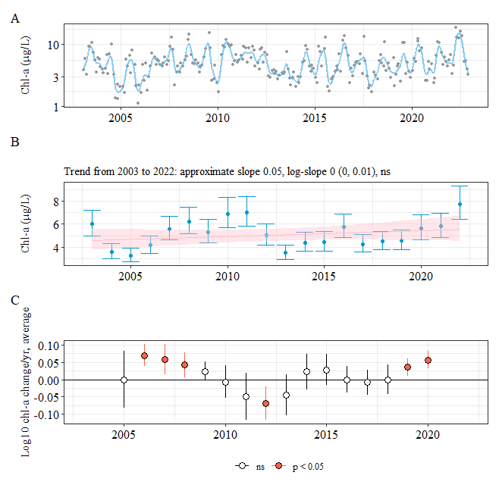

**Figure PI GAM and trend**

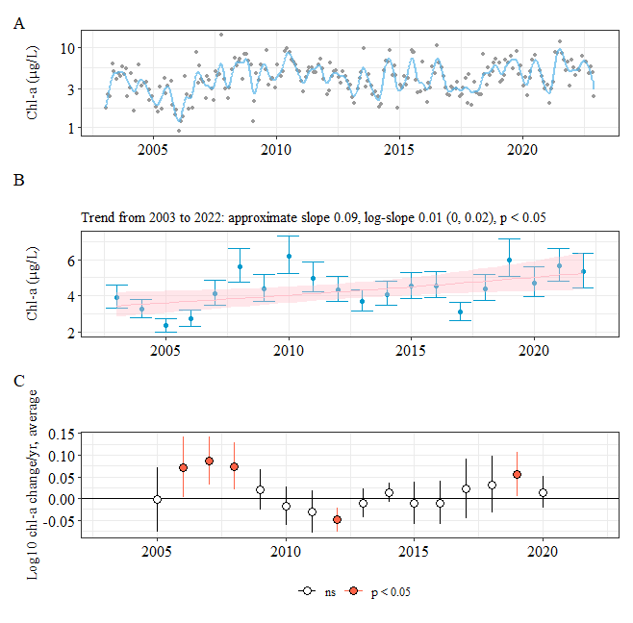

**Figure SS GAM and trend**

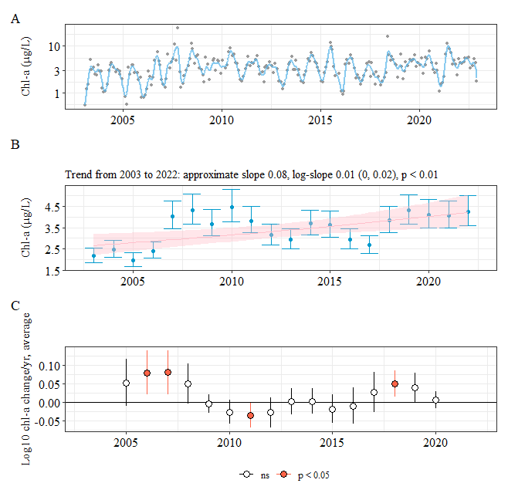

Figure FM GAM and trend

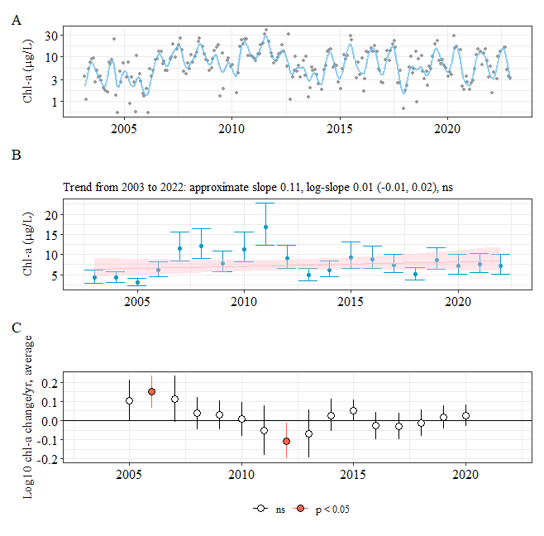

Figure PC GAM and trend

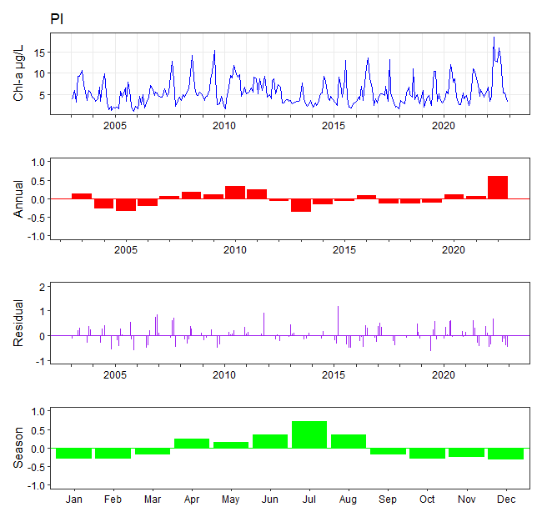

**Figure PI variability**

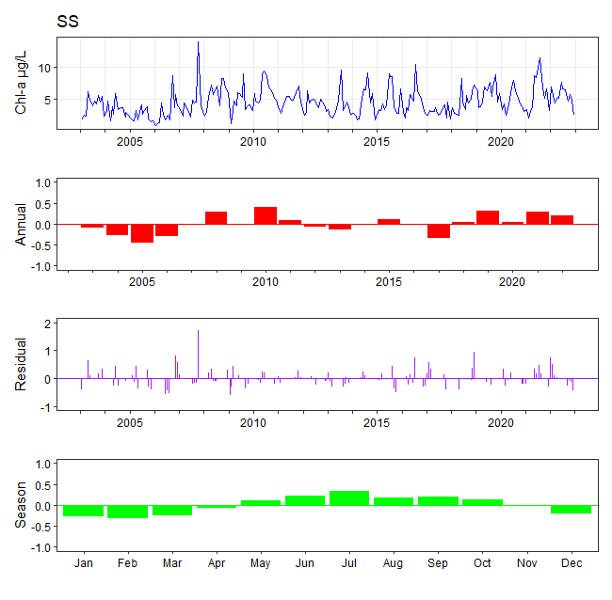

**Figure SS variability**

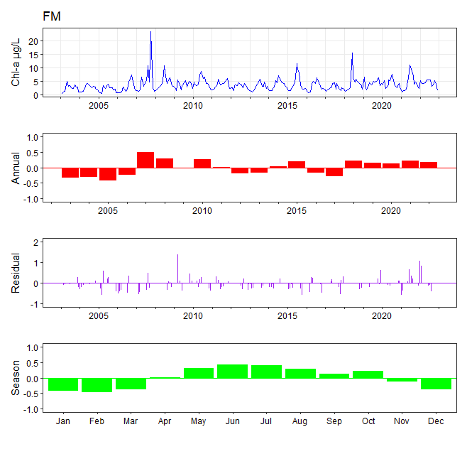

**Figure FM variability**

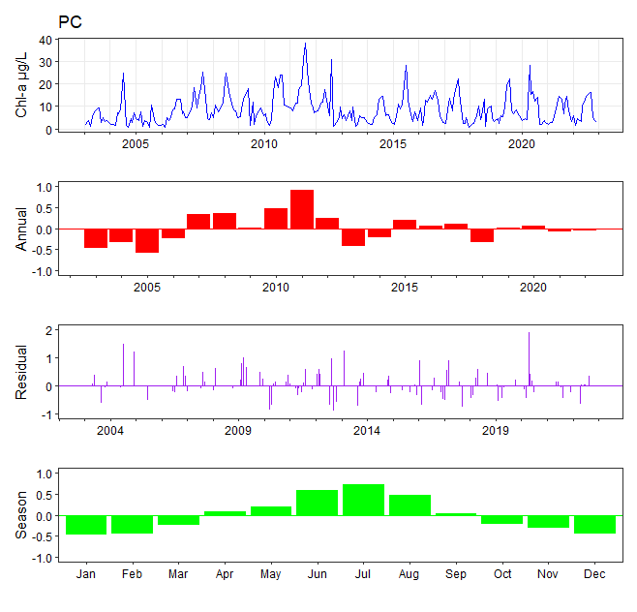

**Figure PC variability**

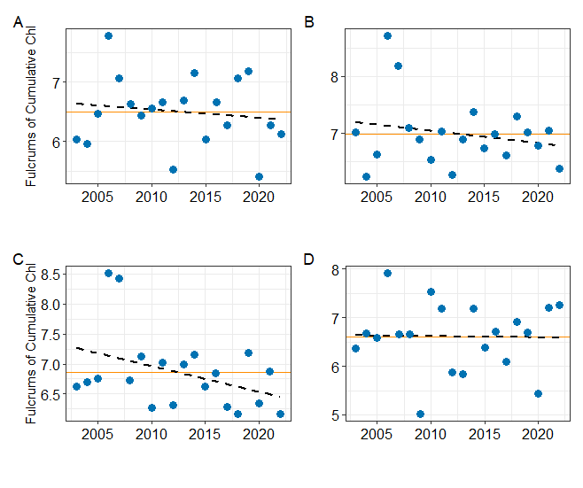

**Figure Fulcrums**

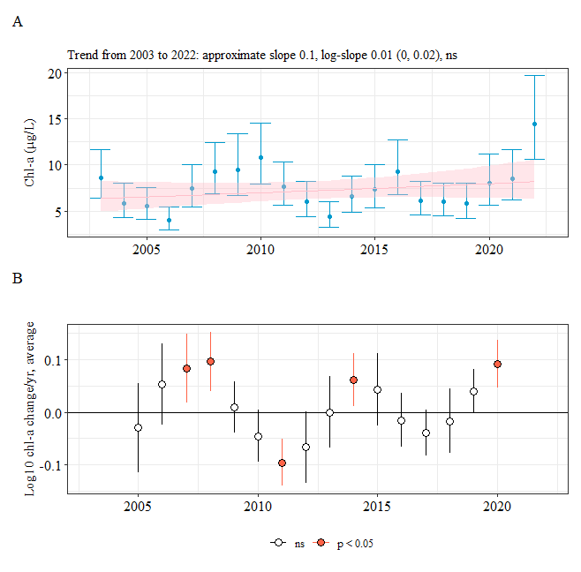

**Figure PI seasonal trends**

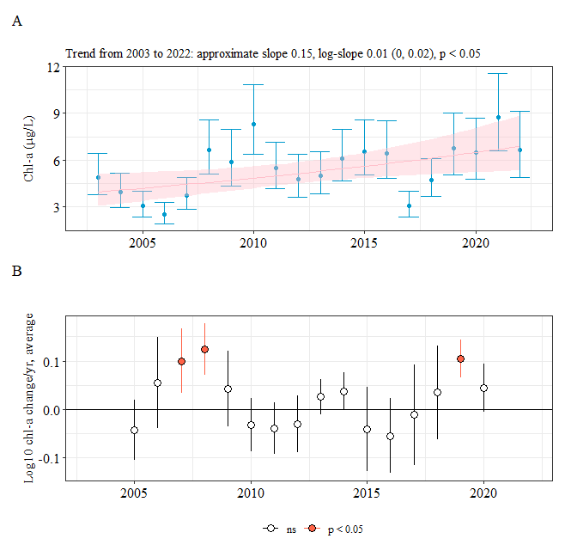

**Figure SS seasonal trends**

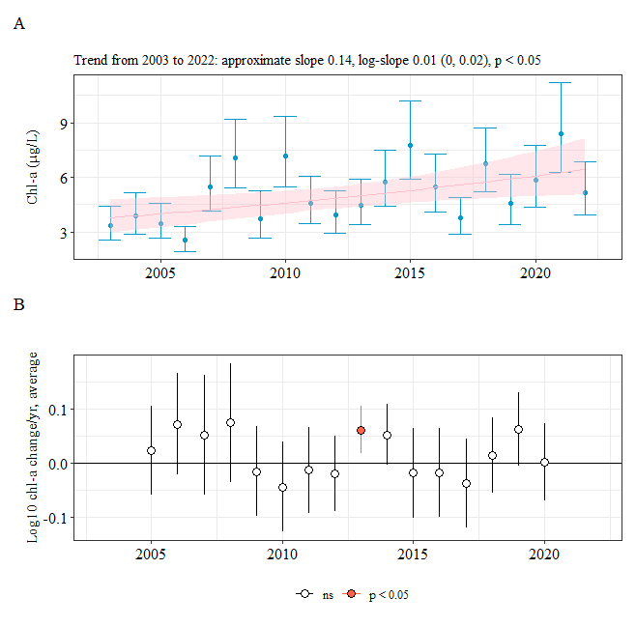

**Figure FM seasonal trends**

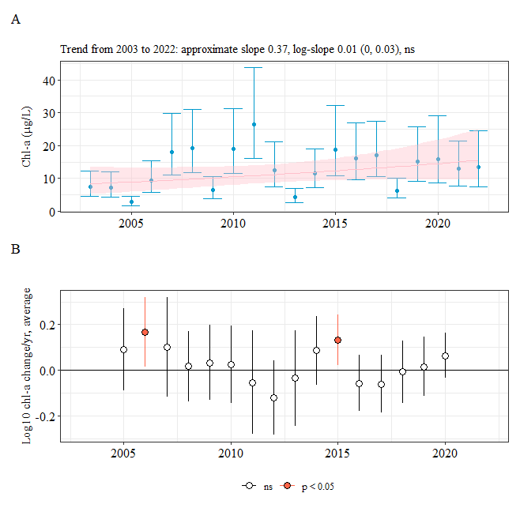

**Figure PC seasonal trends**