Working Title: Event-driven trends and variability in chlorophyll *a* in a back-barrier lagoonal estuary in the southeastern United States

Patterns and scales of phytoplankton variability in a back-barrier lagoonal estuary at a climatic ecotone

Shannon Dunnigan Kimmel*and Nicole Dix

Guana Tolomato Matanzas National Estuarine Research Reserve, Ponte Vedra Beach, FL 32082

*Corresponding author: [Shannon.Dunnigan@dep.state.fl.us](mailto:Shannon.Dunnigan@dep.state.fl.us)

ORCID: Kimmel: 0009-0004-6404-7008

Keywords: chlorophyll-a, Generalized Additive Model, Time Series, Phytoplankton variability, Estuaries

# Abstract

[providing space here]

# Introduction

The problem of nutrient enrichment and pollution in coastal environments is growing worldwide, particularly as populations increase in these watersheds and more of the upland habitats are developed for residential, urban, or industrial complexes (Freeman et al. 2019; Kyzar et al. 2021). Estuaries, the natural buffer zone between rivers and ocean, are often some of the most vulnerable ecosystems as their watersheds are much larger than their area. Effective management of coastal ecosystems to sustain current status or to mitigate impacts requires information on how these systems have changed over time. This is especially true to differentiate between anthropogenic impacts and natural variability within these systems.

**Nutrient enrichment alters coastal ecosystems often first with increases in algal production and biomass (CITATION?)** and the response of these systems is quite variable over space and time (Cloern and Jassby 2010). Anthropogenic impacts are not the only the primary drivers in these systems as climate also plays a large role in long-term conditions. In the Chesapeake Bay, precipitation and tropical cyclone activity results in variable phytoplankton production coupled with underlying increases in chlorophyll *a* (a common proxy for phytoplankton biomass) due to eutrophication (Harding et al. 2016). In the Indian River Lagoon and St. Lucie estuaries, variability in phytoplankton blooms have been attributed to cyclical patterns (e.g. El Niño/La Niña periods) and tropical cyclone events, typically as these events bring large amounts of precipitation (Phlips et al. 2020; Phlips et al. 2021). There are also systems, like the San Francisco estuary which, though nutrient-enriched, do not experience water quality impacts common to other enriched systems (like frequent phytoplankton blooms or low dissolved oxygen) attributed to a variety of variables such as strong tidal flushing and heavy phytoplankton grazing pressure from bivalves (Jassby 2008; Cloern and Jassby 2010; Cloern 2019). Additionally, the issue of nutrient pollution is not isolated to developed watersheds as even watersheds with low levels of development have been found to exhibit high levels of nutrient and chlorophyll *a* concentrations, such as the tidal creeks in the Ashepoo-Combahee-Edisto Basin in South Carolina (Keppler et al. 2015). Therefore the use of observational information from long-term research and monitoring programs provides the most valuable information for place-based and adaptive strategies in the management of coastal ecosystems.

The System-Wide Monitoring Program (SWMP) of the National Estuarine Research Reserve System (NERRS) is an established long-term monitoring program that has been a cornerstone of the NERRS since its inception in 1995. The SWMP utilizes standardized equipment and protocols to collect high-frequency and continuous water quality and meteorological data in a variety of estuarine environments across the United States and Puerto Rico. Due to the standardization of the program, and its well-developed and documented data management protocols for quality assurance and quality control, it serves as an excellent resource for helping to identify trends, patterns, and scales of variability in phytoplankton dynamics as well as their potential drivers within estuarine environments (System 2022).

One of thirty NERRS nationwide, three of which exist in Florida, the Guana Tolomato Matanzas National Estuarine Research Reserve (GTMNERR) has collected long-term data on water quality and meteorological conditions in the Guana-Tolomato-Matanzas (GTM) estuary since 2002. The GTM is a bar-built estuary with enclosed lagoons “rivers” (the Guana, Tolomato, and Matanzas) that trifurcate at the St. Augustine Inlet (Figure 1). The St. Augustine Inlet is one of two inlets in this system and it is stabilized with a jetty and maintained by the US Army Corps of Engineers to a depth of 5-m and the other, the Matanzas Inlet, is one of Florida’s few remaining unstructured inlets on the Atlantic Coast (Dean and O’Brien 1987). Overall, the GTM estuary is a well-mixed and well-flushed estuary with an absence of a freshwater river and a short residence time of approximately 12.6 days (Phlips et al. 2004; Sheng et al. 2008; Gray et al. 2021). The estuary is within a temperate-subtropical climatic ecotone dominated by salt marsh and mangrove habitats, intertidal oyster reefs, tidal creeks, mud flats, and open water (Williams et al. 2014; Bacopoulos et al. 2019). The GTM estuary hosts exceptionally intact and robust populations of eastern oysters (*Crassostrea virginica*) that filter ~60% of the estuary’s volume within a single residence time (Gray et al. 2021). It is likely these filtration services coupled with the short residence times keep phytoplankton biomass low (Dix et al. 2013; Hart et al. 2015).

Cloern and Jassby (2010) provided a conceptual framework for establishing and comparing variability in chlorophyll *a* when they examined 84 estuarine-coastal sites and established underlying patterns in site-specific relative importance of disturbance, annual climate cycles, and levels of nutrient enrichment. For example, sites with regular seasonal patterns in chlorophyll *a* were found to largely be driven by annual cycles such as bivalve grazing pressure which oscillate over the annual temperature cycle. Sites with large annual variability were commonly attributed to disturbance from natural events (e.g. hurricanes) or human actions (implementation of policies that reduced nutrient input into waterways). This study uses the established long-term monitoring framework of the NERRS SWMP to further test the framework provided by Cloern and Jassby (2010) to establish trends, patterns, and scales in variability of chlorophyll *a* for a 20-year time period (2003-2022).

The GTM estuary has previously been described as similar to other temperate estuaries along the southeastern United States in physiochemical variability with factors such as temperature and salinity (Apple et al. 2008). Patterns in community structure and seasonality of ichthyoplankton ingression have also been found to resemble those of temperate, tidally-influenced estuaries such as North-Inlet, South Carolina (Korsman et al. 2017). In Cloern and Jassby (2010), North-Inlet was one of the 84 sites in which strong seasonal patterns were associated with the seasonal filtration rates of native oyster populations. Dix et al. (2013) previously described bivalve grazing pressure from oysters and high tidal exchange supporting small inter-annual variability in chlorophyll *a* in the GTM estuary. Therefore, coupled with low residence times it is hypothesized that chlorophyll *a* patterns in the GTM estuary over two decades would exhibit low inter- and intra-annual variability. However, as is common around the coastal US, there has been a significant increase in coastal population density pressure in the region (Kyzar et al. 2021). Coupled with the ongoing changes in the watershed, increases in chlorophyll *a* concentrations are expected over the time period.

# Methods

## Study Area

The SWMP of the GTMNERR operates and maintains four water quality stations where instruments record continuous conditions and discrete water samples are collected monthly. Established in 2002, the station locations were selected to represent the influence of watersheds with varying degrees of urban development and reflect a diversity of physical processes (e.g., tidal exchange, freshwater input) and climatic conditions (Figure 1). Pine Island (PI) is located off of channel marker 25 in the Tolomato River surrounded by silviculture-dominated uplands in the northern portion of the GTM estuary. The Guana River runs parallel to the Tolomato on the seaward side, with the two lagoons joining 11.3-km north of the St. Augustine Inlet, approximately X-km south of the PI station. The Tolomato River Basin converges with the Matanzas River and Salt Run from the south before flowing into the Atlantic Ocean at the St. Augustine Inlet.

San Sebastian (SS) is located at the confluence of the San Sebastian and Matanzas Rivers. The San Sebastian River drains an urbanized watershed in the western portion of St. Augustine. The Matanzas River estuary is approximately 32 km in length and extends 13 km south of the Matanzas Inlet. The tidal node within the Matanzas is located around the CR-206 bridge with waters flowing northward of the bridge and southward of the bridge at outgoing tides. Fort Matanzas (FM) is located at Channel Marker 75 approximately 4-km north of the Matanzas Inlet.

Pellicer Creek is located in the southern part of the Matanzas River Basin, serves as a border between St. Johns and Flagler counties, and is surrounded by public conservation lands. Pellicer Creek is a tidal creek and is the primary source of natural freshwater drainage into the Matanzas River. SJRWMD collects in the mouth of Pellicer Creek near Marineland, Florida. The Pellicer Creek water quality station (PC) is at the end of a recreational dock in Faver-Dykes State Park located within the Pellicer Creek Aquatic Preserve.

## Water Quality Data

The four water quality stations equipped with YSI EXO2 sondes deployed within one meter of the bottom recorded environmental parameters (e.g. temperature, salinity) every 15 minutes. [add a sentence or two about sonde maintenance and calibration]. Temperature (°C) and salinity (practical salinity units, psu) data from each site was averaged by month. Data flagged as “rejected” or “suspect” were removed.

Discrete water samples were collected in duplicate monthly during ebb tides from as close to sonde depth as possible (no deeper than 3 meters). Samples were filtered in the field whenever feasible; otherwise, they were placed on ice in the dark and filtered immediately upon returning to the laboratory. Chlorophyll *a* was extracted from frozen filters within 28 days and analyzed using Standard Methods (SM10200H; citation). Duplicate samples were averaged by month. Values below the minimum detection limit of 0.55 µg/L were replaced with this nominal base to standardize across the dataset. As with the continuous data, chlorophyll *a* data flagged as “rejected” or “suspect” were removed. At PC, an automatic water sampler was usually deployed in addition to the discrete sample collection and set to collect from the same water depth. In some cases where PC was missing chlorophyll data, values were filled in with data collected at a similar time using the automatic sampler.

## Climate Data

Continuous meteorological data was collected at the Pellicer Creek weather station, approximately 4 km southeast of the Pellicer Creek water quality station. Rainfall data were totaled for each month and year after removing data that failed to meet quality standards. Information on El Niño/Southern Oscillation (ENSO) was downloaded from the National Oceanic and Atmospheric Administration’s Pacific Coast Laboratory (https://psl.noaa.gov/enso/mei/). The Multivariate ENSO Index (MEI) is based on multiple variables that are used to describe conditions in the tropical Pacific during ENSO events. This index is computed for 12 bimonthly rolling windows per year. This rolling window was summed to the following month (representing preceding and existing conditions) and was used to examine climate patterns during this study period.

## Data analysis

All statistical analyses and data visualizations were carried out using R v4.3.0 (R Core Team 2023). Generalized additive models on log10-transformed chlorophyll *a* data were performed for each station using the wqtrends package with terms *s*(“cont_year”), day of the year converted into a continuous numeric variable to represent annual effect, and the upper limit of the basis complexity (*k*) was set to 11 times the number of years for the input data (11 * 20 = 220) (M. Beck et al. 2022; M. W. Beck et al. 2022). Diagnostic information of the model fit and procedure were checked using the mgcv package (Wood 2011). These models computed a smooth temporal pattern in the raw data with an uncertainty of the smoother. The model results were then used to calculate seasonal metrics and trends. [Describe trend test methods] Changes in annual chlorophyll *a* were evaluated using a five-year moving window from 2003-2022. The slope is representative for the central year within each block (two years before and after).

A decomposition analysis was conducted to investigate patterns and scales of variability as in Cloern and Jassby (2010). The predicted values from the GAMs were used to fill in missing data (CITE SUPPLEMENTAL MISSING DATA INFORMATION HERE). Equation 4 from Cloern and Jassby (2010) was applied to monthly chlorophyll *a* data (Equation 1).

Equation 1: $c_{ij}=C_{y_{i}}m_{j}ε_{ij}$

This multiplicative model partitions variability into three components in addition to the long-term mean (*C*) where $c_{ij}$ is the chlorophyll concentration in year *i* (*i*=1,…,N) and month *j* (*j* = 1,…,12); *yi* is the annual effect in the *i*th year; *mj* is the seasonal (monthly) effect in the *j*th month; and $ε_{ij}$ is the residual. Each of the terms measures (multiplicative) deviation of mean chlorophyll *a* whereby values >1 indicates years (*yi*), months (*mj*), and events ($ε_{ij}$) with above average chlorophyll *a*. Together, the components average to 1 and are multipliers of *C*, so their magnitudes are independent of overall mean biomass and are comparable across sites (and ecosystems), and their standard deviations are coefficients of variation.

Seasonality was explored not only through decomposition, but also by testing for changes in phenology of phytoplankton biomass using wql package (Jassby and Cloern 2022). As an indicator of peak annual biomass, phenoPhase() was used to calculate the fulcrum or “center of gravity” as the month each year when the cumulative chlorophyll *a* reached half the total annual cumulative chlorophyll *a* (Greve et al. 2005; Cloern et al. 2023). These fulcrums were then used to determine the time frame of annual peak chlorophyll *a* which was used to further test for trends in seasonal changes over time using meta-analysis with wqtrends.

Spearman’s rank correlations were used to nonparametrically determine monotonic associations between the monthly chlorophyll *a* values and climatic indicators that could be potential drivers of the chlorophyll *a* patterns. Mean temperature, mean salinity, total rainfall, and MEI values were used for both the months when the chlorophyll *a* samples were collected and the preceding months to represent precedent conditions.

# Results

## Chlorophyll patterns

Overall, the GAMs provided a good fit to the chlorophyll *a* data and explained greater than 70% of deviance (range: 71 - 87%) at all sites (Table 1). A unimodal, oscillating pattern in average chlorophyll *a* was visible at all sites (Figure PI GAM, SS GAM, FM GAM, PC GAM). Significant trends in annual chlorophyll *a* over the entire 20-year period (2003-2022) were detected at SS and FM, increasing at 0.09 µg/L/yr and 0.08 µg/L/yr, respectively (Table 2). All sites showed increasing trends within the first decade of the monitoring and within the last five years. All sites had high estimates of chlorophyll *a* change per year from 2005-2009 with 2006 being significant at all sites and 2007 (Figure FM) and 2007-2008 also being significant (Figure PI and SS). They all also showed significant decreasing trends in either 2011 (PI, FM, and PC) or 2012 (SS). For SS, significant high rates of change were detected in 2019 (Figure SS). At FM, significant high rates of changes were detected in 2018 (Figure FM). At PI, however, both 2019 and 2020 have increased rates of change with 2020 being even higher than 2019 (Figure PI).

Low annual and seasonal variability was observed at all stations (Table 3). All scales of variability were larger at PC than the other sites. The largest coefficient of variation was the event-scale variability observed at PC (SDɛ = 0.51) (Table 3). PI and PC show similar patterns to one another as do SS and FM (Figures X-X). Seasonally, PI and PC experienced higher chlorophyll *a* from April – August (Figures X-X), while SS and FM showed a protracted seasonal pattern extending from May – October (Figures X-X).

Average fulcrums at all sites ranged between (6.50-6.99) indicating peak values in chlorophyll *a* concentration occurring mostly in the middle to late part of June (Figure Fulcrums). There was no significant trend in fulcrums over time (p = ___), but deviations in fulcrum timing from average may provide insights into drivers of phytoplankton biomass accumulation. The widest range in fulcrums occurred at PC (months 5.01 – 7.91), and PI had a similar range (5.40 – 7.78). SS and FM had later fulcrums (6.24 – 8.71 at SS and 6.16 – 8.51 at FM). These fulcrum values mirror the patterns observed in the seasonal-scale variability (Figures X variability) where phytoplankton accumulated earlier in the year at PI and PC and extended later in the year at FM and SS. The range of peak biomass of all sites, between May 1 – August 15 (day 121st – 227th), was then tested for trends at each site. This seasonal peak biomass was found to be increasing at FM and SS, but not PC and PI (Figures XXX). For the most part, change in chlorophyll *a* per year for the window of the peak season mirrored the results of the annual changes. However, PI had a high significant change in peak seasonal chlorophyll in 2014 (Figure PI seasonal trends), FM had a significant high slope in 2013 (Figure FM seasonal trends), and PC had one in 2015 (Figure PC seasonal trends). These years were not significant in the long term annual trends at each site.

## Climate and environmental drivers

Water temperatures typically were similar at all sites (Figure WQ Temp/Sal, Table 4). Drops in average water temperatures in the winter were notable in 2002-2003, 2010-2011, 2011-2012, and 2017-2018, an approximate eight-year return interval. SS and FM are more saline stations with average salinities in the 33-34 psu range. PI and PC are further from inlets and experience more brackish conditions with average salinities between 15-27 psu (Table 4). PC also frequently has low salinities compared to all other sites (Figure WQ Temp/Sal).

Average annual rainfall for the 20-year period was 112 cm (Figure Annual Rainfall). The years with the largest deviation from average rainfall were 2006 and 2010, both lower than average. More periods of La Niña conditions were observed than El Niño (Figure MEI index). Strong La Niña conditions were observed in 2010-2012, and strong El Niño conditions were observed between 2015-2017. There was an extreme shift from El Niño to La Niña in 2010-2011, which corresponded to lower than average minimum temperatures and rainfall totals.

Correlated monotonic associations between chlorophyll *a* and climate variables were observed at all stations (Table 5). Temperature the same month of sampling was the most related variable to chlorophyll *a* (positively) all stations. Salinity was positively correlated with chlorophyll *a* at all stations. Rainfall was not significantly correlated with chlorophyll *a* at PI at all and was weakly positively correlated at other stations. MEI was weakly negatively correlated with chlorophyll *a* at all stations.

# Discussion

* What do the results show?
  + Low inter- and intra- annual variability in chl-a at all sampling stations.
  + PC had highest variability in event-scale variability (though all sites did as well)
  + Only FM and SS had significant long-term annual trends in chl-a, which was similar to seasonal trend analysis patterns as well.
  + Sites can be grouped spatially by PI:PC and FM:SS by intra-annual patterns (seasonal variation and range of annual chl-a fulcrums) and range in chl-a (typically much lower at FM:SS than PI:PC).
  + Significant periods of change correspond to periods of drought (2006-2008) and significant weather events (particularly cold snaps 2010-2012, 2018).
* Given the lack of recent information regarding the status of water quality or nutrients within this system, the access of a robust water quality time series, and the continued increase in coastal population density pressure in the region (Kyzar et al. 2021), this study uses the established long-term continuous monitoring framework of the NERRS SWMP to establish trends, patterns, and scales in variability of chlorophyll *a* for a 20-year time period (2003-2022) while providing some potential drivers of that variation.
* The last study to have performed any trend or status of the GTM estuary was performed almost 20 years ago in 2004 using monitoring data collected by the St. Johns River Water Management District (Winkler and Ceric 2004). Their assessment encompassed a suite of water quality indicators which included chlorophyll *a*. At that time, the Northern Coastal Basin, which includes the GTM estuary, was found to have some of the best water quality out of all the basins in the District; however, many of the sites, though deemed of good water quality, provided insufficient data (did not have at least 10 years of data) or had insignificant results for trend tests (Winkler and Ceric 2004).
* Previous studies in the region were conducted at shorter time scales (8-10 years) and did not include all 4 sites, which span the GTM estuary.
  + Dix et al. 2013
    - also used the Cloern and Jassby 2010 calculations for variability in chl-a, but only at FM and SS and only for an 8-year window (2003-2010). The values were much higher than those calculated in this study (suggesting expanding the time frame reduced the variation observed) but FM was still higher than SS even in this study. Like this study, **residual (event-driven) variability was the largest amount of variation** suggesting….
    - Temperature and light availability were not found to play major roles in limiting production, but chl-a concentration was strongly related to temp.
    - High productivity, but low chl-a concentrations showing balance of gain and losses associated with flushing and grazing by zooplankton and filtration by oysters.
    - 2007 *Karenia* *brevis* bloom event within the system – largest event and chla values at FM even in the 20-year period. ***Event-driven variation***
    - Largest monthly rainfall in entire time period was in May 2009, low pressure system (0.45m, 45cm)
  + Hart et al. 2015
    - included PI (expanding beyond Dix et al. 2013) and further investigated flushing and nutrient loading as contributors to phytoplankton biomass and composition, expanding to include communities.
    - Spatial and temporal differences (residence times and rainfall levels) in phytoplankton biomass were found between sites.
    - Found a lack of significant positive relationships between nutrient loads, nutrient concentrations and phytoplankton biomass.
    - PI had higher chl-a concentrations, but lower nutrient loads. It also has the highest residence times compared to FM and SS.
    - Rainfall-related changes in regional flushing rates: negative relationship between high rainfall periods to chl-a biomass. Chl-a generally peaked before major rainfall events or during periods of low rainfall, suggesting increased flushing rates and decreases in salinity as more contributing factors.
    - Community composition varies associated with residence times with faster-growing phytoplankton groups found at FM and SS compared to PI (larger microphytoplankton species, centric diatoms) and FM and SS having higher top-down pressure (larger oyster populations). Lots of small fast-growing species observed (high water turnover rates and low probability of extended periods of nutrient limitation).
* So, 20 years of data tells us more than 10 (or less), but what will 30 and more years of data tell us? How did our interpretations change going from 10 to 20 years? Does that tell us anything about our estuary?
* PI and PC show much similar patterns to one another in terms of variability, trends, duration of seasons and range of fulcrums. FM and SS also behave similarly to one another suggesting that proximity to the inlets (and potentially higher flushing rates) play a larger role in the classification of these sites.
* What are the residence time differences across these sites? could this be a contributing factor in their patterns? Gray et al. 2021 also took depth and “intertidal volume” into consideration…what about that?
* Gray et al. 2021:
  + Higher residence times in areas with higher intertidal area and length of tidal network (e.g., main channels and rivers). Lower residence times were found in areas with higher subtidal area.
  + Overall, 12.6 days for whole estuary

|  |  |  |
| --- | --- | --- |
| Station | Watershed-scale residence time (days) | Watershed-scale residence time per unit of intertidal watershed (days/km-2) |
| Pine Island | 16.1 | 0.71 |
| San Sebastian | 5.5 | >30 | 2.02 | 3.62 |
| Fort Matanzas | 9.3 | 1.08 |
| Pellicer Creek | 17.8 | 2.16 |

* + Watershed-scale residence time lowest at SS and FM and highest at PC and PI. With intertidal watershed taken into consideration, PI had the lowest residence time over all four stations and SS and PC were more comparable.
  + Higher residence time at FM as a result of lower fluxes moving through Matanzas Inlet compared to the St. Augustine Inlet (5.5 at SS) along with increased salt marshes and longer tidal network.
  + The high watershed-scale residence time in Pine Island is due to the presence of the Tolomato River, which mitigates the effect of the large intertidal area in the area.
  + The SS station is located at the boundary between two very different watersheds: one which the San Sebastian River and the large subtidal area contribute to a small residence time (5.5 d) and one in which the shallow areas of the Matanzas River and Moultie Creek trap particles from the study limiting their removal and providing residences times greater than 30 d.
* The sites are spread out throughout the estuary and there are zones of productivity that are likely not captured within the monthly long-term monitoring of the SWMP stations, such as the high area of production in the Pellicer Flats area at the mouth of Pellicer Creek (Brown et al. 2023).
* Bivalve grazing seasons, spat patterns (peaks in the fall) – how do these tie in with the chl-a patterns observed in this data?
  + Marcum et al. 2018:
    - Establish oyster densities in regions for further comparison with residence times:
      * Suggest local decline in oyster populations between reefs sampled by Dix in 2009-2010 and the GTM Monitoring in 2014-2015. Mean density was approximately half of what was previously observed – but reefs in the region are conditionally approved for harvest.
      * Taller reefs in the northern region than southern – likely influenced by tidal range and depth of inundation; though some of the flattest reefs were observed in Salt Run at the inlet, in the middle of the study region, but heavy harvest pressure (though actual harvest region in Salt Run is small).
      * Highest spat observed in Pellicer Flats, but this high abundance of sub-size oysters suggests external pressures such as disease, toxicity, hydrology, and/or predation. The presence of predatory crown conchs in the region linked to drought and increased salinity (Garland and Kimbro 2015). However, lower salinities can also contribute declined growth rates in oyster populations and therefore increased freshwater discharge from Pellicer Creek could also play a significant role in oyster populations in the region.
      * Higher sediment cover in summer than in winter on reefs – suggests increased biological activity (bio-deposits from oysters and reef-associated filter feeders in summer months).
      * High energy Nor’easters during the winter months reduce sedimentation
      * Differences in winter:summer oyster densities between this monitoring and Dix et al. 2013 were attributed to higher winter temperatures during the sampling period of monitoring (2015-2016).
      * *The heavy emphasis on bivalve grazing pressure at mitigating chlorophyll concentrations in the GTM, further supports that potential drivers in chlorophyll a concentrations may not affect chlorophyll a concentrations directly, but in their impact on aspects of the drivers that balance the gain and losses (like oyster recruitment and grazing) of productivity in the GTM. Cloern et al. 2023 found that it was not temperature that was associated with seasonal phytoplankton biomass, but the changing abundance of bivalve filter feeders or their predators.*
* Cloern et al. 2023
  + Changes in phytoplankton phenology are not necessarily responses to or indicators of global warming, but indicators of human disturbance and natural climate oscillations.
  + Biomass can change rapidly and at any time when the balance between productivity and consumption is altered.
* All GTM sites fall within the range of values in coefficients of variation to Cloern and Jassby 2010. The higher values at PC for both annual and seasonal variability suggest slightly more disturbance and influence of the annual cycle at this station compared to others, however even still, this location does not stand out across the other 84 sites in their study.
  + High inter-annual variability is an indicator of systems that are sensitive to variability in nutrient loads (Cloern and Jassby 2010). Therefore, low rates observed in the GTM suggest a lack of sensitivity on annually variable events (like nutrient input)
* Dunn et al. 2023 found increasing chlorophyll in the recent years (2014-2020) of their long-term study in the North-Inlet station – these are suggested to be driven by increased porewater flux volumes and NH4+ related to sea level rise (though a 4-year lag was observed between elevated NH4+ and the chl-a response). They also discuss the lack of increased precipitation (a documented potential driver of nutrient export) observed in North Inlet, further supporting environmental changes in associated with climate warming (sea level rise) as being the main driver in their data.
* All sites had relatively strong (~0.4-0.5) correlations with temperature and chlorophyll *a*, particularly FM. Salinity was more of an influence at PI and PC than SS and FM. Rainfall was significant at SS for both preceding and current month of chl-a samples. PC was the current month (though weak) and FM was the preceding month – likely showing the influence of precipitation and time lag between PC and FM stations.
* 2006 was a drought year, followed by a year with above average rainfall (including the large May 2007 rainfall event). This period of time had the most significant positive rates of change in chlorophyll at most sites.
* 2009-2010 and 2010-2011 had cold snaps in back-to-back winter seasons. There was also very little annual rainfall during this time and high saline conditions. Significant decreases in chl-a were observed within this window of time.
  + Patterns in minimum temperatures are known to be structuring elements of ecotonal environments (references). In the GTM estuary, freezing temperatures of a certain threshold drive mangrove distribution (refs), but this study shows that the open water habitats and plankton community may also be tightly linked to cold events. Food web implications?
  + Cold snaps and hypersaline conditions (due to drought) during this time were attributed to the widespread and protracted decline in seagrass and drift macroalgal communities in the IRL, which altered sources of nutrients toward phytoplankton (Phlips et al. 2021)
  + High saline values were observed in 2006, 2008, 2010-2011, 2012, 2016, 2017 supporting periods of change in the chlorophyll time series.
  + Highest salinities in PC were observed in 2011 and 2012 (May-June, April-May, respectively)
* 2004, 2005, 2016, and 2017 were all active hurricane seasons.
  + 2004 hurricanes on water quality? (Dix et al. 2008)
  + Influence of Irma on fDOM export and tidal flushing? (Schafer et al. 2021 and Brown et al. 2023)
    - FM had a significantly high rate of change in seasonal peak biomass found in 2018 – could be related to export from Irma?
* High rainfall and winds associated with major storms (and nor’easters??) can increase external and internal (e.g., sediment resuspension and benthic biomass disruption) nutrient loads that support bloom development. Such as Irma which was followed by a major bloom event in the IRL which started in the winter of 2017 and extended into 2018 (Phlips et al. 2021)
* Role of Nor’easters in the patterns in this study??
  + Callahan et al. 2022 found that midlatitude weather systems can produce surges just as severe and occur more frequently than tropical cyclones and they peak during the cold season (November – March). How does this contribute to residence times (lack of low-tide events, reduced rates of turnover, higher water levels for a prolonged period of time, etc) during the winter season?
* In the southeastern United States, El Niño and La Niña periods are associated with wetter and dryer than average conditions, respectively (Schmidt and Luthor 2002). El Niño periods are noted for having elevated rainfall levels in the dry season (i.e., late fall through early spring, like increased hurricanes).
  + Higher peaks in bloom biomass were found during El Nino periods than La Nina periods in the IRL (Phlips et al. 2021). The negative associated with the MEI index and chl-a in this study, suggests a similar relationship, though not nearly as strong. In Baffin Bay, Texas, high rainfall El Nino periods were found to decrease intense brown tide blooms due to elevated flushing rates and reduced salinities (Cira et al. 2021). **Highlights importance on regional differences in ecosystem characteristics when it comes to determining the effects on HAB dynamics.**
  + ENSO events and their influence on rainfall levels were found to be of high importance in the IRL, mostly in their impact on external nutrient loading.

# References

Apple, J. K., E. M. Smith, and T. J. Boyd. 2008. Temperature, salinity, nutrients, and the covariation of bacterial production and chlorophyll-a in estuarine ecosystems. *Journal of Coastal Research*: 59–75. <https://doi.org/10.2112/SI55-005.1>.

Bacopoulos, P., A. S. Tritinger, and N. G. Dix. 2019. Sea-Level Rise Impact on Salt Marsh Sustainability and Migration for a Subtropical Estuary: GTMNERR (Guana Tolomato Matanzas National Estuarine Research Reserve). *Environmental Modeling & Assessment* 24: 163–184. <https://doi.org/10.1007/s10666-018-9622-6>.

Beck, M. W., P. De Valpine, R. Murphy, I. Wren, A. Chelsky, M. Foley, and D. B. Senn. 2022. Multi-scale trend analysis of water quality using error propagation of generalized additive models. *Science of The Total Environment* 802: 149927. <https://doi.org/10.1016/j.scitotenv.2021.149927>.

Beck, M., P. de Valpine, R. Murphy, I. Wren, A. Chelsky, M. Foley, and D. Senn. 2022. Wqtrends: Assess water quality trends with generalized additive models.

Cloern, J. E. 2019. Patterns, pace, and processes of water-quality variability in a long-studied estuary. *Limnology and Oceanography* 64. <https://doi.org/10.1002/lno.10958>.

Cloern, J. E., and A. D. Jassby. 2010. Patterns and Scales of Phytoplankton Variability in EstuarineCoastal Ecosystems. *Estuaries and Coasts* 33: 230–241. <https://doi.org/10.1007/s12237-009-9195-3>.

Cloern, J. E., T. S. Schraga, E. Nejad, and T. Eddy. 2023. Phytoplankton as indicators of global warming? *Limnology and Oceanography Letters*: lol2.10354. <https://doi.org/10.1002/lol2.10354>.

Dean, R. G., and M. P. O’Brien. 1987. [*Florida’s east coast inlets: Shoreline effects and recommeded action*](http://hdl.handle.net/1834/18098). University of Florida.

Dix, N., E. Phlips, and P. Suscy. 2013. Factors Controlling Phytoplankton Biomass in a Subtropical Coastal Lagoon: Relative Scales of Influence. *Estuaries and Coasts* 36: 981–996. <https://doi.org/10.1007/s12237-013-9613-4>.

Freeman, L. A., D. R. Corbett, A. M. Fitzgerald, D. A. Lemley, A. Quigg, and C. N. Steppe. 2019. Impacts of Urbanization and Development on Estuarine Ecosystems and Water Quality. *Estuaries and Coasts* 42: 1821–1838. <https://doi.org/10.1007/s12237-019-00597-z>.

Gray, M. W., D. Pinton, A. Canestrelli, N. Dix, P. Marcum, D. Kimbro, and R. Grizzle. 2021. Beyond Residence Time: Quantifying Factors that Drive the Spatially Explicit Filtration Services of an Abundant Native Oyster Population. *Estuaries and Coasts* 45: 1343–1360. <https://doi.org/10.1007/s12237-021-01017-x>.

Greve, W., S. Prinage, H. Zidowitz, J. Nast, and F. Reiners. 2005. [On the phenology of north sea ichthyoplankton](https://doi.org/10.1016/j.icesjms.2005.03.011). *ICES Journal of Marine Science* 62: 1216–1223.

Harding, L. W., C. L. Gallegos, E. S. Perry, W. D. Miller, J. E. Adolf, M. E. Mallonee, and H. W. Paerl. 2016. Long-Term Trends of Nutrients and Phytoplankton in Chesapeake Bay. *Estuaries and Coasts* 39: 664–681. <https://doi.org/10.1007/s12237-015-0023-7>.

Hart, J. A., E. J. Phlips, S. Badylak, N. Dix, K. Petrinec, A. L. Mathews, W. Green, and A. Srifa. 2015. Phytoplankton biomass and composition in a well-flushed, sub-tropical estuary: The contrasting effects of hydrology, nutrient loads and allochthonous influences. *Marine Environmental Research* 112: 9–20. <https://doi.org/10.1016/j.marenvres.2015.08.010>.

Jassby, A. D. 2008. Phytoplankton in the Upper San Francisco Estuary: Recent Biomass Trends, Their Causes, and Their Trophic Significance. *San Francisco Estuary and Watershed Science* 6. <https://doi.org/10.15447/sfews.2008v6iss1art2>.

Jassby, A. D., and J. E. Cloern. 2022. [Wq: Exploring water quality monitoring data](https://CRAN.R-project.org/package=wq).

Keppler, C., D. Bergquist, L. Brock, J. Felber, and D. Greenfield. 2015. A spatial assessment of baseline nutrient and water quality values in the ashepoo–combahee–edisto (ACE) basin, south carolina, USA. *Marine Pollution Bulletin* 99: 332–337. <https://doi.org/10.1016/j.marpolbul.2015.07.035>.

Korsman, B. M., M. E. Kimball, and F. J. Hernandez. 2017. Spatial and temporal variability in ichthyoplankton communities ingressing through two adjacent inlets along the southeastern US Atlantic coast. *Hydrobiologia* 795: 219–237. <https://doi.org/10.1007/s10750-017-3131-5>.

Kyzar, T., I. Safak, J. Cebrian, M. W. Clark, N. Dix, K. Dietz, R. K. Gittman, et al. 2021. Challenges and opportunities for sustaining coastal wetlands and oyster reefs in the southeastern United States. *Journal of Environmental Management* 296: 113178. <https://doi.org/10.1016/j.jenvman.2021.113178>.

Phlips, E. J., S. Badylak, N. G. Nelson, L. M. Hall, C. A. Jacoby, M. A. Lasi, J. C. Lockwood, and J. D. Miller. 2021. [Cyclical patterns and a regime shift in the character of phytoplankton blooms in a restricted sub-tropical lagoon, indian river lagoon, florida, united states](https://www.frontiersin.org/articles/10.3389/fmars.2021.730934). *Frontiers in Marine Science* 8.

Phlips, E. J., S. Badylak, N. G. Nelson, and K. E. Havens. 2020. Hurricanes, El Niño and harmful algal blooms in two sub-tropical Florida estuaries: Direct and indirect impacts. *Scientific Reports* 10: 1910. <https://doi.org/10.1038/s41598-020-58771-4>.

Phlips, E. J., N. Love, S. Badylak, P. Hansen, J. Lockwood, C. V. John, and R. Gleeson. 2004. A Comparison of Water Quality and Hydrodynamic Characteristics of the Guana Tolomato Matanzas National Estuarine Research Reserve and the Indian River Lagoon of Florida**. *Journal of Coastal Research* 10045: 93–109. <https://doi.org/10.2112/SI45-093.1>.

R Core Team. 2023. [*R: A language and environment for statistical computing*](https://www.R-project.org/). Vienna, Austria: R Foundation for Statistical Computing.

Sheng, Y. P., B. Tutak, J. R. Davis, and V. Paramygin. 2008. Circulation and Flushing in the Lagoonal System of the Guana Tolomato Matanzas National Estuarine Research Reserve (GTMNERR), Florida. *Journal of Coastal Research* 10055: 9–25. <https://doi.org/10.2112/SI55-002.1>.

System, N. N. E. R. R. 2022. *System-wide monitoring program data management manual* (version Version 6.7). Centralized Data Management Office.

Williams, A. A., S. F. Eastman, W. E. Eash-Loucks, M. E. Kimball, M. L. Lehmann, and J. D. Parker. 2014. Record Northernmost Endemic Mangroves on the United States Atlantic Coast with a Note on Latitudinal Migration. *Southeastern Naturalist* 13: 56–63. <https://doi.org/10.1656/058.013.0104>.

Winkler, S., and A. Ceric. 2004. *Status and trends in water quality at selected sites in the st. Johns river water management district*. Palatka, Florida.

Wood, S. N. 2011. Fast stable restricted maximum likelihood and marginal likelihood estimation of semiparametric generalized linear models 73: 3–36.

**Table 1**. Generalized additive model output for models fit to chlorophyll *a* timeseries at Pine Island, San Sebastian, Fort Matanzas, and Pellicer Creek with the Guana Tolomato Matanzas National Estuarine Research Reserve. Estimated degrees of freedom (edf) is a measure of wiggliness of the smooth term *s*(“cont_year”), which is the day of the year converted into a continuous numeric variable to represent annual effect. Additional performance statistics are also provided as Akaike Information Criterion (AIC), generalized cross-validation scores (GCV), and adjusted r-squared values.

|  |  |  |  |  |  |  |
| --- | --- | --- | --- | --- | --- | --- |
| Station | edf | *p* | AIC | GCV | Adj. R2 | % deviance explained |
| Pine Island | 83.326 | < 0.001 | -185.29 | 0.031 | 0.631 | 76.2 |
| San Sebastian | 76.291 | < 0.001 | -236.69 | 0.024 | 0.617 | 74.3 |
| Fort Matanzas | 102.870 | < 0.001 | -243.43 | 0.027 | 0.762 | 86.6 |
| Pellicer Creek | 72.590 | < 0.001 | 55.91 | 0.084 | 0.582 | 71.3 |

**Table 2**. Trend summaries for chlorophyll *a* timeseries at Pine Island, San Sebastian, Fort Matanzas, and Pellicer Creek with the Guana Tolomato Matanzas National Estuarine Research Reserve.

* *Include a table with summary information for chl-a at each site (mean, range, etc) in addition to the slopes and significant trends for each station.*

**Table 3**. Standard deviations of chlorophyll *a* variability extracted from timeseries at Pine Island, San Sebastian, Fort Matanzas, and Pellicer Creek with the Guana Tolomato Matanzas National Estuarine Research Reserve. The mean value of each of these (dimensionless) components is 1, so these standard deviations are equivalent to coefficients of variation.

|  |  |  |  |
| --- | --- | --- | --- |
| Station | Annual (SDy) | Seasonal (SDm) | Residual (SDɛ) |
| Pine Island | 0.23 | 0.34 | 0.35 |
| San Sebastian | 0.23 | 0.22 | 0.34 |
| Fort Matanzas | 0.24 | 0.33 | 0.41 |
| Pellicer Creek | 0.35 | 0.41 | 0.51 |

**Table 4**. Summary of site data from 2003-2022 for Pine Island, San Sebastian, Fort Matanzas, and Pellicer Creek in the Guana Tolomato Matanzas National Estuarine Research Reserve. Values include the overall average (minimum – maximum).

|  |  |  |  |
| --- | --- | --- | --- |
| Station | Temperature (°C) | Salinity (psu) | Chlorophyll *a* (µg/L) |
| Pine Island | 23.47 (5.3-33.7) | 27.45 (0.9-41.4) | 5.52 (1.1-18.5) |
| San Sebastian | 22.96 (6.7-33.2) | 33.59 (8.7-39.8) | 4.54 (0.9-14.05) |
| Fort Matanzas | 22.91 (5.6-32.9) | 34.1 (1.7-38.8) | 3.80 (0.55-23.45) |
| Pellicer Creek | 23.61 (3.6-35.9) | 15.39 (0-39.3) | 8.58 (0.55-38.2) |

**Table 5**. Spearman’s rank correlation coefficients (ρ) for average monthly environmental parameters with monthly chlorophyll *a* between 2003-2022 from Pine Island (PI), San Sebastian (SS), Fort Matanzas (FM), and Pellicer Creek (PC) in the Guana Tolomato Matanzas National Estuarine Research Reserve. Water quality data (temperature and salinity) comes from monthly averages of 15-minute continuous data collected by YSI instruments. Rainfall is a monthly total from continuous 15-minute data at a weather station in Pellicer Creek. Chlorophyll are averages from grab samples collected monthly in duplicate at each station. The Multivariate ENSO Index (MEI) values come from the National Oceanic and Atmospheric Administration’s Pacific Coast Laboratory (https://psl.noaa.gov/enso/mei/). Parameters with ‘(P)’ are the averages of the preceding month to the chlorophyll collections. All correlations presented are significant at α = 0.05.

|  |  |  |  |  |
| --- | --- | --- | --- | --- |
| Parameter | Pine Island | San Sebastian | Fort Matanzas | Pellicer Creek |
| Salinity (P) | 0.36 | 0.18 | 0.21 | 0.5 |
| Salinity | 0.41 | 0.18 | 0.23 | 0.52 |
| Temperature (P) | 0.26 | 0.38 | 0.51 | 0.45 |
| Temperature | 0.47 | 0.43 | 0.63 | 0.56 |
| Rainfall (P) | -- | 0.14 | 0.24 | -- |
| Rainfall | -- | 0.16 | -- | 0.08 |
| MEI | -0.23 | -0.18 | -0.15 | -0.21 |

Figure Legends

**Figure 1 Map** of Guana Tolomato Matanzas estuary located in northeast Florida, United States around the city of Saint Augustine, Florida with watersheds (HUC__), water quality monitoring stations (triangles), and the weather station (circle).

**Figure PI GAM and trend.** Chlorophyll *a* at the Pine Island station in the Guana Tolomato Matanzas estuary. (A) time series of monthly average chlorophyll *a* 2003-2022 with generalized additive model predictions (blue line). (B) annual averages (January 1 – December 31; +/- 95% confidence intervals) with trend estimates from meta-analysis. The trend lines (red with 95% CI) estimate the rate of change of chlorophyll *a* per year reported as the log10 slope (+/- 95% CI) in the subtitle: ns: not significant at α = 0.05. (C) estimates of log10 chlorophyll *a* change per year (+/- 95% CI) with trend estimates from a five-year, centered moving window where each point shows a linear trend estimate from two years prior and two years after each year. Estimates prior to 2005 and after 2020 are not available because of an incomplete two-year record for estimating the trend. Significant estimates are shown in red.

**Figure SS GAM and trend.** Chlorophyll *a* at the San Sebastian station in the Guana Tolomato Matanzas estuary. (A) time series of monthly average chlorophyll *a* 2003-2022 with generalized additive model predictions (blue line). (B) annual averages (January 1 – December 31; +/- 95% confidence intervals) with trend estimates from meta-analysis. The trend lines (red with 95% CI) estimate the rate of change of chlorophyll *a* per year reported as the log10 slope (+/- 95% CI) in the subtitle: ns: not significant at α = 0.05. (C) estimates of log10 chlorophyll *a* change per year (+/- 95% CI) with trend estimates from a five-year, centered moving window where each point shows a linear trend estimate from two years prior and two years after each year. Estimates prior to 2005 and after 2020 are not available because of an incomplete two-year record for estimating the trend. Significant estimates are shown in red.

**Figure FM GAM and trend.** Chlorophyll *a* at the Fort Matanzas station in the Guana Tolomato Matanzas estuary. (A) time series of monthly average chlorophyll *a* 2003-2022 with generalized additive model predictions (blue line). (B) annual averages (January 1 – December 31; +/- 95% confidence intervals) with trend estimates from meta-analysis. The trend lines (red with 95% CI) estimate the rate of change of chlorophyll *a* per year reported as the log10 slope (+/- 95% CI) in the subtitle: ns: not significant at α = 0.05. (C) estimates of log10 chlorophyll *a* change per year (+/- 95% CI) with trend estimates from a five-year, centered moving window where each point shows a linear trend estimate from two years prior and two years after each year. Estimates prior to 2005 and after 2020 are not available because of an incomplete two-year record for estimating the trend. Significant estimates are shown in red.

**Figure PC GAM and trend.** Chlorophyll *a* at the Pellicer Creek station in the Guana Tolomato Matanzas estuary. (A) time series of monthly average chlorophyll *a* 2003-2022 with generalized additive model predictions (blue line). (B) annual averages (January 1 – December 31; +/- 95% confidence intervals) with trend estimates from meta-analysis. The trend lines (red with 95% CI) estimate the rate of change of chlorophyll *a* per year reported as the log10 slope (+/- 95% CI) in the subtitle: ns: not significant at α = 0.05. (C) estimates of log10 chlorophyll *a* change per year (+/- 95% CI) with trend estimates from a five-year, centered moving window where each point shows a linear trend estimate from two years prior and two years after each year. Estimates prior to 2005 and after 2020 are not available because of an incomplete two-year record for estimating the trend. Significant estimates are shown in red.

**Figure PI variability**. Phytoplankton patterns of variability at Pine Island in the Guana Tolomato Matanzas estuary. Blue lines are monthly chlorophyll *a* values; red bars are annual components *y*; purple lines are residual components $ε$; and green bars are standard seasonal patterns *m* (Equation 1).

**Figure SS variability**. Phytoplankton patterns of variability at San Sebastian in the Guana Tolomato Matanzas estuary. Blue lines are monthly chlorophyll *a* values; red bars are annual components *y*; purple lines are residual components $ε$; and green bars are standard seasonal patterns *m* (Equation 1).

**Figure FM variability**. Phytoplankton patterns of variability at Fort Matanzas in the Guana Tolomato Matanzas estuary. Blue lines are monthly chlorophyll *a* values; red bars are annual components *y*; purple lines are residual components $ε$; and green bars are standard seasonal patterns *m* (Equation 1).

**Figure PC variability**. Phytoplankton patterns of variability at Pellicer Creek in the Guana Tolomato Matanzas estuary. Blue lines are monthly chlorophyll *a* values; red bars are annual components *y*; purple lines are residual components $ε$; and green bars are standard seasonal patterns *m* (Equation 1).

**Figure Fulcrums**. Annual variability in the season pattern of chlorophyll *a* variability measured as the fulcrum – the date in months when cumulative chlorophyll *a* reached 50% of the total annual cumulative chlorophyll *a* at (A) Pine Island (mean= 6.498), (B) San Sebastian (6.9885), (C) Fort Matanzas (6.8555), and (D) Pellicer Creek (6.6095). Orange horizontal line represents the mean for each station and the black dashed line is a basic linear regression where no sites showed statistical significance (α = 0.05).

**Figure Fulcrums Combined**. Annual variability in the season pattern of chlorophyll *a* variability measured as the fulcrum – the date in months when cumulative chlorophyll *a* reached 50% of the total annual cumulative chlorophyll *a* at Pine Island (“PI”, mean= 6.498), San Sebastian (“SS”, 6.9885), Fort Matanzas (“FM”, 6.8555), and Pellicer Creek (“PC”, 6.6095). Lines represent a basic linear regression for each site where no sites showed statistical significance (α = 0.05).

**Figure PI seasonal trends** Chlorophyll *a* at the Pine Island station in the Guana Tolomato Matanzas estuary. (A) seasonal averages (May 1 – August 15; +/- 95% confidence intervals) with trend estimates from meta-analysis. The trend lines (red with 95% CI) estimate the rate of change of chlorophyll *a* per year reported as the log10 slope (+/- 95% CI) in the subtitle: ns: not significant at α = 0.05. (B) estimates of log10 chlorophyll *a* change per year (+/- 95% CI) with trend estimates from a five-year, centered moving window where each point shows a linear trend estimate from two years prior and two years after each year. Estimates prior to 2005 and after 2020 are not available because of an incomplete two-year record for estimating the trend. Significant estimates are shown in red.

**Figure SS seasonal trends** Chlorophyll *a* at the San Sebastian station in the Guana Tolomato Matanzas estuary. (A) seasonal averages (May 1 – August 15; +/- 95% confidence intervals) with trend estimates from meta-analysis. The trend lines (red with 95% CI) estimate the rate of change of chlorophyll *a* per year reported as the log10 slope (+/- 95% CI) in the subtitle: ns: not significant at α = 0.05. (B) estimates of log10 chlorophyll *a* change per year (+/- 95% CI) with trend estimates from a five-year, centered moving window where each point shows a linear trend estimate from two years prior and two years after each year. Estimates prior to 2005 and after 2020 are not available because of an incomplete two-year record for estimating the trend. Significant estimates are shown in red.

**Figure FM seasonal trends** Chlorophyll *a* at the Fort Matanzas station in the Guana Tolomato Matanzas estuary. (A) seasonal averages (May 1 – August 15; +/- 95% confidence intervals) with trend estimates from meta-analysis. The trend lines (red with 95% CI) estimate the rate of change of chlorophyll *a* per year reported as the log10 slope (+/- 95% CI) in the subtitle: ns: not significant at α = 0.05. (B) estimates of log10 chlorophyll *a* change per year (+/- 95% CI) with trend estimates from a five-year, centered moving window where each point shows a linear trend estimate from two years prior and two years after each year. Estimates prior to 2005 and after 2020 are not available because of an incomplete two-year record for estimating the trend. Significant estimates are shown in red.

**Figure PC seasonal trends** Chlorophyll *a* at the Pellicer Creek station in the Guana Tolomato Matanzas estuary. (A) seasonal averages (May 1 – August 15; +/- 95% confidence intervals) with trend estimates from meta-analysis. The trend lines (red with 95% CI) estimate the rate of change of chlorophyll *a* per year reported as the log10 slope (+/- 95% CI) in the subtitle: ns: not significant at α = 0.05. (B) estimates of log10 chlorophyll *a* change per year (+/- 95% CI) with trend estimates from a five-year, centered moving window where each point shows a linear trend estimate from two years prior and two years after each year. Estimates prior to 2005 and after 2020 are not available because of an incomplete two-year record for estimating the trend. Significant estimates are shown in red.

**Figure WQ Temp/Sal** Monthly averages of 15-minute continuous water quality data collected from YSI instruments deployed at Pine Island, San Sebastian, Fort Matanzas, and Pellicer Creek stations in the Guana Tolomato Matanzas National Estuarine Research Reserve.

**Figure Annual Rainfall**. Annual rainfall collected at the weather station in Pellicer Creek in the Guana Tolomato Matanzas National Estuarine Research Reserve. The dashed horizontal line indicates the average of the 20-year time period of 119.834 cm.

**Figure MEI Index** Multivariate ENSO Index (MEI) from 2003-2022. Positive values (red) indicate El Niño periods and negative values (blue) La Niña periods.

**Figure PI correlations.** Visual of Spearman rho correlation matrix for monthly average environmental data at Pine Island in the Guana Tolomato Matanzas National Estuarine Research Reserve: temperature (temp), salinity (sal), and precipitation (prcp) with monthly chlorophyll a (chla) at each station and the Multivariate ENSO Index (MEI). Variables with “_prec” represent the average of the month preceding the chlorophyll *a* collection. Positive correlations are emphasized with red and negative with blue. Numbers indicate the Spearman’s rho value for that combination of values and all correlations presented are significant at α = 0.05.

**Figure SS correlations.** Visual of Spearman rho correlation matrix for monthly average environmental data at San Sebastian in the Guana Tolomato Matanzas National Estuarine Research Reserve: temperature (temp), salinity (sal), and precipitation (prcp) with monthly chlorophyll a (chla) at each station and the Multivariate ENSO Index (MEI). Variables with “_prec” represent the average of the month preceding the chlorophyll *a* collection. Positive correlations are emphasized with red and negative with blue. Numbers indicate the Spearman’s rho value for that combination of values and all correlations presented are significant at α = 0.05.

**Figure FM correlations.** Visual of Spearman rho correlation matrix for monthly average environmental data at Fort Matanzas in the Guana Tolomato Matanzas National Estuarine Research Reserve: temperature (temp), salinity (sal), and precipitation (prcp) with monthly chlorophyll a (chla) at each station and the Multivariate ENSO Index (MEI). Variables with “_prec” represent the average of the month preceding the chlorophyll *a* collection. Positive correlations are emphasized with red and negative with blue. Numbers indicate the Spearman’s rho value for that combination of values and all correlations presented are significant at α = 0.05.

**Figure PC correlations.** Visual of Spearman rho correlation matrix for monthly average environmental data at Pellicer Creek in the Guana Tolomato Matanzas National Estuarine Research Reserve: temperature (temp), salinity (sal), and precipitation (prcp) with monthly chlorophyll a (chla) at each station and the Multivariate ENSO Index (MEI). Variables with “_prec” represent the average of the month preceding the chlorophyll *a* collection. Positive correlations are emphasized with red and negative with blue. Numbers indicate the Spearman’s rho value for that combination of values and all correlations presented are significant at α = 0.05.

**Figure 1 Map**

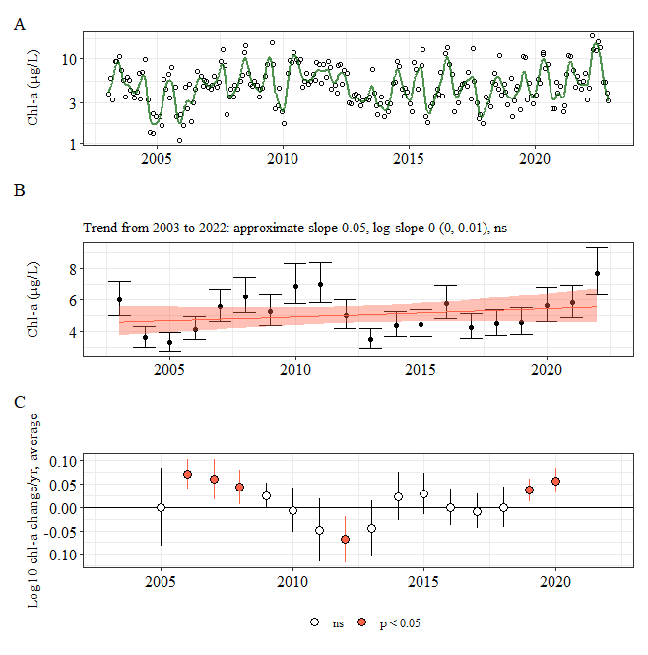

**Figure PI GAM and trend**

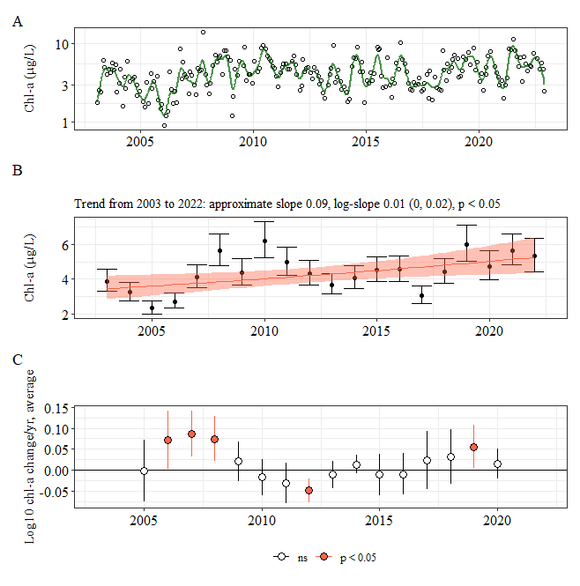

**Figure SS GAM and trend**

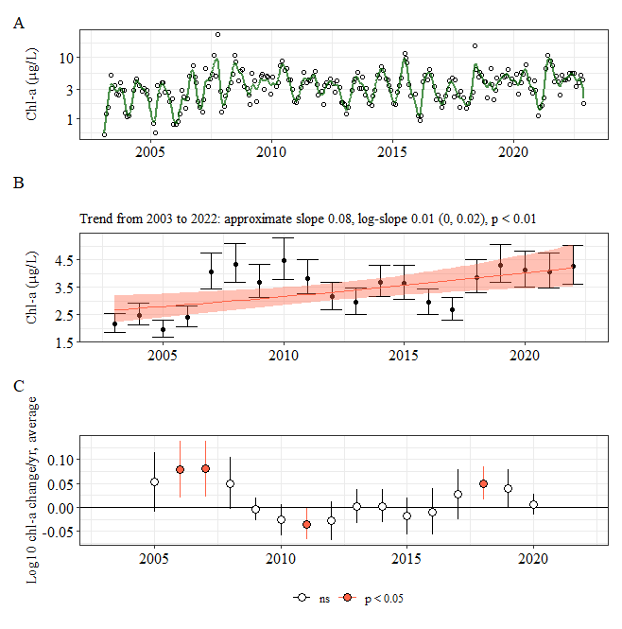

**Figure FM GAM and trend**

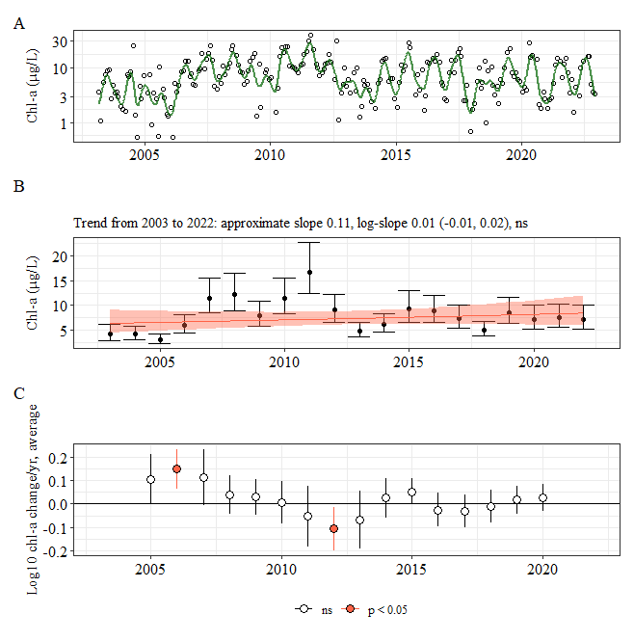

**Figure PC GAM and trend**

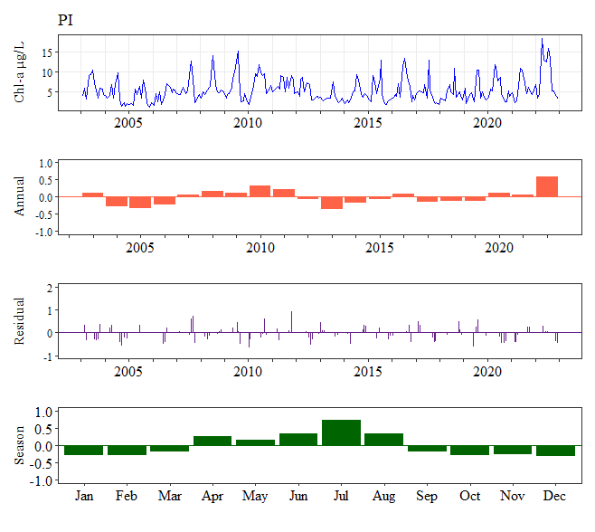

**Figure PI variability**

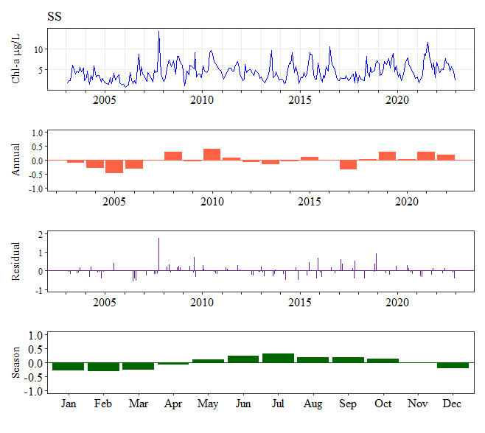

**Figure SS variability**

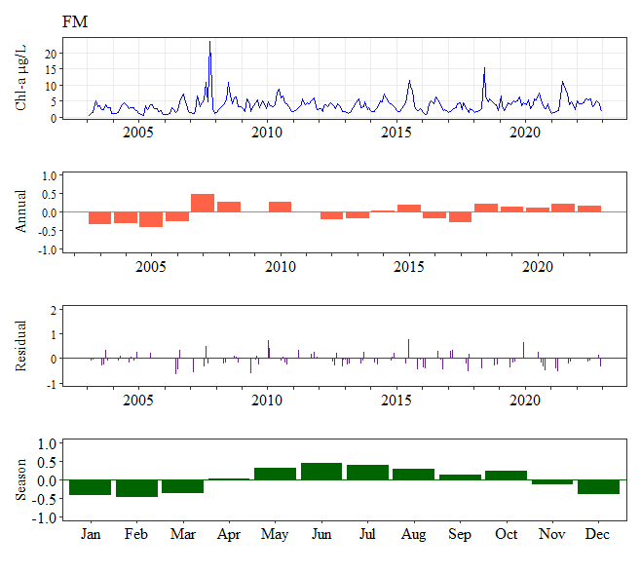

**Figure FM variability**

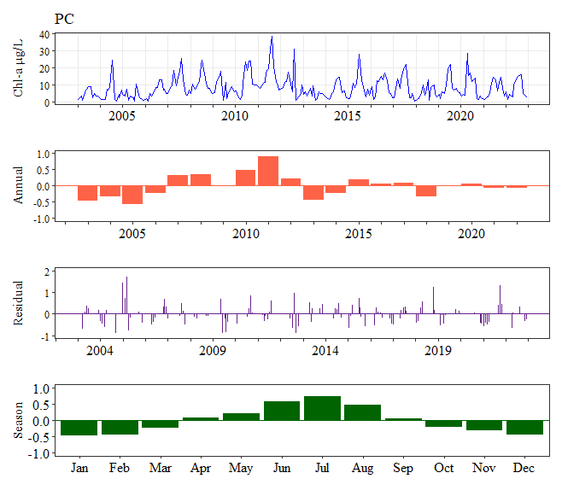

**Figure PC variability**

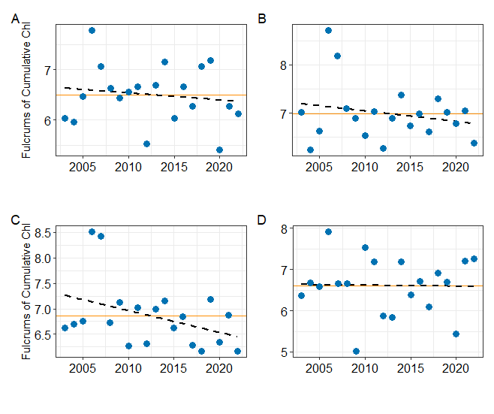

**Figure Fulcrums**

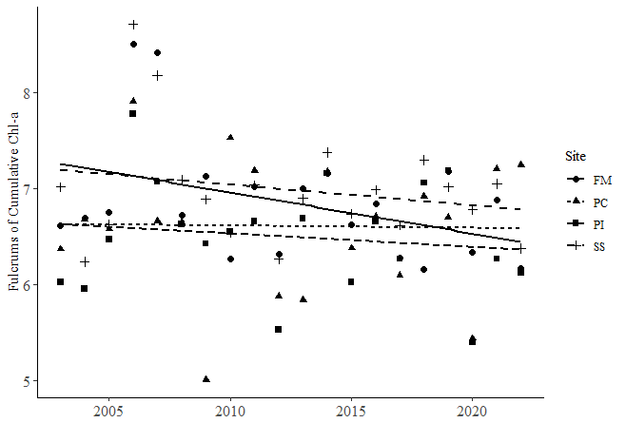

**Fulcrums combined plot**

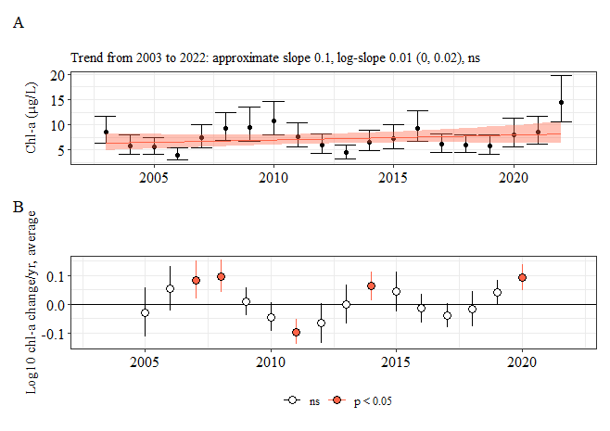

**Figure PI seasonal trends**

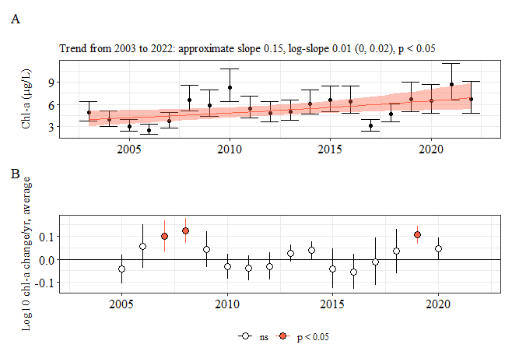

**Figure SS seasonal trends**

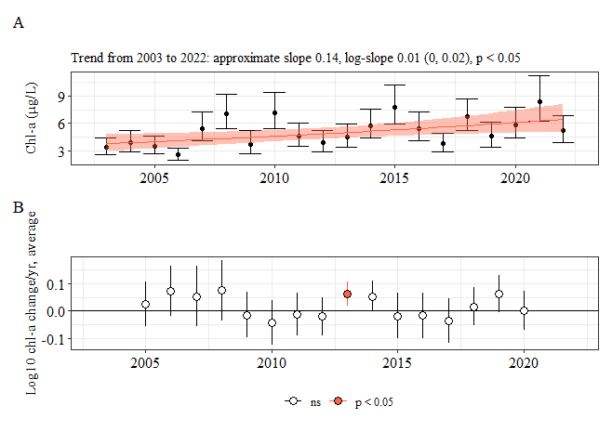

**Figure FM seasonal trends**

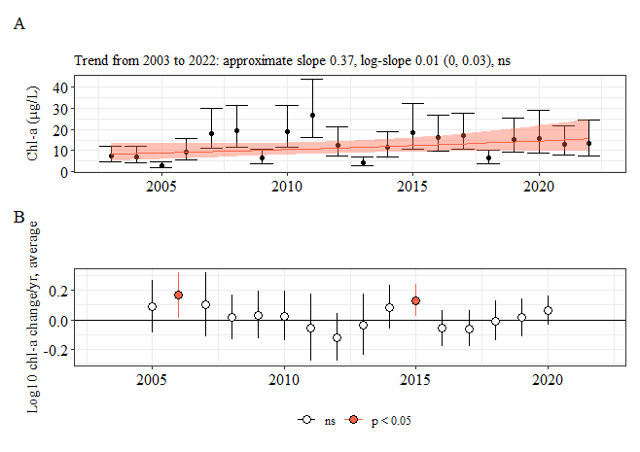

**Figure PC seasonal trends**

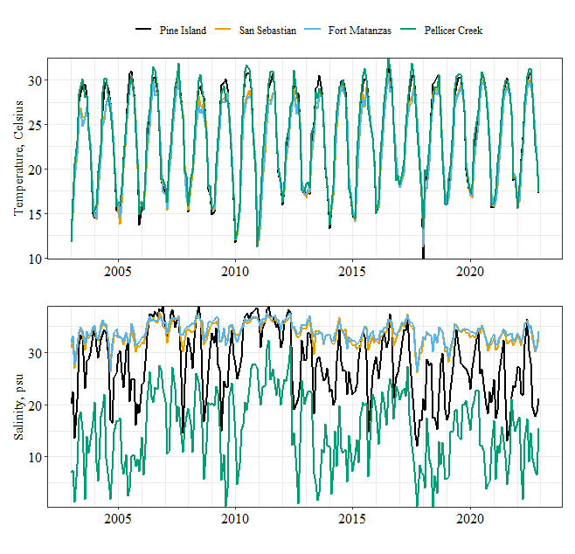

**Figure WQ Temp/Sal**

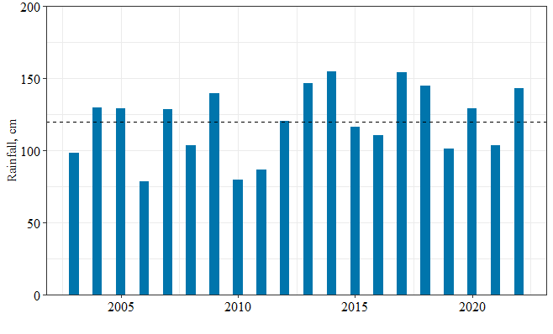

**Figure Annual Rainfall**

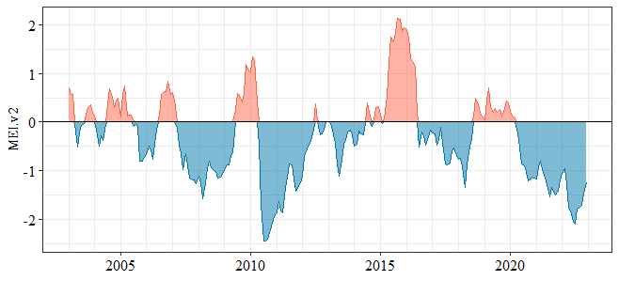

**Figure MEI index**

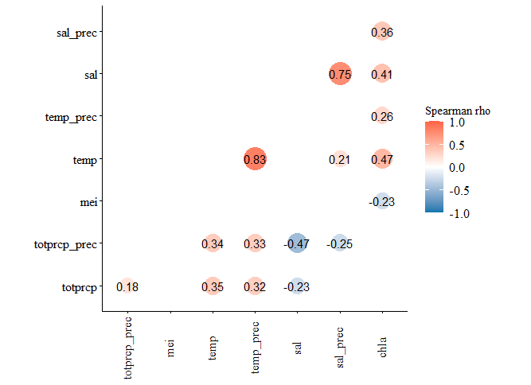

**Figure PI correlations**

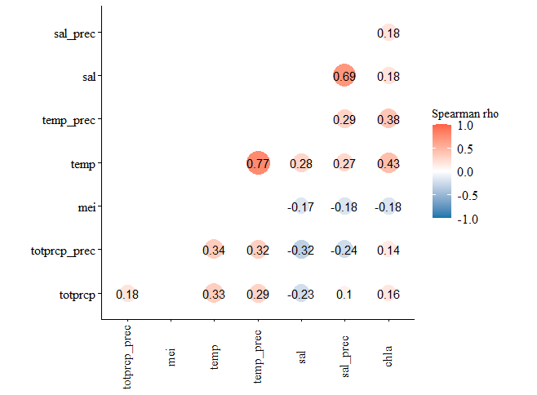

**Figure SS correlations**

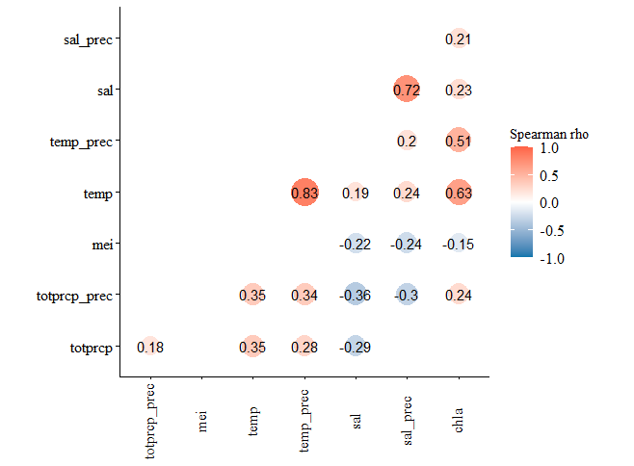

**Figure FM correlations**

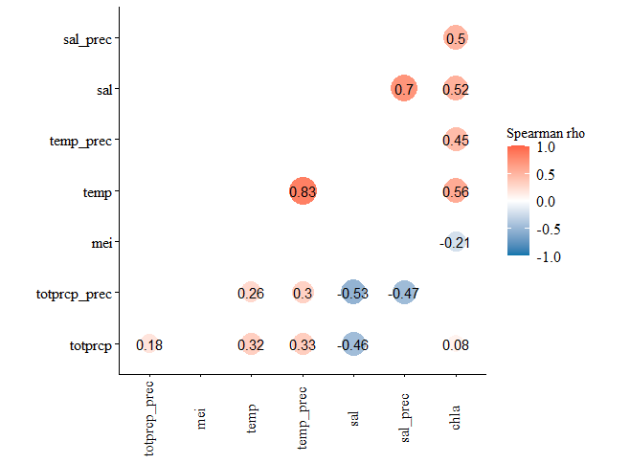

**Figure PC correlations**