Working Title: Event-driven trends and variability in chlorophyll *a* in a back-barrier lagoonal estuary in the southeastern United States

Shannon Dunnigan Kimmel*, Kathryn Petrinec,and Nicole Dix

Guana Tolomato Matanzas National Estuarine Research Reserve, Ponte Vedra Beach, FL 32082

*Corresponding author: [Shannon.Dunnigan@dep.state.fl.us](mailto:Shannon.Dunnigan@dep.state.fl.us)

ORCID: Kimmel: 0009-0004-6404-7008

ORCID: Dix: 0000-0002-0063-5167

Keywords: chlorophyll-a, Generalized Additive Model, Time Series, Phytoplankton variability, Estuaries

# Abstract

[providing space here]

# Introduction

Estuaries are productive ecosystems that provide valuable functions like nutrient cycling, flood water absorption, fisheries, and recreation (Day et al. 2023? …). Nutrient cycling and food web dynamics are driven largely by primary production carried out by autotrophic microalgae (Baker et al. 2021?). Therefore, phytoplankton biomass, estimated by concentrations of chlorophyll *a* in the water column, is a common indicator of ecosystem function (i.e., production and metabolism). This phytoplankton standing stock is the net result of various gain and loss processes (Cloern 2001, Dix et al. 2013), so chlorophyll *a* variability can be a helpful defining feature in estuaries (Cloern & Jassby 2010, others).

Estuaries are increasingly threatened by human activities and the response of these systems is quite variable over space and time (Cloern and Jassby 2010, others). Effective management of coastal ecosystems to sustain current status or to mitigate impacts requires information on how these systems have changed over time. Estuaries are naturally dynamic which can make discerning anthropogenic impacts difficult. Therefore, the use of observational information from long-term research and monitoring programs provides valuable information for place-based and adaptive strategies in the management of coastal ecosystems.

The System-Wide Monitoring Program (SWMP) of the National Estuarine Research Reserve System (NERRS) is an established long-term monitoring program that utilizes standardized protocols to collect water quality and meteorological data in a variety of estuarine environments across the United States and Puerto Rico. Due to the standardization of the program, and its well-developed and documented data management protocols for quality assurance and quality control, it serves as an excellent resource for helping to identify trends, patterns, and scales of variability in phytoplankton dynamics as well as their potential drivers within estuarine environments (System 2022).

One of thirty NERRS nationwide, the Guana Tolomato Matanzas National Estuarine Research Reserve (GTMNERR) has collected long-term data on water quality and meteorological conditions in the Guana-Tolomato-Matanzas (GTM) estuary since 2002. The GTM is a bar-built estuary within a temperate-subtropical ecotone. Bar-built estuaries are a relatively understudied estuary form in ecology, especially in subtropical and tropical latitudes. Some exceptions are Lagoona Madre (major driver freshwater flows, brown tides) and IRL (nutrient pollution, HABS especially where water residence times are long). In contrast to those estuaries, the GTM has high rates of oceanic exchange with two inlets (Sheng, Phlips, Dix), potentially making it more resistant to external disturbances than systems subject to hydrologic restriction via landforms or stratification. Over the last 20 years, however, urbanization in the GTM estuary watershed has been increasing (Kyzar et al. 2021, compare LULC in management plans over time?). Temperatures have also been rising (cite SWMPrats?). In fact, a lack of hard freeze events in recent decades has caused the distribution of cold-sensitive mangroves to expand and outcompete marsh grasses and forbes, especially in the Matanzas River (Rodriguez et al. 2006, Cavanaugh et al. 2014, Chapman et al. 2021). Given these changes, it is important to ask whether primary production in the water column has changed over time and whether climate and/or watershed influences may be driving those patterns.

The first objective of this study was to test for change over time in annual phytoplankton biomass (chlorophyll *a*) at stations varying in anthropogenic and oceanic influences. Given the trends in watershed urbanization and temperature, and subsequent predicted increases in nutrient loading and algal growth rates, we expected to detect increasing trends in chlorophyll *a* over time, especially at stations with most watershed influence.

The second objective of this study was to use variability in phytoplankton biomass (chlorophyll *a*) to investigate primary production dynamics and drivers of change in the GTMNERR. We used multiple methods to characterize annual, seasonal, and residual variability in chlorophyll *a* over 20 years (2003-2022) at the four GTMNERR monitoring stations. We also investigated drivers of variability in phytoplankton biomass by comparing years of significant change in chlorophyll *a* to anomalies in climate patterns and examining correlations between chlorophyll *a* and climate-related variables such as rainfall, salinity, and temperature.

Dix et al. (2013) found relatively low inter- and intra-annual variability in phytoplankton biomass at stations in the Matanzas River using eight years of GTMNERR SWMP data. Therefore, we hypothesized that chlorophyll *a* patterns in the GTM estuary over two decades would exhibit relatively low inter- and intra-annual variability.

* Phlips et al. 2004, Hart et al. 2015
  + Differences in stations
  + So we expected…

# Methods

## Study Area

The Guana, Tolomato, and Matanzas “rivers” are back-barrier, estuarine lagoons that trifurcate at the St. Augustine Inlet (Figure 1). The St. Augustine Inlet is one of two inlets in this system and it is stabilized with a jetty and maintained by the US Army Corps of Engineers to a depth of 5-m and the other, the Matanzas Inlet, is one of Florida’s few remaining unstructured inlets on the Atlantic Coast (Dean and O’Brien 1987). Overall, the GTM estuary is a well-mixed and well-flushed estuary with an absence of a freshwater river and a short residence time of approximately 12.6 days (Phlips et al. 2004; Sheng et al. 2008; Gray et al. 2021). The estuary is within a temperate-subtropical climatic ecotone dominated by salt marsh and mangrove habitats, intertidal oyster reefs, tidal creeks, mud flats, and open water (Williams et al. 2014; Bacopoulos et al. 2019). The GTM estuary hosts exceptionally intact and robust populations of eastern oysters (*Crassostrea virginica*) that filter ~60% of the estuary’s volume within a single residence time (Gray et al. 2021). It is likely these filtration services coupled with the short residence times keep phytoplankton biomass low (Dix et al. 2013; Hart et al. 2015).

The SWMP of the GTMNERR operates and maintains four water quality stations where instruments record continuous conditions and discrete water samples are collected monthly. Established in 2002, the station locations were selected to represent the influence of watersheds with varying degrees of urban development and reflect a diversity of physical processes (e.g., tidal exchange, freshwater input) and climatic conditions (Figure 1). Pine Island (PI) is located off of channel marker 25 in the Tolomato River surrounded by silviculture-dominated uplands in the northern portion of the GTM estuary. The Guana River runs parallel to the Tolomato on the seaward side, with the two lagoons joining 9.0 km north of the St. Augustine Inlet, approximately 8.4 km south of the PI station. The Tolomato River Basin converges with the Matanzas River and Salt Run from the south before flowing into the Atlantic Ocean at the St. Augustine Inlet.

San Sebastian (SS) is located at the confluence of the San Sebastian and Matanzas Rivers. The San Sebastian River drains an urbanized watershed in the western portion of St. Augustine. The Matanzas River estuary is approximately 32 km in length and extends 13 km south of the Matanzas Inlet. The tidal node within the Matanzas is located around the SR-206 bridge with waters flowing northward of the bridge and southward of the bridge at outgoing tides. Fort Matanzas (FM) is located at Channel Marker 75 approximately 3.8 km north of the Matanzas Inlet.

Pellicer Creek is located in the southern part of the Matanzas River Basin, serves as a border between St. Johns and Flagler counties, and is surrounded by public conservation lands. Pellicer Creek is a tidal creek and is the primary source of natural freshwater drainage into the Matanzas River. The Pellicer Creek water quality station (PC) is at the end of a recreational dock in Faver-Dykes State Park located within the Pellicer Creek Aquatic Preserve.

## Water Quality Data

The four water quality stations equipped with YSI EXO2 sondes deployed within one meter of the bottom recorded environmental parameters (e.g. temperature, salinity) every 15-minutes. Sondes were calibrated and maintained in accordance with the NERRS Centralized Data Management Office Standard Operating Procedures active at the time (NERRS 2022b). Temperature (°C) and salinity (practical salinity units, psu) data from each site was averaged by month. Data that failed to meet quality assurance and quality control check and that were flagged as “rejected” or “suspect” were removed for analysis.

Discrete water samples were collected in duplicate monthly during ebb tides from as close to sonde depth as possible (no deeper than 3 meters). Samples collected prior to December 2012 were filtered in the field onto a 0.7 µm pore size glass fiber filter immediately after collection. Samples collected beginning in December 2012 were collected as whole water samples in a dark brown, opaque, sampling bottle and stored in ice and shipped to the laboratory. Samples were then filtered onto a 1.2 µm or 0.7 µm (January 2002 – February 2019, March 2019 – December 2022, respectively) pore size glass-fiber filters in the laboratory immediately upon receiving samples. All samples were wrapped in foil and stored in the freezer (-20 °C) after filtration. Chlorophyll *a* was extracted from frozen filters within 28 days and analyzed using Standard Methods (SM10200H; citation). Duplicate samples were averaged by month. Values below the minimum detection limit of 0.55 µg/L were replaced with this nominal base to standardize across the dataset. As with the continuous data, chlorophyll *a* data that failed to meet quality assurance and quality control checks and were flagged as “rejected” or “suspect” were removed prior to analysis. Data flagged as “suspect” typically meant that the replicate values differed substantially, the lab analyzed an unpreserved sample, or that the laboratory reported that the result did not meet quality control measures. At PC, an automatic water sampler was usually deployed in addition to the discrete sample collection and set to collect from the same water depth. In some cases where PC was missing chlorophyll data, values were filled in with data collected at a similar time using the automatic sampler.

## Climate Data

Continuous meteorological data was collected at the Pellicer Creek weather station, approximately 2.6 km southeast of the Pellicer Creek water quality station. Rainfall data were totaled for each month and year after removing data that failed to meet quality standards. Information on El Niño/Southern Oscillation (ENSO) was downloaded from the National Oceanic and Atmospheric Administration’s Pacific Coast Laboratory (https://psl.noaa.gov/enso/mei/). The Multivariate ENSO Index (MEI) is based on multiple variables that are used to describe conditions in the tropical Pacific during ENSO events. This index is computed for 12 bimonthly rolling windows per year. This rolling window represented the sampling month and the one preceding it and was used to examine climate patterns during this study period.

## Data analysis

All statistical analyses and data visualizations were carried out using R v4.3.0 (R Core Team 2023). Generalized additive models on log10-transformed chlorophyll *a* data were performed for each station using the wqtrends package with the term *s*(“cont_year”), which was the day of the year converted into a continuous numeric variable and the upper limit of the basis complexity (*k*) was set to 11 times the number of years for the input data (11 * 20 = 220) (M. Beck et al. 2022; M. W. Beck et al. 2022). Diagnostic information of the model fit and procedure were checked using the mgcv package (Wood 2011). This model computed a smooth temporal pattern in the raw data with an uncertainty of the smoother for each station. The model results were then used to calculate trends in annual average chlorophyll *a* for the 20-year time period using meta-analysis where the season was set for January 1 to December 31 of each year. Changes in annual chlorophyll *a* were evaluated using a five-year moving window from 2003-2022. The slope is representative for the central year within each block (two years before and after) and thus the changes in slope and its significance were used to identify change points in the timeseries as well as years of significant interest.

We employed the conceptual framework of Cloern and Jassby (2010) to characterize stations with respect to patterns and scales of variability in chlorophyll *a*. Equation 4 from Cloern and Jassby (2010) was applied to the monthly chlorophyll *a* data series (Equation 1).

Equation 1: $c_{ij}=C_{y_{i}}m_{j}ε_{ij}$

This multiplicative model partitions variability into three components in addition to the long-term mean (*C*) where $c_{ij}$ is the chlorophyll concentration in year *i* (*i*=1,…,N) and month *j* (*j* = 1,…,12); *yi* is the annual effect in the *i*th year; *mj* is the seasonal (monthly) effect in the *j*th month; and $ε_{ij}$ is the residual. Each of the terms measures (multiplicative) deviation of mean chlorophyll *a* whereby values >1 indicates years (*yi*), months (*mj*), and events ($ε_{ij}$) with above average chlorophyll *a*. Together, the components average to 1 and are multipliers of *C*, so their magnitudes are independent of overall mean biomass and are comparable across sites (and ecosystems), and their standard deviations are coefficients of variation.

Seasonality was explored not only through decomposition, but also by testing for changes in phenology of phytoplankton biomass using wql package and the filled chlorophyll *a* data. As an indicator of peak annual biomass, phenoPhase() was used to calculate the fulcrum or “center of gravity” as the month each year when the cumulative chlorophyll *a* reached half the total annual cumulative chlorophyll *a* (Greve et al. 2005; Cloern et al. 2023). Fulcrums were then examined by station and by station type: marine-influenced (SS and FM) and freshwater-influenced (PI and PC).

A complete dataset with no missing data gaps was required to use the decomposition analysis from Cloern and Jassby (2010) and to explore seasonality in phytoplankton biomass using functions in the wql package (Jassby and Cloern 2022). Therefore, the predicted values from the GAMs were used to fill in missing data at all sites (Table A1).

Spearman’s rank correlations were used to nonparametrically determine monotonic associations between the monthly chlorophyll *a* averages and climatic indicators that could be potential drivers of the chlorophyll *a* patterns. Chlorophyll *a* data used for this analysis was the original data from the monitoring program and did not include predicted values from the GAMs. The monthly chlorophyll *a* values were compared against the MEI index, salinity, temperature, and rainfall for both the months when the chlorophyll *a* samples were collected and the preceding months to represent precedent conditions. For the temperature, salinity, and rainfall data, monthly aggregations were performed on 15-minute continuous data. Rainfall was monthly totals. Salinity and temperature had three types of aggregations: overall monthly average, and then the monthly average of daily minimums and maximums.

# Results

## Chlorophyll patterns

Overall, the GAMs provided a good fit to the chlorophyll *a* data and explained greater than 70% of deviance (range: 71 - 87%) at all sites (Table 1). Significant trends in annual chlorophyll *a* over the 20-year period (2003-2022) were detected at SS and FM, increasing at 0.09 µg/L/yr and 0.08 µg/L/yr, respectively (PI GAM, SS GAM, FM GAM, PC GAM, Table 2). All sites showed increasing trends within the first decade of the monitoring and within the last five years. Unlike the other three stations, chlorophyll *a* at PI significantly increased in the last ten and five years of the time series (Table 2).

An intra-annual unimodal pattern in average chlorophyll *a* was visible at all stations (Figure PI GAM, SS GAM, FM GAM, PC GAM). Also common among stations was an interannual pattern in chlorophyll *a* with low values in 2005, high values in 2010 – 2011, and low values in 2012 – 2013 (Figure PI GAM, SS GAM, FM GAM, PC GAM). Annual chlorophyll averages plateaued from 2019 – 2022 at SS, FM, and PC but continued to trend upward through 2022 at PI. Significant change points were observed on a nearly decadal cycle (Figure PI GAM, SS GAM, FM GAM, PC GAM).

**Figure changepoint**. Years of significant change points in annual chlorophyll *a*. Red years indicate positive change (increasing slopes), blue years indicate negative change (decreasing slopes).

|  |  |  |  |  |  |  |  |  |  |  |  |  |  |  |  |  |
| --- | --- | --- | --- | --- | --- | --- | --- | --- | --- | --- | --- | --- | --- | --- | --- | --- |
|  | ‘05 | ‘06 | ‘07 | ‘08 | ‘09 | ‘10 | ‘11 | ‘12 | ‘13 | ‘14 | ‘15 | ‘16 | ‘17 | ‘18 | ‘19 | ‘20 |
| PI |  |  |  |  |  |  |  |  |  |  |  |  |  |  |  |  |
| SS |  |  |  |  |  |  |  |  |  |  |  |  |  |  |  |  |
| FM |  |  |  |  |  |  |  |  |  |  |  |  |  |  |  |  |
| PC |  |  |  |  |  |  |  |  |  |  |  |  |  |  |  |  |

Low annual and seasonal variability was observed at all stations (Table 3). All scales of variability were larger at PC than the other sites. The largest coefficient of variation was the event-scale variability observed at PC (SDɛ = 0.51) (Table 3). PI and PC show similar patterns to one another as do SS and FM (Figures X-X). Seasonally, PI and PC experienced higher chlorophyll *a* from April – August (Figures X-X), while SS and FM showed a protracted seasonal pattern extending from May – October (Figures X-X).

Average fulcrum months at all sites ranged between (6.50-6.99) indicating peak values in chlorophyll *a* concentration occurring mostly in the middle to late part of June (Figure Fulcrums). There was no significant trend in fulcrum months over time (p = ___), but deviations in fulcrum timing from average (e.g., late fulcrums in 2006 - 2007 and early fulcrums in 2012 and 2020 at some stations) may provide insights into drivers of phytoplankton biomass accumulation. The widest range in fulcrums occurred at PC (months 5.01 – 7.91) and a similar but narrower range was observed at PI (5.40 – 7.78). Fulcrum months at SS and FM (6.24 – 8.71 at SS and 6.16 – 8.51 at FM) were later than at PI and PC.

## Climate and environmental drivers

Water temperatures typically were similar at all sites (Figure WQ Temp/Sal, Table 4). Drops in average water temperatures in the winter were notable in 2002-2003, 2010-2011, 2011-2012, and 2017-2018, an approximate eight-year return interval. SS and FM are more saline stations with average salinities in the 33-34 psu range. PI and PC are further from inlets and experience more brackish conditions with average salinities between 15-27 psu (Table 4). PC also frequently has low salinities compared to all other sites (Figure WQ Temp/Sal).

Describe Figure Annual Mins and Max Temp and Salinity in terms of any patterns that help explain any of the patterns we observed in CHL

Average annual rainfall for the 20-year period was 112 cm (Figure Annual Rainfall). The years with the largest deviation from average rainfall were 2006 and 2010, both lower than average. More periods of La Niña conditions were observed than El Niño (Figure MEI index). Strong La Niña conditions were observed in 2010-2012, and strong El Niño conditions were observed between 2015-2017. There was an extreme shift from El Niño to La Niña in 2010-2011, which corresponded to lower than average minimum temperatures and rainfall totals.

Correlated monotonic associations between chlorophyll *a* and climate variables were observed at all stations (Table 5). Temperature the same month of sampling was the most related variable to chlorophyll *a* (positively) all stations. Salinity was positively correlated with chlorophyll *a* at all stations. Rainfall was not significantly correlated with chlorophyll *a* at PI at all and was weakly positively correlated at other stations. MEI was weakly negatively correlated with chlorophyll *a* at all stations.

# Discussion

Summarize findings relative to objectives and expectations…

Long-term trends…

* Contrary to expectations, 20-year trends were detected at the stations with least watershed influence (SS and FM). Higher variability at PI and PC…

Patterns in variability…

Cloern and Jassby (2010) provided a conceptual framework for establishing and comparing variability in chlorophyll *a* when they examined 84 estuarine-coastal sites and established underlying patterns in site-specific relative importance of disturbance, annual climate cycles, and levels of nutrient enrichment. For example, sites with regular seasonal patterns in chlorophyll *a* were found to largely be driven by annual cycles such as bivalve grazing pressure which oscillate over the annual temperature cycle. Sites with large annual variability were commonly attributed to disturbance from natural events (e.g. hurricanes) or human actions (implementation of policies that reduced nutrient input into waterways).

Of the 84 sites compared in Cloern and Jassby (2010), North-Inlet exhibited small interannual variability and strong seasonal patterns and in chlorophyll *a* were associated with the seasonal filtration rates of native oyster populations. The GTM estuary is thought to exhibit similar patterns as North-Inlet due to bivalve grazing pressure from oysters and high tidal exchange supporting (Dix et al. 2013).

The GTM estuary has previously been described as similar to North-Inlet in physiochemical factors such as temperature and salinity (Apple et al. 2008) as well as in patterns in community structure and seasonality of ichthyoplankton ingression (Korsman et al. 2017).

Drivers of change…

* nutrient enrichment can alter coastal ecosystems, often first with increases in algal production,...
* Nutrient inputs are not the only drivers in these systems, as climate also plays a large role in long-term conditions. In Chesapeake Bay, precipitation and tropical cyclone activity result in variable phytoplankton production coupled with underlying increases in chlorophyll *a* due to eutrophication (Harding et al. 2016). In the Indian River Lagoon and St. Lucie estuaries, variability in phytoplankton blooms have been attributed to cyclical patterns (e.g. El Niño/La Niña periods) and tropical cyclone events, as these events bring large amounts of precipitation (Phlips et al. 2020; Phlips et al. 2021). There are also systems like the San Francisco estuary which, though nutrient-enriched, do not experience water quality impacts common to other enriched systems (like frequent phytoplankton blooms or low dissolved oxygen) attributed to a variety of variables such as strong tidal flushing and heavy phytoplankton grazing pressure from bivalves (Jassby 2008; Cloern and Jassby 2010; Cloern 2019). Additionally, the issue of nutrient pollution is not isolated to developed watersheds. Watersheds with low levels of development have been found to exhibit high levels of nutrient and chlorophyll *a* concentrations, such as the tidal creeks in the Ashepoo-Combahee-Edisto Basin in South Carolina (Keppler et al. 2015). In the GTM estuary, we found…
* What do the results show?
  + Low inter- and intra- annual variability in chl-a at all sampling stations.
  + PC had highest variability in event-scale variability (though all sites did as well)
  + Only FM and SS had significant long-term annual trends in chl-a, which was similar to seasonal trend analysis patterns as well.
  + Sites can be grouped spatially by PI:PC and FM:SS by intra-annual patterns (seasonal variation and range of annual chl-a fulcrums) and range in chl-a (typically much lower at FM:SS than PI:PC).
  + Significant periods of change correspond to periods of drought (2006-2008) and significant weather events (particularly cold snaps 2010-2012, 2018).
* Given the lack of recent information regarding the status of water quality or nutrients within this system, the access of a robust water quality time series, and the continued increase in coastal population density pressure in the region (Kyzar et al. 2021), this study uses the established long-term continuous monitoring framework of the NERRS SWMP to establish trends, patterns, and scales in variability of chlorophyll *a* for a 20-year time period (2003-2022) while providing some potential drivers of that variation.
* The last study to have performed any trend or status of the GTM estuary was performed almost 20 years ago in 2004 using monitoring data collected by the St. Johns River Water Management District (Winkler and Ceric 2004). Their assessment encompassed a suite of water quality indicators which included chlorophyll *a*. At that time, the Northern Coastal Basin, which includes the GTM estuary, was found to have some of the best water quality out of all the basins in the District; however, many of the sites, though deemed of good water quality, provided insufficient data (did not have at least 10 years of data) or had insignificant results for trend tests (Winkler and Ceric 2004).
* Previous studies in the region were conducted at shorter time scales (8-10 years) and did not include all 4 sites, which span the GTM estuary.
  + Dix et al. 2013
    - also used the Cloern and Jassby 2010 calculations for variability in chl-a, but only at FM and SS and only for an 8-year window (2003-2010). The values were much higher than those calculated in this study (suggesting expanding the time frame reduced the variation observed) but FM was still higher than SS even in this study. Like this study, **residual (event-driven) variability was the largest amount of variation** suggesting….
    - Temperature and light availability were not found to play major roles in limiting production, but chl-a concentration was strongly related to temp.
    - High productivity, but low chl-a concentrations showing balance of gain and losses associated with flushing and grazing by zooplankton and filtration by oysters.
    - 2007 *Karenia* *brevis* bloom event within the system – largest event and chla values at FM even in the 20-year period. ***Event-driven variation***
    - Largest monthly rainfall in entire time period was in May 2009, low pressure system (0.45m, 45cm)
  + Hart et al. 2015
    - included PI (expanding beyond Dix et al. 2013) and further investigated flushing and nutrient loading as contributors to phytoplankton biomass and composition, expanding to include communities.
    - Spatial and temporal differences (residence times and rainfall levels) in phytoplankton biomass were found between sites.
    - Found a lack of significant positive relationships between nutrient loads, nutrient concentrations and phytoplankton biomass.
    - PI had higher chl-a concentrations, but lower nutrient loads. It also has the highest residence times compared to FM and SS.
    - Rainfall-related changes in regional flushing rates: negative relationship between high rainfall periods to chl-a biomass. Chl-a generally peaked before major rainfall events or during periods of low rainfall, suggesting increased flushing rates and decreases in salinity as more contributing factors.
    - Community composition varies associated with residence times with faster-growing phytoplankton groups found at FM and SS compared to PI (larger microphytoplankton species, centric diatoms) and FM and SS having higher top-down pressure (larger oyster populations). Lots of small fast-growing species observed (high water turnover rates and low probability of extended periods of nutrient limitation).
* So, 20 years of data tells us more than 10 (or less), but what will 30 and more years of data tell us? How did our interpretations change going from 10 to 20 years? Does that tell us anything about our estuary?
* PI and PC show much similar patterns to one another in terms of variability, trends, duration of seasons and range of fulcrums. FM and SS also behave similarly to one another suggesting that proximity to the inlets (and potentially higher flushing rates) play a larger role in the classification of these sites.
* What are the residence time differences across these sites? could this be a contributing factor in their patterns? Gray et al. 2021 also took depth and “intertidal volume” into consideration…what about that?
* Gray et al. 2021:
  + Higher residence times in areas with higher intertidal area and length of tidal network (e.g., main channels and rivers). Lower residence times were found in areas with higher subtidal area.
  + Overall, 12.6 days for whole estuary

|  |  |  |
| --- | --- | --- |
| Station | Watershed-scale residence time (days) | Watershed-scale residence time per unit of intertidal watershed (days/km-2) |
| Pine Island | 16.1 | 0.71 |
| San Sebastian | 5.5 | >30 | 2.02 | 3.62 |
| Fort Matanzas | 9.3 | 1.08 |
| Pellicer Creek | 17.8 | 2.16 |

* + Watershed-scale residence time lowest at SS and FM and highest at PC and PI. With intertidal watershed taken into consideration, PI had the lowest residence time over all four stations and SS and PC were more comparable.
  + Higher residence time at FM as a result of lower fluxes moving through Matanzas Inlet compared to the St. Augustine Inlet (5.5 at SS) along with increased salt marshes and longer tidal network.
  + The high watershed-scale residence time in Pine Island is due to the presence of the Tolomato River, which mitigates the effect of the large intertidal area in the area.
  + The SS station is located at the boundary between two very different watersheds: one which the San Sebastian River and the large subtidal area contribute to a small residence time (5.5 d) and one in which the shallow areas of the Matanzas River and Moultie Creek trap particles from the study limiting their removal and providing residences times greater than 30 d.
* The sites are spread out throughout the estuary and there are zones of productivity that are likely not captured within the monthly long-term monitoring of the SWMP stations, such as the high area of production in the Pellicer Flats area at the mouth of Pellicer Creek (Brown et al. 2023).
* Bivalve grazing seasons, spat patterns (peaks in the fall) – how do these tie in with the chl-a patterns observed in this data?
  + Marcum et al. 2018:
    - Establish oyster densities in regions for further comparison with residence times:
      * Suggest local decline in oyster populations between reefs sampled by Dix in 2009-2010 and the GTM Monitoring in 2014-2015. Mean density was approximately half of what was previously observed – but reefs in the region are conditionally approved for harvest.
      * Taller reefs in the northern region than southern – likely influenced by tidal range and depth of inundation; though some of the flattest reefs were observed in Salt Run at the inlet, in the middle of the study region, but heavy harvest pressure (though actual harvest region in Salt Run is small).
      * Highest spat observed in Pellicer Flats, but this high abundance of sub-size oysters suggests external pressures such as disease, toxicity, hydrology, and/or predation. The presence of predatory crown conchs in the region linked to drought and increased salinity (Garland and Kimbro 2015). However, lower salinities can also contribute declined growth rates in oyster populations and therefore increased freshwater discharge from Pellicer Creek could also play a significant role in oyster populations in the region.
      * Higher sediment cover in summer than in winter on reefs – suggests increased biological activity (bio-deposits from oysters and reef-associated filter feeders in summer months).
      * High energy Nor’easters during the winter months reduce sedimentation
      * Differences in winter:summer oyster densities between this monitoring and Dix et al. 2013 were attributed to higher winter temperatures during the sampling period of monitoring (2015-2016).
      * *The heavy emphasis on bivalve grazing pressure at mitigating chlorophyll concentrations in the GTM, further supports that potential drivers in chlorophyll a concentrations may not affect chlorophyll a concentrations directly, but in their impact on aspects of the drivers that balance the gain and losses (like oyster recruitment and grazing) of productivity in the GTM. Cloern et al. 2023 found that it was not temperature that was associated with seasonal phytoplankton biomass, but the changing abundance of bivalve filter feeders or their predators.*
* Cloern et al. 2023
  + Changes in phytoplankton phenology are not necessarily responses to or indicators of global warming, but indicators of human disturbance and natural climate oscillations.
  + Biomass can change rapidly and at any time when the balance between productivity and consumption is altered.
* All GTM sites fall within the range of values in coefficients of variation to Cloern and Jassby 2010. The higher values at PC for both annual and seasonal variability suggest slightly more disturbance and influence of the annual cycle at this station compared to others, however even still, this location does not stand out across the other 84 sites in their study.
  + High inter-annual variability is an indicator of systems that are sensitive to variability in nutrient loads (Cloern and Jassby 2010). Therefore, low rates observed in the GTM suggest a lack of sensitivity on annually variable events (like nutrient input)
* Dunn et al. 2023 found increasing chlorophyll in the recent years (2014-2020) of their long-term study in the North-Inlet station – these are suggested to be driven by increased porewater flux volumes and NH4+ related to sea level rise (though a 4-year lag was observed between elevated NH4+ and the chl-a response). They also discuss the lack of increased precipitation (a documented potential driver of nutrient export) observed in North Inlet, further supporting environmental changes in associated with climate warming (sea level rise) as being the main driver in their data.
* All sites had relatively strong (~0.4-0.5) correlations with temperature and chlorophyll *a*, particularly FM. Salinity was more of an influence at PI and PC than SS and FM. Rainfall was significant at SS for both preceding and current month of chl-a samples. PC was the current month (though weak) and FM was the preceding month – likely showing the influence of precipitation and time lag between PC and FM stations.
* 2006 was a drought year, followed by a year with above average rainfall (including the large May 2007 rainfall event). This period of time had the most significant positive rates of change in chlorophyll at most sites.
* 2009-2010 and 2010-2011 had cold snaps in back-to-back winter seasons. There was also very little annual rainfall during this time and high saline conditions. Significant decreases in chl-a were observed within this window of time.
  + Patterns in minimum temperatures are known to be structuring elements of ecotonal environments (references). In the GTM estuary, freezing temperatures of a certain threshold drive mangrove distribution (refs), but this study shows that the open water habitats and plankton community may also be tightly linked to cold events. Food web implications?
  + Cold snaps and hypersaline conditions (due to drought) during this time were attributed to the widespread and protracted decline in seagrass and drift macroalgal communities in the IRL, which altered sources of nutrients toward phytoplankton (Phlips et al. 2021)
  + High saline values were observed in 2006, 2008, 2010-2011, 2012, 2016, 2017 supporting periods of change in the chlorophyll time series.
  + Highest salinities in PC were observed in 2011 and 2012 (May-June, April-May, respectively)
* 2004, 2005, 2016, and 2017 were all active hurricane seasons.
  + 2004 hurricanes on water quality? (Dix et al. 2008)
  + Influence of Irma on fDOM export and tidal flushing? (Schafer et al. 2021 and Brown et al. 2023)
    - FM had a significantly high rate of change in seasonal peak biomass found in 2018 – could be related to export from Irma?
* High rainfall and winds associated with major storms (and nor’easters??) can increase external and internal (e.g., sediment resuspension and benthic biomass disruption) nutrient loads that support bloom development. Such as Irma which was followed by a major bloom event in the IRL which started in the winter of 2017 and extended into 2018 (Phlips et al. 2021)
* Role of Nor’easters in the patterns in this study??
  + Callahan et al. 2022 found that midlatitude weather systems can produce surges just as severe and occur more frequently than tropical cyclones and they peak during the cold season (November – March). How does this contribute to residence times (lack of low-tide events, reduced rates of turnover, higher water levels for a prolonged period of time, etc) during the winter season?
* In the southeastern United States, El Niño and La Niña periods are associated with wetter and dryer than average conditions, respectively (Schmidt and Luthor 2002). El Niño periods are noted for having elevated rainfall levels in the dry season (i.e., late fall through early spring, like increased hurricanes).
  + Higher peaks in bloom biomass were found during El Nino periods than La Nina periods in the IRL (Phlips et al. 2021). The negative associated with the MEI index and chl-a in this study, suggests a similar relationship, though not nearly as strong. In Baffin Bay, Texas, high rainfall El Nino periods were found to decrease intense brown tide blooms due to elevated flushing rates and reduced salinities (Cira et al. 2021). **Highlights importance on regional differences in ecosystem characteristics when it comes to determining the effects on HAB dynamics.**
  + ENSO events and their influence on rainfall levels were found to be of high importance in the IRL, mostly in their impact on external nutrient loading.

# References

Apple, J. K., E. M. Smith, and T. J. Boyd. 2008. Temperature, salinity, nutrients, and the covariation of bacterial production and chlorophyll-a in estuarine ecosystems. *Journal of Coastal Research*: 59–75. <https://doi.org/10.2112/SI55-005.1>.

Bacopoulos, P., A. S. Tritinger, and N. G. Dix. 2019. Sea-Level Rise Impact on Salt Marsh Sustainability and Migration for a Subtropical Estuary: GTMNERR (Guana Tolomato Matanzas National Estuarine Research Reserve). *Environmental Modeling & Assessment* 24: 163–184. <https://doi.org/10.1007/s10666-018-9622-6>.

Beck, M. W., P. De Valpine, R. Murphy, I. Wren, A. Chelsky, M. Foley, and D. B. Senn. 2022. Multi-scale trend analysis of water quality using error propagation of generalized additive models. *Science of The Total Environment* 802: 149927. <https://doi.org/10.1016/j.scitotenv.2021.149927>.

Beck, M., P. de Valpine, R. Murphy, I. Wren, A. Chelsky, M. Foley, and D. Senn. 2022. Wqtrends: Assess water quality trends with generalized additive models.

Cloern, J. E. 2019. Patterns, pace, and processes of water-quality variability in a long-studied estuary. *Limnology and Oceanography* 64. <https://doi.org/10.1002/lno.10958>.

Cloern, J. E., and A. D. Jassby. 2010. Patterns and Scales of Phytoplankton Variability in EstuarineCoastal Ecosystems. *Estuaries and Coasts* 33: 230–241. <https://doi.org/10.1007/s12237-009-9195-3>.

Cloern, J. E., T. S. Schraga, E. Nejad, and T. Eddy. 2023. Phytoplankton as indicators of global warming? *Limnology and Oceanography Letters*: lol2.10354. <https://doi.org/10.1002/lol2.10354>.

Dean, R. G., and M. P. O’Brien. 1987. [*Florida’s east coast inlets: Shoreline effects and recommeded action*](http://hdl.handle.net/1834/18098). University of Florida.

Dix, N., E. Phlips, and P. Suscy. 2013. Factors Controlling Phytoplankton Biomass in a Subtropical Coastal Lagoon: Relative Scales of Influence. *Estuaries and Coasts* 36: 981–996. <https://doi.org/10.1007/s12237-013-9613-4>.

Freeman, L. A., D. R. Corbett, A. M. Fitzgerald, D. A. Lemley, A. Quigg, and C. N. Steppe. 2019. Impacts of Urbanization and Development on Estuarine Ecosystems and Water Quality. *Estuaries and Coasts* 42: 1821–1838. <https://doi.org/10.1007/s12237-019-00597-z>.

Gray, M. W., D. Pinton, A. Canestrelli, N. Dix, P. Marcum, D. Kimbro, and R. Grizzle. 2021. Beyond Residence Time: Quantifying Factors that Drive the Spatially Explicit Filtration Services of an Abundant Native Oyster Population. *Estuaries and Coasts* 45: 1343–1360. <https://doi.org/10.1007/s12237-021-01017-x>.

Greve, W., S. Prinage, H. Zidowitz, J. Nast, and F. Reiners. 2005. [On the phenology of north sea ichthyoplankton](https://doi.org/10.1016/j.icesjms.2005.03.011). *ICES Journal of Marine Science* 62: 1216–1223.

Harding, L. W., C. L. Gallegos, E. S. Perry, W. D. Miller, J. E. Adolf, M. E. Mallonee, and H. W. Paerl. 2016. Long-Term Trends of Nutrients and Phytoplankton in Chesapeake Bay. *Estuaries and Coasts* 39: 664–681. <https://doi.org/10.1007/s12237-015-0023-7>.

Hart, J. A., E. J. Phlips, S. Badylak, N. Dix, K. Petrinec, A. L. Mathews, W. Green, and A. Srifa. 2015. Phytoplankton biomass and composition in a well-flushed, sub-tropical estuary: The contrasting effects of hydrology, nutrient loads and allochthonous influences. *Marine Environmental Research* 112: 9–20. <https://doi.org/10.1016/j.marenvres.2015.08.010>.

Jassby, A. D. 2008. Phytoplankton in the Upper San Francisco Estuary: Recent Biomass Trends, Their Causes, and Their Trophic Significance. *San Francisco Estuary and Watershed Science* 6. <https://doi.org/10.15447/sfews.2008v6iss1art2>.

Jassby, A. D., and J. E. Cloern. 2022. [Wq: Exploring water quality monitoring data](https://CRAN.R-project.org/package=wq).

Keppler, C., D. Bergquist, L. Brock, J. Felber, and D. Greenfield. 2015. A spatial assessment of baseline nutrient and water quality values in the ashepoo–combahee–edisto (ACE) basin, south carolina, USA. *Marine Pollution Bulletin* 99: 332–337. <https://doi.org/10.1016/j.marpolbul.2015.07.035>.

Korsman, B. M., M. E. Kimball, and F. J. Hernandez. 2017. Spatial and temporal variability in ichthyoplankton communities ingressing through two adjacent inlets along the southeastern US Atlantic coast. *Hydrobiologia* 795: 219–237. <https://doi.org/10.1007/s10750-017-3131-5>.

Kyzar, T., I. Safak, J. Cebrian, M. W. Clark, N. Dix, K. Dietz, R. K. Gittman, et al. 2021. Challenges and opportunities for sustaining coastal wetlands and oyster reefs in the southeastern United States. *Journal of Environmental Management* 296: 113178. <https://doi.org/10.1016/j.jenvman.2021.113178>.

Phlips, E. J., S. Badylak, N. G. Nelson, L. M. Hall, C. A. Jacoby, M. A. Lasi, J. C. Lockwood, and J. D. Miller. 2021. [Cyclical patterns and a regime shift in the character of phytoplankton blooms in a restricted sub-tropical lagoon, indian river lagoon, florida, united states](https://www.frontiersin.org/articles/10.3389/fmars.2021.730934). *Frontiers in Marine Science* 8.

Phlips, E. J., S. Badylak, N. G. Nelson, and K. E. Havens. 2020. Hurricanes, El Niño and harmful algal blooms in two sub-tropical Florida estuaries: Direct and indirect impacts. *Scientific Reports* 10: 1910. <https://doi.org/10.1038/s41598-020-58771-4>.

Phlips, E. J., N. Love, S. Badylak, P. Hansen, J. Lockwood, C. V. John, and R. Gleeson. 2004. A Comparison of Water Quality and Hydrodynamic Characteristics of the Guana Tolomato Matanzas National Estuarine Research Reserve and the Indian River Lagoon of Florida**. *Journal of Coastal Research* 10045: 93–109. <https://doi.org/10.2112/SI45-093.1>.

R Core Team. 2023. [*R: A language and environment for statistical computing*](https://www.R-project.org/). Vienna, Austria: R Foundation for Statistical Computing.

Sheng, Y. P., B. Tutak, J. R. Davis, and V. Paramygin. 2008. Circulation and Flushing in the Lagoonal System of the Guana Tolomato Matanzas National Estuarine Research Reserve (GTMNERR), Florida. *Journal of Coastal Research* 10055: 9–25. <https://doi.org/10.2112/SI55-002.1>.

NOAA National Estuarine Research Reserve System (NERRS). 2022a. System-wide Monitoring Program Data Management Manual, v6.7. Centralized Data Management Office: www.nerrsdata.org. 201pp.

NOAA National Estuarine Research Reserve System (NERRS). 2022b. YSI/Xylem EXO Multi-Parameter Water Quality Monitoring Standard Operating Procedure, v2.2. Centralized Data Management Office: www.nerrsdata.org. 37pp.

Williams, A. A., S. F. Eastman, W. E. Eash-Loucks, M. E. Kimball, M. L. Lehmann, and J. D. Parker. 2014. Record Northernmost Endemic Mangroves on the United States Atlantic Coast with a Note on Latitudinal Migration. *Southeastern Naturalist* 13: 56–63. <https://doi.org/10.1656/058.013.0104>.

Winkler, S., and A. Ceric. 2004. *Status and Trends in Water Quality at Selected Sites in the St. Johns River Water Management District*. Palatka, Florida.

Wood, S. N. 2011. Fast stable restricted maximum likelihood and marginal likelihood estimation of semiparametric generalized linear models 73: 3–36.

**Table 1**. Generalized additive model output for models fit to chlorophyll *a* monthly timeseries at Pine Island, San Sebastian, Fort Matanzas, and Pellicer Creek with the Guana Tolomato Matanzas National Estuarine Research Reserve from 2003-2022. Estimated degrees of freedom (edf) is a measure of wiggliness of the smooth term *s*(“cont_year”), which is the day of the year converted into a continuous numeric variable. Additional performance statistics are also provided as Akaike Information Criterion (AIC), generalized cross-validation scores (GCV), adjusted r-squared values, and percent of deviance explained.

|  |  |  |  |  |  |  |
| --- | --- | --- | --- | --- | --- | --- |
| Station | edf | *p* | AIC | GCV | Adj. R2 | % deviance explained |
| Pine Island | 83.326 | < 0.001 | -185.29 | 0.031 | 0.631 | 76.2 |
| San Sebastian | 76.291 | < 0.001 | -236.69 | 0.024 | 0.617 | 74.3 |
| Fort Matanzas | 102.870 | < 0.001 | -243.43 | 0.027 | 0.762 | 86.6 |
| Pellicer Creek | 72.590 | < 0.001 | 55.91 | 0.084 | 0.582 | 71.3 |

**Table 2**. Trend summaries for chlorophyll *a* timeseries at Pine Island, San Sebastian, Fort Matanzas, and Pellicer Creek with the Guana Tolomato Matanzas National Estuarine Research Reserve.

* *Include a table with summary information for chl-a at each site (mean, range, etc) in addition to the slopes and significant trends for each station.*

**Table 3**. Standard deviations of chlorophyll *a* variability extracted from timeseries at Pine Island, San Sebastian, Fort Matanzas, and Pellicer Creek with the Guana Tolomato Matanzas National Estuarine Research Reserve. The mean value of each of these (dimensionless) components is 1, so these standard deviations are equivalent to coefficients of variation.

|  |  |  |  |
| --- | --- | --- | --- |
| Station | Annual (SDy) | Seasonal (SDm) | Residual (SDɛ) |
| Pine Island | 0.23 | 0.34 | 0.35 |
| San Sebastian | 0.23 | 0.22 | 0.34 |
| Fort Matanzas | 0.24 | 0.33 | 0.41 |
| Pellicer Creek | 0.35 | 0.41 | 0.51 |

**Table 4**. Summary of site data from 2003-2022 for Pine Island, San Sebastian, Fort Matanzas, and Pellicer Creek in the Guana Tolomato Matanzas National Estuarine Research Reserve. Values include the overall average (minimum – maximum).

|  |  |  |  |
| --- | --- | --- | --- |
| Station | Temperature (°C) | Salinity (psu) | Chlorophyll *a* (µg/L) |
| Pine Island | 23.47 (5.3-33.7) | 27.45 (0.9-41.4) | 5.52 (1.1-18.5) |
| San Sebastian | 22.96 (6.7-33.2) | 33.59 (8.7-39.8) | 4.54 (0.9-14.05) |
| Fort Matanzas | 22.91 (5.6-32.9) | 34.1 (1.7-38.8) | 3.80 (0.55-23.45) |
| Pellicer Creek | 23.61 (3.6-35.9) | 15.39 (0-39.3) | 8.58 (0.55-38.2) |

**Table 5**. Spearman’s rank correlation coefficients (ρ) for average monthly environmental parameters with monthly chlorophyll *a* between 2003-2022 from Pine Island (PI), San Sebastian (SS), Fort Matanzas (FM), and Pellicer Creek (PC) in the Guana Tolomato Matanzas National Estuarine Research Reserve. Water quality data (temperature and salinity) comes from aggregations of 15-minute continuous data collected by YSI instruments. Daily minimums (min.) are the monthly average of the daily minimums for the month. Maximums are calculated similarly, and then there is the monthly average of all the data collected. Rainfall is a monthly total from continuous 15-minute data at a weather station in Pellicer Creek. Chlorophyll are averages from grab samples collected monthly in duplicate at each station. The Multivariate ENSO Index (MEI) values come from the National Oceanic and Atmospheric Administration’s Pacific Coast Laboratory (https://psl.noaa.gov/enso/mei/). Parameters with ‘(P)’ are the values of the preceding month to the chlorophyll collections. All correlations presented are significant at α = 0.05.

|  |  |  |  |  |  |
| --- | --- | --- | --- | --- | --- |
| **Parameter** | **Aggregation Type** | **Pine**  **Island** | **San Sebastian** | **Fort Matanzas** | **Pellicer Creek** |
| Salinity | Daily Min. (P) | 0.37 | -- | -- | 0.5 |
| Daily Min. | 0.41 | -- | -- | 0.52 |
| Daily Max. (P) | 0.35 | 0.24 | 0.27 | 0.48 |
| Daily Max. | 0.42 | 0.23 | 0.3 | 0.51 |
| Monthly Avg. (P) | 0.36 | 0.18 | 0.21 | 0.5 |
| Monthly Avg. | 0.41 | 0.18 | 0.23 | 0.52 |
| Temperature | Daily Min. (P) | 0.26 | 0.36 | 0.5 | 0.45 |
| Daily Min. | 0.47 | 0.42 | 0.62 | 0.57 |
| Daily Max. (P) | 0.27 | 0.40 | 0.53 | 0.45 |
| Daily Max. | 0.47 | 0.44 | 0.63 | 0.56 |
| Monthly Avg. (P) | 0.26 | 0.38 | 0.51 | 0.45 |
| Monthly Avg. | 0.47 | 0.43 | 0.63 | 0.56 |
| Rainfall | Total (P) | -- | 0.14 | 0.24 | -- |
| Total | -- | 0.16 | -- | 0.08 |
| MEI | Index | -0.23 | -0.18 | -0.15 | -0.21 |

Figure Legends

**Figure 1 Map** of Guana Tolomato Matanzas estuary located in northeast Florida, United States around the city of Saint Augustine, Florida with watersheds (HUC__), water quality monitoring stations (triangles), and the weather station (circle) as part of the Guana Tolomato Matanzas National Estuarine Research Reserve System-Wide Monitoring Program.

**Figure PI GAM and trend.** Chlorophyll *a* at the Pine Island station in the Guana Tolomato Matanzas estuary. (A) time series of monthly average chlorophyll *a* 2003-2022 with generalized additive model predictions (blue line). (B) annual averages (January 1 – December 31; +/- 95% confidence intervals) with trend estimates from meta-analysis. The trend lines (red with 95% CI) estimate the rate of change of chlorophyll *a* per year reported as the log10 slope (+/- 95% CI) in the subtitle: ns: not significant at α = 0.05. (C) estimates of log10 chlorophyll *a* change per year (+/- 95% CI) with trend estimates from a five-year, centered moving window where each point shows a linear trend estimate from two years prior and two years after each year. Estimates prior to 2005 and after 2020 are not available because of an incomplete two-year record for estimating the trend. Significant estimates are shown in red.

**Figure SS GAM and trend.** Chlorophyll *a* at the San Sebastian station in the Guana Tolomato Matanzas estuary. (A) time series of monthly average chlorophyll *a* 2003-2022 with generalized additive model predictions (blue line). (B) annual averages (January 1 – December 31; +/- 95% confidence intervals) with trend estimates from meta-analysis. The trend lines (red with 95% CI) estimate the rate of change of chlorophyll *a* per year reported as the log10 slope (+/- 95% CI) in the subtitle: ns: not significant at α = 0.05. (C) estimates of log10 chlorophyll *a* change per year (+/- 95% CI) with trend estimates from a five-year, centered moving window where each point shows a linear trend estimate from two years prior and two years after each year. Estimates prior to 2005 and after 2020 are not available because of an incomplete two-year record for estimating the trend. Significant estimates are shown in red.

**Figure FM GAM and trend.** Chlorophyll *a* at the Fort Matanzas station in the Guana Tolomato Matanzas estuary. (A) time series of monthly average chlorophyll *a* 2003-2022 with generalized additive model predictions (blue line). (B) annual averages (January 1 – December 31; +/- 95% confidence intervals) with trend estimates from meta-analysis. The trend lines (red with 95% CI) estimate the rate of change of chlorophyll *a* per year reported as the log10 slope (+/- 95% CI) in the subtitle: ns: not significant at α = 0.05. (C) estimates of log10 chlorophyll *a* change per year (+/- 95% CI) with trend estimates from a five-year, centered moving window where each point shows a linear trend estimate from two years prior and two years after each year. Estimates prior to 2005 and after 2020 are not available because of an incomplete two-year record for estimating the trend. Significant estimates are shown in red.

**Figure PC GAM and trend.** Chlorophyll *a* at the Pellicer Creek station in the Guana Tolomato Matanzas estuary. (A) time series of monthly average chlorophyll *a* 2003-2022 with generalized additive model predictions (blue line). (B) annual averages (January 1 – December 31; +/- 95% confidence intervals) with trend estimates from meta-analysis. The trend lines (red with 95% CI) estimate the rate of change of chlorophyll *a* per year reported as the log10 slope (+/- 95% CI) in the subtitle: ns: not significant at α = 0.05. (C) estimates of log10 chlorophyll *a* change per year (+/- 95% CI) with trend estimates from a five-year, centered moving window where each point shows a linear trend estimate from two years prior and two years after each year. Estimates prior to 2005 and after 2020 are not available because of an incomplete two-year record for estimating the trend. Significant estimates are shown in red.

**Figure Seasonal variability**. Phytoplankton patterns of variability at Pine Island (A), San Sebastian (B), Fort Matanzas (C), and Pellicer Creek (D) water quality stations in the Guana Tolomato Matanzas estuary. Green bars are standard seasonal patterns *m* (Equation 1) using monthly chlorophyll *a* data from 2003-2022.

**Figure Fulcrums Combined**. Annual variability in the season pattern of chlorophyll *a* measured as the fulcrum – the date in months when cumulative chlorophyll *a* reached 50% of the total annual cumulative chlorophyll *a* at Pine Island (“PI”, mean= 6.50), San Sebastian (“SS”, 6.99), Fort Matanzas (“FM”, 6.86), and Pellicer Creek (“PC”, 6.61). Dashed horizontal line represents the average fulcrum for all sites (6.74). Each point is additionally colored based on whether the station is more “Marine-Influenced” (gray) or “Freshwater-Influenced (black).

**Figure Annual Mins and Max Temp and Salinity** Annual temperature (Celsius) maximums (panel A) and minimums (Panel C) as well as annual salinity (PSU) maximums (Panel B) and minimums (Panel D) from the Pine Island (black), San Sebastian (orange), Fort Matanzas (blue), and Pellicer Creek (green) water quality stations in the Guana Tolomato Matanzas estuary.

**Figure Annual Rainfall**. Annual rainfall (centimeters) collected at the weather station in Pellicer Creek in the Guana Tolomato Matanzas National Estuarine Research Reserve. (A) The dashed horizontal line indicates the average of the 20-year time period of 119.83 cm. (B) Deviations of each annual rainfall from the average annual rainfall. Triangles represent “wetter” years in which the annual rainfall exceeded the average. Circles represent “drier” years in which the annual rainfall was less than the average.

**Figure MEI Index** Multivariate ENSO Index (MEI) from 2003-2022. Positive values (red) indicate El Niño periods and negative values (blue) La Niña periods.

**Appendix Figures**

**Figure PI variability**. Phytoplankton patterns of variability at Pine Island in the Guana Tolomato Matanzas estuary. Blue lines are monthly chlorophyll *a* values; red bars are annual components *y*; purple lines are residual components $ε$; and green bars are standard seasonal patterns *m* (Equation 1).

**Figure SS variability**. Phytoplankton patterns of variability at San Sebastian in the Guana Tolomato Matanzas estuary. Blue lines are monthly chlorophyll *a* values; red bars are annual components *y*; purple lines are residual components $ε$; and green bars are standard seasonal patterns *m* (Equation 1).

**Figure FM variability**. Phytoplankton patterns of variability at Fort Matanzas in the Guana Tolomato Matanzas estuary. Blue lines are monthly chlorophyll *a* values; red bars are annual components *y*; purple lines are residual components $ε$; and green bars are standard seasonal patterns *m* (Equation 1).

**Figure PC variability**. Phytoplankton patterns of variability at Pellicer Creek in the Guana Tolomato Matanzas estuary. Blue lines are monthly chlorophyll *a* values; red bars are annual components *y*; purple lines are residual components $ε$; and green bars are standard seasonal patterns *m* (Equation 1).

**Figure WQ Temp/Sal** Monthly averages of 15-minute continuous water quality data collected from YSI instruments deployed at Pine Island, San Sebastian, Fort Matanzas, and Pellicer Creek stations in the Guana Tolomato Matanzas National Estuarine Research Reserve.

**Figure PI correlations.** Visual of Spearman rho correlation matrix for monthly average environmental data at Pine Island in the Guana Tolomato Matanzas National Estuarine Research Reserve: temperature (temp), salinity (sal), and precipitation (prcp) with monthly chlorophyll a (chla) at each station and the Multivariate ENSO Index (MEI). Variables with “_prec” represent the average of the month preceding the chlorophyll *a* collection. Positive correlations are emphasized with red and negative with blue. Numbers indicate the Spearman’s rho value for that combination of values and all correlations presented are significant at α = 0.05.

**Figure SS correlations.** Visual of Spearman rho correlation matrix for monthly average environmental data at San Sebastian in the Guana Tolomato Matanzas National Estuarine Research Reserve: temperature (temp), salinity (sal), and precipitation (prcp) with monthly chlorophyll a (chla) at each station and the Multivariate ENSO Index (MEI). Variables with “_prec” represent the average of the month preceding the chlorophyll *a* collection. Positive correlations are emphasized with red and negative with blue. Numbers indicate the Spearman’s rho value for that combination of values and all correlations presented are significant at α = 0.05.

**Figure FM correlations.** Visual of Spearman rho correlation matrix for monthly average environmental data at Fort Matanzas in the Guana Tolomato Matanzas National Estuarine Research Reserve: temperature (temp), salinity (sal), and precipitation (prcp) with monthly chlorophyll a (chla) at each station and the Multivariate ENSO Index (MEI). Variables with “_prec” represent the average of the month preceding the chlorophyll *a* collection. Positive correlations are emphasized with red and negative with blue. Numbers indicate the Spearman’s rho value for that combination of values and all correlations presented are significant at α = 0.05.

**Figure PC correlations.** Visual of Spearman rho correlation matrix for monthly average environmental data at Pellicer Creek in the Guana Tolomato Matanzas National Estuarine Research Reserve: temperature (temp), salinity (sal), and precipitation (prcp) with monthly chlorophyll a (chla) at each station and the Multivariate ENSO Index (MEI). Variables with “_prec” represent the average of the month preceding the chlorophyll *a* collection. Positive correlations are emphasized with red and negative with blue. Numbers indicate the Spearman’s rho value for that combination of values and all correlations presented are significant at α = 0.05.

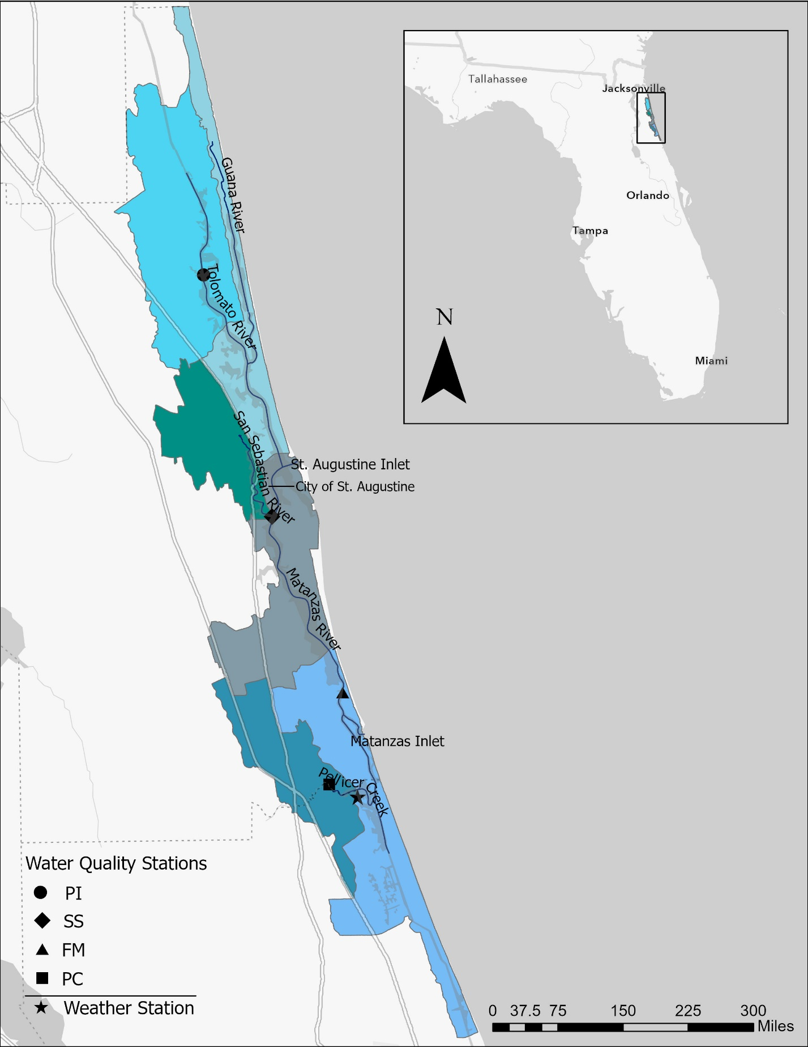

**Figure 1 Map**

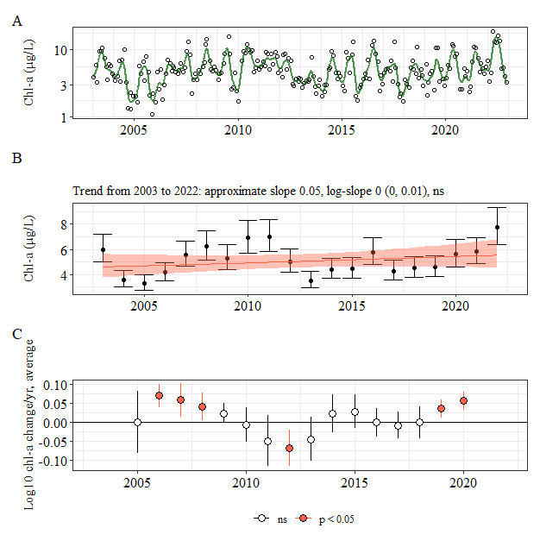

**Figure PI GAM and trend**

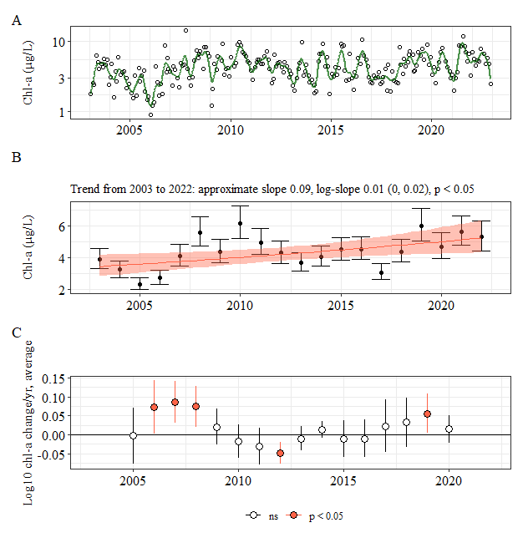

**Figure SS GAM and trend**

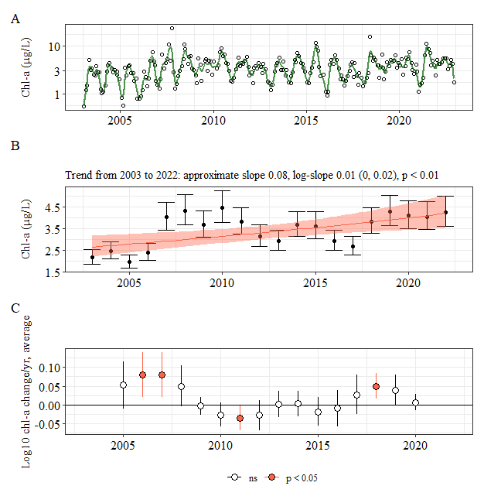

**Figure FM GAM and trend**

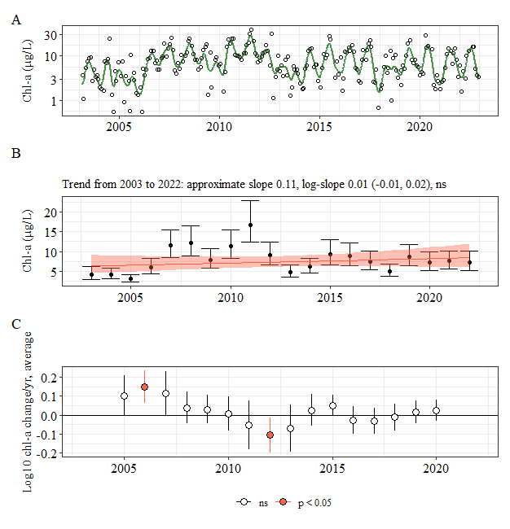

**Figure PC GAM and trend**

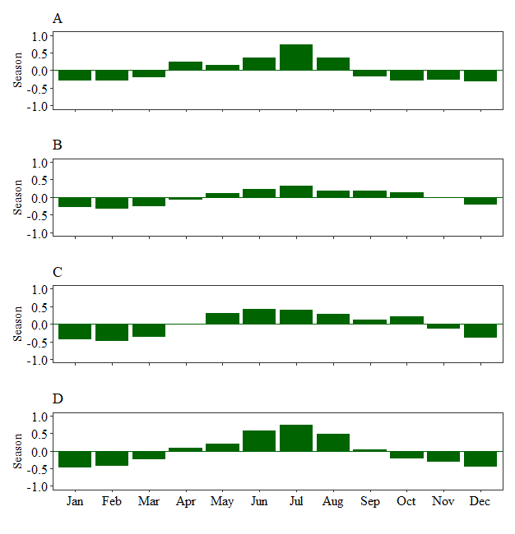

**Figure Seasonal Variability**

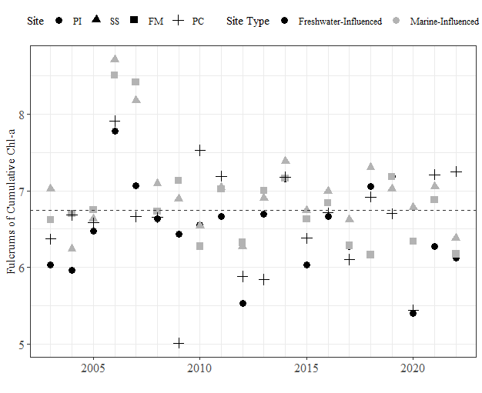

**Figure Fulcrums Combined**

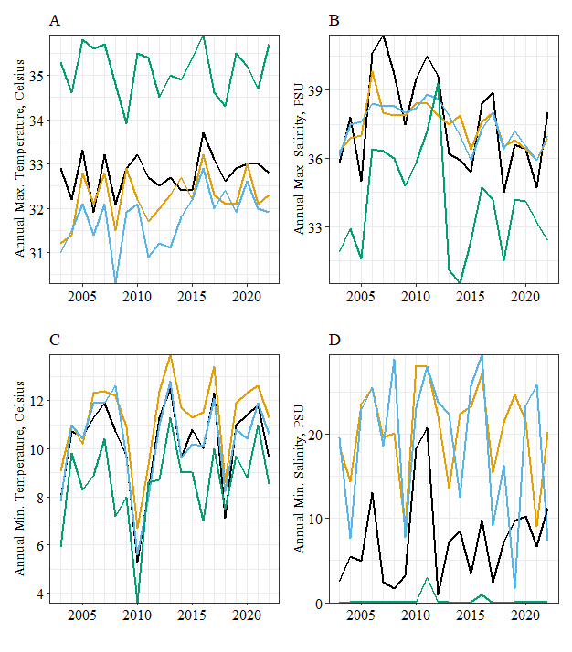

**Figure Annual Mins and Max Temp and Salinity**

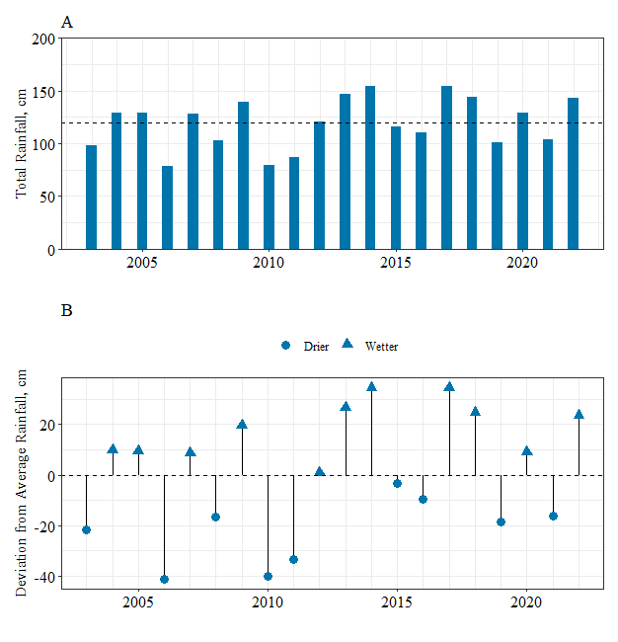

**Figure Annual Rainfall**

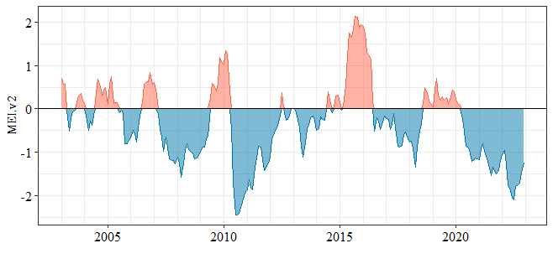

**Figure MEI index**

**Appendix – Missing Data**

**Table A1.** Stations and the month and year in which they had missing values that were filled in with the averaged daily predicted values from the generalized additive model outputs to create the “filled chlorophyll *a* data set that was used in decomposition and seasonal analysis.

|  |  |
| --- | --- |
| **Station** | **Missing Data** |
| Pine Island (PI) | - Jan 2005  - Jun 2009  - Feb 2010  - Aug 2015  - Aug 2020 |
| San Sebastian (SS) | - Jan 2005  - Jun 2009  - Feb 2010  - Sep 2019  - Aug 2020  - Jul 2022 |
| Fort Matanzas (FM) | - Jan 2005  - Jun 2009  - Feb 2010  - Nov 2015 |
| Pellicer Creek (PC) | - Jan 2003  - Jan 2005  - Sep 2009  - Feb 2010  - Aug 2015  - Sep 2015  - Jul 2020  - Jul 2022 |

**Table.** Total annual precipitation (centimeters) at the Pellicer Creek Weather station from 2003-2022 and deviations from the average annual precipitation (119.83 cm).

|  |  |  |
| --- | --- | --- |
| **Year** | **Total (cm)** | **Deviation from Average (cm)** |
| 2003 | 98.13 | -21.70 |
| 2004 | 129.54 | 9.71 |
| 2005 | 129.23 | 9.40 |
| 2006 | 78.69 | -41.14 |
| 2007 | 128.45 | 8.62 |
| 2008 | 103.36 | -16.47 |
| 2009 | 139.38 | 19.55 |
| 2010 | 79.78 | -40.05 |
| 2011 | 86.64 | -33.19 |
| 2012 | 120.52 | 0.69 |
| 2013 | 146.54 | 26.71 |
| 2014 | 154.38 | 34.55 |
| 2015 | 116.49 | -3.34 |
| 2016 | 110.20 | -9.63 |
| 2017 | 154.15 | 34.32 |
| 2018 | 144.39 | 24.56 |
| 2019 | 101.32 | -18.51 |
| 2020 | 128.89 | 9.06 |
| 2021 | 103.47 | -16.36 |
| 2022 | 143.13 | 23.30 |

**Figure PI variability**

**Figure SS variability**

**Figure FM variability**

**Figure PC variability**

**Figure WQ Temp/Sal**

**Figure PI correlations**

**Figure SS correlations**

**Figure FM correlations**

**Figure PC correlations**