In-House Presentation
Movies recommendation sysytem
Date: 29/03/2025
Course Name (Course Code)
Degree : BCA
Presented By:
Subhash Ranjan
External Project Guide: Internal Project Guide: Mr. Varun Kuttan Mr. Shiv sadan panday Company Name:
TMU Department Name:
 CCSIT
FACULTY OF ENGINEERING & COMPUTING SCIENCES
TEERTHANKER MAHAVEER UNIVERSITY, MORADABAD
- Project Theme
- Problems
- Description
- Project Workflow
- Approach for implementation
- Technology used

- Tools
Agenda
- Advantages
- Conclusion
- APPENDIX (if any)
22

Project Theme

- A personalized movie recommendation system that suggests movies to users based on their preferences and interactions using machine learning algorithms.
Pro
ject Theme
- It enhances user experience by providing relevant movie recommendations.
33

Problem Statement
With an overwhelming number of movies available on various platforms, users struggle to find relevant content.

Traditional search methods are inefficient and time-consuming.
Problems
A smart recommendation system can help users by suggesting movies based on their viewing history and preferences.
44

Project Description Scope of the Work
The system will suggest movies based on user interests.

It will use machine learning techniques such as contentbased filtering, collaborative filtering, and hybrid models.
Description
Users will get personalized recommendations to enhance their movie-watching experience.
55

Project Workflow
Data Collection - Gather movie datasets from sources like MovieLens, IMDb, or TMDb.
Data Preprocessing - Clean and format data, handle missing values.
Feature Engineering - Extract features like movie genres, actors, ratings, etc.

Model Training - Implement ML algorithms such as SVD, KNN, and Cosine
Project

Workflo
w
Similarity.
Recommendation Generation - Suggest movies based on user preferences.
User Interface & Deployment - Deploy the system using Flask, Streamlit, or a Web App.
66


Approach for implementation
Approach for Implementation
Step 1: Load and preprocess dataset (MovieLens/IMDb/TMDb).
Step 2: Implement content-based filtering (TF-IDF, Cosine Similarity).
Step 3: Implement collaborative filtering (User-User & Item-Item).
Step 4: Train and evaluate models using metrics like RMSE, Precision, and Recall.
Step 5: Build a user-friendly interface.
Step 6: Deploy the system using Flask/Django.
77
Technology to be Used
Software Platform :
Python: A high-level programming language widely used for machine learning, data science, and web development.

Pandas: A Python library for data manipulation and analysis, especially useful for handling structured datasets.
Technology used
NumPy: A library for numerical computing, providing support for large multidimensional arrays and matrices.
Scikit-learn: A machine learning library in Python that provides simple and efficient tools for data mining and analysis.
88
TensorFlow/Keras: Open-source deep learning frameworks used for building and training neural networks.
Surprise Library: A Python library specialized in building recommendation systems using collaborative filtering.

Flask/Django: Web frameworks used to develop and deploy applications.
Technology

use
d
Streamlit: A Python framework for creating interactive web apps for data science and machine learning projects.
99

Tools
Jupyter Notebook : Interactive environments for writing and testing Python code.
MySQL / MongoDB : Databases used for storing user interactions and movie data.

Google Cloud / Heroku: Cloud platforms for deploying the recommendation system.
Tool
s
GitHub: A version control system for managing project code and collaboration.
₁₀₁₀ T012D/ Template Version 5.0

Advantages of the Project
Personalized Experience: Users receive recommendations tailored to their interests.
Time-Saving: Helps users find relevant movies quickly without manual searching.
content improvements.  11  11 | T012D/ Template Version 5.0

Enhanced User Engagement: Encourages users to explore new content, increasing platform retention.
Advantag
e
Scalability: Can handle large datasets and millions of users efficiently.
Improved Content Discovery: Suggests diverse and lesser-known movies based on user preferences.
Data-Driven Decisions: Streaming platforms can analyze user behavior for
Conclusion

The Movie Recommendation System helps users find relevant movies based on their preferences.
conclusio
n
12
12
T012D/ Template Version 5.0
It uses machine learning techniques like content-based filtering, collaborative filtering, and hybrid models.
Future improvements can include AI-based personalized recommendations and deep learning models.
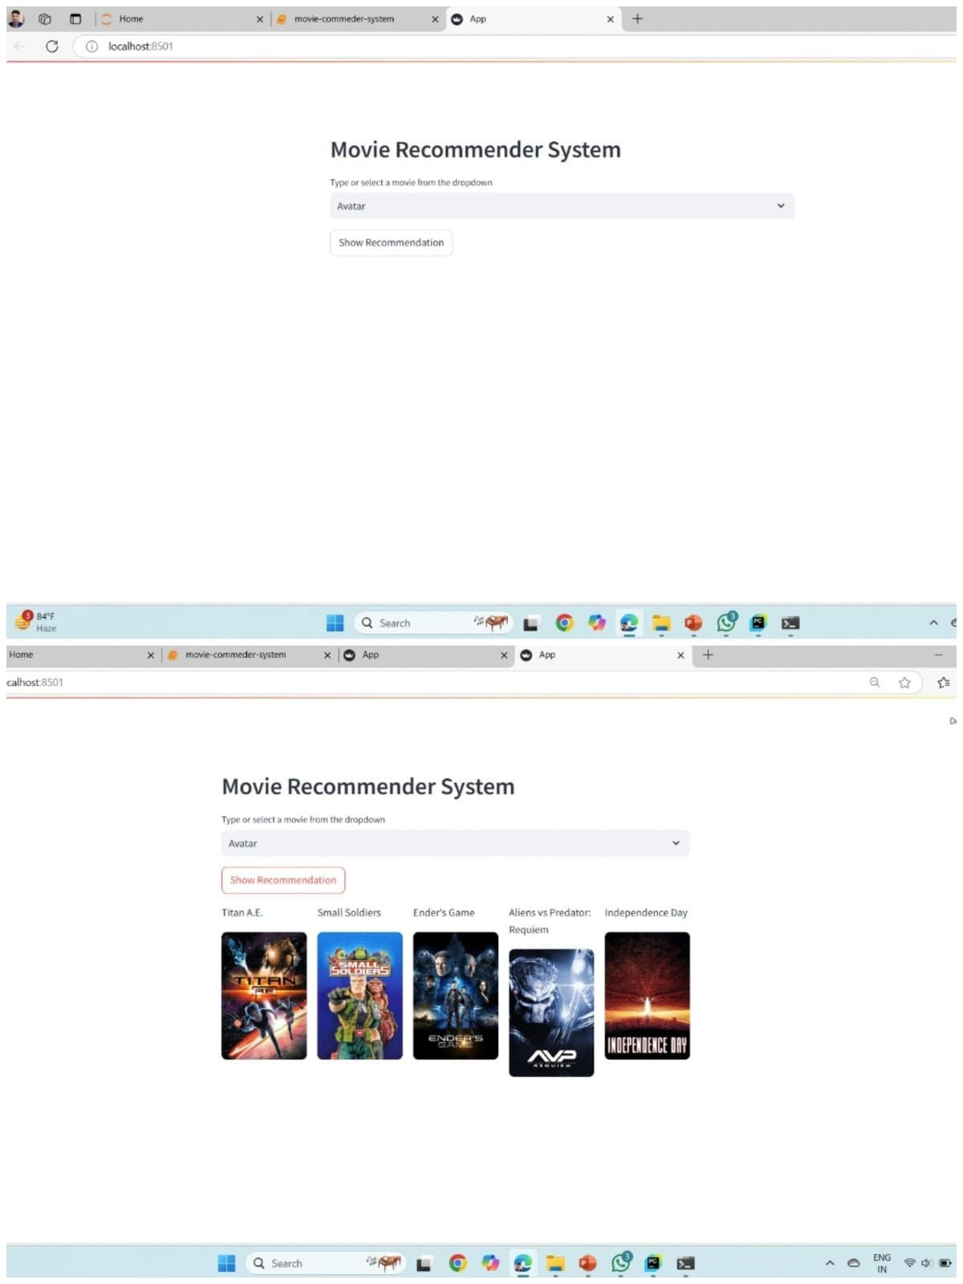

13
Appendix
13
T012D/ Template Version 5.0
THANKS
T004/ Version 1.0

