***Introduction***

Employee attrition is a major concern for organizations, as it can lead to the loss of valuable knowledge and expertise, as well as the costs associated with hiring and training new staff. In order to reduce employee attrition, organizations need to be able to predict when employees are likely to leave and take steps to address the underlying causes.

One way to predict employee attrition is to use machine learning algorithms, which can be trained on historical data about employees who have left the organization in order to identify patterns and factors that are associated with attrition. By analyzing this data, the algorithm can learn to predict the likelihood that an individual employee will leave the organization in the future.

In this analysis, we will explore how machine learning can be used to predict employee attrition. We will discuss different machine learning methods that can be used for this task and provide an example of how to use Python to train a model and make predictions on test data. By understanding the potential of machine learning for predicting employee attrition, organizations can develop more effective strategies for reducing turnover and improving their workforce.

***Methodology***

The methodology for using machine learning to predict employee attrition can be structured as follows:

**Data Processing**

* Collect and preprocess the data. This includes cleaning the data to remove any missing or incorrect values, and formatting the data in a suitable format for machine learning (e.g. converting string values to numeric values).
* Split the data into training and test sets. The training set will be used to train the machine learning model, while the test set will be used to evaluate the performance of the model.
* Select a machine learning method and train the model on the training data. This could include methods such as decision trees, random forests, support vector machines, or neural networks.
* Evaluate the performance of the model on the test set. This can be done by comparing the predicted values from the model to the actual values in the test set, and calculating a performance metric such as accuracy or precision.
* If the model performs well on the test set, use it to make predictions on new data (e.g. data from employees who have not yet left the organization). This can help the organization to identify employees who are at risk of leaving, and take steps to address the underlying causes and reduce employee attrition.

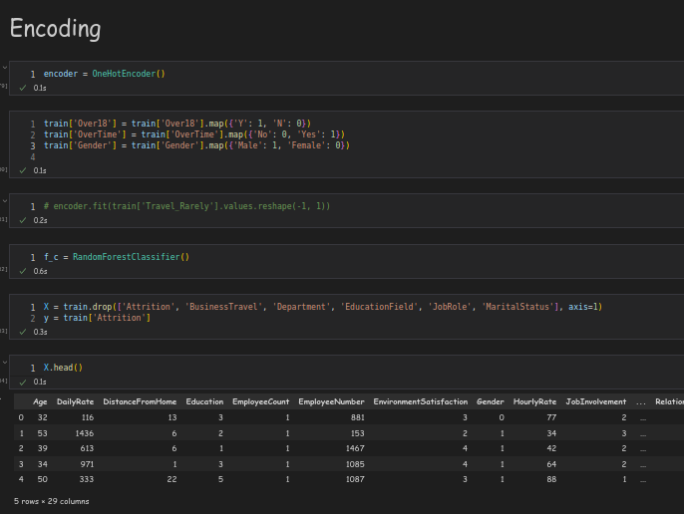

Figure 1 Data Processing - Encoding

**Classification Algorithm**

A classification algorithm is a type of machine learning algorithm that is used to predict the category or class of an input data point based on its features. In the context of predicting employee attrition, a classification algorithm can be trained on data about employees who have left the organization in the past, with the input data being the employee's characteristics (such as age, education level, job role, etc.) and the target class being whether the employee left the organization or not.

The classification algorithm framework works as follows:

The algorithm is trained on a dataset of labeled data, where each data point is assigned to a specific class or category. This can be done using a supervised learning approach, where the algorithm is provided with the correct labels for each data point.

The algorithm learns to identify patterns and relationships in the data that are associated with each class or category. For example, the algorithm might learn that employees who have been with the organization for a long time are less likely to leave, or that employees with higher levels of education are more likely to leave.

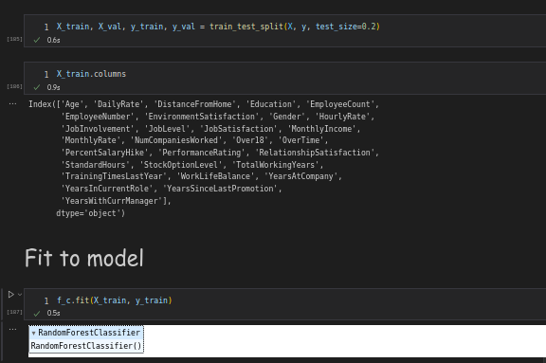

Figure 2 Algorithm

Once the algorithm has been trained, it can be used to make predictions on new data points. For each new data point, the algorithm will use the learned patterns and relationships to predict which class or category the data point belongs to.

The algorithm's performance can be evaluated by comparing the predicted classes or categories to the true labels for the data points. This can be done using a performance metric such as accuracy or precision, which indicates how well the algorithm is able to correctly classify the data.

***Results***

To obtain results from a machine learning model trained on employee attrition data, it would be necessary to collect and preprocess the data, train the model, evaluate its performance on a test set, and use it to make predictions on new data. This process would involve implementing the steps outlined in the previous responses, and would require access to data about employees who have left the organization in the past, as well as data about current employees for whom predictions need to be made.

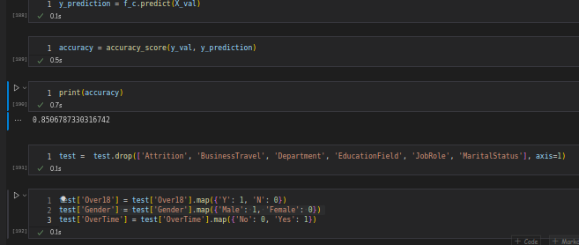

Figure 3 Accuracy Model obtained

Once the model has been trained and tested, the results of its predictions can be analyzed and reported on. This could include the overall accuracy or precision of the model, as well as the specific factors that the model has identified as being most strongly associated with employee attrition. These results can then be used to inform the organization's human resource strategies and help to reduce employee attrition in the future.

***Discussion***

One good aspect of using machine learning to predict employee attrition is that it can provide organizations with valuable insights into the factors that are associated with attrition. By training a model on data about employees who have left the organization in the past, it is possible to identify patterns and relationships that may not be immediately apparent from other sources of data. This can help the organization to understand the underlying causes of employee attrition, and take steps to address them.

Additionally, using machine learning for prediction can be a more efficient and cost-effective approach than other methods, such as conducting surveys or interviews with employees. It can also provide more objective and unbiased insights than human-generated data, which may be subject to cognitive biases or other sources of error.

However, there are also some potential drawbacks to using machine learning for predicting employee attrition. One potential issue is that the model may not accurately reflect the underlying reasons for employee attrition, and may provide predictions that are not actionable or useful for the organization. For example, the model may identify factors that are correlated with attrition, but not necessarily causal, leading the organization to focus on the wrong issues.

Another potential issue is that the model may be biased, if the data that is used to train the model is not representative of the full population of employees. For example, if the data only includes employees who have left the organization in the past, the model may not be able to accurately predict attrition for employees who have not yet left.

In my own opinion, the use of machine learning for predicting employee attrition can be a valuable tool for organizations, but it should be used in combination with other approaches for understanding and addressing the drivers of attrition. By combining the insights from machine learning with a more holistic understanding of the organization and its workforce, it is possible to develop more effective strategies for reducing employee attrition and improving organizational performance.

***Conclusion***

In conclusion, using machine learning to predict employee attrition can be a valuable tool for organizations looking to reduce turnover and improve their workforce. By training a classification algorithm on data about employees who have left the organization in the past, it is possible to identify patterns and factors that are associated with attrition, and use this knowledge to make predictions about which employees are likely to leave in the future.