**LITERATURE REVIEW**

**AI ALGORITHMS**

**MACHINE LEARNING**

**Student Name:**

**Admission Number**

**STUDY AREA: AI ALGORITHMS**

**Abstract**

Multiple systems emulate the structure that is determined by data. The concept is based on actual learning of this data and making a spin on how to apply and model the data into critical decisions. The applications applied to structure these data is embedded on libraries that will simulate and apply capable methods to structure the data into important concept. The components that enable the intelligence and manipulation of these data structures are preferred through the python data learning. Most language used to stricture the importance of big data is Python. Most of its methods are classified as critical and therefore this enumerates into better concepts posed by the data scientists applying the language. Most users applying the language find it literate and easier to apply the various instances that are supposed to model the data. There are critically a huge barrier between the achievements of companies applying their models through uncleaned methods and companies that apply a significantly critical methods through learned methods.

Most of these are essentially one of the most critical stable instances that modelling and data machine learning has enabled companies to emulate. In most instances we are applying dynamic structure to already set data to get a more literate way to emulate any supposedly similar data with the same concepts.In the current market analysis most of the dynamic user surveys are based on the emulation of the way each user applies the learning. Data science and Artificial intelligence has been one of the critical based evaluation and up-voted goal that has been achieved through the learning of data. Each concept is based on the critical goal of modules within the intelligence to accomplish a simple and actual work bit by bit. This simulates a better way to accomplish a way more bigger task by combining these modules into one single structure of multiple structures. Generically most of the users create data sets and its determined by the language used. For instance python has been one of the applied language to harvest data. Data harvesting is also one of the most critical supplied methods that has imposed a great challenge to developers and data scientist into classifying the critical data into important data. Models evaluate the stricture of the data into conceptional designs that can be evaluated into accuracy determination with the model used. Identifying a research topic to complete a critical analysis of the data can be based on the evaluation of the multiple instances.

All instances that are used within the usability and applicability of the language is based on the core hardware and software capabilities to handle critical data.The python library is embedded with a long stretch of libraries that sequence a low level applicability and way more complex system operating usability and applies all the conceptual structure based on the various evaluations. Each library covers a way more critical path way to evaluate all the conceptual design and stricture of the data based on the simulation of the concepts applied. Machine learning applies a conceptual way to iterate between the various methods of data and how to apply all the logical structures into a way more capable design that can be used to mode and critically analyze a modern way to apply various decisions.

Data variables are interpreted by a preprocessed structure that enumerates them to structure even better functionality during the actual machine learning process. Scientist find this as the default process that enumerates the structure of the model and data precision so that later when the data features are being enumerated we can identify the classification of the data based on the actual significant methodologies on the structure.

**Introduction**

Computer science focuses on a majority of concepts and applied sciences and therefore most of the instances the computer systems and applicability are structured as essential computer science field. With the emergence of the various computer systems and AI support vectors we can complement a way better way that structures the instances purportedly to emulate way better instances in the computer science field. Artificial intelligence as one of the major critical sections applied within the computer science field is emulated by various other categories that apply a critical based methodology that tends to emulate other fields in the computer science field. Applying the various structures within the drawing board of an AI system we can categorize a more specific instance of applied generally of critically usage of other methodologies such as machine learning that is classified as classical machine learning or deep machine learning. These two methods are a classfull methodology of the computer science field and apply a majority usability in other fields dealing with the computer science sector.

The structure and purpose of this paper is to identify the various usability of the python language and how its applied and used among the various users. Most of the content in the paper is applicable as determined by the various logicality and how its being emulated in real life structures. Each applicability of the various python libraries such as numpy, pandas and scikit-learn are just a sample of the various critical methods and functionalities that are emulated within the documentation to give a glimpse of the actual usability of the data and generalize the knowledge toe the rest of the users who want to apply the concepts.

Based on the various features that are critically analyzed by these sectors, we get an augmented way to determine the way robotics and other categorical implementation are being determined. These applied methods literally enables us to grow scientifically and reach goals we can’t achieve over a shorter period of time. Therefore the usability of these major systems enable us to reduce a certain workload that can be determined by learning an environmental imbalance of a critical time section and also determine the ways to make a better evaluation of the existing methods. Determining a machine learning environment has been critical over the years and therefore this has been a critical factor that needed to be solved.

Python over the years has been a interpreted language that has enabled scientists to perform analytical study, augmented analysis and more often a more desirable way to learn at least anything with the use of data science and machine learning. The manipulation of each concept based on the critical evaluation of all the concepts and analysis breakdowns comes the execution structure of the python codes that is single threaded over the years with the use of CPython. Generically, this environment based on the concepts of hardware and usability, a long code is stipulated to run on the CPU as single thread and structure a code fail at the end of the execution. A replacement that has been redone over the CPython is the PyPy environment that has a structural way to stipulate all the conceptual design of running the code.

With preference to the study of the dynamic applicability of the python language, most users emulate the data science and artificial intelligence structures based on the use of machine learning. Most of the studies shows that users determine how to use python and apply a more conceptual way to try and learn their environments.

There are various implementation of the python libraries that require a higher system requirement and therefore these instances applicably pose issues to users with low system specification requirements. The PyPy environment tries to incorporate the various pending requirements with the ones existing with the system specification requirements based on the emulation of services wanted to be done. At any point the requirements are not met, the user will tend to user a lesser version which instantly still will be supported by python. Python has grown over the years, it has dynamically allocated better software modules that can be applied by adding and subtracting the existing software's with better modules and deducting the unnecessarily modules from the previous environments into supplying better functionalities with the library usability. Most of the python libraries in the current python 3.10 are embedded to each other rather than the python 2.7 environment. Therefore over the years we can determine that the python language is still on daily improvement.

Python language generalizes the use of automation on system software s to perform tasks that are emulated at greater limits. Each concept is based on how the system reacts to the automated programs. Python significantly enables a user to perform automated structures that can possibly structure a better way to simulate all the possible categories of the actual data set and also get the datasets on an online based functionality and scrap the data from any online platform.

Conceptually these instances are one of the major usability of the python language. Automation is distinctively one of a categorical implementation that is determined by what a user wants to apply or generalize. Datasets are also a categorical implementation that most members of the python language community use to make a generalized evaluation of a data category. The most used methods of these data’s are gotten from the online platforms. One of this methods is the Kaggle website which stores multiple identical datasets that can be manipulated by anyone from a beginner level to the professional level.

Generically we are applying a conceptual view on most of the python libraries instances and the actual usage of the actual data formats. Each category is based on actual simulation of how the user decides to interact with the system. Data learning requires a majority of accessible memory to store the variables with the use of a huge datasets. Python enumerates a greater logicality and usability that structures the way users use the libraries and therefore a greater usability means a more comprehensible code that can emulate speed and also automation.

1. **Machine Learning IN Artificial Intelligence**

Introduction of supervised and unsupervised learning is a categorical implementation that structures can emulate to factor a specific dataset with a specific type of learning algorithm to classify or composite a certain method. Each structure is embedded on the logicality that comes with it. We can structure all the feasible study by determining the type of data before applying the algorithm but still we wouldn't identify the actual specificity of the data trend. It might look like a timeseries and thus we apply clustering and yet the data might just need a linear model to evaluate all the necessary models. Its critical to structure all the importance's of the model and determine if the model applied is correct. As a data scientist this is a critical step and thus, we need to stipulate all the logical evaluation as needed.

**2.1. Supervised Learning**

Most of the generalized methodologies are structured essentially by the methods provided by python. Most companies retract to the applicable means that they can get to structure the necessity of the data and also apply various fiscal methods that will help them structure potential means to evaluate and reprocess their existing data into greater heights. As data is a major key in data processing and scientific learning, we can categorize the use of available efficient ways and also structure the capabilities of the concept of the data.

There are various key structure that make up the basic level of scientific structure and more-so the basic implementation of the interactive environment usability that stabilizes the way users structure their performance. Each user has first to interact with the kernel indirectly to stipulate the various purposed they want to conduct. Each methodology is a critical process where, all the implementation will be performed in these kernels. A kernel can be implemented on the system at any structure and thus data learning and scientific computing can be achieved. Achieving a critical based structure with the implementation of the theoretical analysis and basic functions will enable the user to achieve faster processing

Scientific computing structures multiple use if digital sources and dynamically allocate the sources a specific structure to be read by any library embedded in python and structure the usability that comes with it. Each logic is determined by what the user necessarily wants to perform, therefore based on a determined topic, multiple selections can be made to emulate the specific concept needed.

In theory every implacability of the instances used by a user can be emulated by the structure the libraries pose. Each library has a critical usability and therefore the kernel purports to use the memory even greatly. Thus GPU kernel systems should be preferred to run this manipulation. A GPU system is a kernel based component that can be added generically to the existing computer motherboard to purposefully run dynamic processing of the data and emulate the better processing of the data.

In the previous years, the users tried to incorporate the various languages to structure the usability of machine learning and also emulate the precision methods, with a python based environment users can now apply a more generic methodology that structures the even better methods and libraries that are assembled within the python libraries. With this the other languages can then be generically used into other sectors and apply structures that can be used to support the learned environments.

Logically learning a datasets with a language like c/c++ would require a lot of library import to structure the various essential slots to just read the data. This has been made possible by emulating the structure and also performing fewer lines of codes to emulate a huge task. Tasks in python are interpreted line by line and therefore a single line could perform multiple instances than that of which could be written in another language.

There are over three hundred python libraries that legitimately are used to structure important curvature within the functionality of data scientists. Most of these language processing tools are embedded through the throughput of the python libraries and therefore, some of them are complex as for instance some might be used in language processing, image segmentation, classification, modelling among other various structures. We are going to emulate a number of structures accordingly to the way they are supposed to be emulated. To structure a typo within the language we need necessarily to structure a more comprehensible way to perform a classification of the model or rather emulate the various data structure we have.

* + 1. **Python With other languages**

In the current applicability of the python language, we find that most other languages are interconnected to the functionality of the python language processing from databases to other languages. Necessarily, performing classification with JSON data, we can emulate the use of JavaScript to embed the data into JSON categorically and let python read the data set singularly from top to bottom.

On the other hand XML files can be read by python through the use of the listing the details in directory and determining the actual library to use to read the JSON files by importing json **(import json).** Logically we can interpret any other language and embed it into python, necessarily we are emulating a comprehensible way to structure complete emulsion of python into another language and structure it to perform logical implementation. Previously none of this was made possible since most of the usability was concentrated on the development of other instances before python analysis was actually performed.

The interest with applying the python language with other language is to precisely embed the characteristics that python posses into other languages and also embed the functionality of other language to the python language. we can iterate this through the logicality that python language will be processed and interpreted as its supposed to while the other languages are compiled.

Compiling python into other compiler will sure cause problems but that's not the actual point. We are necessarily combining a logic of python usability and apply generic means to run the python environment into other language environments and expect a critical output that will be beneficial to the performance of the data being assessed.

* + 1. **Decision Trees**

AS determined above, machine learning is structured into various components and categories and therefore, the decision trees are just a type of structured and supervised algorithms that are structures to classify the efficiency and predictiveness of the dataset and update each data tree bitwise and always ensure that the data partitions are updated continuously.

The features of the data structure are comprehended by the feasibility study that, decision trees ensure a transient way to classify every parent and child tree branch and ensure that consistently all these data partitions are updated. Linear regressions is a component data that determines most of the structures to determine the classification of the data.

Each formality is determined by the actual conditional structured statement that improves the way the classification is made. The major aim of determining the various positioning and actual classification of the data is based on the identical data partitions and also by what range the data is determined.

More essentially we might have data that is based on independent variables or rather categorical data formats. Each of there data type variables still need to be classified and this algorithm favors and alternates its values into making a structural way to implement and structure the data into partitions.

Both the categorical variables and identical ones can be classified rather than being regressed to find the classified best model. Each independent classification of the data is based on the features of the condition and how they iterate over the classified instances, The branch and the tree are based to qualify the conditions and also iterate over the data partitions to perform the classifications.

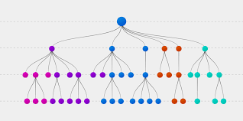

Machine learning with this algorithms equates to better potential of getting very productive mean score and achieving an actual model since the model algorithms structures each function to possessively structure all the data endpoints and partition them into branch and child that have critical endpoints.

* + 1. **Logistic Regression**

This algorithm is based on the stylistically of the data and estimating of the actual values both discrete values that can be identical to the performance of the independent variable structure. Finding the exact linear model we need to extract a multiple number of feasible structures that necessarily will be required to formulate all the encompassed structure and also evaluate the consistent nature of the data.

Each feasible requirement can be based on the actuality that comes with the data segments. Therefore formatting discrete data we evaluate a consistent and way possible method that needs to stricture the most important nature of the model. In this algorithm we are evaluating a multiple number of functions and real number domain functions that needs to be evaluated through the potential need of the formulation Each category needs to be structured in an identical way and formatted criticality towards achieving the goal of the model.

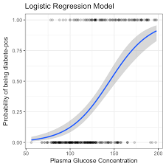

Evaluating a consistent model such as the linear model encompasses the categorical implementation of all the features and actual fundamental functionality that are necessarily required to make it functional. We are going to evaluate a majority number of errors as supposed to be encountered during the modelling and classification of the various loaded data. Python on the other hand, iterates over the data and calculates the actual data potentiality and achieves a critical based standard deviation error that can be mapped as the critical section of the data. At various data levels if the data is structured using a logical way then we will encounter a logical transformation that

The relationship between the independent and the dependent variable is based by the intercept class and the slope of the determined data. Each structure is based on the evaluation of the represented linear equation based on the familiarity and consistent of the data patterns. Each logic is evaluated and derived through the best fit evaluation for all the lines that are regressed through the data model patterns.

* + 1. **Vector Machines**

In machine learning classification we iterate over a number of instances, most of the instances can be categorized into supervised learning, while the rest can be categorized into unsupervised learning. Among these two classification support vectors is a supervised classification that outlines the classification and detection of mostly healthcare industry to determine the existence of medicines and also ways to categorize immunity and disease transformation. A better way t structure the way vector machines are used is by classifying each instance to the way its required. Support vector machines are used to perform image segmentation and text categorization such that we can identify adherence to the subroutines set for certain medical treatments or rather medical dialysis of a certain disease. Each methodology is structured to compute a grid line of how to achieve various results and by what classification will the learning be of great potential. Literally most of the usability of the support vector machines are based with the conceptual design of factoring the healthcare industry and determining the logical ways to determine medications, symptoms and such.

* + 1. **Bayesian Network.**

Risk assessment is one of the critical core values of using python. Determining the actual instances that resolve to a risk negative or positivity. With this we are going to emulate the various structure of the Bayesian model and comprehend the various performance metrics when using this model. Most of the instances are supplied by the enumeration of the critical enhancement of the various structures of the dataset. Each concept is to perform a critical based analysis to determine how a categorical implementation can be performed avoiding the major risks that have negative impacts and simulate the positive risks which might actually benefit the instances used and by what rate are the two initializing each factorization.

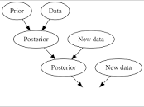

Factoring the various feasibility can be an advantage to whoever is performing the learning. A data scientist will categorize their feasibility with the various levels they can factor. This for essence has been a critical patch that brings more issues and necessarily this can disrupt the normalcy of attaining a better model.

The risk assessment generality continuously checks for the feasible structure of the data and structures it to determine the accuracy levels of the multiple instances if the data is modeled with other multiple models structures. With this we can determine an actual structure that will logically enable us to necessarily format and comprehend the current data formality into the deterministic structure.

Public structuring and interventions has expressed a higher potential to fix the logical interpretation of dynamic possibility of having even better simulations. This as a resultant has enable capable transition through the various ages to structure code and also to perform the various analyses in a better way that will help factorize all the sequential data parts into a major indication.

Python data analysis has evaluated potential capabilities that will enable a feasible way to perform all these implementations. Data harvesting through the use of python also has critically enabled scientist to perform and get data through various methods such as scrapping and identical mapping of figures and data tables from xml files to the various json processed data. Identically this has enabled achieve the necessarily data storage systems to be accessed and data processed limitless.

* 1. **Unsupervised Learning**

Most of the critical evaluation are considered actual depending on the functionality of the models needed. The required instances are actual and structured factoring the most consistent variables and evaluating the critical section. Each functionality that is needed to be added to the data needs to be determined on an actual basic requirement where processing of the data evaluates all the consideration of the formulated data and necessarily factor all the variables.

Most of the unsupervised learning algorithms can be categorized through clustering or rather association method. Each with which is comprehended by the classification of the model. There are multiple models that use majority of clustering or association to structure their model and thus, this is one of the most classical way of determining a model structure. The number of structures that needs to be performed on the dataset is dependable on the actual dataset format.

* + 1. **K-means clustering**

Most data end points are critically based n how they are evaluated by a model. In this algorithm we are structuring the important structures to the most k-group and assigning a number of clusters based on the distance that they relate to the central part. Evaluation most of these can be explained in this manner.

The cluster of the model is a single span of a network model that attenuates in a spindle an not the clusters are moved within a spindle and correlated to the center most point and this, each cluster is make according to the one nearest to the central of the group.

Based on this description most of the analysis will be based on the characterization of the features of the data and also evaluated by the factors of the data models and the k-groups which later will be graded by the means and also structures. Evaluating this is such a critical way is its supposed to be done manually and thus, this is where the python modelling language comes in. Each algorithms superseded within this documentation is handled by the python language using multiple libraries. Each of which can be identical to the structure needed.

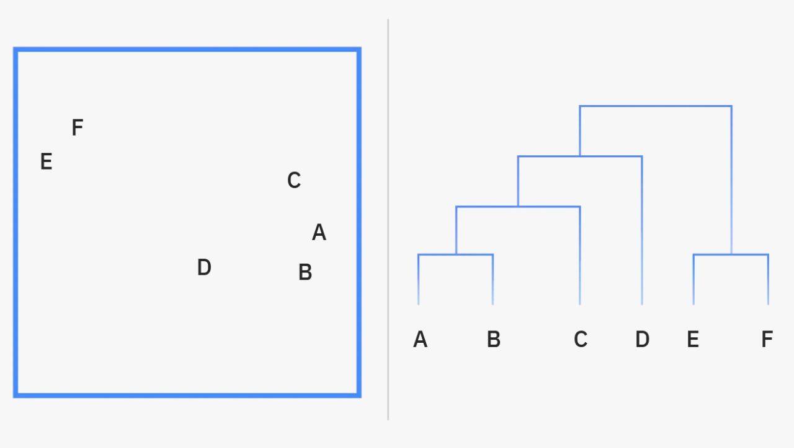

* + 1. **Gaussian Model**

The gaucian model structures more categorically data with the use of association to cluster the data. This model determines a normal distribution of the data and exactly mounts an actual deterministic value to determine the maximization potential of the model. It then distributes the actual end point data points and generically maps them to the actual feature relations. Each functionality is embedded by an infinite number of function's that literally approximate the way each value will be factored and therefore, this sounds to be the most possible better probabilistic technique to cluster data. As clustering is considered,most of the actual functionalities can be made possible by evaluating all the logical structures and structuring all the logical values. The model itself clusters a multiple number of spindles or rather groups and identifies them identically to the modded data evaluation to give a critical end value through the potential throughout of the data. Each logicality is embedded to the functionality of the relation and therefore this is considered as one of the major key values that are actuate within the model.

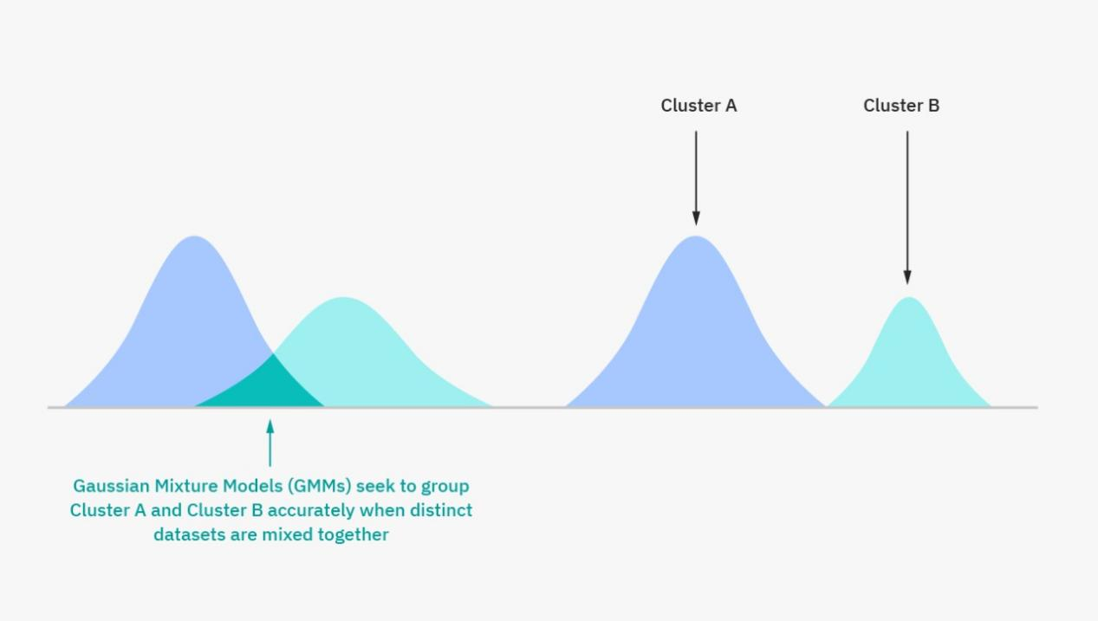

* + 1. **Principal component Analysis.**

Among the majority use of dimensionality and actualization, most of the methods used to determine how these data are identified is by generically determining the actual features of the data and by what levels it can be reused. We determine this data formats by evaluating all the categorical evaluation and embedding the stricture into a complete critical based feature. Dimensionality requires a complete trace of the actual figures that structures the comprehensible stability of the data.

Therefore most of the relation are enhanced to reduce the redundancy of the data by compressing the dataset and evaluating the best method to extract the features from the dataset. This dataset sets a data dimension of new dimension with the existing data model mapping all the logical features towards the critical components needed through the data evaluation, Most if the evaluation is based on the criticality f the data and therefore each relation between the components is mapped by the various functions ideally to feature the specific usable columns and data rows within the dataset.

The principal components that are yielded by the PCA algorithm are determined by a critical base feature functionality that is based on the duality of the various functions within the algorithm. It creates multiple principles that have different functionality. Most if the principals are based on the number of dimensions that are being determined by the actual determinant when using the algorithm. We can base the discussion over a multiple number of principal component values that are used to evaluate the feature extraction and determine the actual functionalities.

Each category implements a variance relation where a process is automated to determine a number principal components that are determined. The first second and infinite n number of times are all uncorrelated to the other principal component where, the first and the second cannot be similar for all the rest components that are being determined. The function loops over the dataset to get a number of actual dimensions and stores them onto a principal component all structural to themselves alone.

We can then iterate the actual end points that are generated as principal component values and place them over a classfull number for a glimpse and store the necessarily model over a certain number of features, We can the identify the model and the structure that was used to specifically ascertain the components of the data. Each feature is determined by the way the model structures the data and therefore it probably chooses whats best for the dataset.

* + 1. **Autoencoders.**

Generically most of the functionality can be mapped against the most unique factorization of the consistency of how the functionality of encoders can be featured and therefore within this documentation we are structuring the functionality to the independent features that are required to compose a neural network.

Neural networks are enhanced by the determinant encoders and evaluating the features within the data.Most of the actual input data end points are determined as the input that are used to structure the potential dataset. The outgoing data is determined as the output since most of it will be termed as decoding initializing all the conceptual processes and identical to the functionality of the data.

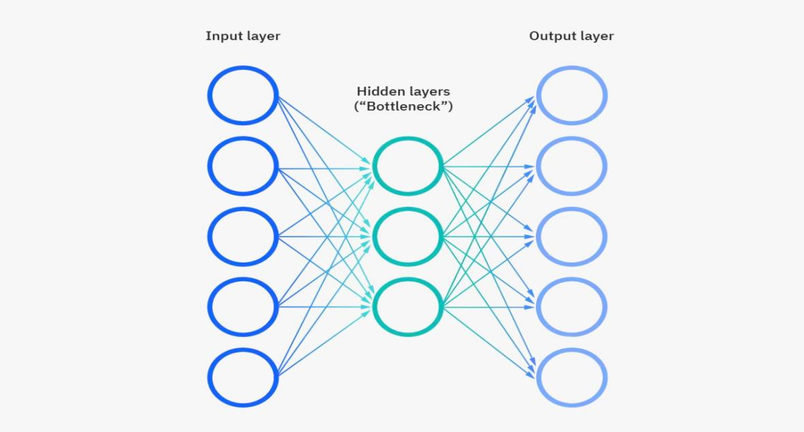

The relation between logical and factorial structure can be based on the simulation of the actual functionality of both the bottleneck and the decoding output.

**Discussion**

A variety of analysis can be based on supervised, unsupervised learning and this characterizes all the feasible structure to determine an actual range of the data features and enable a user o independently determine an actual model to structure the data with. Most of the instances we can structure the potentiality of the data by how eminent can be structured through the feasible functionality of the data.

Given a data driven segment as the actual source of data, the generic requirements to hold a certain type of data like that will require a much greater memory storage that will hold all the limits of the data as the drive in to the visualization. This is critical as the requirements of the system will require a much great throughout to process a certain kind of data. There wold need to store the variable names and all the instances that come in as input and the threaded modeled data. Each structure satisfies all the requirements that is necessarily needed.

Based on how each scientist classifies their data we can determine that the first class step is to always visualize and process the data to determine which variables would be used as factors during the process, or rather which variables would be used to identify the actual dataset group and also sample the data into test and train during the whole machine learning process. We can equate the process into structural and variable based instances that will productively ensure we have the correct instances during our preprocessing.

Each step is based on an actual independent or dependent variable, we can then classify the sampled data into training and testing datasets within the same dataset. During processing most of the scientist process the data into clean variables and also structure the essential means and remove null values. The directed ways to manipulate the feasible means is to identify all the logical structures. Its evident of how this will help structure the data more logically.

Structuring an essential data stretch according to machine learning, one might need to classify all the essential factors of a model and ensure that all the features are fiscal. At other times a scientist might encounter a timeseries dataset. These data has a variable that can independently change the data into a timeseries dataset, converting the rest of the data based on the date factor and can be plotted using a regression of a scatter plot.

Visualization is one key involvement that needs to be used to actually structure the data and ensure that all the critical functionalities are first laid out before the actual modelling and classification is performed. Factoring the essential parts needs an actual potential structure to fist visualize the endpoints of a dataset and visualize the critical sectors of the data. The virtual that comes with the processing of data is, identical forms can be pre-shared between the columns and one has to determine the actual columns they have to deal with and necessarily remove them before continuing to perform the various validation.

This reduces the number of variables stored within the memory and actually gives the scientist a better capability to structure a better precise model. Precision is key, and one would always want to work with a lesser data format and thus, data cleaning is another critical process that is required between the instances.

**Conclusion**

The feasible study is evaluated by the continuous determination of the actual structure of the previous works done. We can evaluate all the necessarily factors and the naturalism of the previous tasks and also embed our analysis based on the critical sections. Python being a major initialization, we are sure to interpret the most of the codes and also evaluate the consistent structure of the algorithms and how they are potentially mapped in day to day functionality.

Critically you can analyze all the functionality of a data set through a machine learning mode wither unsupervised or supervised learning. Each concept is based on the features of the data and how actual the data levels are being factored. Aligning the critical sections of an interpretation can be feasible and therefore there are a majority of factors which can be embedded to the type of variables, type of characters embedded within the data concept and how each is being manipulated concisely. Based on the various data interpretation we are logically featuring all the advanced levels of the data and formulating newer ones to structure a more dynamic way to perspective categorize each of them.

The formulation of the actual dependent and independent data variables can be reliable when actually made feasible by the design and classification of the data. Each consistent structure is factored by the way its supposed to be partitioned and made actual through the algorithm. Most scientist classify a dataset by the way each variable is aligned through the dataset. Formulating all the structures can be reliable and such it helps the data scientist determine the actual algorithm that can be used to identify the classification or outlier management of the data.

We can then determine the actual errors and get a consistent way to factor the input and output of the data partitioned and also get visualization of the data methods. The model algorithm used will independently be based on the type of data we are learning and by what output do we want to get at the end of the learning.

Machine learning has a simpler categorical feasibility that enables most users get an actual independent characteristic of the data and determine and actual generalization of the whole dataset by the listing of the columns, structure and also the type of the data variables within the data.

Consistently we can generalize these methods to the first prepossessing methods a user initializes to determine the actual determinant method based on the feasibility and round-table determination that is used by the user.An actual independent characteristics can be determined if the variables are string variables or rather if they are integers and actual features that are characterized by the logicality of the feasible structures.

The methodology is then to structure the independent factors that can be used to generalize and make a feasible structure that will model the data. Determining the actual data models using train and test dataset enables the algorithms chosen to extract the actual model using the same data lengths and determine an actual prediction and outliers based on these features.

Categorically we can instantiate all the various prepossessed ways and determine the RMSE using the actual models that are used. Not all models can enable you to get the actual standard error, while some can enable you to get an accuracy feature that is based on the consistency of the data.

Based on the feasibility study of the data we can generalize all the potential characteristics of the data outliers and get an actual accuracy of the model depending on the modelling structure. It would be useful if one identifies a logical structure and manipulates all the feasibility methods to structure a potentially better model through the visualization of the data.

**References**

Balyen, Lokman, and Tunde Peto. "Promising artificial intelligence-machine learning-deep learning algorithms in ophthalmology." *The Asia-Pacific Journal of Ophthalmology* 8, no. 3 (2019): 264-272.

Jordan, Michael I., and Tom M. Mitchell. "Machine learning: Trends, perspectives, and prospects." *Science* 349, no. 6245 (2015): 255-260.

Mohammed, Mohssen, Muhammad Badruddin Khan, and Eihab Bashier Mohammed Bashier. *Machine learning: algorithms and applications*. Crc Press, 2016.

Fatima, Meherwar, and Maruf Pasha. "Survey of machine learning algorithms for disease diagnostic." *Journal of Intelligent Learning Systems and Applications* 9, no. 01 (2017): 1.

Panch, Trishan, Peter Szolovits, and Rifat Atun. "Artificial intelligence, machine learning and health systems." *Journal of global health* 8, no. 2 (2018).

Sarker, Iqbal H. "Machine learning: Algorithms, real-world applications and research directions." *SN Computer Science* 2, no. 3 (2021): 1-21.

Bini, Stefano A. "Artificial intelligence, machine learning, deep learning, and cognitive computing: what do these terms mean and how will they impact health care?." *The Journal of arthroplasty* 33, no. 8 (2018): 2358-2361.

Kaplan, Alan, Hui Cao, J. Mark FitzGerald, Nick Iannotti, Eric Yang, Janwillem WH Kocks, Konstantinos Kostikas et al. "Artificial intelligence/machine learning in respiratory medicine and potential role in asthma and COPD diagnosis." *The Journal of Allergy and Clinical Immunology: In Practice* 9, no. 6 (2021): 2255-2261.

Sarker, Iqbal H. "Machine learning: Algorithms, real-world applications and research directions." *SN Computer Science* 2, no. 3 (2021): 1-21.

Sha, Wuxin, Yan Li, Shun Tang, Jie Tian, Yuming Zhao, Yaqing Guo, Weixin Zhang et al. "Machine learning in polymer informatics." *InfoMat* 3, no. 4 (2021): 353-361.