1. Area of circle

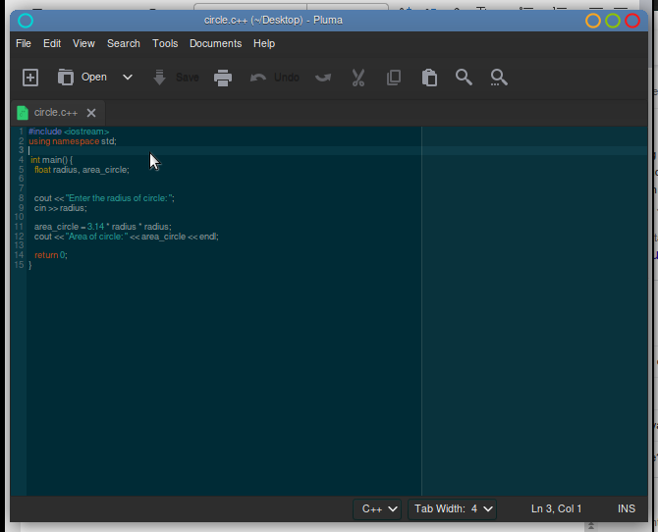

1. Sum of a 2 \* 2 Matrix

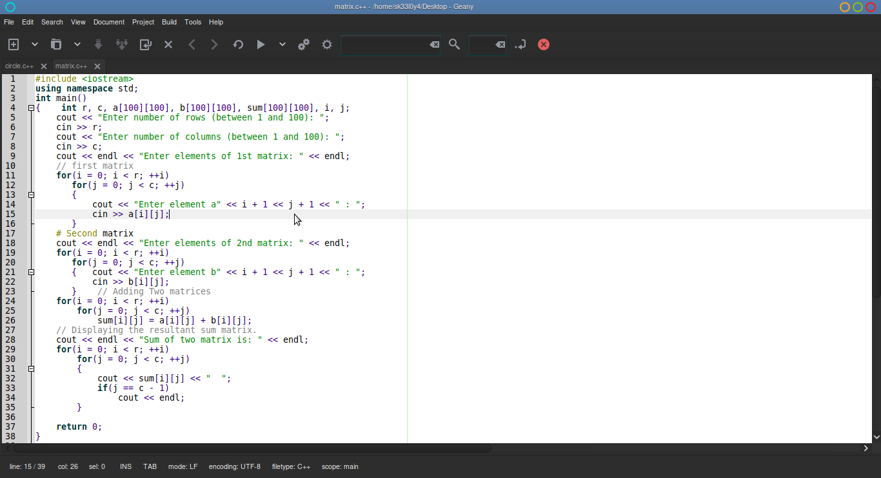

1. C++ advantages over c

- C++ is Object oriented

- C++ and allows exception handling