VLSM Network Addressing Using Cisco Packet Tracer

Module Code
CN7029
Module Leader
Dr. Aloysius Edoh

Submitted by:
[Student Name]
U2561315

Table of Contents

1. Introduction 2
2. Objectives and overview of the coursework 2
3. Design and build computer network using packet tracer 3
Subnet A 3
Subnet B 3
Subnet C 4
4. Simulate the designed computer network using packet tracer 5
Network Topology 5
1. Subnet A 5
2. Subnet B 6
3. Subnet C 6
Physical Topology 6
4. IP address details of the Sub Network C 9
5. Network Design and Simulation 10
6. Network Evaluation and result simulation. 11
7. Router CLI Configurations 13
8. Conclusion 16
9. References 17

- Introduction
Network addressing contains a number of elements that basically needs to be structured with perfectionism and correct feasibility. By designing a network, one has to factor all the values necessary for the correct functionality of the network, otherwise it will breakdown and most of the devices will not connect correctly. There are a number of factors that needs to be determined to actually create a better network, the network topology is also a critical element that needs to be correctly determined so that each device within the network connects correctly. In this report we are going to discuss most of the network architecture that we have covered in the previous classes, connection functionality and how each device functions within the network.
- Objectives and overview of the coursework
In this report we are going to evaluate the essential functionality of the following features and objectives:
- IP management
- Subnet IP addressing
- Router configurations
- Network topology
- Subnet Configuration
- Hosts IP allocation
- Classfull configurations
- Design and build computer network using packet tracer
Network design involves the determining of IP addresses of each component and device that will be included on the network design. Therefore, its essential to determine also how many subnets will be included within the network address factoring that each device is supposed to be connected to the network using an IP address. (Javid, 2014) explains that in most cases the design is factored by the essential structure of the network whereby each components directly communicates to another component either using a direct connection or a wireless connection.
The following discussion below describes the steps undertaken to find the network’s subnet masks and usable IP addresses for each subnet.
Description
Subnets are split networks that basically define a singular network IP addresses into various categories. (Sikarti, et al, 2023) explains that each subnet has its own network IP address and a subnet mask, and usable number of IP addresses that will be allocated to network devices within the subnet.

Subnet A
For subnet A, we only have two devices (Router model 1841) which basically connect from router 1 to router 2. Using the student ID number U2561315, I implemented the IP finding method and arrived at IP address 191.13.15.0/25. The two network components will use network IP address having a bit mask of 30 since I only needed 2 usable bits. 2² = 4 bits. Arriving at a subnet mask 255.255.255.252 also represented as 11111111.11111111.11111111.11111000. The two routers use the IP address 191.13.15.17/30 and 191.13.15.18/30

Subnet B
For subnet B, we have 4 devices including 3 hosts and one server. I arrived at the subnet mask of /29 since I only required 4 usable IP addresses. 2³ = 8 which makes it correct to assign all the devices in the subnet correct IP addresses. The subnet Mask for this subnet section will be 11111111.11111111.11111111.11111000 which explains why we required the three bits.
The broad cast IP address for this subnet will be 191.13.15.7 and the network IP address for the subnet will be 191.13.15.0. Each usable IP address is assigned to the respective devices.

Subnet C
For subnet C, we are allocated 5 devices including a server and 4 host devices. Each of this devices are allocated IP addresses in the subnet range of 191.13.15.8 / 29 to 191.13.15.16 /29 where the first and last IP addresses are the subnet network IP address and broadcast IP address respectively.
Task: 3.1.2: - Table 2
Subnet | Network Address | Mask | First Host Address | Last Host Address | Broadcast | Bit mask
A | 191.13.15.16 | 255.255.255.252 | 191.13.15.17 | 191.13.15.18 | 191.13.15.19 | /30
B | 191.13.15.0 | 255.255.255.248 | 191.13.15.1 | 191.13.15.6 | 191.13.15.7 | /29
C | 191.13.15.8 | 255.255.255.248 | 191.13.15.9 | 191.13.15.15 | 191.13.15.16 | /29

- Simulate the designed computer network using packet tracer
Each element within the network describes a certain variable functionality. Routers switches and cables all have a feasible structure that creates a functionality that is required within the network elements. Each of them is used to correctly implement the functional features of the network that essentially are categorized by what elements are on what side of the network. The topology below describes the architecture of the network based on the features needed for the functionality of the actual design. Essentially, (Atjo, et al, 2023) explains that misplaced or incorrect functionality within the design of the component connection will lead to incorrect results.

Network Topology
VLSM on IP address - 191.13.15.0/25 to three subnets
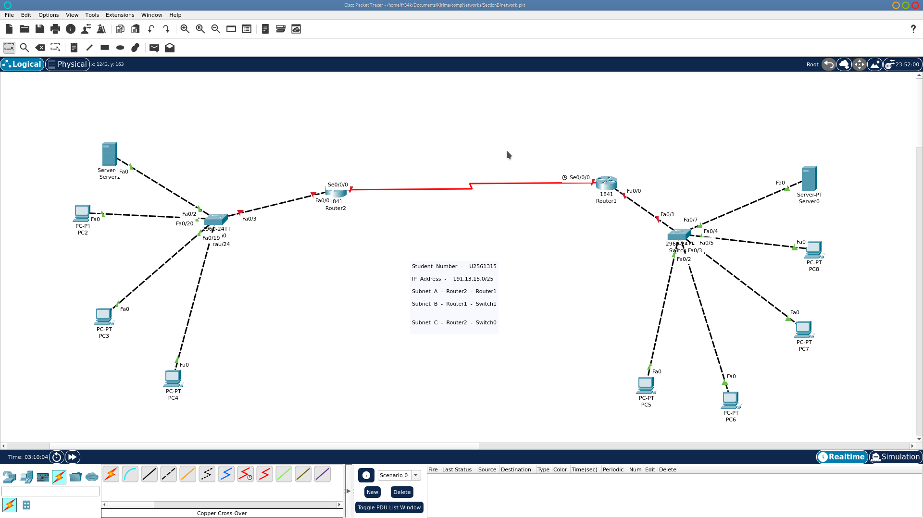
- Subnet A
Router 2 and Router 1
2 users will only require 2 host bits
2² = 4
Mask = OLD( 255.255.255.10000000 ) / 25 - 255.255.255.128
Mask = NEW(255.255.255.11111000 ) / 30 - 255.255.255.252
1st Address 191.13.15.16/30 ( 191.13.15.00010000 )
Last Address 191.13.15.19/30 ( 191.13.15.00010011 )
- Subnet B
Router 2 and Switch 0
4 users will require 4 host bits
2³ = 8
Mask = OLD (255.255.255.10000000 /25 - 255.255.255.128
Mask = New (255.255.255.00001111 /29 - 255.255.255.248
1st IP address - - 191.13.15.0 /29
Last IP address - - 191.13.15.7 /29
- Subnet C
Router 1 - Switch 1
5 users will require 5 host bits
2³ = 8
Mask = OLD (255.255.255.10000000 /25 - 255.255.255.128
Mask = New (255.255.255.00001111 /29 - 255.255.255.248
1st IP address = 191.13.15.8 / 29
Last IP address = 191.13.15.16 / 29

Physical Topology
The network components are connected directly using the below mentioned cable types. Each device simulates the actual environment necessary for the correct functionality required for the connectivity of the devices. The following table gives actual cable types that are needed for the components.
Table 3
 | Type of cable used
1. Between Routers and Switches | Copper Cross Over
2. Between Routers | Serial DTE
4. Between Switches and Computers | Copper Cross Over
6. Between Switches and servers | Copper Cross Over

Table 4: Network B
Host 1
IP Address | 191.131.5.2
IP Mask | 255.255.255.248
Gateway Address | 191.13.15.0

Host 2
IP Address | 191.13.15.3
IP Mask | 255.255.255.248
Gateway Address | 191.13.15.0

Host 3
IP Address | 191.13.15.4
IP Mask | 255.255.255.248
Gateway Address | 191.13.15.0

Server
IP Address | 191.13.15.5
IP Mask | 255.255.255.248
Gateway Address | 191.13.15.0

- IP address details of the Sub Network C
PC 3
IP Address | 191.13.15.6
IP Mask | 255.255.255.248
Gateway Address | 191.13.15.1

PC 4
IP Address | 191.13.15.5
IP Mask | 255.255.255.248
Gateway Address | 191.13.15.1

PC 6
IP Address | 191.13.15.3
IP Mask | 255.255.255.248
Gateway Address | 191.13.15.1
PC 5
IP Address | 191.13.15.4
IP Mask | 255.255.255.248
Gateway Address | 191.13.15.1

Server2
IP Address | 191.13.15..2
IP Mask | 255.255.255.248
Gateway Address | 191.13.15.1

- Network Design and Simulation
The network variables required for the actual functionality of the network are identified by structuring packets correctly within each attribute. The correct formulation that identifies each packet status is in the PDU window that show cases the correct status and actual determinable error that can be found within the simulation. (Allison, 2022) states that each component status is derived from the connection types made and also the actual functionality that comes with the connection device. Each of the components implement a direct status based on the success rate of a packet message. The images below describe the host messages sent from one device to another and their success rate.
Host 1
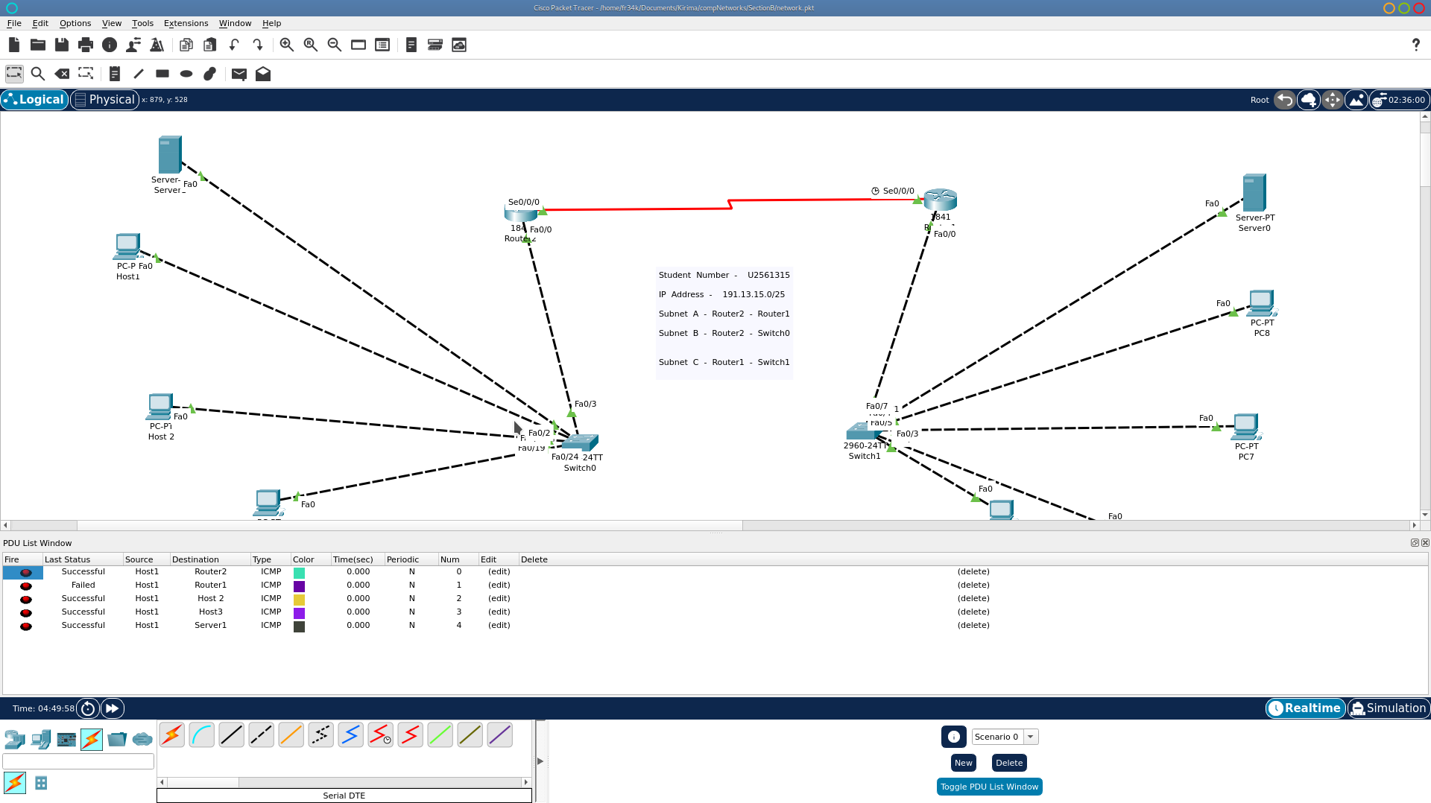
Host 2
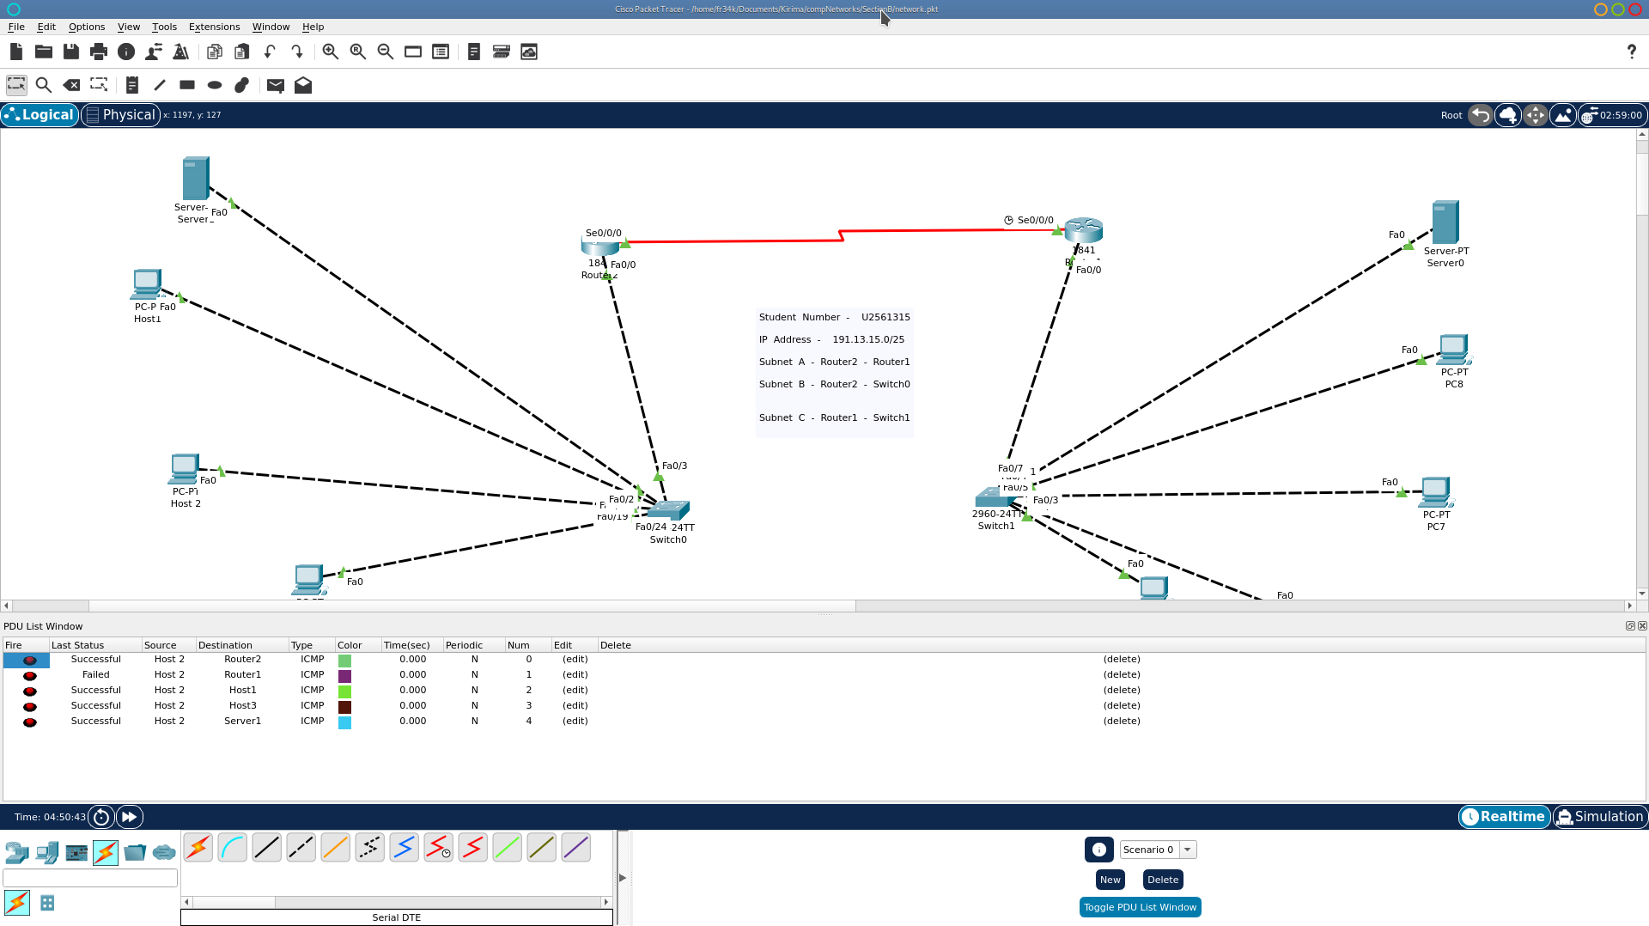

Host 3
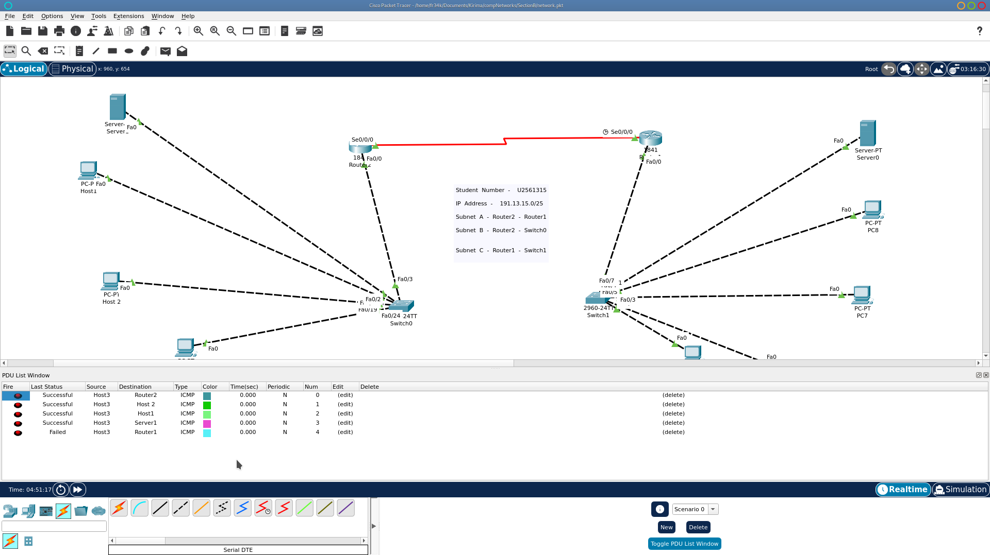

- Network Evaluation and result simulation.
The configuration of the devices are directly connected and therefore the state of the devices is structure based on the correct formalization of identical devices and the status of the messages sent from one device to the other. Each of this is explained by (Almalki, 2020) who states that the evaluated packets can be successful from one component to the other based on the various features of either the component or the device connection. The following images showcases the actual configurations done on the system devices to implement the network.
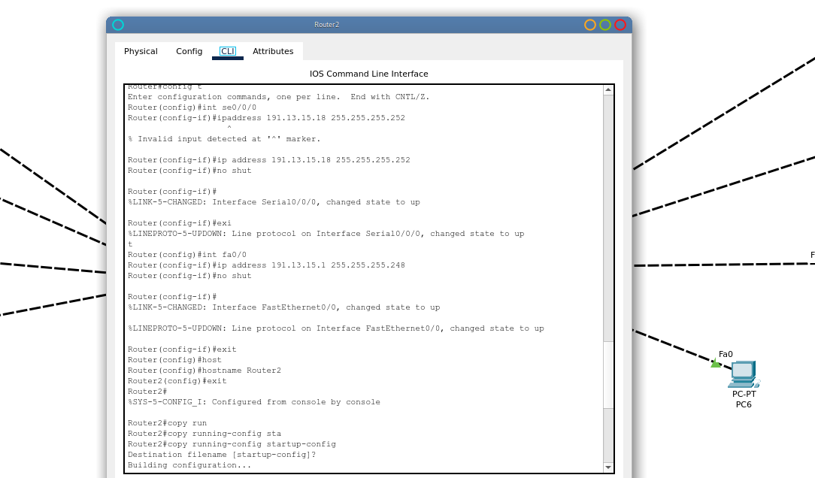
The image above showcases the configurations done on the router to enable connection between one router to the other.
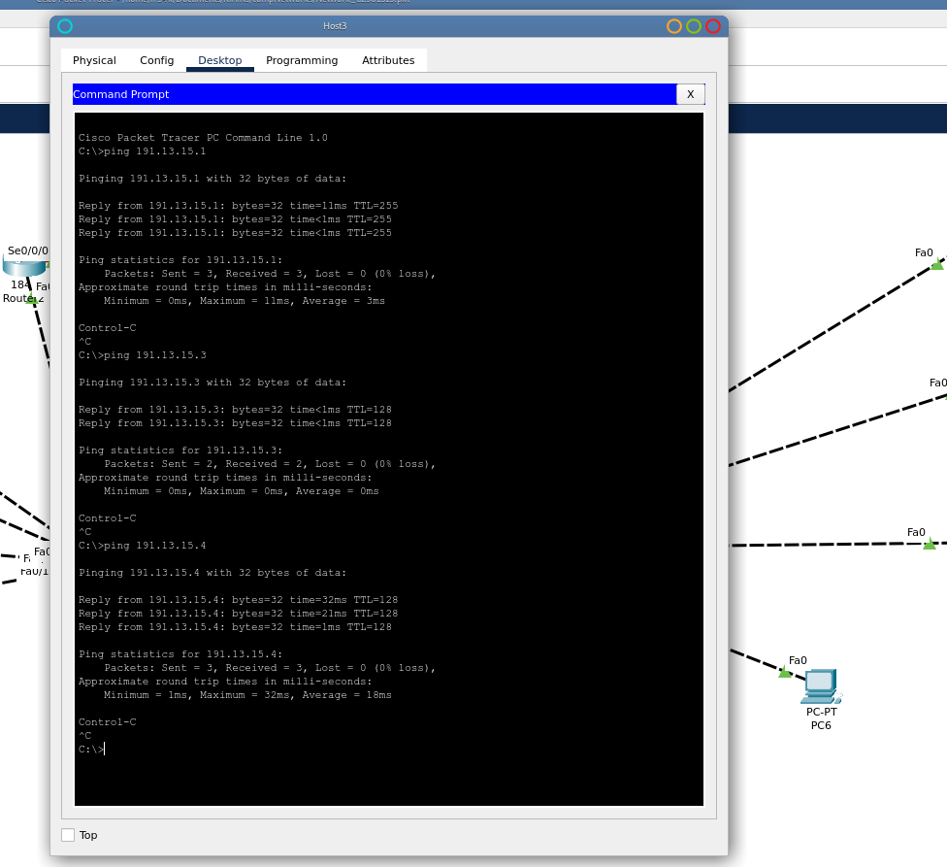
The ping statuses of the devices connection also give a positive success rate without packet loss indicating that our connection is correctly made.
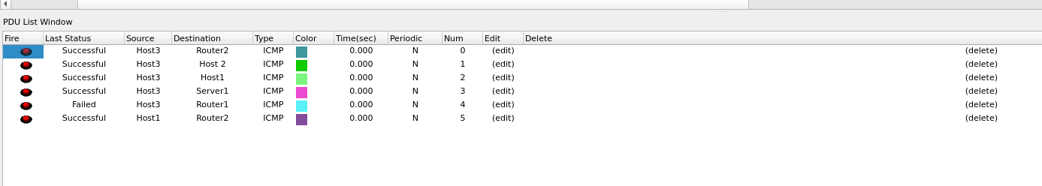
The image above show cases the actual packet message status for the hosts in network B to the various connection points. As indicated in the image all the status are correct based on the configurations done on the router.
- Router CLI Configurations
Router Commands
1.Router1
Router>en
Router#config t
Enter configuration commands, one per line. End with CNTL/Z.
Router(config)#int se0/0/0
Router(config-if)#ip address 191.13.15.17 255.255.255.252
Router(config-if)#no shut
%LINK-5-CHANGED: Interface Serial0/0/0, changed state to down
Router(config-if)#
Router(config-if)#exit
Router(config)#int fa0/0
Router(config-if)#ip address 191.13.15.9 255.255.255.248
Router(config-if)#no shut
Router(config-if)#
%LINK-5-CHANGED: Interface FastEthernet0/0, changed state to up
%LINEPROTO-5-UPDOWN: Line protocol on Interface FastEthernet0/0, changed state to up
Router(config-if)#exit
Router(config)#copy ru
Router(config)#copy run
Router(config)#exit
Router#
%SYS-5-CONFIG_I: Configured from console by console
Router#config t
Enter configuration commands, one per line. End with CNTL/Z.
Router(config)#hostna
Router(config)#hostname Router1
Router1(config)#exit
Router1#
%SYS-5-CONFIG_I: Configured from console by console
copy run
Router1#copy running-config sta
Router1#copy running-config startup-config
Destination filename [startup-config]?
Building configuration...
[OK]
Router1#

2.Router 2
Router>en
Router#config t
Enter configuration commands, one per line. End with CNTL/Z.
Router(config)#int se0/0/0
Router(config-if)#ip address 191.13.15.18 255.255.255.252
Router(config-if)#no shut
Router(config-if)#
%LINK-5-CHANGED: Interface Serial0/0/0, changed state to up
Router(config-if)#exi
%LINEPROTO-5-UPDOWN: Line protocol on Interface Serial0/0/0, changed state to up
t
Router(config)#int fa0/0
Router(config-if)#ip address 191.13.15.1 255.255.255.248
Router(config-if)#no shut
Router(config-if)#
%LINK-5-CHANGED: Interface FastEthernet0/0, changed state to up
%LINEPROTO-5-UPDOWN: Line protocol on Interface FastEthernet0/0, changed state to up
Router(config-if)#exit
Router(config)#host
Router(config)#hostname Router2
Router2(config)#exit
Router2#
%SYS-5-CONFIG_I: Configured from console by console
Router2#copy run
Router2#copy running-config sta
Router2#copy running-config startup-config
Destination filename [startup-config]?
Building configuration...
[OK]
Router2#

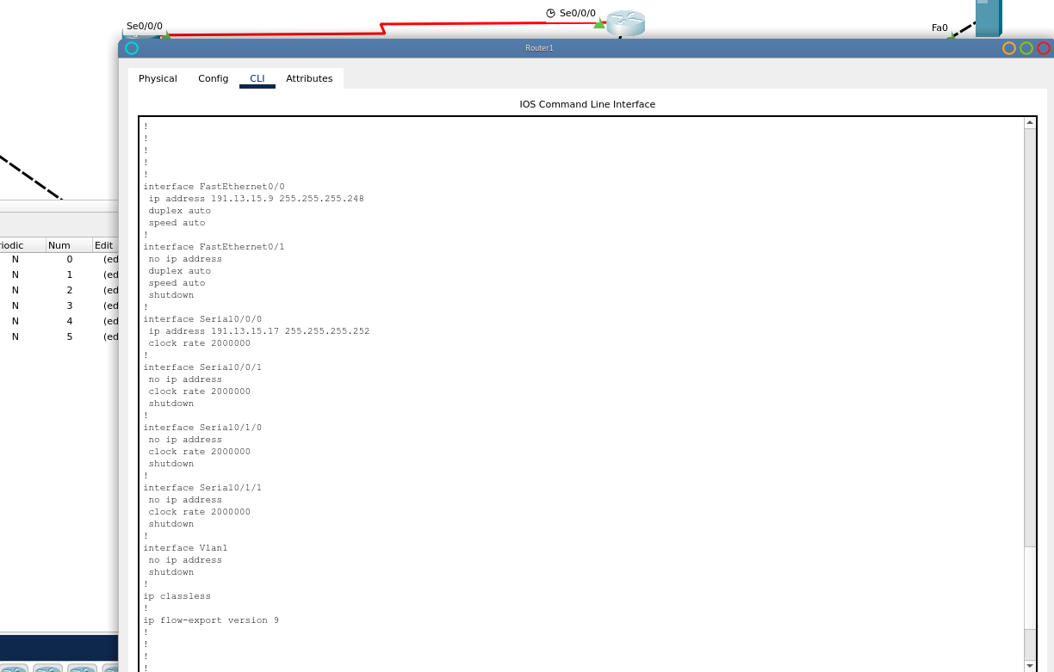
The image above show cases the running configuration of the router after the saving of each configurations made on the router.
- Conclusion
Based on the configuration made on the devices within the network, its direct the configuration made are correctly implemented which identifies that each subnet is functionally identical and that its essential message parsing are correctly implemented. Each configuration from router 2 to router 1 are correctly implemented. Cisco is a good software that basically helps identify network patterns and also describes all the essential services and directories that needs to be implemented within the network design. All of this services are directly versed in the software. It helpful to identify bugs in the simulation before setting up the real network design implementation.

Thank You

- References
Javid, S. R. (2014). Role of packet tracer in learning computer networks. International Journal of Advanced Research in Computer and Communication Engineering, 3(5), 6508-6511.
Sikarti, S., Syah, F. F., Dewi, A. R. C., & Aribowo, D. (2023). Simulasi Perencanaan Jaringan Transport Metro Ethernet Menggunakan Aplikasi Cisco Packet Tracer Versi 6.2. 0. Simpati: Jurnal Penelitian Pendidikan dan Bahasa, 1(2), 31-39.
Atjo, M. F., Olii, D., Manggopa, H., & Rompas, P. T. D. (2023). The Effect of Packet Tracer Simulator Media on Motivation and Learning Outcomes of Basic Network TKJ Students of Cokroaminoto Vocational School, Kotamobagu. International Journal of Information Technology and Education, 2(2), 26-44.
Almalki, F. A. (2020). Implementation of 5G IoT based smart buildings using VLAN configuration via cisco packet tracer. International Journal of Electronics Communication and Computer Engineering, 11(4), 56-67.
Allison, J. (2022, July). Simulation-based learning via cisco packet tracer to enhance the teaching of computer networks. In Proceedings of the 27th ACM Conference on on Innovation and Technology in Computer Science Education Vol. 1 (pp. 68-74).

