**Data cleansing and Visualization**

**Load Data**

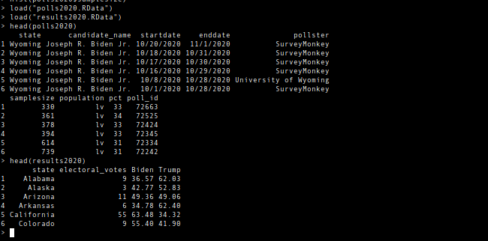

**Dimensions and Summary of the Data sets**

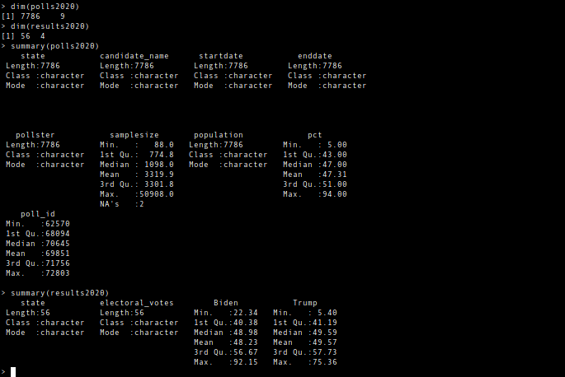

**Various Visualization**

**polls2020$SampleSize**

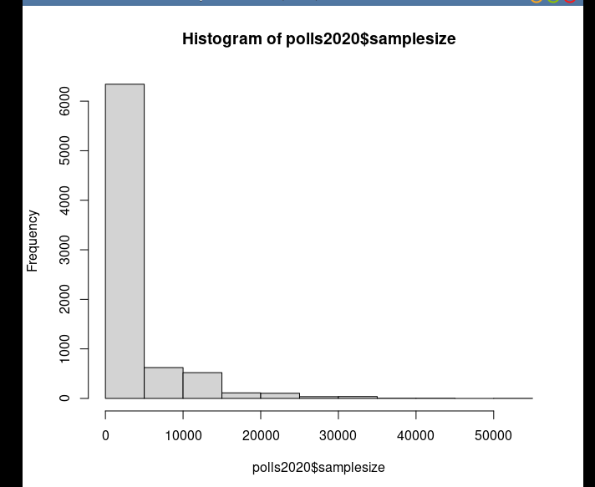

**Box Plots**

**polls2020$Samplesize**

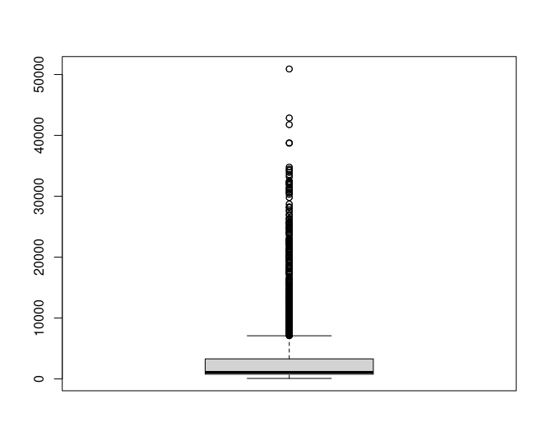

**Correcting errors in Polls2020 dataset.**

1. **change all character to uppercase**

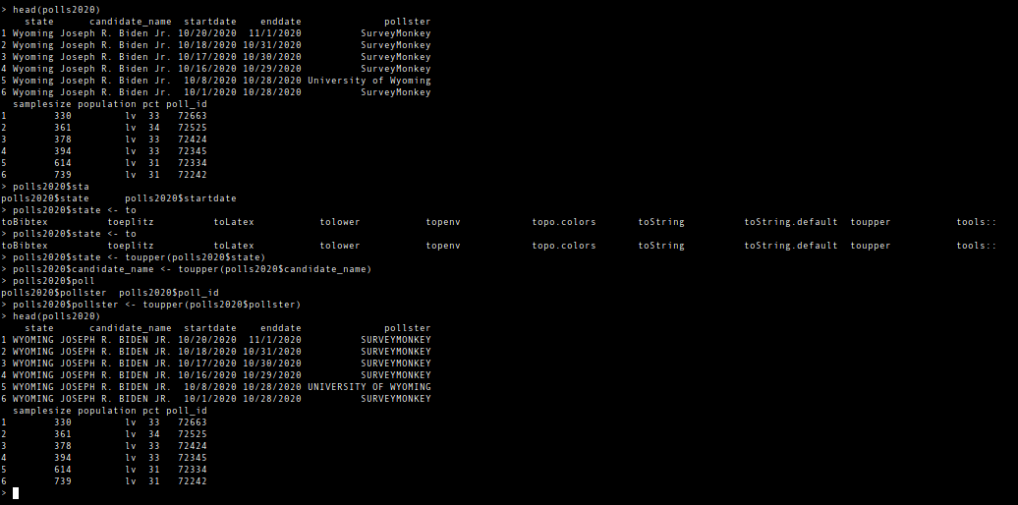

1. Trimming for Whitespaces

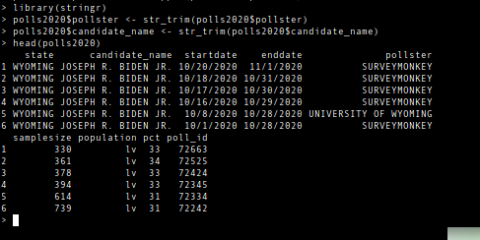

1. **Replace Outliers**



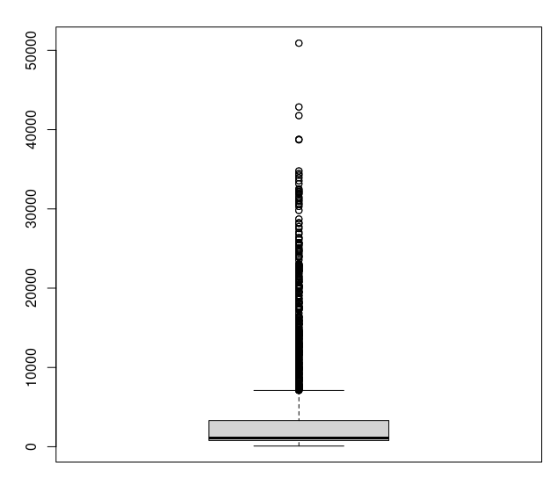

1. **Checking for missing values**

**Found missing values.**

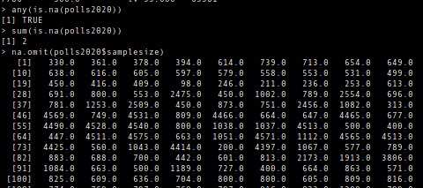

**Replacing them with 0 for all the missing values**

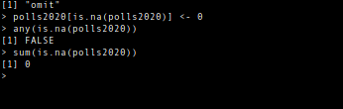

**In relation to the values.**

**Functional parts of the polls plotted in one graph.**

