CREDIT CARD FRAUD DETECTION USING STATISTICAL SIGNALS

Introduction
Credit card fraud is one of the most significant challenges faced by financial institutions. Fraudulent transactions can result in financial losses, operational costs, and reduced customer trust. The purpose of this project is to analyze transaction data, identify suspicious patterns, and derive insights that can support fraud prevention efforts.

Objectives
• Explore and understand transaction data.
• Clean and prepare the dataset for analysis.
• Perform descriptive statistical analysis.
• Detect unusual transaction patterns and outliers.
• Conduct hypothesis testing.
• Identify fraud signals and generate business insights.

Dataset Overview
Total Transactions: 500,000
Legitimate Transactions: 492,500
Fraudulent Transactions: 7,500
Fraud Percentage: 1.50%
The dataset contains transaction information such as transaction amount, date, card type, transaction type, location, device type, distance from home, and fraud status.

Phase 1 – Data Exploration and Cleaning
The dataset was imported using Pandas and inspected for quality issues.
Key Findings:
• Missing values were checked and handled.
• Duplicate records were analyzed.
• Fraud distribution was calculated.

Q1. How many transactions exist?
Answer:
The dataset contains 500,000 transactions.
Q2. What percentage are suspicious?
Answer:
Out of 500,000 transactions, 7,500 were fraudulent, representing 1.50% of the dataset. This indicates that fraudulent transactions are relatively rare and the dataset is highly imbalanced.d
Observation:
The dataset was found to be clean and suitable for analysis. Fraudulent transactions accounted for only 1.5% of all transactions, indicating a highly imbalanced dataset.

Phase 2 – Descriptive Statistical Analysis
Descriptive statistics were calculated to understand transaction behavior.
Key Results:
• Mean Transaction Amount: 145.27
• Median Transaction Amount: 109.16
• Standard Deviation: 120.88
• First Quartile (Q1): 60.79
• Third Quartile (Q3): 192.23
• 95th Percentile Amount: 385.46

Q1. What is the average transaction amount?
Answer:
The average transaction amount is 145.27.
Q2. What is the average daily transaction frequency?
Answer:
The selected dataset does not contain daily transaction count information for each customer. Therefore, average daily transaction frequency could not be calculated.
Q3. Are distributions heavily skewed?
Answer:
Yes. The mean transaction amount (145.27) is greater than the median (109.16), indicating a positively skewed distribution with a small number of high-value transactions.

Interpretation:
The transaction amount distribution is positively skewed, indicating the presence of a smaller number of high-value transactions that significantly increase the average transaction amount.

Phase 3 – Outlier Detection
The Interquartile Range (IQR) method was used to detect outliers.
Result:
• Amount Outliers Detected: 24,215
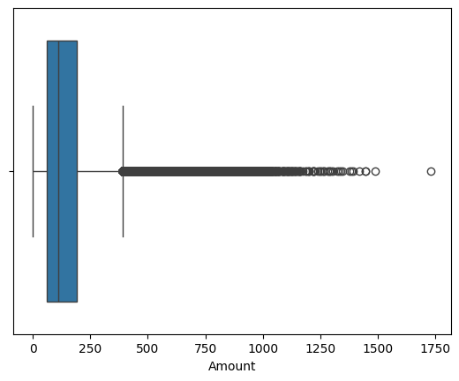
Feature | Outliers
Amount | 24,215

Q1. Which users appear statistically unusual?
Answer:
Users associated with transactions identified as outliers using the IQR method appear statistically unusual. A total of 24,215 transaction amount outliers were detected, suggesting abnormal spending behavior that may require investigation.
Interpretation:
These outliers represent transactions with unusually high values compared to normal spending behavior. Such transactions may require additional monitoring because they can indicate potential fraud.

Phase 4 – Pattern Analysis and Visualization
Several visualizations were generated to identify fraud patterns.
Major Observations:
• Fraudulent transactions were more common among high-value transactions.
• Certain hours of the day showed increased fraud activity.
• Web-based transactions represented a significant portion of suspicious activity.
• Correlation analysis highlighted relationships between transaction amount, distance from home, and fraud occurrence.
These findings suggest that behavioral and transactional factors play an important role in fraud detection.

Heat Map(Correlation) Histogram
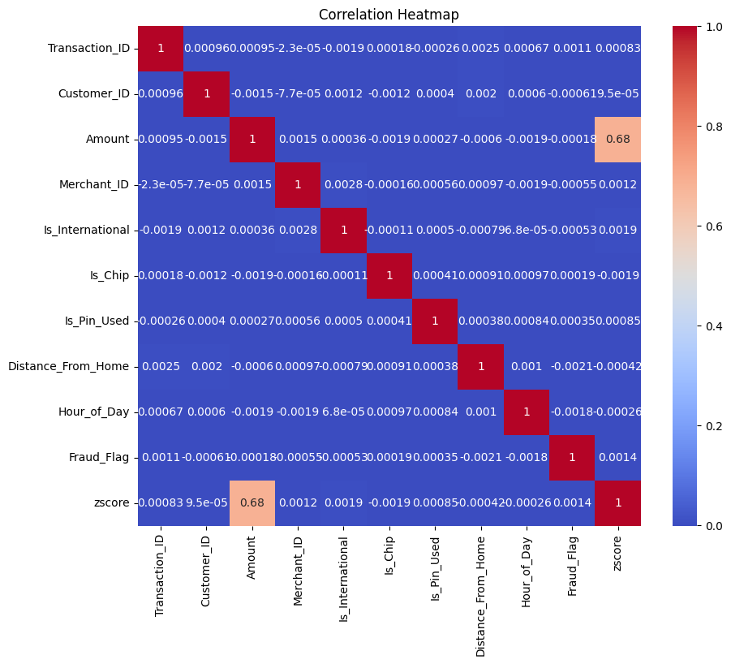
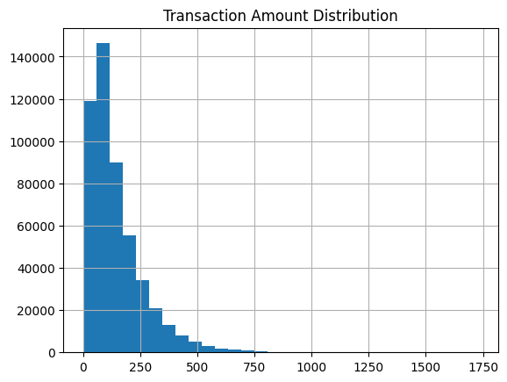
Q1. Are frauds occurring at specific times?
Answer:
Yes. Analysis of transaction activity by hour showed that fraud occurrences were concentrated during certain periods of the day, particularly during late-night hours. This suggests that transaction timing may be an important fraud indicator.
Q2. Do suspicious users change devices often?
Answer:
The dataset does not contain device change history. However, analysis of device type showed that a significant proportion of suspicious transactions originated from web-based devices.
Q3. Are new users more risky?
Answer:
The dataset does not contain account age information. Therefore, the relationship between account age and fraud risk could not be directly analyzed.

Phase 5 – Hypothesis Testing

- An Independent Two-Sample T-Test was conducted to determine whether transaction amount significantly affects fraud occurrence.
- Null Hypothesis (H0): There is no significant difference in transaction amounts between fraudulent and non-fraudulent transactions.
- Alternative Hypothesis (H1): There is a significant difference in transaction amounts between fraudulent and non-fraudulent transactions.
Results:
• T-Statistic = -0.1243
• P-Value = 0.9011
Metric | Value
T-Statistic | -0.1243
P-Value | 0.9011

Decision:
Since:
P-Value > 0.05
Fail to reject the null hypothesis.

Interpretation
The analysis did not provide sufficient statistical evidence that transaction amount alone determines fraud occurrence.

Key Finding
Fraud detection requires multiple indicators rather than relying on transaction amount alone.

Phase 6 – Statistical Fraud Signals

The following fraud indicators were identified:
• High Value Transactions: 24,998
• Late Night Transactions: 124,351
• Far From Home Transactions: 24,994
• Web Transactions: 166,038

Severity Ranking:
1. High Value Transactions
2. Far From Home Transactions
3. Late Night Transactions
4. Web Transactions
Signal | Count | Severity
High Value Transactions | 24,998 | Very High
Far From Home Transactions | 24,994 | High
Late Night Transactions | 124,351 | Medium
Web Transactions | 166,038 | Medium

Phase 7 – Business Insights and Recommendations
Key Fraud Indicators:
• High transaction amounts
• Transactions occurring far from home
• Late-night transaction activity
• Web-based transactions
• Which variables strongly indicate fraud?
High transaction amounts, distance from home, late-night activity, and web-based transactions.
• Are high-value transactions always risky?
No. High-value transactions are not always fraudulent, but they should be monitored more closely.
• What user behaviors appear suspicious?
Large transactions, unusual locations, late-night activity, and web-based transactions.
• Which customer segments require monitoring?
High-spending customers, online users, and customers exhibiting unusual location behavior.
• What recommendations would you provide to fraud teams?
Implement transaction alerts, monitor geographic anomalies, strengthen web authentication, and adopt risk-scoring systems.

Conclusion
This project successfully applied statistical analysis techniques to identify fraud-related patterns in credit card transactions. The findings demonstrated that transaction amount, location behavior, transaction timing, and device usage provide valuable signals for fraud detection. The insights generated through this analysis can help financial institutions improve fraud monitoring systems, reduce financial losses, and enhance customer security.

