Time Series Forecasting of COVID-19 Vaccination Trends: A Comparative Analysis of the United States and India
Ryan Weeks, Sarah Yawn, Lisa Hansen
November 9, 2025

Introduction
The COVID-19 pandemic required countries worldwide to implement vaccination programs to protect their populations. Understanding how these programs are performing and predicting future trends helps healthcare leaders make better decisions about where to allocate resources and how to plan for the future. This analysis examines vaccination patterns in two major countries—the United States and India—to provide insights for strategic healthcare planning.

Business Problem
Healthcare administrators need accurate predictions of vaccination trends to make informed decisions about staffing, vaccine supplies, and outreach programs. Knowing whether vaccination efforts are speeding up, slowing down, or staying steady allows leaders to plan effectively and use resources wisely.

Hypothesis
We predicted that forecasting models could successfully identify patterns in vaccination data and make reliable predictions. Specifically, we expected that the United States, which started vaccinating earlier, would show declining daily vaccination numbers as most people who want vaccines have already received them. We also expected India to show continued growth in total vaccination coverage as their program continues expanding to reach more people.

Methodology
We analyzed two datasets: United States daily vaccination counts (470 data points) and India's percentage of fully vaccinated population (399 data points). The US data tracked how many vaccines were given each day, while the India data showed the cumulative percentage of the population fully vaccinated over time.
We used Prophet forecasting models to analyze the data and predict future trends for the next 365 days. We configured the models to account for country-specific holidays and seasonal patterns that scale proportionally with overall vaccination activity levels.

Results

United States Findings
The US vaccination data showed a clear downward trend from peak activity to lower, more stable rates. This pattern indicates the vaccination program has matured, shifting from mass vaccination efforts to routine maintenance. The US reached its highest vaccination rates early in the campaign, then experienced steady decline as the easily accessible population became vaccinated.
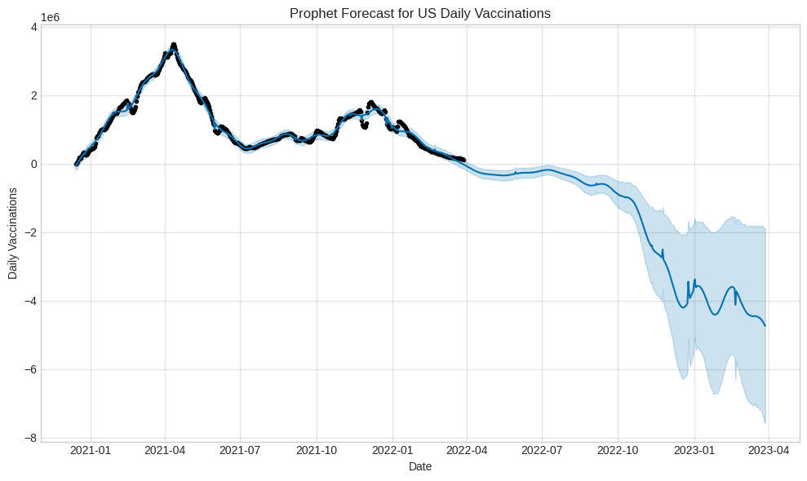
The model revealed strong weekly patterns, with fewer vaccinations occurring on weekends (especially Sundays) and higher numbers on weekdays. Yearly patterns showed peaks in spring and declines during summer months, likely reflecting seasonal public health campaigns and when booster shots become available.

India Findings
India's data demonstrated steady upward growth in cumulative vaccination coverage, though the growth rate is gradually slowing as coverage increases. This pattern suggests India's vaccination program is still actively expanding but approaching a point where reaching additional people becomes more challenging.
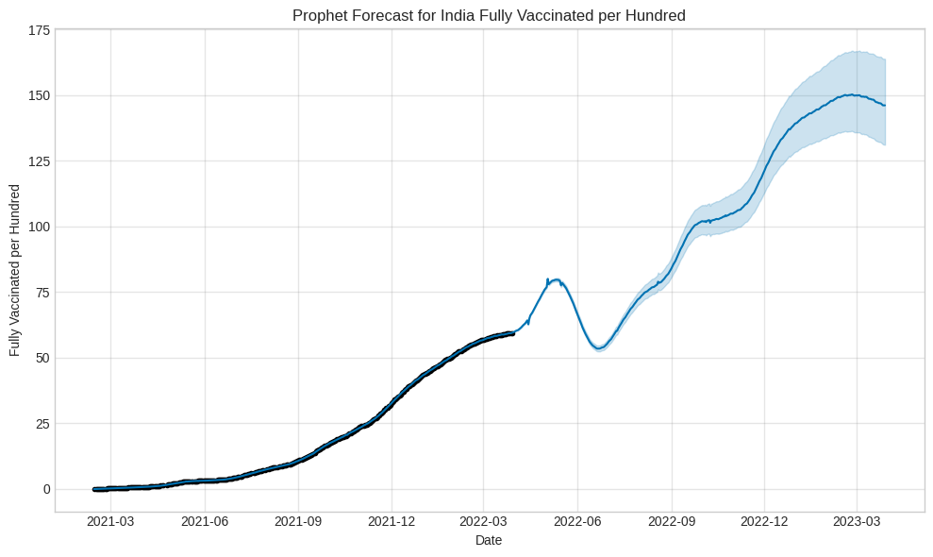
Like the US, India showed weekly patterns with weekend decreases, though the overall upward trend was the dominant feature. The cumulative nature of this metric means that even with daily fluctuations, the overall percentage continues climbing steadily.

Comparison
The contrasting trends reveal that these countries are at different stages of their vaccination programs. The US shows declining daily activity typical of programs shifting from mass vaccination to ongoing maintenance, while India displays sustained growth characteristic of active population expansion efforts. These differences reflect factors such as population size, when vaccinations began, vaccine availability, and healthcare infrastructure.

Recommendations
Seasonal Timing: The spring peaks in US vaccinations suggest optimal timing for public health campaigns. Fall and winter booster campaigns could align with periods when people are historically more receptive to vaccination.
Weekend Access: The consistent weekend decreases indicate barriers to access. Expanding weekend vaccination through pharmacies and mobile clinics could improve coverage in both countries.

Ethical Considerations
This analysis used aggregated data that protects individual privacy. However, researchers working with more detailed data must implement strong privacy protections, especially when analyzing specific neighborhoods or small populations where individuals might be identifiable.
The models show overall trends but do not reveal disparities across different racial, ethnic, or socioeconomic groups. Healthcare systems have an obligation to examine data by demographic factors to identify and address equity gaps. Overall improvements may hide persistent disparities affecting specific communities.
While this analysis used publicly available data, healthcare systems should inform patients about how their health information may be used for research and planning purposes, providing opportunities to opt out when possible.

Conclusion
This analysis demonstrates that forecasting models can effectively predict vaccination trends and support public health planning. Our predictions were confirmed: the United States shows declining daily vaccinations characteristic of a mature program, while India displays continued growth in cumulative coverage.
The US should transition from large-scale vaccination infrastructure to sustainable routine services integrated into primary care. India should maintain expansion efforts while preparing for eventual saturation and developing strategies to reach harder-to-access populations.
Both countries showed weekly patterns with weekend decreases, highlighting operational factors that could be modified to improve effectiveness. The yearly patterns suggest opportunities for strategically timed campaigns during periods of higher receptivity.

References
Centers for Disease Control and Prevention. (2023). COVID-19 vaccinations in the United States. https://covid.cdc.gov/covid-data-tracker/#vaccinations
Cleveland, R. B., Cleveland, W. S., McRae, J. E., & Terpenning, I. (1990). STL: A seasonal-trend decomposition procedure based on loess. Journal of Official Statistics, 6(1), 3-73.
Ministry of Health and Family Welfare, Government of India. (2023). COVID-19 vaccine tracker. https://www.mohfw.gov.in/
Taylor, S. J., & Letham, B. (2018). Forecasting at scale. The American Statistician, 72(1), 37-45. https://doi.org/10.1080/00031305.2017.1380080
World Health Organization. (2021). Ethics and COVID-19: Resource allocation and priority-setting. https://www.who.int/ethics/publications/ethics-covid-19-resource-allocation.pdf

APPENDIX A: SUPPLEMENTARY MATERIALS

Model Specifications and Parameters

United States Daily Vaccinations Model

Model: Prophet
Seasonality Mode: Multiplicative
Yearly Seasonality: Enabled
Weekly Seasonality: Enabled
Daily Seasonality: Disabled
Country Holidays: United States
Training Data Points: 470
Future Forecast Period: 365 days
Total Forecast Points: 835

India Fully Vaccinated Per Hundred Model

Model: Prophet
Seasonality Mode: Multiplicative
Yearly Seasonality: Enabled
Weekly Seasonality: Enabled
Daily Seasonality: Disabled
Country Holidays: India
Training Data Points: 399
Future Forecast Period: 365 days
Total Forecast Points: 764

Sample Forecast Output

US Daily Vaccinations (First 5 Predictions)
Date | Predicted (yhat) | Lower Bound | Upper Bound
2020-12-14 | -57,860 | -186,577 | 73,668
2020-12-15 | -21,233 | -151,260 | 101,527
2020-12-16 | 15,655 | -112,226 | 151,844
2020-12-17 | 52,631 | -69,650 | 185,757
2020-12-18 | 89,383 | -45,207 | 223,462

India Fully Vaccinated Per Hundred (First 5 Predictions)
Date | Predicted (yhat) | Lower Bound | Upper Bound
2021-02-13 | -0.042 | -0.151 | 0.070
2021-02-15 | -0.012 | -0.127 | 0.098
2021-02-16 | 0.003 | -0.105 | 0.112
2021-02-17 | 0.017 | -0.093 | 0.117
2021-02-18 | 0.032 | -0.078 | 0.140

Appendix B: Discussion Questions
- What are the primary advantages of using Prophet for time series forecasting compared to traditional ARIMA models?
Prophet offers automatic detection of changepoints, explicit modeling of multiple seasonality patterns (daily, weekly, yearly), built-in holiday effects, and robustness to missing data. Unlike ARIMA, which requires stationary data and careful parameter tuning, Prophet handles trends and seasonality automatically, making it more accessible for practitioners.
- How does multiplicative seasonality differ from additive seasonality, and why was it chosen for these vaccination datasets?
Additive seasonality assumes seasonal fluctuations remain constant regardless of trend level, while multiplicative seasonality scales proportionally with the trend. Multiplicative was chosen because vaccination seasonal effects (e.g., weekend dips) scale with overall program intensity—a 20% weekend reduction matters more at 1 million daily doses than at 100,000.
- What factors might explain the weekly seasonality patterns observed in both countries' vaccination data?
Weekly patterns likely reflect operational factors including reduced staffing on weekends, clinic scheduling practices, patient preferences for weekday appointments, and administrative processing delays. Additionally, many vaccination sites operate limited hours or close entirely on Sundays.
- Why do the uncertainty intervals widen as the forecast extends further into the future?
Uncertainty compounds over time as each prediction step introduces additional error. Long-term forecasts accumulate uncertainty from trend estimation, seasonal pattern variation, and unforeseen events. This reflects the fundamental principle that near-term predictions are more reliable than distant projections.
- How might external factors like vaccine mandates or new variant emergence affect the accuracy of these forecasts?
Prophet models assume historical patterns continue, so policy changes (mandates, recommendations) or epidemiological developments (new variants, waning immunity) that alter behavior would reduce forecast accuracy. These represent structural breaks not captured in historical data, requiring model retraining or external regressor incorporation.
- What are the implications of comparing a flow metric (daily vaccinations) versus a stock metric (cumulative coverage percentage)?
Flow metrics reveal immediate program activity and operational intensity, useful for short-term resource planning. Stock metrics show overall progress toward population immunity goals. Flow metrics are more volatile and sensitive to operational factors, while stock metrics show smoother trends but mask current activity levels.
- How could these forecasting models be improved by incorporating additional regressors or external data sources?
Adding regressors for vaccine supply availability, public sentiment indicators (social media analysis), policy interventions (mandate timing), media coverage intensity, or local outbreak severity could improve accuracy. Weather data might explain some seasonal patterns, while demographic factors could enable stratified forecasting.
- What strategic decisions could healthcare administrators make based on the declining trend observed in US daily vaccinations?
Administrators should consolidate vaccination sites, shift from dedicated centers to integrated primary care delivery, reallocate personnel to other services, adjust vaccine inventory orders, and invest in targeted outreach for underserved populations rather than maintaining mass vaccination infrastructure.
- At what point might India's vaccination coverage growth plateau, and what indicators would suggest this transition?
Plateaus typically occur at 60-80% coverage depending on vaccine hesitancy levels. Early indicators include: decreasing week-over-week growth rates, increasing proportion of second-dose versus first-dose administrations, geographic clustering of unvaccinated populations, and shifts in demographics of newly vaccinated individuals toward harder-to-reach groups.
- How do country-specific holidays incorporated into the models affect vaccination patterns, and what does this reveal about program operations?
Holidays typically show reduced vaccination activity, revealing that vaccination programs operate within normal societal rhythms rather than as emergency-independent operations. This indicates potential capacity for surge operations during non-holiday periods if needed, and suggests holiday-adjacent periods for targeted campaigns may be less effective.

