Orai channels

Calcium release-activated channels (CRAC) are specialized plasma membrane Ca2+ ion channels. When calcium ions (Ca2+) are depleted from the endoplasmic reticulum (a major store of Ca2+) of mammalian cells, the CRAC channel is activated to slowly replenish the level of calcium in the endoplasmic reticulum. The Ca2+ Release-activated Ca2+ (CRAC) Channel (CRAC-C) Family (TC# 1.A.52) is a member of the Cation Diffusion Facilitator (CDF) Superfamily. These proteins typically have between 4 and 6 transmembrane α-helical spanners (TMSs). The 4 TMS CRAC channels arose by loss of 2TMSs from 6TMS CDF carriers, an example of 'reverse' evolution'.

Pfam

PF07856: Mediator of CRAC channel activity
Pfam phylogeny

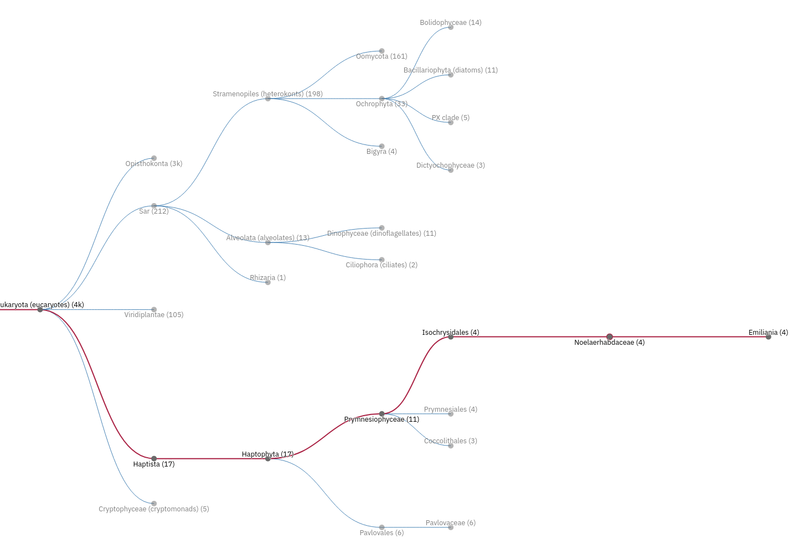
Uniprot
Orai → prot existence → homology

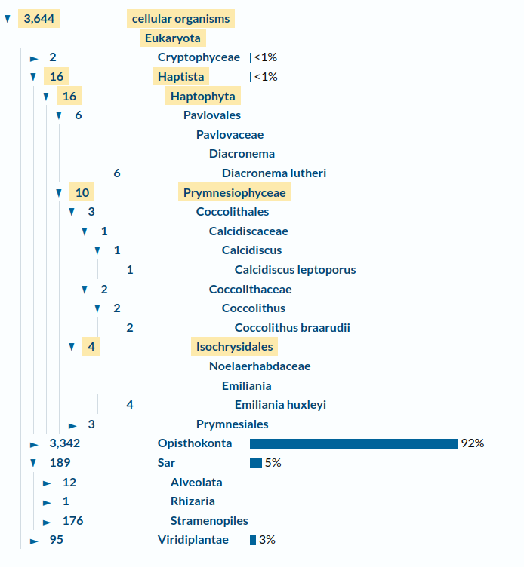

Interpro: Q09232

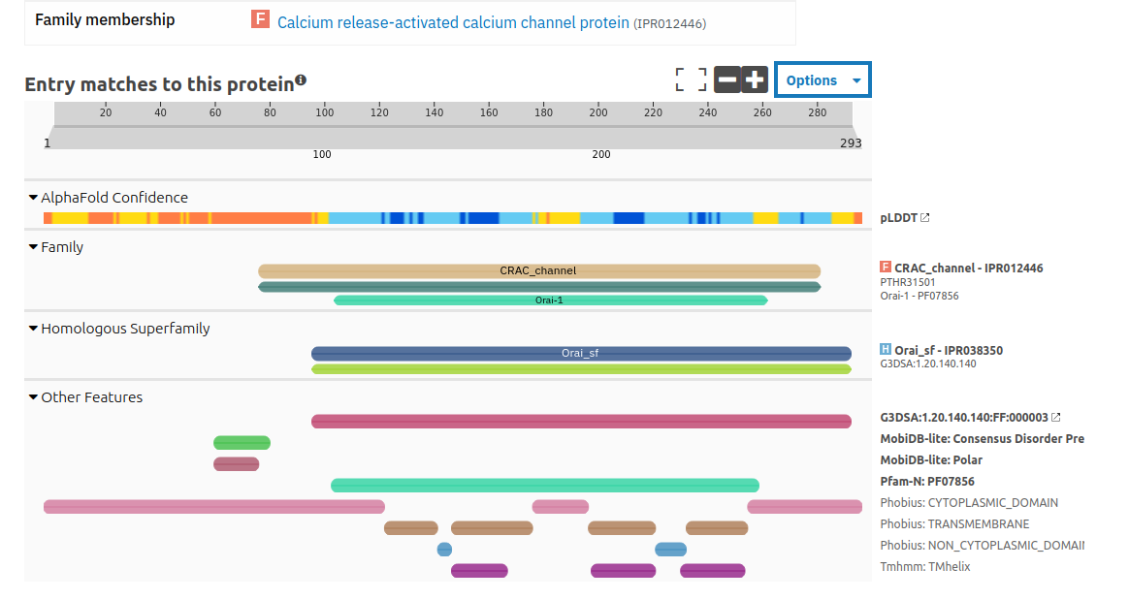

Erro 2012: https://link.springer.com/chapter/10.1007/978-94-007-2888-2_15

- CRAC: Calcium release activated Ca current is generated by Orai1
- Orai 1 is thus a key store operated ca channel (SOC), responsible for store operated ca entry (SOCE)
- Sensing of filling state of ER triggers current
- Before the identification of STIM1 and Orai1, TRPC proteins were found to be involved in SOCE in different cell types, more likely conducting the non-selective capacitative current described as I SOC.
- N-terminus of Orai1 contains proline/arginine-rich regions and a membrane-proximal domain (between residues 68 and 91) with the ability to bind calmodulin in a Ca2+-dependent manner: involved in fast Ca2+-dependent inactivation of I CRAC, an event that occurs within the first 100 ms upon CRAC channel opening induced by a local increase in the [Ca2+]i close to the channel pore [143, 144], that protects against cellular damage by limiting Ca2+ influx
- C-terminal region of all three Orais contains a putative coiled-coil sequence that plays a key role for dynamic interaction with STIM1 [145, 146]. A deletion or single point mutation (L273S) within this region has been shown to disrupt the functional communication of Orai1 with STIM1
- 2-aminoethoxydiphenyl borate (2-APB). This agent acts as a direct Orai3 activator. In addition, low 2-APB concentrations activate Orai1 and Orai2 currents when co-expressed with STIM1. By contrast, at high concentrations, 2-APB is a potent antagonist or Orai1-conducted currents.
- on selectivity of Orai1 has been attributed to two conserved negatively charged glutamate residues located in the first and the third transmembrane regions (E106 and E190) human.
- Orai 2 and 3 minor component of current, important in some tissues. An Orai2 isoform in mouse may be a negative regulator of Orai1
- Orai1 is H2O2 sensitive
- shown several store-operated currents with different biophysical properties in distinct cell types, operated through different signaling pathways, and suggest that these currents might be conducted through homo or heteromeric combinations of the different channel subunits identified with the participation of STIM1 to confer store-operated behaviour. STIM1 has been reported to interact physically both with Orai1 and TRPC channels

https://www.nature.com/articles/nature05108

interaction between wild-type Stim and Orai, assessed by co-immunoprecipitation, is greatly enhanced after treatment with thapsigargin to induce Ca2+ store depletion.

Li 2021 https://www.mdpi.com/2073-4409/10/11/3062

Beginning with extracellular ligand stimulation, G proteins activate phospholipase C, and the latter decomposes phosphatidylinositol 4,5-bisphosphate (PIP2) in the PM into diacylglycerol (DAG) and inositol-1,4,5-trisphosphate (IP3) [15]. IP3 drains the ER Ca2+ store via Ca2+ release through IP3 receptors. Subsequently, ER-localized STIMs oligomerize and accumulate at ER–PM junctions. Oligomeric STIMs contact the negatively charged cytosolic face of the PM and directly interact with PM-localized Orai channels through their STIM1–Orai-activating region (SOAR) domains

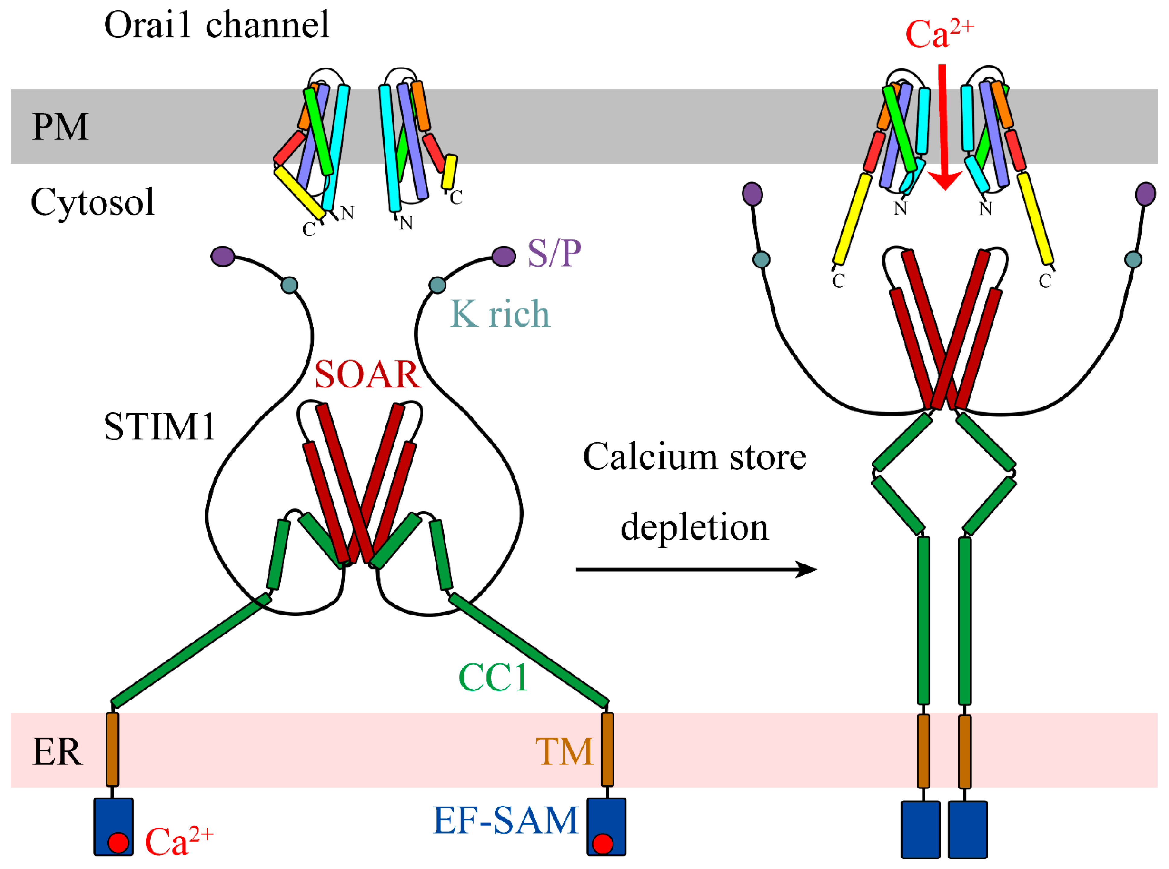

- Orai’s are 1000x selective for Ca over K / Na
- Slow ca permeation rate (100x slower than most ca channels)
- Thus can drive long, sustained ca increases

Drosophila Orai may make a hexamer:

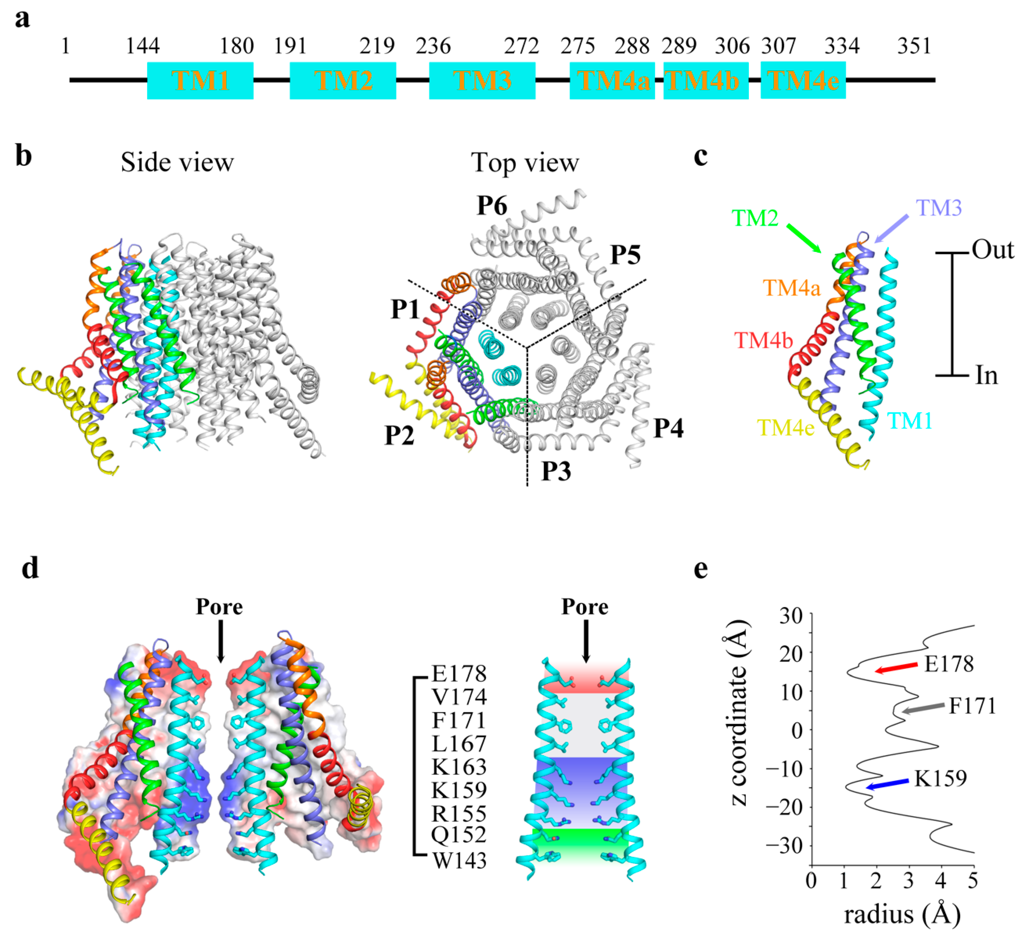

Conserved Pro288 (corresponding to P245 in hOrai1) yields bend in TM4. TM4 is crucial – undergoing conformational rearrangement when binding STIMs. Pore: glutamate ring (red). Hydrophobic (grey), basic (blue)

- Constitutively active mutants: dOrai-H206A , dOrai-P288L
- hOrai1-F257 in TM4, hOrai1-L261 in TM4 and hOrai1-F178A in TM3 (corresponding to F300, L304 and F250 in the dOrai channel, respectively), that interfere with the intra-subunit interactions between the TM3 and TM4 helices, cause a decrease in Ca2+ influx without attenuating the association of STIM1 with hOrai1
- L81A, E173A and H169A mutants of hOrai1 obviously attenuate or abolish extracellular Ca2+ influx
- mutations, such as R83A-K87A and R77A-K78A in the constitutively mutant hOrai1-P245L [39] and R155S/K159S/K163S in the open state dOrai-H206A [38], were introduced in the positively charged basic region to prevent electrostatic repulsion; these mutations greatly attenuate the influx of extracellular Ca2+. These results indicated that the basic region near the cytosolic face of the pore may play some unexpected but important roles in Ca2+ permeation.

Vig 2006: https://www.sciencedirect.com/science/article/pii/S0960982206021531#fig1

The channel pore of CRACM1 is highly selective for Ca2+ ions because of the presence of critical glutamate residues in TM1 and TM3 (E106 and E190) as well as aspartate residues (D110 and D112) within a Ca2+ binding motif located in the extracellular loop that connects TM1 and TM2. Mutations of either of these critical residues alter the CRAC-channel selectivity by enhancing monovalent cation permeation relative to Ca2+, providing unambiguous evidence that CRACM1 harbors the CRAC-channel pore.

(CRACM1 = Orai1human)

Jardin 2022: https://www.mdpi.com/1422-0067/23/23/14568

- (SOCE), a major mechanism of Ca2+ mobilization in the electrically non-excitable and excitable cells, where the release of Ca2+ stored in the intracellular compartments, mainly the endoplasmic reticulum (ER), leads to the activation of Ca2+ channels in the plasma membrane (PM), followed by a massive Ca2+ influx from the extracellular medium [4,5]. SOCE is mediated by two types of channels, the Ca2+ release-activate calcium (CRAC) and the store-operated calcium (SOC) channels. The passing of Ca2+ from the extracellular milieu through the channels generates two distinct currents, Icrac and Isoc, each with identifiable features. Whereas CRAC influx is mediated exclusively by the ER Ca2+ sensor, STIM1, and Orai1 channels, TRPC1 proteins associate with Orai1 and STIM1 to form the SOC channels
- current evidence supports that native CRAC channels consist of the heteromeric association of Orai1, Orai2, and/or Orai3 (PMID: 28294127, PMID: 29604961, PMID: 31015290), where the presence of Orai2 and Orai3 in native CRAC channels ensures that the magnitude of Ca2+ influx is proportional to the strength of agonist stimulation
- While the transmembrane domains (TM1–4) are highly conserved in all three isoforms, there are clear differences between the cytosolic regions, with 34% and 46% of sequence similarity between the N-terminus and C-terminus, respectively, of Orai1 and Orai3. The extracellular regions of the Orai proteins diverge as well, with an Orai3 third loop longer than the one exhibited by Orai1 and Orai2
- In 2012, the structure of dOrai was crystallized, featuring an unexpected arrangement of six dOrai subunits conforming to the channel [22]. Although tetrameric and pentameric stoichiometries for the human Orai channels have been proposed, it is currently accepted that the Orai1 proteins might form a hexamer
- one dOrai channel is formed by three dimers with a crossing C-termini. The TM1 domains form the inner ring that acts as the ion-conducting pore. TM2–3 generate a central ring that protects the pore from interaction with the lipids in the PM. TM4 arranges as the outer ring, interacting with other PM components.
- An α-helix of the TM1 domain, known as the extended transmembrane Orai1 N-terminus (ETON, aa 73–90), reaches the cytoplasm and is required for the association with STIM1 and the gating of the channel
- he pore region is composed of a basic domain (hOrai1 aa R83, K87, and R91, whose mutation to W induced SCID), a hydrophobic segment (hOrai1 aa L95, F99, and V102), and the selectivity filter, formed by a ring of six glutamates (hOrai1 aa E106).
- first extracellular loop (loop1) that contains an acidic calcium accumulating region (CAR, hOrai1 aa D110, D112, D114) that ensures Ca2+ influx even in low Ca2+ conditions
- only cytosolic Orai1 loop (loop2), located between TM2 and TM3, possesses two modulating domains that control Ca2+ influx through Orai1: the first one (hOrai1 aa 151–154) facilitates Orai1 fast calcium-dependent inactivation (FCDI) [28], and the second region within loop2 is an interacting domain (hOrai1 aa 157–167) with the chaperonin-containing T-complex protein 1 chaperonin complex (CCT) that mediates Orai1 internalization and recycling, thus acting as a regulator of Ca2+ signaling mediated by SOCE
- (loop3), which contains the unique glycosylation site within Orai1 (hOrai1 aa N223), allowing the interaction with lectins (carbohydrate-binding proteins) in a cell-type dependent manner, which results in the attenuation of SOCE
- All loops contain cysteine residues (hOrai1 loop1-C126, loop2-C143, and loop3-C195) that modulate the redox regulation of Orai1 channels as treatment with H2O2 significantly impaired SOCE
- in bending in a highly conserved region (hOrai1 aa 268–291), known as TM4 extended (TM4x) [32], which results in an antiparallel association between the C-termini of two neighboring dOrai subunits
- Orai1 C-terminal exhibits a region (hOrai1 aa 260–275), termed as the C-terminus internalization handle (CIH), which exert a negative effect over SOCE by contributing to the internalization of Orai1 during meiosis through caveolin- and dynamin-dependent endocytic pathway
- Orai1 C-termini is considered the primary binding site with STIM1, as deletion of this fragment completely abolishes the association between STIM1-Orai1
- Although still a matter of debate (extensively discussed in [43]), several reports have demonstrated that STIM1 interacts with Orai1 N-termini to gate and modulate the opened Orai1 channel
- Orai1 contributes to several other ca elevation pathways
- STIM1 binds to Orai1 C-termini (aa 260–275) by an activating region located in the cytosolic STIM1-CC1α3 and -CC2 domain (aa 312–387) [37], which was simultaneously characterized by three independent groups and dubbed as CAD (CRAC activating domain) [34], SOAR (STIM1-Orai1 activating region) [35], and OASF (Orai1 activating small fragment)

Human Orai1 has two variants initiated by alternative translation:

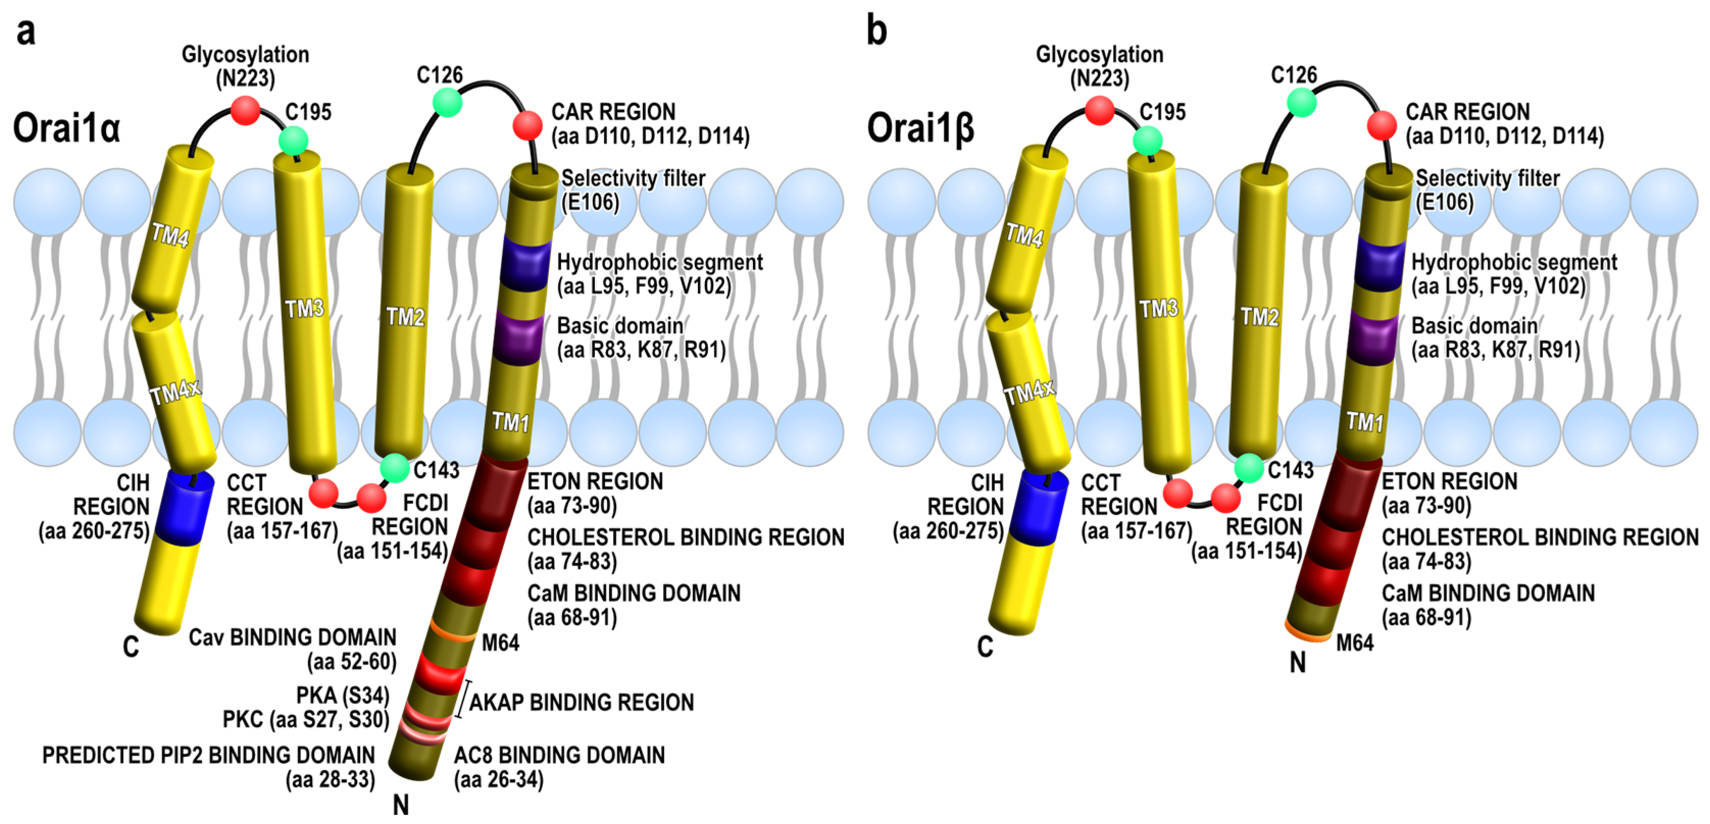

Bouron 2022 https://www.sciencedirect.com/science/article/pii/S0143416022001300?via%3Dihub

in most instances, IP3-mobilizing molecules generate biphasic Ca2+ responses reflecting the release of Ca2+ from the endoplasmic reticulum (ER) and the uptake of Ca2+ from the extracellular medium. Hence, the release and entry of Ca2+ are two functionally interconnected biological processes involving distinct molecular entities.

some Orai channels can function in a store-independent manner: Orai1 has been shown to display some constitutive Ca2+ entry, at least in some cancer cells. Orai channels can also be recruited by agonists like arachidonic acid forming arachidonate-regulated channels (ARC) [6] or function under the control of Ca2+ pumps (e.g. SPCA1, SPCA2) or potassium channels (e.g. SK3) [7]. Additionally, blockers of L-type voltage-operated Ca2+ channels like the dihydropyridine amlodipine can trigger a STIM-dependent entry of Ca2+ via Orai channels but independently of ER Ca2+ stores

STIM1 also works with non selective channels, such as Pannexins in neurones

Johnson 2022: https://www.sciencedirect.com/science/article/pii/S0143416022000197?via%3Dihub

Various PTMs in STIM and Orai proteins
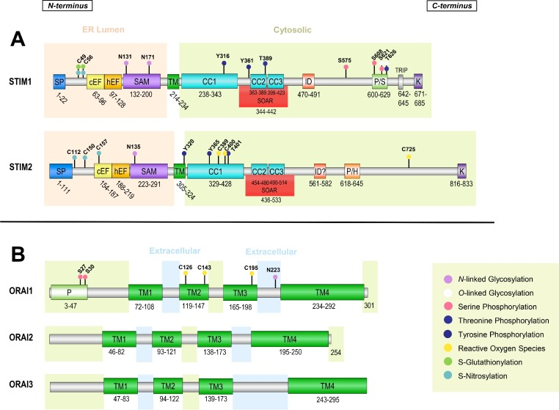

Orai Evolution

https://www.ncbi.nlm.nih.gov/pmc/articles/PMC2894845/

- Cation Diffusion Facilitator (CDF) proteins are ubiquitous across ToL
- Most members of the CDF family possess six putative transmembrane spanners with N- and C-termini on the cytoplasmic side of the membrane
- he generalized transport reaction for CDF family members involves heavy metal:H+ antiport
- Montanini et al. [48], have analyzed the phylogenetic distribution of CDF homologues and established that these proteins fall into three major and two minor clusters. The major clusters segregate according to substrate specificity (cluster 1, Zn2+; cluster 2, Fe2+/Zn2+, and cluster 3, Mn2+). The proteins analyzed here are all in cluster 1 of Montanini
- They suggest loss of 2 TM domain to generate CRAC channels.
- Paper as a whole not convincing

Cai 2007 https://www.sciencedirect.com/science/article/pii/S0022283607003592?via%3Dihub#fig2

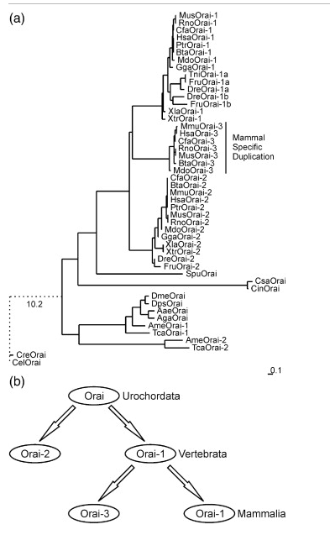

- Nematodes and insects have 1 orai
- sea urchins have 1, branching into 2 in the vertebrae, further duplication in mammals
- different duplications in fish genomes (have 6)
- tblastN searches of microbial genomes using CelOrai, yielded only one hit in the critical TM1 region: Pyrococcus furiosus, a hyperthermophilic archaeon. Critical E
- PfuCaT is proposed to function as a cation transport protein based on sequence similarity with a family of bacterial Co/Zn/Cd transport proteins, but the signature motif of the two internal repeats containing the two key acidic residues (see below) is only evident in PfuCaT and its homologues in P. horikoshii and T. kodakaerensis, not in the bacterial Co/Zn/Cd transport proteins.
- . The sequence similarity outside the internal repeats is very limited between PfuCaT and Orai proteins
- R91, whose mutation disrupts the Ca2+ channel function and causes severe combined immunodeficiency in patients,13 is highly conserved in the TMS1 of Orai sequences, but not in PfuCaT-N

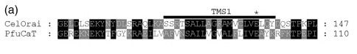

- Internal repeat homology in transmembrane segments 1 and 3
- one highly conserved Gly residue, located in the middle of TMS1 and -3, likely provides structural flexibility to the conformational changes of Orai channels in different activation/closed states

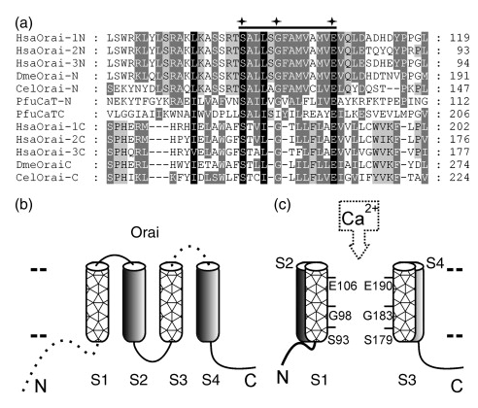

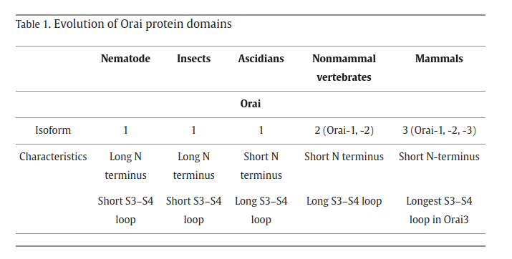

Cai 2006: https://academic.oup.com/mbe/article/25/7/1357/1042794?login=true

choanoflagellates Monosiga brevicollis

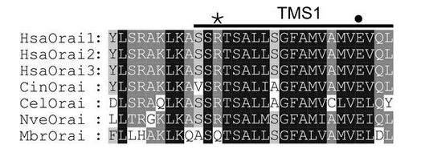

R91 not conserved, though E106 is

Stromal Interaction Molecule-1 (STIM1)

- ER intraluminal calcium sensor
- Also acts as the calcium sensor of the agonist sensitive acidic ca stores
- 1 TM, Nt in luman with low affinity EF hand, sterile alpha motif and non-ca binding EF hand. Cytosolic: 2 coiled-coil, ezrin/radixin/moesin-like domain, Pro rich Ct, and SOAR/CAD domain in Ct which have a role in Orai binding
- STIM2: high N-terminal homology with STIM1

Schindle 2009: https://www.sciencedirect.com/science/article/pii/S0143416009001341?via%3Dihub#bib36

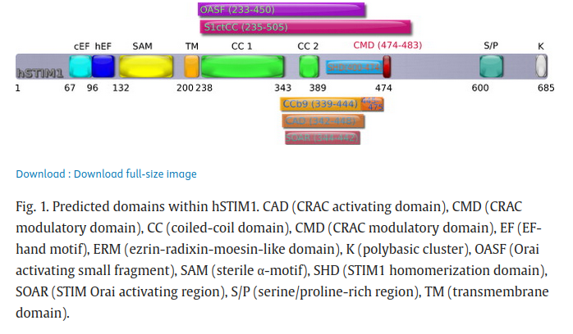

Ca2+ depletion of endoplasmic reticulum leads to a rapid unfolding of STIM's luminal EF-hand and sterile α-motif (EF-SAM) domain [27]. This allows the SAM and CAD/SOAR domain to induce oligomerization of STIM, the latter via a cytosolic homomerization motif [32], which is the key step that triggers the coupling to Orai [31], [60] and most likely [53] involves interaction via coiled-coil domains in STIM1/Orai C-termini

Gudlur 2019: https://physoc.onlinelibrary.wiley.com/doi/10.1113/JP276524

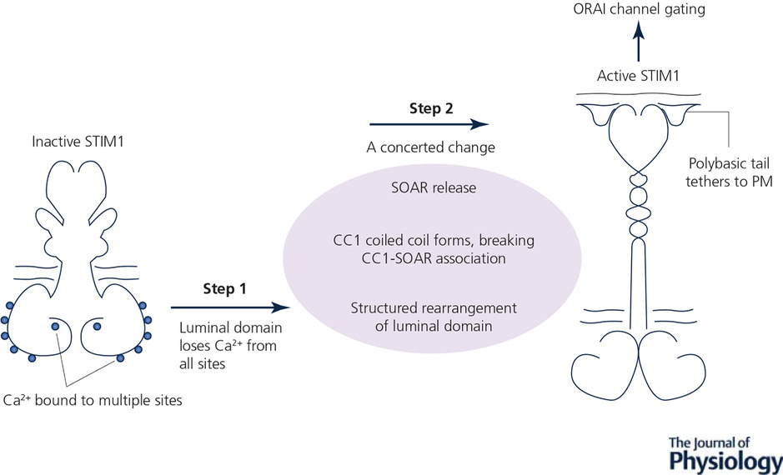

Relatively poor conservation:

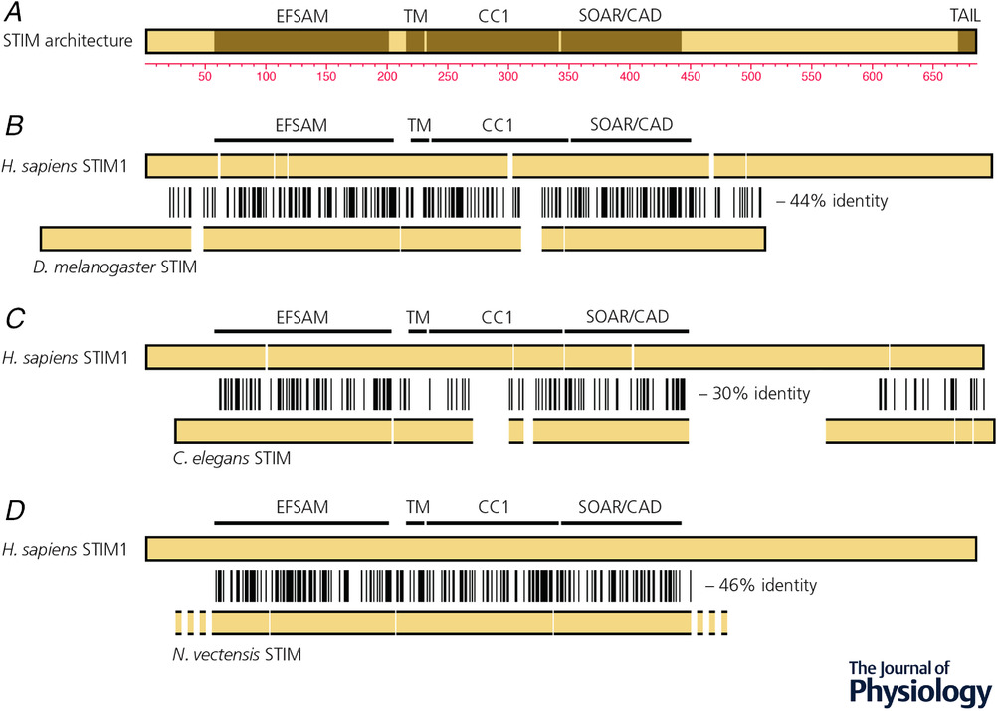

The STIM domain that communicates with the CRAC channel was identified in two steps. An initial study found that the cytoplasmic region of STIM, STIM1CT, activates ORAI channels when expressed in cells (Huang et al. 2006). STIM1CT lacks the STIM1 luminal domain and transmembrane segment, and hence it is a soluble cytoplasmic protein, unregulated by store depletion. Engineered truncations then delineated the minimal region that gated ORAI channels as STIM1(344–442), termed SOAR (STIM1 Orai activating region) or CAD (CRAC activation domain) (Kawasaki et al. 2009; Park et al. 2009; Yuan et al. 2009). SOAR/CAD or other STIM cytoplasmic fragments decorated the PM if, and only if, ORAI was coexpressed at sufficient levels (Muik et al. 2008, 2009; Kawasaki et al. 2009; Park et al. 2009; Yuan et al. 2009; Zhou et al. 2010). Moreover, fluorescence resonance energy transfer (FRET) was observed between appropriately labelled ORAI1 and STIM1 after store depletion, and constitutive FRET occurred between ORAI1 and SOAR/CAD or other STIM1 cytoplasmic fragments (Barr et al. 2008; Muik et al. 2008; Navarro-Borelly et al. 2008; Calloway et al. 2009). These observations implied that STIM binds either to ORAI or to a closely associated protein. Later, the functional reconstitution of calcium flux with recombinant STIM1CT and ORAI1 confirmed that a direct STIM–ORAI interaction underlies channel gating (Zhou et al. 2010; Gudlur et al. 2014).
The protein–protein interaction filled in only a part of the picture. STIM is anchored in the ER, and ORAI is in the PM, so the two can communicate directly only at close appositions of the two membranes termed ‘ER–PM junctions’. Because the ER–PM spacing is ∼15 nm (Wu et al. 2006), and because STIM was able to gate even channels with short ORAI cytoplasmic segments such as those formed by the truncated ORAI1(65–301) (Zhou et al. 2010), STIM had to extend from the ER to position SOAR/CAD near the PM. It was recognized early that the predicted coiled-coil 1 region (CC1) would be of sufficient length to place SOAR/CAD in the vicinity of the PM, and demonstrated later that an artificial spacer of 30 glycine residues between the transmembrane helix and SOAR/CAD sufficed to allow channel activation

Collins 2011: https://www.sciencedirect.com/science/article/pii/S0962892411000031?via%3Dihub

SOEC pathway has unusual features:
- it is one of only a few known ‘inside-out’ signaling mechanisms. Specifically, it allows changes in luminal ER Ca2+ to regulate the opening of a PM Ca2+ channel.
- STIM proteins have the interesting characteristic that they can directly bridge the ER to the PM at specialized junctions (the ER–PM junctions) that now appear to be ubiquitous in all eukaryotic cells.
- , the activation of STIM involves an oligomerization process that is different from other receptors that oligomerize, in that ligand (i.e. Ca2+) dissociation rather than ligand binding triggers STIM oligomerization and activation

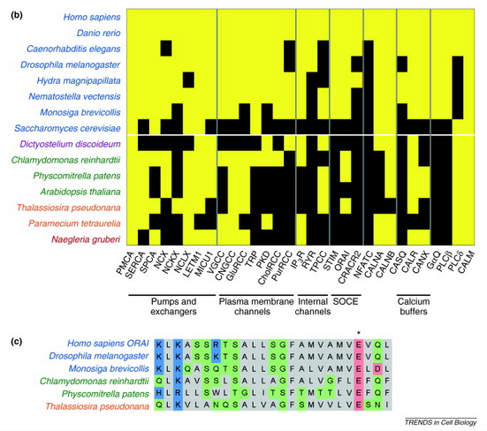

STIM is absent in plants, diatoms, dictyostelium …
Orai present in some.

Although Ca2+ release from internal stores is an ancient signaling mechanism prominent in all human cells, each of these types of release channels has also been lost during the evolution of a number of modern organisms (Figure 2; Box 1). For example, the IP3R is absent from the genome of the diatom Thalassiosira pseudonana [40], and the two-pore channel was lost during the evolution of Caenorhabditis elegans [41]. A number of species, including the yeast S. cerevisiae [42], lack all three of these channel types (IP3R, RyR and two-pore). However, S. cerevisiae uses a TRP-family channel (YVC1) to release Ca2+ from vacuolar stores [24]. Thus, although internal Ca2+ release mechanisms are present in almost every eukaryote, the channels used, and presumably the current and activation properties of those channels, vary widely.

How are STIM and Orai connected in evolutionary time?

- First, STIM and Orai homologs are present in the genome of the single-celled choanoflagellate Monosiga brevicollis 61, 62), which diverged from the human line before the apparent origins of the RyR, the muscle ER Ca2+ storage protein calsequestrin [63], or the T-cell differentiation transcription factor NFATc => not just for these pathways
- a number of species that have the IP3R lack STIM and Orai; examples include Paramecium tetraurelia [33] and Naegleria gruberi [22]. Therefore, the presence of STIM and Orai is not a universal complement to IP3-mediated Ca2+ signaling
- distant but recognizable Orai homologs appear in the genomes of green algae (Chlamydomonas reinhardtii) [27], moss (Physcomitrella patens) [64] and the diatom T. pseudonana [40]. Although it is impossible to determine by sequence analysis alone whether these homologs function as store-operated Ca2+ channels, it is interesting to note that the putative homologs in each of these species have conserved the E106 residue
- Several of these species with Orai ancestors lack the IP3R (Physcomitrella patens is an example 23, 64). The distant Orai homologs are suggestive of the presence of SOCE without IP3-mediated signaling. This could imply an initial evolutionary role for SOCE in regulating ER Ca2+ levels before SOCE became crucial for prolonging IP3-mediated Ca2+ signals
- the co-appearance of clear STIM homologs with PLCβ and GαQ in M. brevicollis and animals supports the alternative model that STIM arose as a complement to receptor-operated IP3 signaling, and that this system co-opted an existing Orai channel for SOCE
- the co-appearance of clear STIM homologs with PLCβ and GαQ in M. brevicollis and animals supports the alternative model that STIM arose as a complement to receptor-operated IP3 signaling, and that this system co-opted an existing Orai channel for SOCE

ER Ca homeostasis without STIM or Orai

Eukaryotic cells need to keep a high Ca2+ concentration (approx. 400 μmol/l) in the ER to regulate chaperones and enzymes that control protein folding, modification and secretion. How do organisms that lack STIM and Orai regulate ER Ca2+? One mechanism has been uncovered in the yeast S. cerevisiae. In this organism, depletion of Ca2+ from the secretory pathway results in Ca2+ influx across the plasma membrane through a voltage-gated Ca2+ channel homolog Cch1 (which has no homology to Orai) [104], and this leads indirectly to refilling of ER Ca2+ stores. This regulatory process involves two stress-response pathways. One is the unfolded protein response (UPR) [105], which is triggered when low ER and Golgi Ca2+ leads to incorrect folding, glycosylation and sorting of secreted proteins. This in turns activates the cell wall integrity MAPK pathway, which protects cells from lysis during polarized growth and in response to hypo-osmotic shock 105, 106. This suggests that yeast employ a STIM-independent ER Ca2+ homeostasis mechanism that is triggered indirectly by defects in the secretory system.

Very distant STIM related proteins in diatoms:
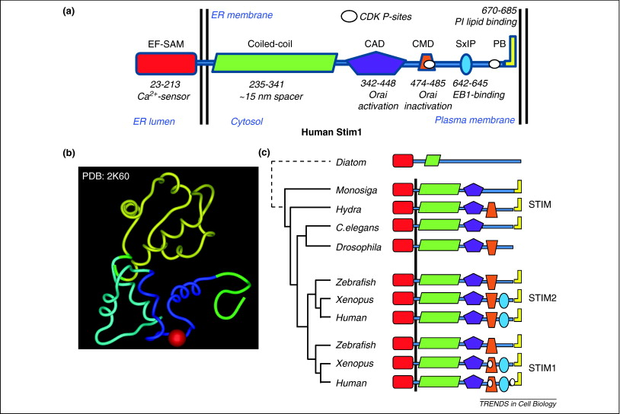

CAD is cruicial for Orai interaction:

The evolutionarily conserved minimal functional motifs of STIM1 and STIM2 (Figure 3c) consist of the EF-SAM Ca2+ sensor in the lumen of the ER, a single transmembrane-spanning domain, and a cytosolic coiled-coil domain that probably serves as a spacer of approx. 15 nm (estimated as 0.15 nm per amino acid for an alpha helix [77]) to bridge the space between the ER and PM (in STIM homologs, this domain is often broken into two segments). A subsequent CRAC activation domain (CAD; also termed STIM1 Orai activating region, SOAR) also contributes to the oligomerization 73, 78, 79, and acts as the main mediator of Orai recruitment and activation. The formation of a CAD tetramer is sufficient for binding to Orai [79] and, within the native protein, the same CAD is required to recruit and activate PM-localized Orai at ER–PM junctions.

