Project File Organisation/Naming Conventions

**Google Drive**

Presentations - WK00_Name-Presentation

Presentation feedback - WK00_Presentation-Feedback

Desk crit - WK00_Desk-Crit

Meeting notes - WK00_Meeting-Notes  
Playtesting results - WK00_MONTH(JUL/AUG/SEPT/OCT/NOV)-00

Art - HUD_Name_v00, UI_Name_v00, CA_Name_v00

Level Design - FBX_Name_v00, Texture_Name_v00

Sound and Music - Sound_Name_v00, Music_Name_v00

**Project Files**

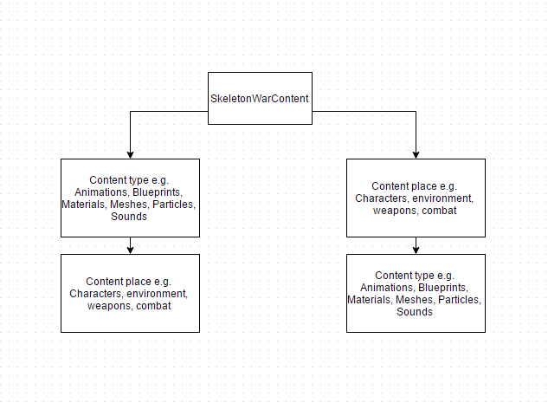

Blueprints - bp_name

Sound - sfx_name and music_name

Particles effects - pfx_name

Materials and Textures - t_name and t_name_m

Meshes - mesh_type(weapon, skele, environ,etc.)_name

Animations - anim_name

Fonts - font_name

Maps - map_name

UMG - hud_name