CPE301 – SPRING 2019

Design Assignment 1, Part A

Student Name: James Skelly

Student #: 2000945485

Student Email: skellj1@unlv.nevada.edu

Primary Github address: https://github.com/skellj1/submission_da

Directory: skellj1/submission_da

Submit the following for all Labs:

1. In the document, for each task submit the modified or included code (only) with highlights and justifications of the modifications. Also, include the comments.
2. Use the previously create a Github repository with a random name (no CPE/301, Lastname, Firstname). Place all labs under the root folder ESD301/DA, sub-folder named LABXX, with one document and one video link file for each lab, place modified asm/c files named as LabXX-TYY.asm/c.
3. If multiple asm/c files or other libraries are used, create a folder LabXX-TYY and place these files inside the folder.
4. The folder should have a) Word document (see template), b) source code file(s) and other include files, c) text file with youtube video links (see template).

1. **COMPONENTS LIST AND CONNECTION BLOCK DIAGRAM w/ PINS**

* Components used for this assignment include Atmel Studio 7 Simulator (for programming in assembly, viewing register and memory contents after execution, and analyzing processor status, status register at termination of program, and cycle counter) and the online hexadecimal calculator (<https://www.miniwebtool.com/hex-calculator/>) in order to verify correct calculation.

1. **INITIAL/MODIFIED/DEVELOPED CODE OF TASK 1/A**

/*

* Skelly_James_DA1.asm

*

* Created: 2/3/2019 3:11:23 PM

* Author: James Skelly (CPE 301, Sp. 2019)

*/

.ORG 0X00 ; Sets the program to begin at memory location 0x00

.EQU MULTIPLICAND = 0XFFFF ; Initializes the multiplicand (16-bit value)

.EQU MULTIPLIER = 0XFF ; Initializes the multiplier (8-bit value)

LDI R25, HIGH(MULTIPLICAND) ; Places the higher 8-bits of the multiplicand into register 25

LDI R24, LOW(MULTIPLICAND) ; Places the lower 8-bits of the multiplicand into register 24

LDI R22, MULTIPLIER ; Loads the multiplier value into register 22

LDI R21, MULTIPLIER ; Keeps a copy of the multiplier in register 21 for review when

;program terminates

LDI R16, 0x00 ; Places the value zero into register 16

LOOP: ; Loop label for repeated (iterative) addition

ADD R20, R24 ; Begins repeated addition of the lower 8 bits of the multiplicand,

; places the value of the repeated addition in the first solution

; register, R18

ADC R19, R25 ; Repeated addition of upper 8 bits, including addition of carry bit

; from SREG, places result in R19, the second solution register

ADC R18, R16 ; Allocates bits 16-23 of the third solution register, initially adding

; the value 0 until further iterations where it will begin to sum

; up the carry values it receives from the SREG carry bit

DEC R22 ; Decrements R17, the multiplier, by 1 on each iteration

BRNE LOOP ; Branches back to the top of the LOOP subroutine until R17 is zero

RJMP END ; Jumps to the END label

END: RJMP END ; Program terminates

1. **DEVELOPED MODIFIED CODE OF TASK 2/A from TASK 1/A**

Not available for this assignment.

1. **SCHEMATICS**

Not available for this assignment.

1. **SCREENSHOTS OF EACH TASK OUTPUT (ATMEL STUDIO OUTPUT)**

**TASKS**

1. Perform a multiplication of a 16-bit multiplicand with an 8-bit multiplier **without using the MUL instruction.** Use iterative addition to perform this multiplication.
2. Registers R25:R24 should hold the multiplicand, R22 should hold the multiplier, and R20:R19:R18 should hold the result, which will be 24 bits.
3. Verify your algorithm using any valid form of verification.
4. Determine the execution time @ 16 MHZ, and the number of cycles, of your algorithm during simulation.

SAMPLE SOLUTION 1

**Below is the code which initializes the multiplicand and the multiplier and places the necessary values for calculation into the registers specified in the instructions. The values 0xFFFF and 0xFF were selected so that the maximum execution time would be reached, as this multiplier will force the multiplicand to add to itself 255 times.**

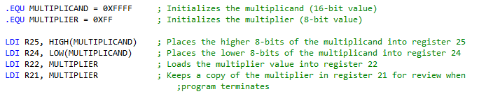

**At the completion of the execution of the code, we can look to the “Processor Status” and “Registers” windows to determine number of clock cycles, time elapsed (execution time), and to verify that the registers hold the values that we expect.**

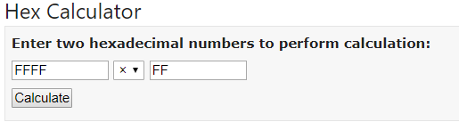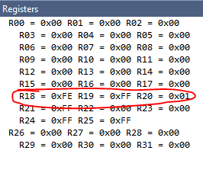

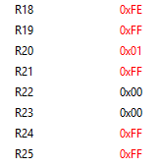

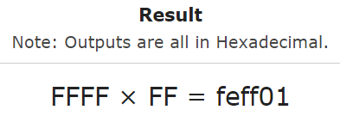

**Above we can see the status of the data registers (the 24-bit result can be placed in R18:R19:R20 so that they are in order from MSB to LSB, or viceversa) at the end of the code execution. The result was verified with the online hex calculator shown above and to the right. Note also that the multiplicand is held in R24:R25 and the multiplier is held in R21.**

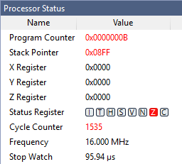

**Shown to the left is the “Processor Status” window at the completion of execution. From this window, we can see that the entire execution took 95.94 us, or 1535 clock cycles at 16 MHz.**

SAMPLE SOLUTION 2

**Here is a second example in which the value of the multiplicand was selected to be 0xAF23, and the value of the multiplier was selected to be 0x23.**

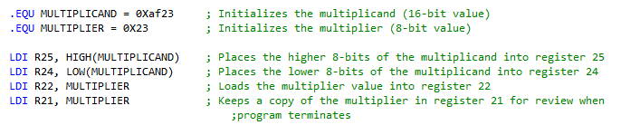

**Below, we can see the solution stored in the solution registers R18:R19:R20, along with the multiplier in R21 and the multiplicand in R24 and R25.**

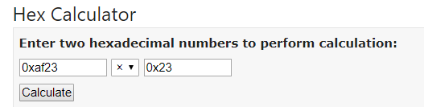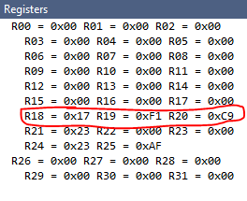

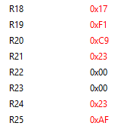

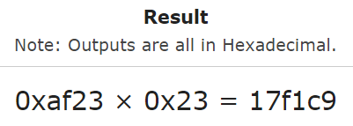

**We can see on the right that the online hex calculator used for verification has a result which matches the result registers above to the left.**

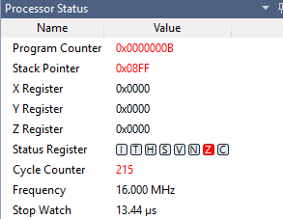

**Shown to the left is the “Processor Status” window at the completion of execution. From this window, we can see that the entire execution took only 13.44 us, or 215 clock cycles at 16 MHz. Notice that this is a much smaller execution time than we had in solution 1. This is because the first solution used the maximum 8 bit and maximum 16 bit value for the largest possible computation using iterative addition to multiply.**

SAMPLE SOLUTION 3

**Here is one final sample solution to test the program, which uses 0x7254 as the multiplicand, and 0x10 as the multiplier.**

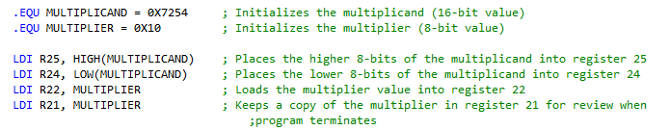

**Below, we can see the solution stored in the solution registers R18:R19:R20, along with the multiplier in R21 and the multiplicand in R24 and R25.**

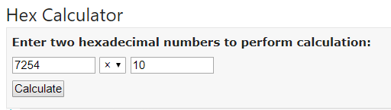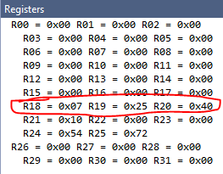

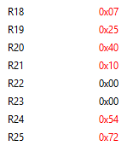

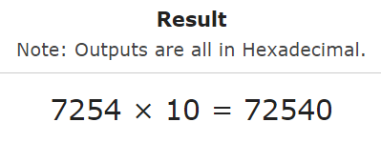

**We can see on the right that the online hex calculator used for verification has a result which matches the result registers above to the left.**

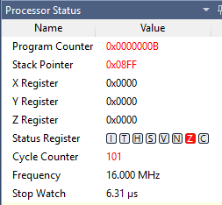

**Note that as we decrease the value of the multiplier in each solution, the number of cycles/execution time decrease notably. This is because for repeated addition, the number of cycles is based entirely on the multiplier value, as repeated addition is simply the sum of the multiplicand added to itself n times, where n is the value of the multiplier.**

**Below is a final screenshot of the program written in Atmel Studio 7 with registers and processor status also viewable.**

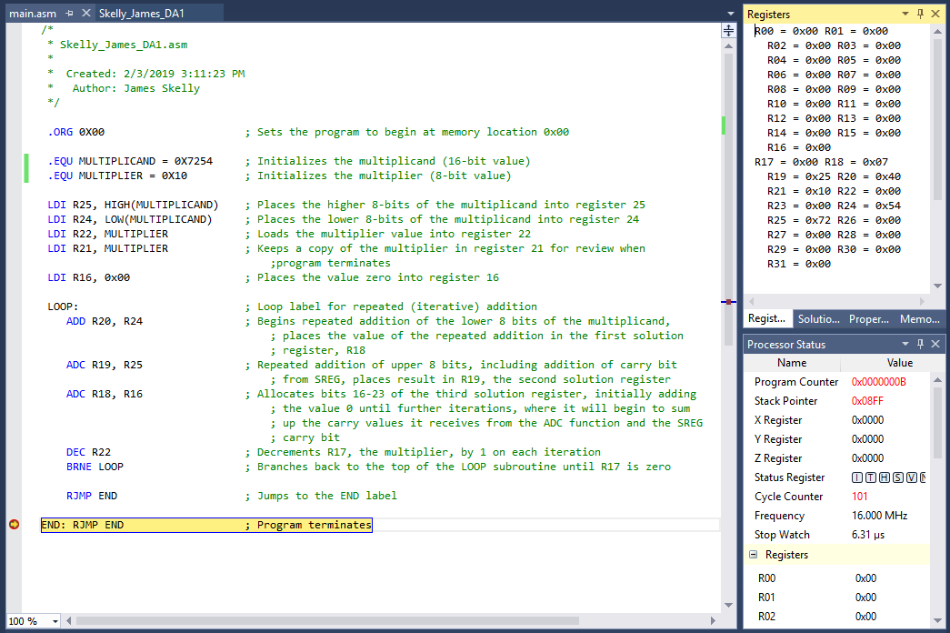

1. **SCREENSHOT OF EACH DEMO (BOARD SETUP)**

Not available for this assignment.

1. **VIDEO LINKS OF EACH DEMO**

Not available for this assignment.

1. **GITHUB LINK OF THIS DA**

https://github.com/skellj1/submission_da

**Student Academic Misconduct Policy**

<http://studentconduct.unlv.edu/misconduct/policy.html>

“This assignment submission is my own, original work”.

James W. Skelly